**JAVA PROGRAMMING**

**CS6308**

**LAB 8 - HUNGMAN GAME**

**Name:** VIJAI SURIA M

**Reg No.:** 2021503568

**Date:** 27.09.2023

Write a program to implement Hangman game in Java, a word-guessing game where one player thinks of a Secret word, and another player (the computer i.e., Guesser or user) tries to guess it by stating one letter at a time. If the guessed letter is in the secret word, it's revealed in the display; otherwise the number of attempt is reduced by one. The player usually has a limited number of incorrect guesses allowed before they lose the game. The game ends when the player successfully guesses the word (win) or when they run out of allowed incorrect guesses (lose).The game typically has the following components:

**Input**:

The guesser or user tries to guess the secret word by stating each of the character in the secret word.

**Output**:

A representation of the secret word is displayed with underscores for each letter that hasn't been guessed yet.

For example, if the secret word is "java" and the player has guessed 'a', the display would be "_ a _ a".

**Method: Guessing**

Guessing: Fix the maximum attempts. Create a guessed Letter Boolean array of secret word length size to verify the guessed character of secret word.

Process the guess [10 points each]

1. Check input is a valid input (i.e., a character) Check if the guessed letter is in the secret word.
2. Update guessed Letters array.
3. Check if the entire word has been guessed.
4. Increment attempts if the guess is incorrect.
5. Print game messages Win/Lose Conditions
6. The player receives feedback on their guesses, including whether the guessed letter is in the word and the current state of the word display.
7. Replay: After the game ends, the players may choose to play again with a new secret word.

Increase the complexity of the program by having more than one secret Word and choose it randomly. Give clues about the secret Word and reduce the points accordingly.

**CODE:**

|  |
| --- |
| import java.time.LocalDate;  import java.time.LocalTime;  import java.util.*;  class Hangman3568 {      public static void main(String[] args) {          System.out.println("Current Date: " + LocalDate.now());          System.out.println("Current Time: " + LocalTime.now());          System.out.println("Name: Vijai Suria M \nRegister Number: (2021503568)");          String words[] = { "java", "internship", "college", "computer", "github" };          String hints[][] = {                  { "Widely used programming language", "Platform independence" },                  { "Temporary work experience", "Academic years" },                  { "Higher education institution", "Beyond high school" },                  { "Data processing device", "Calculations electronically" },                  { "Code collaboration platform", "Version control" }          };          Scanner in = new Scanner(System.in);          int chances, length, mode;          boolean k = true;          while (k) {              int clu = 0;              Random rand = new Random();              int ran = rand.nextInt(5);              String tobe = words[ran];              length = tobe.length();              char[] actual = tobe.toCharArray();              char[] guessword = new char[length];              for (int i = 0; i < length; i++)                  guessword[i] = ' ';              chances = length + (length / 3);              boolean t = false;              while (chances > 0) {                  for (int i = 0; i < length; i++) {                      if (guessword[i] == ' ')                          System.out.print("_ ");                      else                          System.out.print(guessword[i]);                  }                  System.out.println("\n" + chances + " chances left");                  char guess;                  if (clu <= 1) {                      System.out.print("Enter 1 for clue, 2 for guessing:");                      mode = in.nextInt();                  } else {                      if (t == false)                          System.out.println("No clues left");                      t = true;                      mode = 2;                  }                  if (mode == 1) {                      System.out.println("Clue :" + hints[ran][clu]);                      clu++;                      chances--;                  } else {                      in.nextLine();                      System.out.println("Guess a letter : ");                      guess = in.next().charAt(0);                      chances--;                      if (!(guess >= 'a' && guess <= 'z')) {                          System.out.println("Invalid input. Only give small letter alphabets!");                      } else {                          for (int i = 0; i < actual.length; i++) {                              if (guess == actual[i]) {                                  guessword[i] = actual[i];                              }                          }                      }                  }                  boolean found = true;                  for (int i = 0; i < length; i++) {                      if (guessword[i] == ' ') {                          found = false;                          break;                      }                  }                  if (found == true) {                      break;                  }              }              boolean f = true;              for (int i = 0; i < length; i++) {                  if (guessword[i] == ' ') {                      f = false;                      break;                  }              }              if (f == true) {                  System.out.println("Congratulations!! You have found the word!!The word is " + tobe);              } else {                  System.out.println("Chance over..!! Better luck next time");              }              int p = 0;              System.out.print("Enter 0 to exit, 1 to play again:");              p = in.nextInt();              if (p == 0)                  k = false;          }          in.close();      }  } |

**OUTPUT:**

1. Player winning against computer:

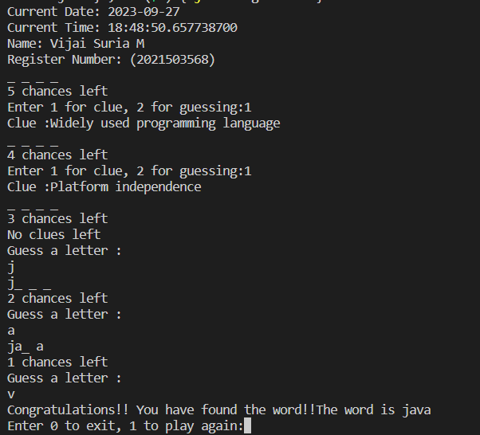

1. Player losing against computer

