| Exp: 04 Date: 16/08/2023  JAVA PROGRAMMING LAB 4 |
| --- |

Name: VIJAI SURIA M

Reg No. : 2021503568

1. **Write a program to determine the custom grade of the marks given. If the marks go beyond 100 or lower than 0 then state the input is invalid.**

**90 to 100 : Grade O**

**80 TO 89 : Grade A+**

**70 TO 79 : Grade A**

**60 TO 69 : Grade B+**

**50 to 59 : Grade B**

**0 TO 49 : Grade U**

**Hint: use If statement**

| import java.time.LocalDate;  import java.time.LocalTime;  import java.util.Scanner;  public class Grade3568 {  public static void main(String[] args) {  System.out.println("Current Date: " + LocalDate.now());  System.out.println("Current Time: " + LocalTime.now());  System.out.println("Name: Vijai Suria M \nRegister Number: (2021503568)");  Scanner in = new Scanner(System.in);  System.out.print("Enter the number of Subject: ");  int n = in.nextInt();  int[] marks = new int[n];  System.out.println("Enter the Subject marks (space seperated): ");  for(int i=0;i<n;i++){  marks[i] = in.nextInt();  }  System.out.println("Grade Reports:");  for(int i=0;i<n;i++){  if(marks[i]>=90 && marks[i]<=100)  System.out.println("Subject-"+ (i+1)+" Grade: O");  else if(marks[i]>=80 && marks[i]<=89)  System.out.println("Subject-"+ (i+1)+" Grade: A+");  else if(marks[i]>=70 && marks[i]<=79)  System.out.println("Subject-"+ (i+1)+" Grade: A");  else if(marks[i]>=60 && marks[i]<=69)  System.out.println("Subject-"+ (i+1)+" Grade: B+");  else if(marks[i]>=50 && marks[i]<=59)  System.out.println("Subject-"+ (i+1)+" Grade: B");  else if(marks[i]>=0 && marks[i]<=49)  System.out.println("Subject-"+ (i+1)+" Grade: U");  else  System.out.println("Subject-"+ (i+1)+" Invalid Marks");  }  in.close();  }  } |
| --- |

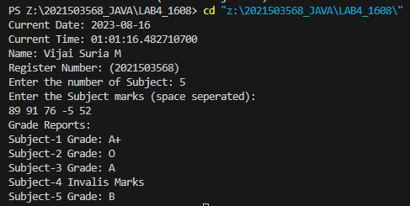

1. **Write a program that simulates the coin toss as head or tail. Use Random number 0 or 1 to determine the system input. The program should print the result as head if it one and tail if it is zero. Read the input from the user as a character ‘h’ or ‘t’ or ‘H’ or ‘T’ and tell the user whether he or she has predicted the coin toss correctly . Declare the result as Won the toss! Or lose! (Hint: Use Random class to get the random input 0 to 1).**

| import java.time.LocalDate;  import java.time.LocalTime;  import java.util.Random;  import java.util.Scanner;  public class Toss3568 {  public static void main(String[] args) {  System.out.println("Current Date: " + LocalDate.now());  System.out.println("Current Time: " + LocalTime.now());  System.out.println("Name: Vijai Suria M \nRegister Number: (2021503568)");  Scanner in = new Scanner(System.in);  Random random = new Random();  int res = random.nextInt(2);  System.out.print("Enter your choice (h/t) or (H/T): ");  char ch=in.next().charAt(0);  if(ch=='h' || ch=='H'){  if(res==1)  System.out.println("Won the toss!");  else  System.out.println("Loss the toss!");  }  else{  if(res==0)  System.out.println("Won the toss!");  else  System.out.println("Loss the toss!");  }  System.out.println(res);  in.close();  }  } |
| --- |

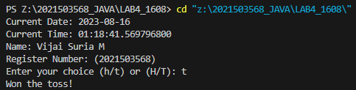

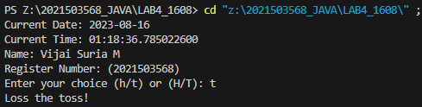

1. **Write a program to output the number of days of the month(1 to 12) in the given year. The value of the month February is 28 or 29 based on the leap year. Give warning for invalid input that is of digit less than 4 or greater than 5. Hint: Use Switch statement**

| import java.time.LocalDate;  import java.time.LocalTime;  import java.util.Scanner;  import java.time.Year;  public class Days3568 {      public static void main(String[] args) {          System.out.println("Current Date: " + LocalDate.now());          System.out.println("Current Time: " + LocalTime.now());          System.out.println("Name: Vijai Suria M \nRegister Number: (2021503568)");          Scanner in = new Scanner(System.in);          System.out.print("Enter the month(1-12): ");          int month = in.nextInt();          if(month<1 || month>12){              System.out.println("Invalid month");              System.exit(0);          }          System.out.print("Enter the year: ");          int year = in.nextInt();          if(year<=999 || year>9999){              System.out.println("Invalid year");              System.exit(0);          }          switch(month){              case 1:                  System.out.println("The number of days in the month (January) is "+31);                  break;              case 2:                  Year y = Year.of(year);                  if(y.isLeap())                      System.out.println("The number of days in the month (Febrauary) is "+29);                  else                  System.out.println("The number of days in the month (Febrauary) is "+28);                  break;              case 3:                  System.out.println("The number of days in the month (March) is "+31);                  break;              case 4:                  System.out.println("The number of days in the month (April) is "+30);                  break;              case 5:                  System.out.println("The number of days in the month (May) is "+31);                  break;              case 6:                  System.out.println("The number of days in the month (June) is "+30);                  break;              case 7:                  System.out.println("The number of days in the month (July) is "+31);                  break;              case 8:                  System.out.println("The number of days in the month (August) is "+31);                  break;              case 9:                  System.out.println("The number of days in the month (September) is "+30);                  break;              case 10:                  System.out.println("The number of days in the month (October) is "+31);                  break;              case 11:                  System.out.println("The number of days in the month (November) is "+30);                  break;              case 12:                  System.out.println("The number of days in the month (December) is "+31);                  break;              default:                  System.out.println("Invalid Month");                  break;          }          in.close();      }  } |
| --- |

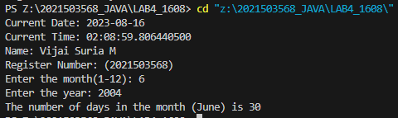

1. **Write a program that verbalize the user inputs between 1 and 9999 number.**

**For example Input number : 852 Eight hundred and fifty two**

| import java.util.Scanner;  public class Verbalize3568 {  private static final String[] units = {"", "One", "Two", "Three", "Four", "Five", "Six", "Seven", "Eight", "Nine"};  private static final String[] teens = {"Ten", "Eleven", "Twelve", "Thirteen", "Fourteen", "Fifteen", "Sixteen", "Seventeen", "Eighteen", "Nineteen"};  private static final String[] tens = {"", "", "Twenty", "Thirty", "Forty", "Fifty", "Sixty", "Seventy", "Eighty", "Ninety"};  private static final String[] thousands = {"", "Thousand", "Million", "Billion"};  public static void main(String[] args) {  Scanner scanner = new Scanner(System.in);  System.out.print("Input number: ");  int number = scanner.nextInt();  if (number < 1 || number > 9999) {  System.out.println("Number out of range.");  } else {  String verbalized = verbalizeNumber(number);  System.out.println(verbalized);  }  scanner.close();  }  private static String verbalizeNumber(int number) {  if (number == 0) {  return "Zero";  }  String verbalized = "";  int thousandsIndex = 0;  while (number > 0) {  if (number % 1000 != 0) {  verbalized = verbalizeChunk(number % 1000) + thousands[thousandsIndex] + " " + verbalized;  }  number /= 1000;  thousandsIndex++;  }  return verbalized.trim();  }  private static String verbalizeChunk(int number) {  if (number == 0) {  return "";  }  if (number < 10) {  return units[number];  } else if (number < 20) {  return teens[number - 10];  } else if (number < 100) {  return tens[number / 10] + " " + units[number % 10];  } else {  return units[number / 100] + " Hundred " + verbalizeChunk(number % 100);  }  }  } |
| --- |

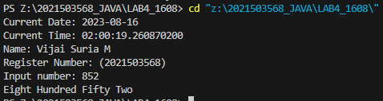

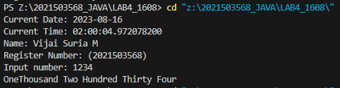

1. **Write a program to create 24-hour digital watch. Get the input from the user for the day(Mon, Tue, Wed, Thu, Fri, Sat, Sun) , hour (24-hour) , minute and seconds . The input of the user is valid then the digital clock should advance the input by one second and display the new day, hour, minute and second.**

**Sample input:**

**Input day : Mon**

**Input hour : 23**

**Input minute : 59**

**Input second : 59**

**Sample output:**

**Tue 0 0 0**

**Hint: Use for statement**

| import java.time.LocalDate;  import java.time.LocalTime;  import java.util.Scanner;  public class Time3568 {      public static String nextDay(String day)      {          if(day.equals("Sun"))            return "Mon";          if(day.equals("Mon"))            return "Tue";          if(day.equals("Tue"))            return "Wed";          if(day.equals("Wed"))            return "Thu";          if(day.equals("Thu"))            return "Fri";          if(day.equals("Fri"))            return "Sat";              return "Sun";        }        public static void main(String[] args) {          System.out.println("Current Date: " + LocalDate.now());          System.out.println("Current Time: " + LocalTime.now());          System.out.println("Name: Vijai Suria M \nRegister Number: (2021503568)");          String day;          int hour,minute,sec;          Scanner in = new Scanner(System.in);          System.out.print("Enter day:");          day=in.nextLine();          System.out.print("Enter hour:");          hour = in.nextInt();          System.out.print("Enter minute:");          minute = in.nextInt();          System.out.print("Enter second:");          sec = in.nextInt();          if(sec+1 <=59)              sec+=1;          else{              sec =0;              if(minute+1 <=  59)                  minute++;              else              {                  minute =0;                  if(hour+1<=23)                      hour++;                  else                  {                      hour = 0;                      day=nextDay(day);                  }              }          }          System.out.println(day+" "+hour+" "+minute+" "+sec);          in.close();      }  } |
| --- |

