**“HEAVY METAL ANALYSIS FROM SOIL SAMPLE”**

**A PROJECT REPORT**

**SUBMITTED TO THE**



**SCHOOL OF SCIENCE**

**SAGE UNIVERSITY BHOPAL [M.P]**

**TOWARDS PARTIAL FULLFILLMENT**

**OF THE REQUIREMENT FOR THE DEGREE**

**MASTER OF FORENSIC SCIENCE [2021-2023]**

**BY**

**AMRITA VIJAYAN**

**UNDER THE SUPERVISION**

**OF**

**SUPERVISOR CO-SUPERVISOR**

**Anita Yadav C.R.Patle**

**Associate Professor Assistant Professor**

 **SAGE UNIVERSITY, BHOPAL**

**SCHOOL OF SCIENCE**

**CERTIFICATE FROM THE SUPERVISOR**

This is to certify that the work incorporated in the project report entitled “HEAVY METAL ANALYSIS FROM SOIL SAMPLE” is a record of work carried out by Amrita Vijayan, 21MSC5FRC10026 under my guidance and supervision for the award of Degree of Master of Forensic Science, Sage university Bhopal.

To the best of my knowledge and belief the project report

1. Embodies the work of the candidate himself
2. Has duly been completed
3. Fulfils the requirement of the ordinance/guidelines relating to the Master of Forensic Science degree of the university and
4. Is up to the desired standard both in respect of contents and language for being referred to the examiners.

**Dr. Anita Yadav**

The project work as mentioned above is hereby being recommended and forwarded for examination and evaluation.

**Dr. Abhineet Goyal**

**School of Science**

 **SAGE UNIVERSITY, BHOPAL**

**SCHOOL OF SCIENCES**

**CERTIFICATE FROM THE CO-SUPERVISOR**

This is to certify that the work embodies in this dissertation entitled “HEAVY METAL ANALYSIS FROM SOIL SAMPLE’’ being submitted by, [Enrollment Number; 21MSC5FRC10026] In partial fulfilment of the requirement for the award of “Master of science in Forensic Science “ to Sage University, Bhopal [M.P] during the academic year 2022-2023 is a record of Bonafede piece of work, carried out by her under my supervision and guidance

**Supervisor**

**Dr. Anita Yadav**



**SAGE UNIVERSITY BHOPAL**

**SCHOOL OF SCIENCES**

**PLAGIARISM CERTIFICATE**

 **SAGE UNIVERSITY BHOPAL**

**SCHOOL OF SCIENCES**

**ACKNOWLEDGEMENT**

It is my proud privilege to present a project on “HEAVY METAL ANALYSIS FROM SOIL SAMPLE”. I take this opportunity to express deep sense of gratitude and would like to give thanks to my supervisor, Dr. Anita Yadav, Sage University Bhopal for their valuable guidance, inspiration and encouragement that has held to successful completion of this work. I would like to express my heartfelt thanks towards co-supervisor C.R.Patle for their suggestions throughout the project work. I would also like to thank my family, without their support this work would not have been carried out. I could not have accomplished, what I actually have, without their guidance.

I would like to express my heartfelt thanks to my HOS Dr. Abhineet Goyal for the support provided throughout the project and sense of gratitude for being a constant source of inspiration. I am also thankful to all faculty members and staff of department of their suggestions and support. I would like to deeply thank my family and friends for all the encouragement they have rendered time to time. Last but not the least, I dedicate my work to almighty God without whose wish and helping this work would not have taken the shape it has now and also my family members whose support and encouragement had led me to complete this task.

**Enrolment Numbers: 21MSC5FRC10026**

TABLE OF CONTENTS

ABSTRACT

ACKNOWLEDGEMENT

LIST OF TABLES

LIST OF FIGURES

1. CHAPTER ONE
   1. Introduction
   2. Statement of Problem
   3. Purpose of Study
2. CHAPTER TWO: LITERATURE REVIEW
   1. Introduction
   2. review of work done in last 10 yrs
   3. Research Gap
   4. Objectives

3. CHAPTER THREE: METHODOLOGY

3.1 Introduction

3.2 Type of work

3.3 data preparation/ collection

3.4 data analysis

4. CHAPTER FOUR: FINDINGS RESULT AND DISCUSSIONS

5. CHAPTER FIVE: FINDINGS RESULT AND DISCUSSIONS

5.1 conclusion in reference to objective

5.2 suggestions

5.3 scope of future work

APPENDIX A:

REFERENCES

LIST OF TABLES

Table 1.

Table 2.

Table 3.

LIST OF FIGURES

Figure 1.

Figure 2.

Figure 3.

ABSTRACT

A layer of loose surface above land is called soil. It is usually amalgamation of gases, rocks, minerals organic and inorganic materials. Soil is of utmost importance for sustaining life, unfortunately due to rapid urbanisation and industrialization heavy metals are entering our ecosystem thereby disturbing normal functioning of the biosphere. The current study focuses on analysis of heavy metals present in the soil thereby assessing soil pollution due to the presence of heavy metals in soil.

This study mainly concentrates on the analysis of two metals namely- Iron (Fe) and Zinc (Zn). For the current study soil samples from three different industrial areas were collected at a regular interval of 1.5 km. Mainly top soil was taken for the analysis.

Soil samples of these three industrial areas were compared on the basis of presence of heavy metals.

Statement of Problem

According to Kerala State Council for Science, Technology and Environment (KSCSTE) periyar and chaliyar are the polluted rivers of Kerala, and approximately 260 million industrial effluents are being dumped on a daily basis, converting it into the lake chock-full of toxins. It usually creates rage among the people thereby frequently making headlines in the media or news channels.

The risk of Heavy Metal contamination is well known especially for the children, impact will greater as compared to adults. Areas near the vicinity of industrial area are said to be in the radar of Heavy Metal Pollution zones thereby, making living around that area susceptible to the Heavy Metal contamination and ill effects caused by them (Teodor Velea et.al.,2008).

This study was conducted keeping the above-mentioned points in mind with the seriousness of this issue and looking at the fact that very little amount of work or study has been carried out, especially in the regions covered in this research.

Purpose of study

Heavy metal pollution is a serious threat to the ecosystem. Though they are present in the earth’s crust, but in trace amounts making it safe for the human exposure. Once the limits exceed it causes serious threats and health problems. Chronic exposure to these Heavy metals may cause irreversible health problems. This research solely aims at studying the amount of trace metals present in the samples and assessing whether they are within the safe limits for human exposure and if exceeding, then up to what limits

CHAPTER 1

INTRODUCTION

Soil has essential as well as hazardous components including the biotic and abiotic factors. The gross metallic concentration may be of geochemical interest, but the availability of metals may be agricultural of interest [54]. Usually metals whose atomic weight and density exceeds four-five times that of water are said to be Heavy Metals. They are ubiquitous and almost found everywhere on earth surface. Though they can be found everywhere but once they exceed their normal limit, they are supposed to pose threat to ecosystem including biotic (such as plants, animals, humans) and abiotic factors (such as soil, water). Arsenic (Ar), Lead (Pb), Cadmium (Cd), Chromium (Cr), Zinc (Zn), Selenium (Se), Nickel (Ni) and iron (Fe) are some of the metals that are classified as heavy metals [51]. There are almost 60 heavy metals which are known till now. Their increasing concentration can adversely affect the physiology of the plants such as nutrient absorption, photosynthesis etc. [9].

Urbanization and industrialization has lead to increase in heavy metal concentration thereby increasing heavy metal pollution. Ill effects of heavy metals are greater than that of normal metals that cannot be overlooked, thereby creating an urge to keep heavy metal concentration under control [1]. The speedy increase on the population has pressurized the land for raising the food supply o meet the increasing demand of food thereby leading to excessive use of chemicals- pesticides and insecticides that comes handy and are cheap, thereby accelerating the accumulation of heavy metal concentration in soil, further declining the living and nutritional standards. Such cases are seen mostly in Asian and African continents [39]. During such conditions usually children are affected the most out of all the population, as their digestion is active thereby leading to increase in piling up of toxic heavy metals in the body further causing poisoning symptoms and other health problems which may even be fatal. In cities the heavy metal toxicity is directly proportional to the vehicular emissions. The deteriorating health conditions of people living in the urban cities has lead to research of heavy metal toxicity in the soils of urban cities [4].

Wastewaters are used in the country side for supplying water through the fields and this inturn increases the heavy metal concentration in the soils. The heavy metals whose concentrations are increased in the soils due to wastewater supply includes Ni, Cd, Cr, Pb, Mn, Zn. When the heavy metal concentration in the top soil surpasses the retaining capacity of soil then it is transferred to the sub surface or ground water [13]. There may be various reasons for the increasing concentrations of heavy metals in the soil that may including natural and man-made activities. Majority of the heavy metal contamination is caused by mining alone others include waste water discharge by industries, and other common dumping entailing wastes from sewage, paints, fertilizers, pesticides and sometimes domestic wastes too such as electric appliances [12].

Nanotechnology and its use also has several repercussions as the release of nanoparticles and toxic metals are not regulated or treated leading to nano-toxicity that has various impacts on soil, plants as well as human health [39].

AAS (Atomic Absorption Spectroscopy), ICP-OES (Inductively Coupled Optical Emission Spectroscopy), ICP-MS (Inductively Coupled Plasma-Mass Spectroscopy), NAA (Neutron Activation Analysis), XRF (X-Ray Fluorescence Spectrometry), SEM-EDX (Scanning Electron Microscope with Energy Dispersive X-rays) etc are some of the instruments that are used for the quantitative and qualitative analysis of heavy metals. Though all these instruments are used but AAS (Atomic Absorption Spectroscopy) is commonly used. It is a precise and a highly sensitive instrument having sensitivity upto ppt (parts per trillion) [33].

Being non-biodegradable, they easily accumulate and elevate the toxicity and transferred to next Trophic levels thereby increasing the toxicity at each trophic level and causing fatal consequences. One of the major pathways is through dietary uptake, as most of the agricultural fields are watered through wastewater, which is the major source heavy metal [13]. Though the major route is through agricultural fields from soil to plants, but it is not merely restricted to that route rather it may also enter the food chain through aquatic means, as these heavy metals are also being dumped into the sea, they easily enter the aquatic food chain as they are absorbed by the aquatic plants which are eaten by marine fishes which are further prey to big fishes, which then enters the humans with increased concentration. There are also researches that indicates transfer of metal nanoparticles from marine microalgae (*Criscosphaera elongata*) to Sea urchin (*Paracentrotus lividus*) larvae

Out of all Lead (Pb) and Cadmium (Cd) are of utmost toxicity. And due to their absorption and accumulation they cause various issues like Kidney, bone, nervous and cardiovascular diseases. And as stated the main exposure to heavy metals is through plants which they uptake from soil and keep on increasing to several folds while they are being transferred to higher trophic level. Cadmium (Cd) and Copper (Cu) have greater transfer quotient than other heavy metals [38].

Mostly the heavy metal pollution is due to anthropogenic causes and due to the practice that humans followed since time immemorial. For reversing the current status strict measures need to be taken including stringent control over the dumping of domestic and untreated industrial wastes. Recycling of some heavy metals which can be recycled is also advised [18].

Researches have also showed that the heavy metal analysis can also provide with the glimpse of past human activities. As usually the composition of soil is due to the mixture of natural and anthropogenic activities, so even the fertilizers and pesticides could gives us the jist of the human activities, therefore any changes could easily be linked to activities of the past civilization [41].

Amongst heavy metals some are useful and even have biological importance while others don’t so the heavy metals that don’t find any importance are categorized as non-essential, while others like Zn, Fe, Cu are important for the normal functioning of the body, though their excess amount can cause malfunctioning of organs and other health complication [39].

Human activities change agricultural land a lot and thus it can be said that the agricultural lands are reflection of social activities and financial resources. Activities of humans shape the land to large extent and may even cause pollution. As known the industrialization and urbanization has led to never ending saga of industries dumping wastes rich in heavy metals into the rivers [3].

As the major route for exposure of various heavy metals is through food, therefore immense attention has been given to the problem of heavy metal transmission through food. The transmission of heavy metal through food is due to the land use pattern, human activities such as use of loads of pesticides and insecticides in the agricultural lands. These heavy metal transmission through the food causes serious health problems such as gastro-intestinal problems, cardiovascular diseases. Out of various heavy metals Cadmium (Cd) and Lead (Pb) are said to more hazardous than other heavy metals and Copper (Cu) and Zinc (Zn) being the least concerning Heavy metals. National and International Regulatory Authority is said to be the governing body responsible to keep the heavy metal concentration under safe limits in foods and vegetables. The heavy metal concentration varies from place to place depending upon its vicinity to the industrial place, land use pattern, human use of chemicals and other natural or anthropogenic factors [2].

LITERATURE REVIEW

Metals having density four-five times greater than that of water are called heavy metals. And somehow toxicity is related to weight. Humans are the prime reason for the increase of these metals which is a global concern. Corrosion of metals, deposition in the atmosphere, metal erosion and evaporation has also called environmental pollution [52]. All the toxic metals can be categorized as heavy metals, disregarding their atomic mass. They do show metallic properties. Some define heavy metal as transition element like Copper (Cu), Zinc (Zn), Lead (Pb). These elements cause pollution as they are being emitted by vehicles that operate on petrol, emissions from factories and dumping from various industries [56].

There are various instruments for the analysis of Heavy Metals such as AAS (Atomic Absorption Spectroscopy), ICP-OES (Inductively Coupled Plasma-Optical Emission Spectrophotometer), ICP-MS (Inductively Coupled Plasma-Mass Spectroscopy), NAA (Neutron Activation Analysis) etc. AAS (Atomic Absorption Spectroscopy) is one of the common instruments used for the analysis of metals and some metalloids. It was discovered by Alan Walsh in 1950s. it is precise, durable, saves time and can even analyse around 62 elements in single liquid. Calibration curve obtained by the standards of known concentration helps to determine the concentration of the samples. For the detection and analysis of trace samples or metals at very low concentration usually flame or furnace spectroscopy is used [34].

ICP-OES (Inductively Coupled Plasma-Optical Emission Spectroscopy) is also used for metal analysis. It more advance than AAS and used for the analysis of trace metal and also plays an important role in the Heavy Metal pollution analysis as it can detect metals at nanogram/millilitre levels [34].

|  |  |  |  |  |
| --- | --- | --- | --- | --- |
| Heavy metal | Bio-importance | Toxicity in humans | Major route of Exposure | Reference |
| Cadmium (Cd) | - | Intestinal, lung Disorders; cadmium pneumonitis; osteo toxic effect; steroidogenesis changes; delayed menstruation etc. | Through rice consumption; Tobacco use | [43]; [44] |
| Zinc (Zn) | Neurosensory, sexual, and immune function. | Gastro-intestinal toxicity, Cancer, Neurotoxicity, Hepatic toxicity organ dysfuntion | Medication, deodorants, disinfectants | [45]; [43] |
| Copper (Cu) | Connective tissue and bone development | Intestinal, liver damage with abdominal pain, nausea, vomiting. | Dietary uptake | [46]; [43] |
| Lead (Pb) | - | Haemoglobin synthesis, intestinal, kidney, reproductive Disorders | Dietary uptake | [43] |
| Arsenic (As) | Metabolism of amino acid | Stops synthesis of ATP during respiration. | - | [57]; [43] |
| Aluminium (Al) | - | Cancer, Alzheimer, Gastro intestinal Problems. | Dietary uptake | [47]; [43] |
| Mercury (Hg) | Sweet mercury used as diuretic around 1600 | Gastro intestinal disorders, abortion, organ sensitivity | Environmental exposure | [51]; [43] |
| Manganese (Mn) | Lipid, amino acid metabolism | Parkinson syndrome | Dietary uptake; transferrin and macroglobulins and albumin | [46] |

Table 1. Illustrating heavy metals their importance in human body, toxicity, and route of exposure.

Heavy metals cause various hazardous and lethal health problems table 1. Explains though they are poisonous at high concentrations but at low concentrations they may be useful for our body or may be used for therapeutic purposes.

Cadmium (Cd) can cause calcium pneumonitis, steroidogenesis changes, gastro intestinal problems, lung disorders and many others. Major route of exposure is through dietary uptake as the agricultural fields are irrigated with the help of wastewaters rich in heavy metals, therefore the major route of entry is through rice consumption, or through excessive use of Tobacco [43];[44].

Though Zinc (Zn) is capable causing health problems such as cancer, neurotoxicity, Hepatic toxicity, organ dysfunction in excessive amount, but at low concentrations, it is important for certain body functions such as neurosensory and immune functions. Major route of entry is dietary uptake thereafter exposure to certain deodorants, disinfectants etc. [45];[43].

Another metal Copper (Cu) also causes problems such as liver and intestinal damage, nausea, vomiting, abdominal pain, whereas at low concentrations is important for the development of bone and connective tissue development [43];[46]

Lead has no such importance for the living beings and is also one of the most toxic Heavy metals for humans. It causes severe problems such as decrease in haemoglobin synthesis, dysfunction of kidney, liver and reproductive organs [43].

Arsenic (As) in recent study found to be important for the metabolism of amino acids in low concentrations, whereas in high concentrations can cause reduction in the synthesis of ATP during respiration [57];[43].

Another heavy metal Aluminium (Al) causes ill effects like Alzheimer’s, Cancer and gastro-intestinal problems [47];[43].

Calomel (sweet mercury) was earlier used as diuretic and also as a medication for curing yellow fever and typhus. But at high concentrations it causes abortion gastro intestinal problems and organ sensitivity. Major route of exposure is through environmental exposure [51];[43].

Manganese (Mn) also cause hazardous issues such as Parkinson’s syndrome at low concentration is important for lipid and amino acid metabolism. Major route exposure is through dietary uptake [46].

OBJECTIVE-

The main objective of this research is to study the trends and patterns observed in the heavy metal concentration of samples collected from three different industrial sites of India. And to know about the concentration at which it differs from the safe exposable limits.

RESEARCH GAP-

The need to carry out this research was felt by looking into seriousness of this topic and also after knowing the fact that very limited researches were carried out in this topic, especially in the regions that were covered in his topic. Living in the 21st century, curbing pollution is the need of the hour.

METHODOLOGY-

Study Area-

Samples were collected from three different industrial sites of India. Aluva district of Kerala, BHEL of Madhya Pradesh, BSP of Chhattisgarh were included in this research. In Aluva, district Kerala the samples were collected from bankside of Aluva Mahadeva Temple situated at latitudinal extension of 10˚6’28.0656’’N and longitudinal extension of 76˚21’2.4948’’E. the samples were collected at a regular interval of 1km towards North direction. Ten samples were collected from the region. There was a strong to chose this site as it is one of the most polluted rivers of Kerala and around 240 large and small factories are said to dump their untreated waste into this river, thereby creating it a hub of toxic compounds. Sample collection started from this riverbank. 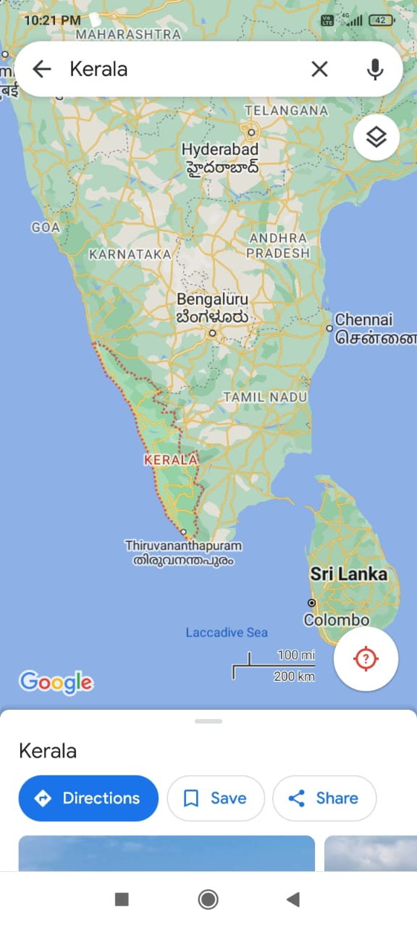 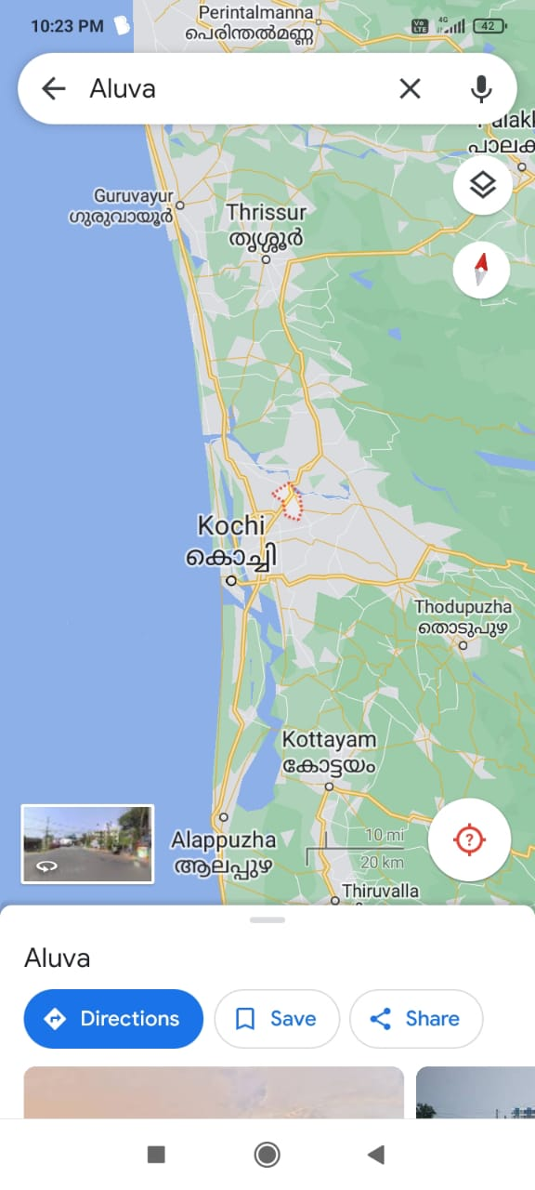

Another 10 samples were collected from industrial area of Chhattisgarh, BSP (Bhilai Steel Plant). Having the latitudinal extension of 21.1653˚N and longitudinal extension of 81.3955˚E. Situated at a distance of 33km from the Capital of the State (Raipur), it is known to be an urban agglomeration. Together with Durg they called Twin city (Durg-Bhilai). The population of the twin city is expected to be 1,266,000.

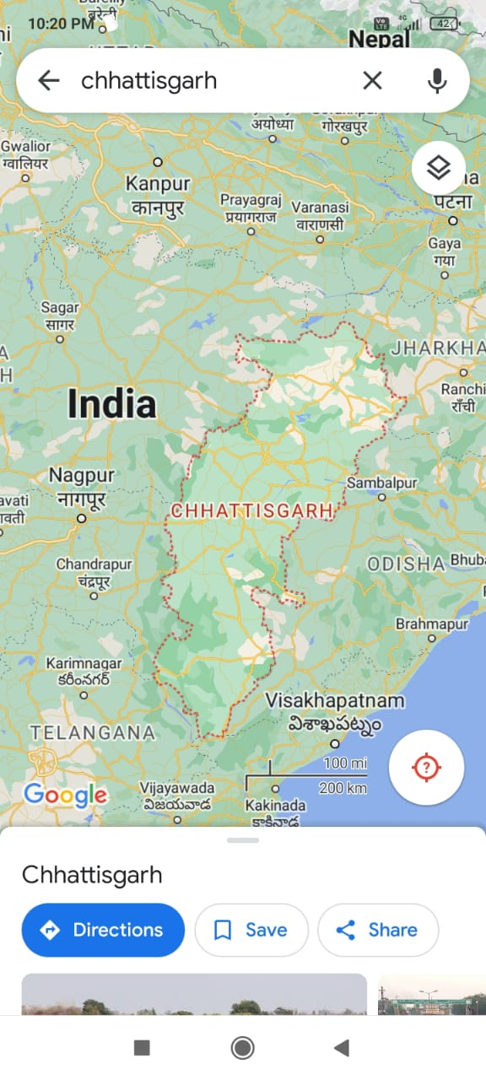 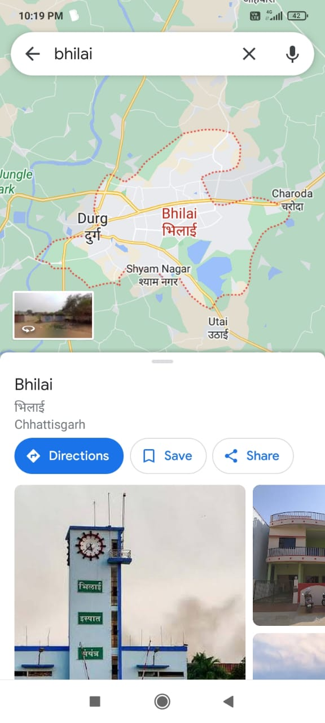

Lastly ten samples were taken from the area near the BHEL (Bharat Heavy Electrics Limited), Madhya Pradesh. BHEL has 23.22979 as its latitudinal extension and 77.41179 as longitudinal extension. Ten samples were collected from this region starting from the area near BHEL towards south-east direction.

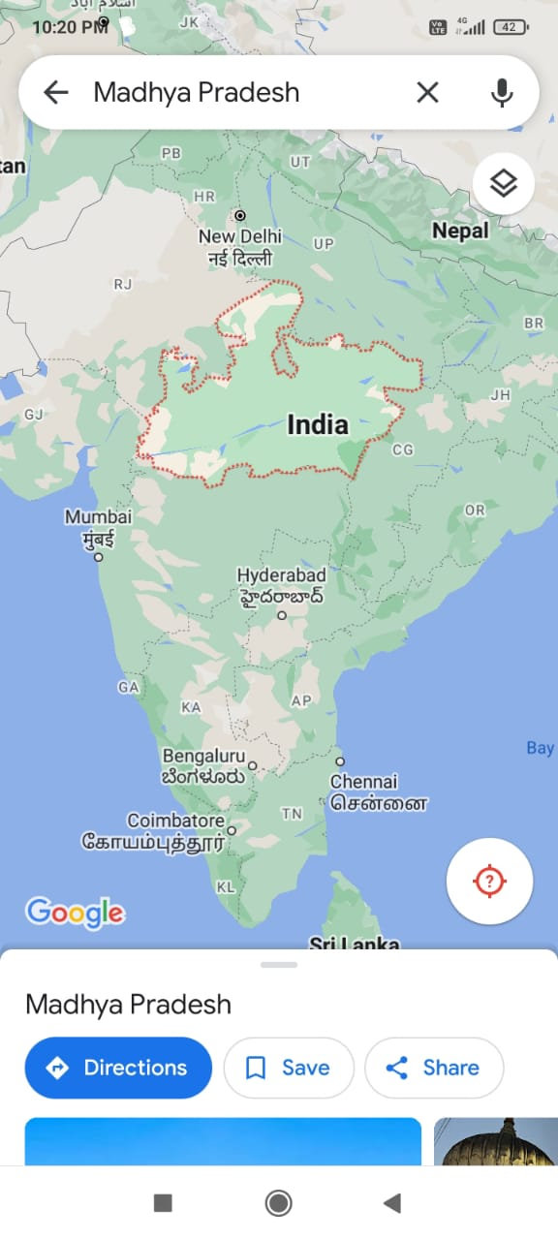 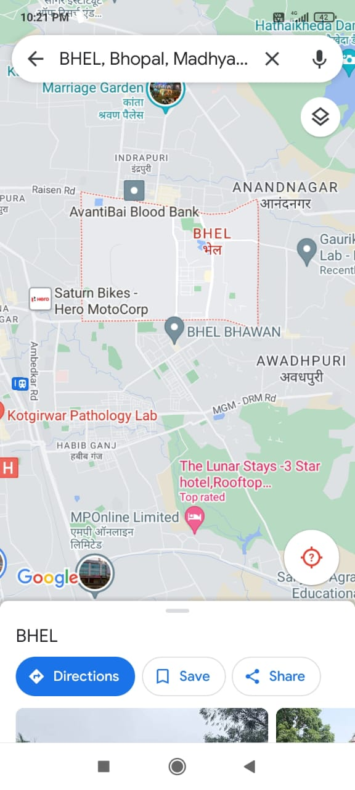

Sample Collection-

Ten-ten samples were collected from each industrial site while collecting the samples following things were kept in mind-

* Distance of the site from the Industry.
* Collection at a regular interval of 1km.
* Distance upto 10km was taken in this research.

For the purpose of collection at each site samples were taken from all the four sides of 1×1m squares, then those four samples were mixed together then divided into four equal halves, one part was taken and the step was repeated one more time. After collection samples were air dried, then were packed into zipper bags.

Sample Analysis-

For the analysis purpose the dried samples were weighed 0.25g. after that samples were digested in Nitric then was analysed in AAS.

For digestion- 250ml flasks were taken then weighed samples were emptied into the flask. 2-3ml of 70% concentrated Nitric acid (HNO3) was added to each flak and was kept overnight to digest. After digestion the samples were filtered with help of Whatman filter paper of 125mm diameter and a funnel. The undigested samples were discarded. The filtered samples were diluted upto the mark of 12.5 ml and were kept in 50ml transparent clear glass bottles.

Instrumentation

AAS (Atomic Absorption Spectroscopy)- It was invented by Alan Walsh in 1950s.it works on the following principle of Beer and Lambert’s law. It usually consists of Hollow cathode lamp, which is selected on the basis of the metal to be analysed or the metal of interest. When voltage is applied between cathode and anode the inert gas present in the chamber gets ionised, and its ionized atoms hit the cathode and result in emission of atoms of elements forming atomic cloud also called (sputtering). Next part of the sample being the sample insertion port, when sample in liquid form nebulization is required. In which samples reach the nebulizer with help of a very thin tube by the capillary action, nebulizer converts the sample into aerosols the sample may get mixed with oxidative and fuels and then reaches atomizer that is used to form atoms in this flame atomizer was used. When the sample reach flame the solvent gets evaporated also called desolation, then samples converted in to gaseous molecules (volatilization), then these gaseous molecules dissociate and produce atoms (dissociation). Then from radiation source radiation of particular wavelength falls in to the atom that they absorb and gets excited. Radiation absorption directly proportional to the concentration of the metal atoms present in the sample. The non-absorbed transmitted light reaches the monochromator, adjusted in such manner that only particular wavelength light reaches the monochromator then it reaches multiplier that amplifies the signals and finally, enters detector where we receive results in the form of graph.

In this AAS graphite furnace of make- PerkinElmer PinAAcle 900H was used. It is highly sensitive, efficient and time saving instrument. It has Flame, Furnace, flow injection, FIAS-furnace and Mercury/Hydride capabilities. For the gas Acetylene was used.

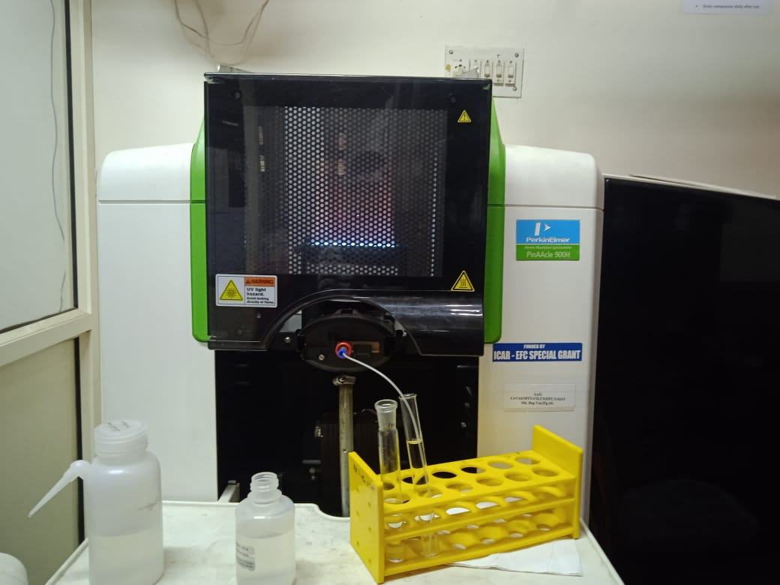

RESULTS & DISCUSSIONS-

Table 2. Concentrations of Iron and Zinc in samples collected from Aluva, near Kochi (Kerala).

|  |  |  |
| --- | --- | --- |
| S.No. | Fe (Iron) mg/kg | Zn (Zinc) mg/kg |
| Sample 1 | 7000.00 | 5.95 |
| Sample 2 | 19525.00 | 259.35 |
| Sample 3 | 19000.00 | 12.75 |
| Sample 4 | - | - |
| Sample 5 | 12277.50 | 8.80 |
| Sample 6 | 22300.00 | 114.10 |
| Sample 7 | 9520.00 | 38.45 |
| Sample 8 | 17355.00 | 72.30 |
| Sample 9 | 16897.50 | 16.85 |
| Sample 10 | 9622.50 | 13.00 |

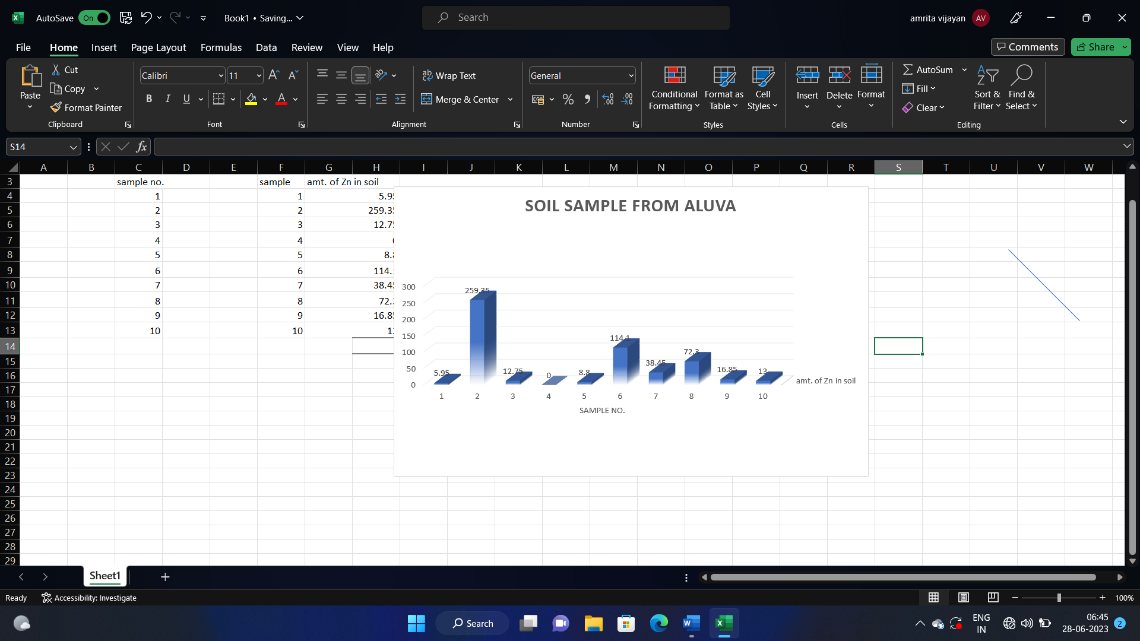

According to the WHO (World Health Organization) the permissible limit of Zinc in soil should be 50mg/kg and that of Iron is 5000mg/kg. Comparing the results with the permissible limits from the WHO it is evident that in all the samples collected from Aluva, Kochi (Kerala) site Iron exceeded the permissible level and Sample 2,6 and Sample 8 exceeded in their Zinc limit.

Table 3. Concentrations of Iron and Zinc in samples collected from BSP (Bhilai Steel Plant), Chhattisgarh region.

|  |  |  |
| --- | --- | --- |
| S.No. | Fe (Iron) mg/kg | Zn (Zinc) mg/kg |
| Sample 1 | 1630.00 | 30.27 |
| Sample 2 | 5380.00 | 16.7 |
| Sample 3 | 1690.00 | 53.32 |
| Sample 4 | 6530.00 | 23.7 |
| Sample 5 | 17900.00 | 22.2 |
| Sample 6 | 2240.00 | 17.2 |
| Sample 7 | 2420.00 | 16.2 |
| Sample 8 | 2300.00 | 67.2 |
| Sample 9 | 17770.00 | 24.2 |
| Sample 10 | 2210.00 | 16.7 |

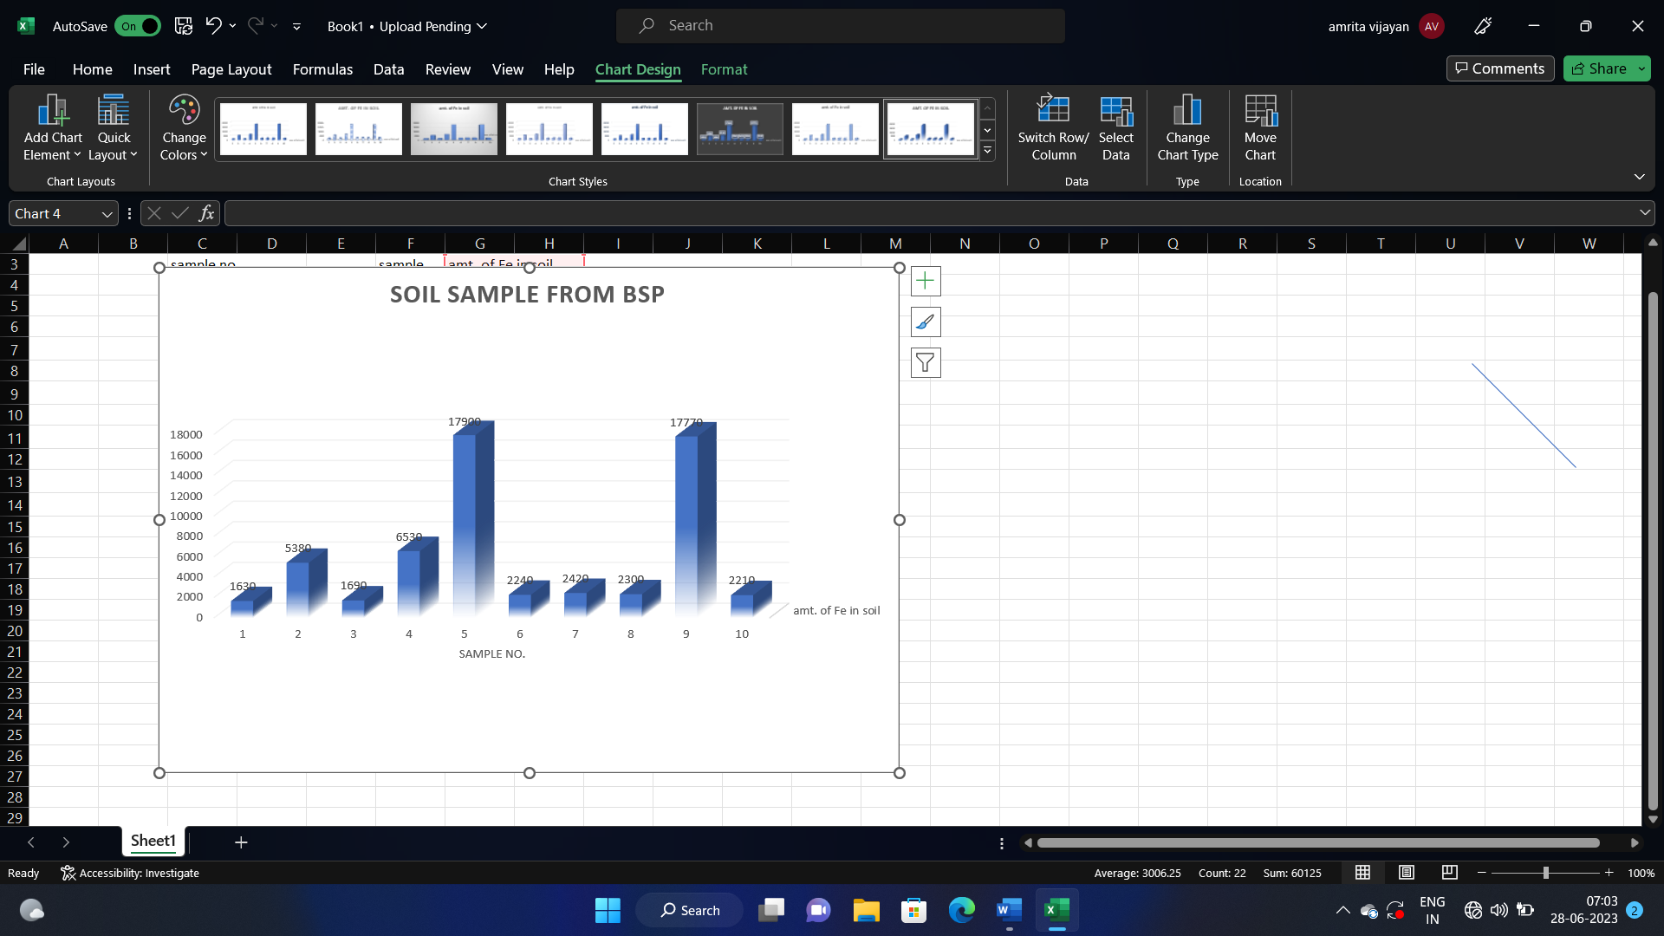

In the samples collected from the Bhilai area of Chhattisgarh Sample no. 2 slightly exceed in its iron concentration whereas the concentration of Zinc is under the permissible limit by WHO. Sample no. 3 slightly exceed in its Zinc concentration whereas the Iron is under the limit. In Sample no. 4 the concentration of iron is greater whereas the concentration of zinc is normal. Sample 8 exceeded in its Zinc concentration, whereas the Iron level is under the limit. In Sample 9 the level of Iron is relatively high as compared to the safe limits, whereas the level of Zinc is normal.

Table 4. Concentrations of iron and zinc in samples collected from BHEL, Madhya Pradesh

|  |  |  |
| --- | --- | --- |
| S.No. | Fe (Iron) mg/kg | Zn (Zinc) mg/kg |
| Sample 1. | 1240.00 | 22.7 |
| Sample 2. | 1730.00 | 17.7 |
| Sample 3. | 1020.00 | 33.2 |
| Sample 4. | 8810.00 | 17.9 |
| Sample 5. | 1120.00 | 22.7 |
| Sample 6. | 1020.00 | 24.2 |
| Sample 7. | 1910.00 | 16.7 |
| Sample 8. | 2270.00 | 23.7 |
| Sample 9. | 2250.00 | 77.7 |
| Sample 10. | 2260.00 | 16.2 |

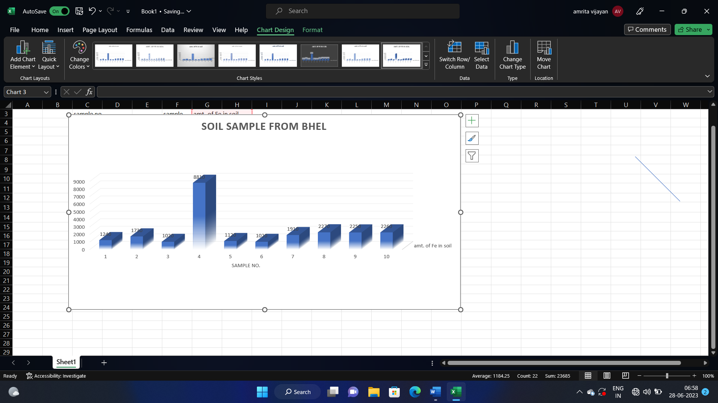

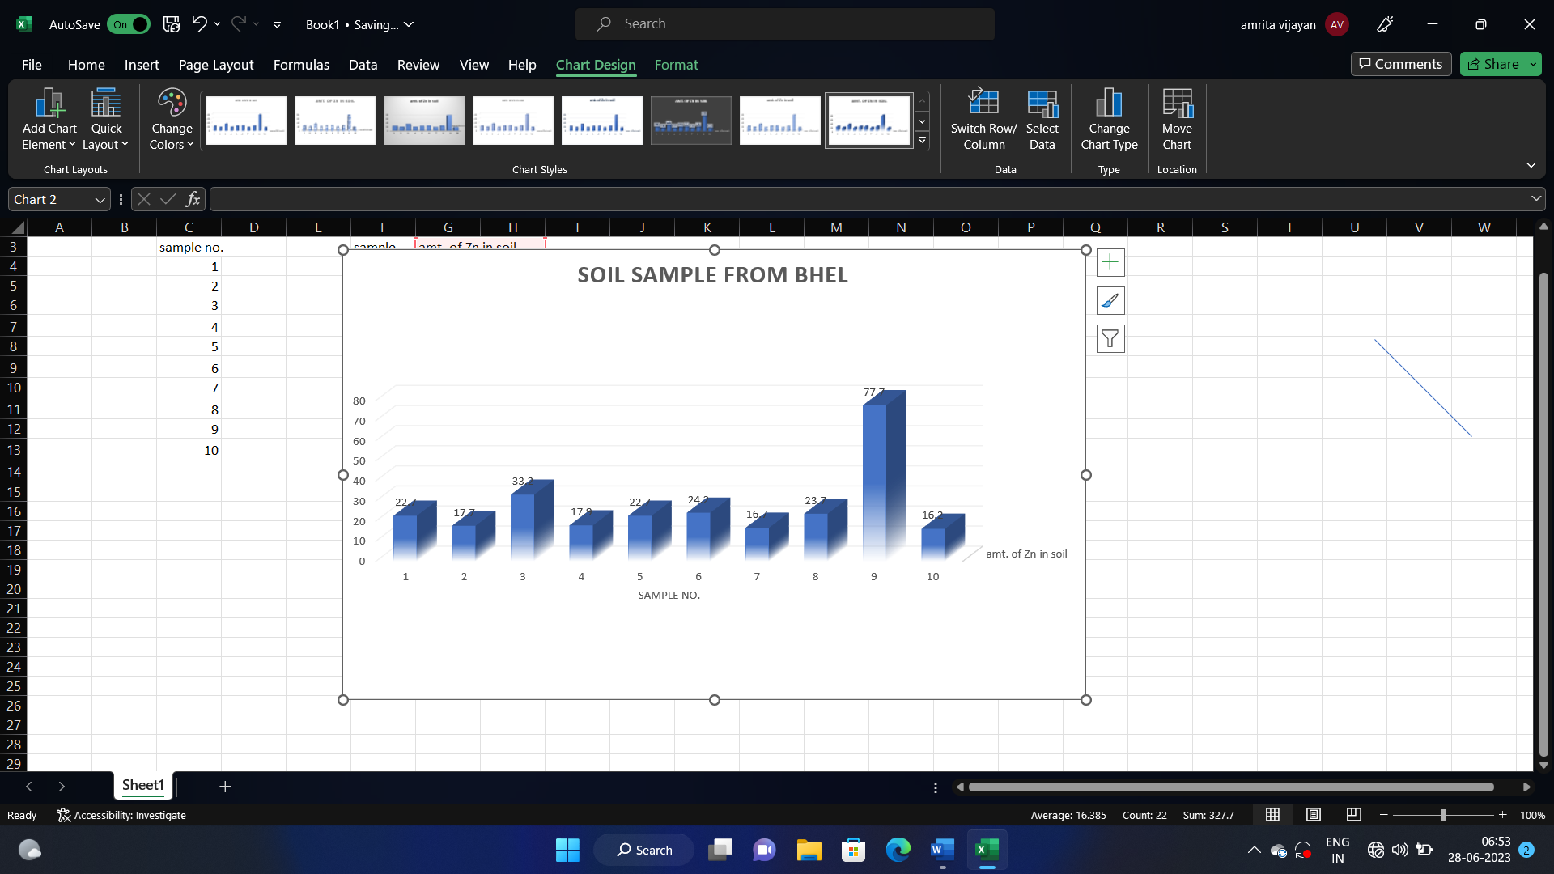

In the samples collected from BHEL site the samples have Iron and Zinc concentrations less than the specified limit except Sample 4 where the limit of iron is more than the safe limit, and Sample 9 where the limit of Zinc is greater than the permissible limit.

REFERNCE-

1. Osobamiro TM, Awolesi O, Alabi OM, Oshinowo AY, Idris MA, Busari FA. Heavy Metal Levels of Soil Samples Collected From a Major Industrial Area in Abeokuta, Southwestern Nigeria. International Journal of Scientific and Research Publications. 2019;9(8).
2. Khan S, Farooq R, Shahbaz S, Khan MA, Sadique M. Health risk assessment of heavy metals for population via consumption of vegetables. World Appl Sci J. 2009;6(12):1602-6.
3. Lin YP, Teng TP, Chang TK. Multivariate analysis of soil heavy metal pollution and landscape pattern in Changhua county in Taiwan. Landscape and Urban planning. 2002 Dec 20;62(1):19-35.
4. Tume P, Bech J, Sepulveda B, Tume L, Bech J. Concentrations of heavy metals in urban soils of Talcahuano (Chile): a preliminary study. Environmental monitoring and assessment. 2008 May;140:91-8.
5. Bingham F. Soil test for phosphate: New method of chemical analysis of soil for available phosphate is rapid and accurate. California Agriculture. 1949 Aug 1;3(8):11-4.
6. Ruffell A. Forensic pedology, forensic geology, forensic geoscience, geoforensics and soil forensics. Forensic Science International. 2010 Oct 10;202(1-3):9-12.
7. Soodan RK, Pakade YB, Nagpal A, Katnoria JK. Analytical techniques for estimation of heavy metals in soil ecosystem: A tabulated review. Talanta. 2014 Jul 1;125:405-10.
8. Singh V, Chandel CS. Analytical study of heavy metals of industrial effluents at Jaipur, Rajasthan (India). Journal of environmental science & engineering. 2006 Apr 1;48(2):103-8.
9. Suciu I, Cosma C, Todică M, Bolboacă SD, Jäntschi L. Analysis of soil heavy metal pollution and pattern in Central Transylvania. International journal of molecular sciences. 2008 Apr 2;9(4):434-53.
10. Malavika KV, Manchakkal M, Johnson AA. Flood Mapping and Impact Analysis using GIS.
11. Zhang P, Qin C, Hong X, Kang G, Qin M, Yang D, Pang B, Li Y, He J, Dick RP. Risk assessment and source analysis of soil heavy metal pollution from lower reaches of Yellow River irrigation in China. Science of the Total Environment. 2018 Aug 15;633:1136-47.
12. Chen W, Li H. Cost-effectiveness analysis for soil heavy metal contamination treatments. Water, Air, & Soil Pollution. 2018 Apr;229:1-3.
13. Sharma RK, Agrawal M, Marshall F. Heavy metal contamination of soil and vegetables in suburban areas of Varanasi, India. Ecotoxicology and environmental safety. 2007 Feb 1;66(2):258-66.
14. Reza SK, Baruah U, Singh SK, Das TH. Geostatistical and multivariate analysis of soil heavy metal contamination near coal mining area, Northeastern India. Environmental earth sciences. 2015 May;73:5425-33.
15. Horneck DA, Sullivan DM, Owen JS, Hart JM. Soil test interpretation guide.
16. Osobamiro TM, Awolesi O, Alabi OM, Oshinowo AY, Idris MA, Busari FA. Heavy Metal Levels of Soil Samples Collected From a Major Industrial Area in Abeokuta, Southwestern Nigeria. International Journal of Scientific and Research Publications. 2019;9(8).
17. Ogunlana R, Korode AI, Ajibade ZF. Assessing the level of heavy metals concentration in soil around transformer at Akoko community of OndoState, Nigeria. Journal of Applied Sciences and Environmental Management. 2020;24(12):2183-9.
18. Arao T, Ishikawa S, Murakami M, Abe K, Maejima Y, Makino T. Heavy metal contamination of agricultural soil and countermeasures in Japan. Paddy and water Environment. 2010 Sep;8:247-57.
19. Bodar CW, Pronk ME, Sijm DT. The European Union risk assessment on zinc and zinc compounds: the process and the facts. Integrated Environmental Assessment and Management: An International Journal. 2005 Nov;1(4):301-19.
20. Yahaya MI, Mohammad S, Abdullahi BK. Seasonal variations of heavy metals concentration in abattoir dumping site soil in Nigeria. Journal of Applied Sciences and Environmental Management. 2009;13(4).
21. Ogunlana R, Korode AI, Ajibade ZF. Assessing the level of heavy metals concentration in soil around transformer at Akoko community of OndoState, Nigeria. Journal of Applied Sciences and Environmental Management. 2020;24(12):2183-9.
22. Duruibe, Ogwuegbu, Egwurugwu. Heavy metal pollution and human biotoxic effects. International Journal of physical sciences. 2007 May 31;2(5):112-8.
23. Stojić N, Pucarević M, Mrkajić D, Kecojević I. Transformers as a potential for soil contamination. Metalurgija. 2014 Oct 1;53(4):689-92.
24. Peplow D. Environmental impacts of mining in eastern Washington. University of Washington Water Center; 1999.
25. Olowomofe OH, Afolabi OM. Global Journal of Engineering Science and Research Management.
26. Ogunlana R, Korode AI, Ajibade ZF. Assessing the level of heavy metals concentration in soil around transformer at Akoko community of OndoState, Nigeria. Journal of Applied Sciences and Environmental Management. 2020;24(12):2183-9.
27. Arslan B, Karcioglu O. Poisoning in the Modern World-New Tricks for an Old Dog?. IntechOpen; 2019.
28. Gill P. Electrical power equipment maintenance and testing. CRC press; 2008 Dec 22.
29. Chiroma TM, Ebewele RO, Hymore FK. Comparative assessment of heavy metal levels in soil, vegetables and urban grey waste water used for irrigation in Yola and Kano. International refereed journal of engineering and science. 2014 Feb;3(2):01-9.
30. Ogunlana R, Korode AI, Ajibade ZF. Assessing the level of heavy metals concentration in soil around transformer at Akoko community of OndoState, Nigeria. Journal of Applied Sciences and Environmental Management. 2020;24(12):2183-9.
31. Senesi GS, Dell’Aglio M, Gaudiuso R, De Giacomo A, Zaccone C, De Pascale O, Miano TM, Capitelli M. Heavy metal concentrations in soils as determined by laser-induced breakdown spectroscopy (LIBS), with special emphasis on chromium. Environmental research. 2009 May 1;109(4):413-20.
32. Granero S, Domingo JL. Levels of metals in soils of Alcalá de Henares, Spain: human health risks. Environment International. 2002 Jul 1;28(3):159-64.
33. Soodan RK, Pakade YB, Nagpal A, Katnoria JK. Analytical techniques for estimation of heavy metals in soil ecosystem: A tabulated review. Talanta. 2014 Jul 1;125:405-10.
34. Nyarko BJ, Dampare SB, Serfor-Armah Y, Osae S, Adotey D, Adomako D. Biomonitoring in the forest zone of Ghana: the primary results obtained using neutron activation analysis and lichens. International Journal of Environment and Pollution. 2008 Jan 1;32(4):467-76.
35. Dell'Aglio M, Gaudiuso R, Senesi GS, De Giacomo A, Zaccone C, Miano TM, De Pascale O. Monitoring of Cr, Cu, Pb, V and Zn in polluted soils by laser induced breakdown spectroscopy (LIBS). Journal of Environmental Monitoring. 2011;13(5):1422-6.
36. Cullum BM, Vo-Dinh T. Sample collection and preparation of liquid and solids. Handbook of Spectroscopy. 2003 Aug 26;2:1.
37. Beckhoff B, Kanngießer B, Langhoff N, Wedell R, Wolff H, editors. Handbook of practical X-ray fluorescence analysis. Springer Science & Business Media; 2007 May 18.
38. Khan S, Farooq R, Shahbaz S, Khan MA, Sadique M. Health risk assessment of heavy metals for population via consumption of vegetables. World Appl Sci J. 2009;6(12):1602-6.
39. Rai PK, Lee SS, Zhang M, Tsang YF, Kim KH. Heavy metals in food crops: Health risks, fate, mechanisms, and management. Environment international. 2019 Apr 1;125:365-85.
40. Li Z, Ma Z, van der Kuijp TJ, Yuan Z, Huang L. A review of soil heavy metal pollution from mines in China: pollution and health risk assessment. Science of the total environment. 2014 Jan 15;468:843-53.
41. Aston MA, Martin MH, Jackson AW. The use of heavy metal soil analysis for archaeological surveying. Chemosphere. 1998 Aug 1;37(3):465-77.
42. Duruibe, Ogwuegbu, Egwurugwu. Heavy metal pollution and human biotoxic effects. International Journal of physical sciences. 2007 May 31;2(5):112-8.
43. Genchi G, Sinicropi MS, Lauria G, Carocci A, Catalano A. The effects of cadmium toxicity. International journal of environmental research and public health. 2020 Jun;17(11):3782.
44. Nriagu J. Zinc toxicity in humans. School of Public Health, University of Michigan. 2007 Mar 22:1-7.
45. Fraga CG. Relevance, essentiality and toxicity of trace elements in human health. Molecular aspects of medicine. 2005 Aug 1;26(4-5):235-44.
46. Exley C. The toxicity of aluminium in humans. Morphologie. 2016 Jun 1;100(329):51-5.
47. Needleman H. Lead poisoning. Annu. Rev. Med.. 2004 Feb 18;55:209-22.
48. Velea T, Gherghe L, Predica V, Krebs R. Heavy metal contamination in the vicinity of an industrial area near Bucharest. Environmental Science and Pollution Research. 2009 Aug;16:27-32.
49. Pandey B, Hussain N, Srivastav DK. Physico chemical study of soil near bhilai steel plant effluent channel. Indian Journal of Scientific Research. 2018;9(1):89-91.
50. Ozuah PO. Mercury poisoning. Current problems in pediatrics. 2000 Mar 1;30(3):91-9.
51. Tchounwou PB, Yedjou CG, Patlolla AK, Sutton DJ. Heavy metal toxicity and the environment. Molecular, clinical and environmental toxicology: volume 3: environmental toxicology. 2012:133-64.
52. Bothe H. Plants in heavy metal soils. Detoxification of heavy metals. 2011:35-57.
53. Li Z, Ma Z, van der Kuijp TJ, Yuan Z, Huang L. A review of soil heavy metal pollution from mines in China: pollution and health risk assessment. Science of the total environment. 2014 Jan 15;468:843-53.
54. Zimmerman AJ, Weindorf DC. Heavy metal and trace metal analysis in soil by sequential extraction: a review of procedures. International journal of analytical chemistry. 2010 Apr 18;2010.
55. Singh R, Gautam N, Mishra A, Gupta R. Heavy metals and living systems: An overview. Indian journal of pharmacology. 2011 May;43(3):246.
56. Hunter P. A toxic brew we cannot live without: micronutrients give insights into the interplay between geochemistry and evolutionary biology. EMBO reports. 2008 Jan;9(1):15-8.
57. Bahiru DB, Teju E. Levels of some selected metals (Fe, Cu and Zn) in selected vegetables and soil around eastern industry zone, central Ethiopia. African Journal of Agricultural Research. 2019 Jan 10;14(2):78-91.
58. Gambardella C, Gallus L, Gatti AM, Faimali M, Carbone S, Antisari LV, Falugi C, Ferrando S. Toxicity and transfer of metal oxide nanoparticles from microalgae to sea urchin larvae. Chemistry and Ecology. 2014 May 19;30(4):308-16.