**“HEAVY METAL ANALYSIS FROM SOIL SAMPLES”**

**Amrita Vijayan1, Anita Yadav2, C.R. Patle3**

**Authors Affiliation:** 1M.Sc. Forensic Science, School of Sciences 2Associate Professor, Forensic Science, School of Sciences 3Assistant Professor, Forensic Science, School of Sciences

**Corresponding Author:**

**Abstract**

The layer of loose surface above land is termed as soil. It is typically composed of a combination of gases, rocks, minerals, organic, and inorganic materials. Soil holds utmost importance for the sustenance of life; regrettably, as a result of rapid urbanization and industrialization, heavy metals are being introduced into our ecosystem, thereby disrupting the normal functioning of the biosphere. The current study is focused on the analysis of heavy metals that are found in the soil, thus evaluating soil pollution caused by the presence of heavy metals within the soil.

This study primarily centres on the analysis of two metals, namely Iron (Fe) and Zinc (Zn). For the study, soil samples were collected from three distinct industrial areas at regular intervals of 1 km. Predominantly, the topsoil was selected for the analysis. Soil samples from these three industrial areas were then compared based on the presence of heavy metals.

**Keyword:** Heavy metal, Soil, Contamination, Health, AAS.

**Introduction**

The soil comprises both essential and hazardous components, encompassing biotic and abiotic factors [1]. Heavy metals are defined as metals with atomic weights and densities exceeding four to five times that of water. Among the metals classified as heavy metals are Arsenic (Ar), Lead (Pb), Cadmium (Cd), Chromium (Cr), Zinc (Zn), Selenium (Se), Nickel (Ni), and Iron (Fe) [2].

The rise of heavy metal pollution resulting from urbanization and industrialization has led to an escalation in heavy metal concentrations [3]. Rapid population growth has strained land resources, causing heightened chemical usage such as pesticides, thereby accelerating the buildup of heavy metal concentrations in soil. Such occurrences are prevalent across Asian and African continents [4].

Wastewaters are employed in rural areas for irrigating fields [5]. Mining activities predominantly account for heavy metal contamination [6]. Environmental pollution is also attributed to metal corrosion, atmospheric deposition, metal erosion, and evaporation [7]. Several instruments, including Atomic Absorption Spectroscopy (AAS), are employed for Heavy Metal analysis [8]. Dietary uptake is a major entry route, followed by exposure to deodorants, disinfectants, etc. [9];[10].

Non-essential heavy metals encompass those of negligible significance [11]. Industrialization and urbanization have resulted in a continuous stream of industries discharging heavy metal-rich waste into rivers [12]. Heavy metals, emitted by vehicles and industrial dumping, contribute to pollution [13]. Research has demonstrated the potential of heavy metal analysis in revealing past human activities [14].

Certain heavy metals, such as Zn, Fe, and Cu, play vital roles in normal bodily functions [15]. Heavy metal concentrations vary across locations, influenced by proximity to industrial sites, land use patterns, human chemical usage, and other natural or anthropogenic factors [16]. Dietary uptake stands as a primary pathway, particularly as agricultural fields are often irrigated with wastewater, a primary source of heavy metals [17].Research also indicates the transfer of metal nanoparticles from marine microalgae (Criscosphaera elongata) to Sea urchin (Paracentrotus lividus) larvae [18].

Lead (Pb) and Cadmium (Cd) are profoundly toxic. Cadmium (Cd) and Copper (Cu) exhibit higher transfer quotients than other heavy metals [19].

**Methodology**

*Sample Collection –*

Samples were obtained from three distinct industrial sites in India, encompassing the Aluva district of Kerala, BHEL (Bharat Heavy Electricals Limited) in Madhya Pradesh, and BSP (Bhilai Steel Plant) in Chhattisgarh, for inclusion in this research. Ten samples were collected from each industrial site, adhering to considerations such as site distance, regular 1 km interval collection, and a 10 km maximum distance for inclusion in this study. Collection involved obtaining samples from all sides of a 1×1 m square, subsequently combining these four samples, dividing them into equal halves, selecting one part, and repeating the process once more. Following collection, the samples were air-dried and then packaged in zipper bags.

*Chemicals Used* - The chemicals utilized included 69% Nitric Acid from Merck, Distilled Water, and Acidulated Water.

*Equipment Used -* The equipment employed encompassed Beakers, Glass Rods, Glass Vials, Test Tubes, and the AAS PerkinElmer PinAAcle 900H.

*Standard Preparation -* Standard solutions for Zinc and Iron were prepared by diluting a 1000 ppm solution to 1 ppm using the N1V1=N2V2 formula.

*Instrumentation -* The AAS PerkinElmer PinAAcle 900H was utilized for Heavy Metal analysis of the soil samples in this study. AAS operates based on the principles of Beer and Lambert’s Law. This highly sensitive, efficient, and time-saving instrument offers multiple capabilities including flame, furnace, flow injection, FIAS-furnace, and Mercury/Hydride capabilities. Acetylene gas was employed as the gas medium.

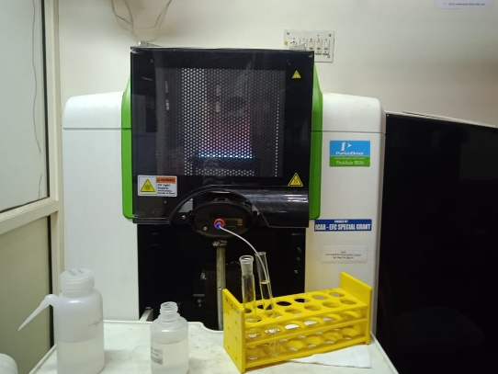

Figure 1. AAS PerkinElmer PinAAcle 900H

**Procedure-**

*Sample Pre-treatment*:For analysis, the dried samples were weighed at 0.25 grams. Subsequently, the samples underwent digestion in Nitric acid and were subsequently analyzed using AAS.

*For Acid Digestion*: Employing 250-ml flasks, weighed samples were introduced. To each flask, 2-3 ml of 69% concentrated Nitric acid (HNO3) were added, and the flasks were left overnight for digestion. After digestion, filtration was conducted using a 125 mm diameter Whatman filter paper and funnel. Undigested samples were discarded, while the filtered samples were diluted to 12.5 ml and stored in 50-ml transparent, clear glass bottles. AAS was employed for sample analysis.

**RESULTS & DISCUSSIONS**

The collected data was analyzed using diverse statistical techniques. The primary objective of the study was to assess Fe and Zn levels in different industrial cities across India. For all sites, calculations were performed to determine the mean, median, and standard deviation, offering insights into the average value and dispersion from the central value.

Table 1: Values of Iron (Fe) in samples taken from three different sites

|  |  |  |  |  |
| --- | --- | --- | --- | --- |
| Site | Mean of soil samples (mg/kg) | Median of soil samples (mg/kg) | Standard Deviation of soil samples (mg/kg) | Range of soil samples (min-max) |
| 1 | 13349.8 | 14587 | 7629.15 | 7000-22300 |
| 2 | 6007 | 2360 | 6441.95 | 1630-17900 |
| 3 | 2363 | 1820 | 2324.15 | 1020-8100 |

The provided table illustrates that the mean Iron (Fe) level in soil samples from Site 1 was 13349.8 mg/kg, and the range between 7000 to 22300 mg/kg. Site 2 exhibited a mean Iron (Fe) value of 6007 mg/kg in collected samples, with a range of 1630-17900 mg/kg. As for Site 3, the mean Iron (Fe) value from samples was 2363 mg/kg, falling within a range of 1020-8100 mg/kg.

Table 2: Values of Zinc (Zn) in samples taken from three different sites

|  |  |  |  |  |
| --- | --- | --- | --- | --- |
| Site | Mean of soil samples (mg/kg) | Median of soil samples (mg/kg) | Standard Deviation of soil samples(mg/kg) | Range of soil samples (min-max) |
| 1 | 54.155 | 14.925 | 78.49 | 5.95-259.35 |
| 2 | 28.76 | 22.95 | 17.49 | 16.7-67.2 |
| 3 | 27.27 | 22.7 | 18.42 | 17.7-77.7 |

The table reveals that the mean Zinc (Zn) value obtained from samples collected at Site 1 was 54.155 mg/kg, encompassing a range of 5.95-259.35 mg/kg. At Site 2, the mean Zinc (Zn) value in collected samples was 28.76 mg/kg, within a range of 16.7-67.2 mg/kg. Site 3 exhibited a mean Zinc (Zn) value of 27.27 mg/kg, with the range spanning 17.7-77.7 mg/kg.

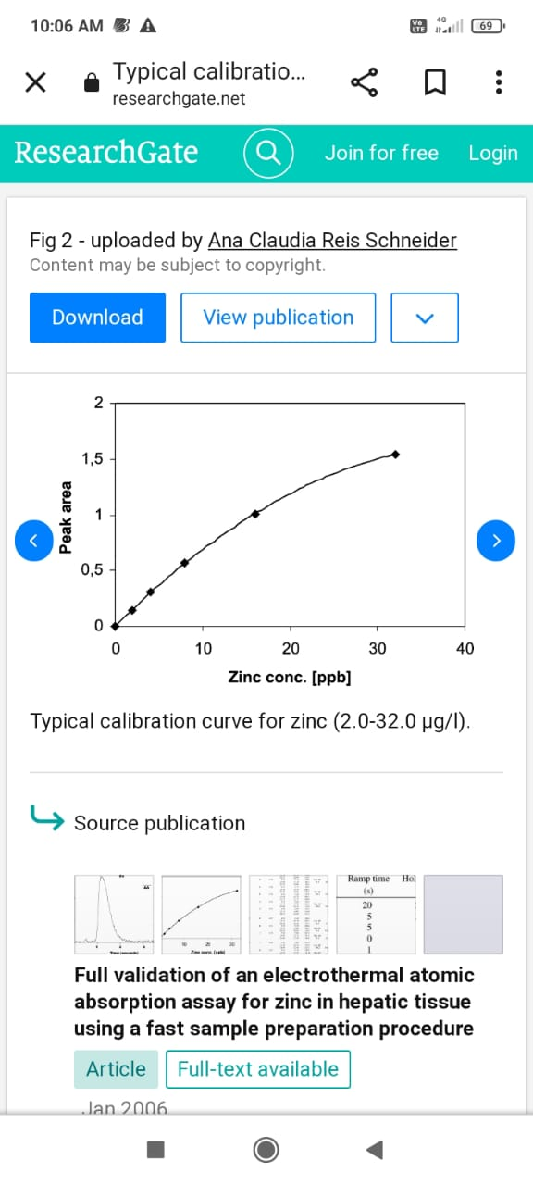 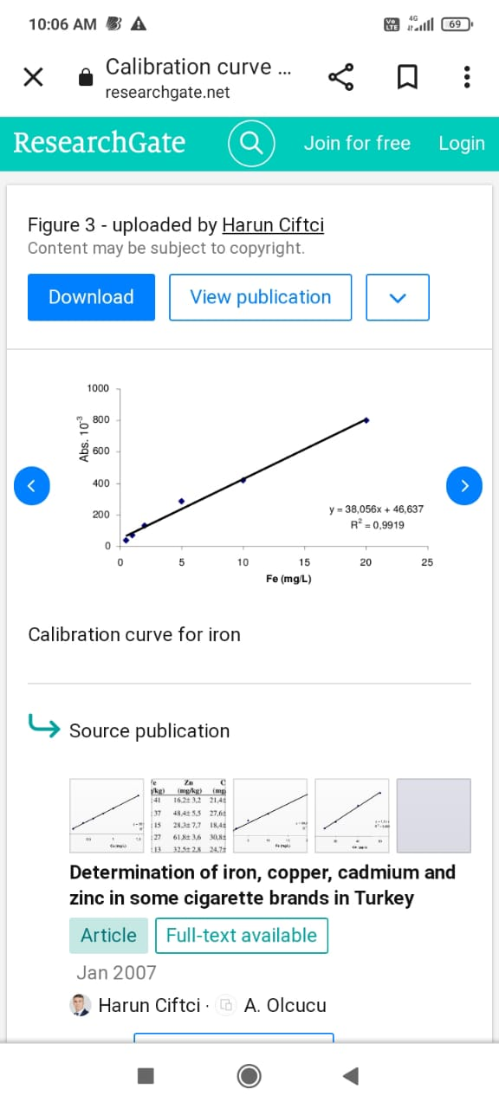

Figure 2: Calibration curve for Zinc(Zn) Figure 3: Calibration curve for Iron(Fe)

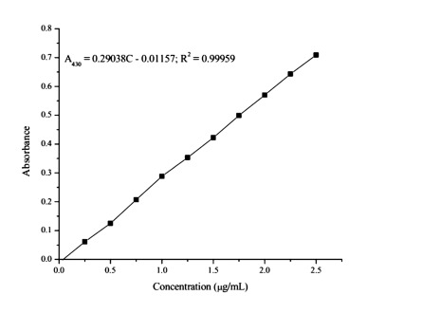 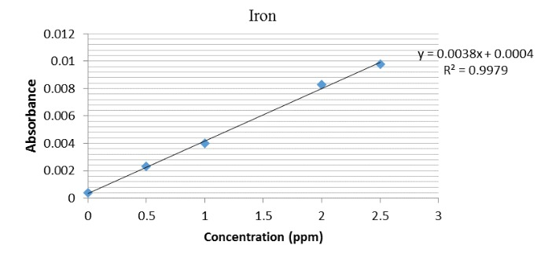

Figure 4: Zinc(Zn) metal analysed using AAS. Figure 5: Iron(Fe) metal analysed using AAS.

**CONCLUSION**

The study assesses the current pattern and distribution of Heavy Metal concentrations, focusing on Iron (Fe) and Zinc (Zn), near specific industrial zones in India. While certain metals hold biological significance, elevated concentrations can lead to irreversible and potentially fatal harm. The results indicate that samples from Site 1 surpass the WHO-established permissible limits (7000 mg/kg for Iron, 50 mg/kg for Zinc). In contrast, samples from Site 3 remain within the acceptable thresholds outlined by WHO.

**REFERENCES**

1. Zimmerman AJ, Weindorf DC. Heavy metal and trace metal analysis in soil by sequential extraction: a review of procedures. International journal of analytical chemistry. 2010 Apr 18;2010.
2. Suciu I, Cosma C, Todică M, Bolboacă SD, Jäntschi L. Analysis of soil heavy metal pollution and pattern in Central Transylvania. International journal of molecular sciences. 2008 Apr 2;9(4):434-53.
3. Osobamiro TM, Awolesi O, Alabi OM, Oshinowo AY, Idris MA, Busari FA. Heavy Metal Levels of Soil Samples Collected from a Major Industrial Area in Abeokuta, Southwestern Nigeria. International Journal of Scientific and Research Publications. 2019;9(8).
4. Rai PK, Lee SS, Zhang M, Tsang YF, Kim KH. Heavy metals in food crops: Health risks, fate, mechanisms, and management. Environment international. 2019 Apr 1;125:365-85.
5. Tchounwou PB, Yedjou CG, Patlolla AK, Sutton DJ. Heavy metal toxicity and the environment. Molecular, clinical and environmental toxicology: volume 3: environmental toxicology. 2012:133-64.
6. Chen W, Li H. Cost-effectiveness analysis for soil heavy metal contamination treatments. Water, Air, & Soil Pollution. 2018 Apr;229:1-3.
7. Bothe H. Plants in heavy metal soils. Detoxification of heavy metals. 2011:35-57.
8. Nyarko BJ, Dampare SB, Serfor-Armah Y, Osae S, Adotey D, Adomako D. Biomonitoring in the forest zone of Ghana: the primary results obtained using neutron activation analysis and lichens. International Journal of Environment and Pollution. 2008 Jan 1;32(4):467-76.
9. Fraga CG. Relevance, essentiality and toxicity of trace elements in human health. Molecular aspects of medicine. 2005 Aug 1;26(4-5):235-44.
10. Genchi G, Sinicropi MS, Lauria G, Carocci A, Catalano A. The effects of cadmium toxicity. International journal of environmental research and public health. 2020 Jun;17(11):3782.
11. Rai PK, Lee SS, Zhang M, Tsang YF, Kim KH. Heavy metals in food crops: Health risks, fate, mechanisms, and management. Environment international. 2019 Apr 1;125:365-85.
12. Lin YP, Teng TP, Chang TK. Multivariate analysis of soil heavy metal pollution and landscape pattern in Changhua county in Taiwan. Landscape and Urban planning. 2002 Dec 20;62(1):19-35.
13. Hunter P. A toxic brew we cannot live without: micronutrients give insights into the interplay between geochemistry and evolutionary biology. EMBO reports. 2008 Jan;9(1):15-8.
14. Aston MA, Martin MH, Jackson AW. The use of heavy metal soil analysis for archaeological surveying. Chemosphere. 1998 Aug 1;37(3):465-77.
15. Rai PK, Lee SS, Zhang M, Tsang YF, Kim KH. Heavy metals in food crops: Health risks, fate, mechanisms, and management. Environment international. 2019 Apr 1;125:365-85.
16. Khan S, Farooq R, Shahbaz S, Khan MA, Sadique M. Health risk assessment of heavy metals for population via consumption of vegetables. World Appl Sci J. 2009;6(12):1602-6.
17. Sharma RK, Agrawal M, Marshall F. Heavy metal contamination of soil and vegetables in suburban areas of Varanasi, India. Ecotoxicology and environmental safety. 2007 Feb 1;66(2):258-66.
18. Gambardella C, Gallus L, Gatti AM, Faimali M, Carbone S, Antisari LV, Falugi C, Ferrando S. Toxicity and transfer of metal oxide nanoparticles from microalgae to sea urchin larvae. Chemistry and Ecology. 2014 May 19;30(4):308-1
19. Khan S, Farooq R, Shahbaz S, Khan MA, Sadique M. Health risk assessment of heavy metals for population via consumption of vegetables. World Appl Sci J. 2009;6(12):1602-6.
20. https://www.omicsonline.org/articles-images/2161-0525-5-334-t011.html [Accessed on 9 July 2023]