**Multiple Choice Answers:**

1 – 4

2 – 1,2,3,4

3 – 2

4 – 2

5 – 1

6 – 2

7 – 3,4,5

8 – 4

9 – 3

10 – 4

11 – 4

12 – 1,3,4

13 – 4

14 – 2

15 – 3

16 – 4

17 – 1

18 – 2

19 – 3

20 – 4

**Validation Rules**

A: Only Admins should be allowed to change the account owner.

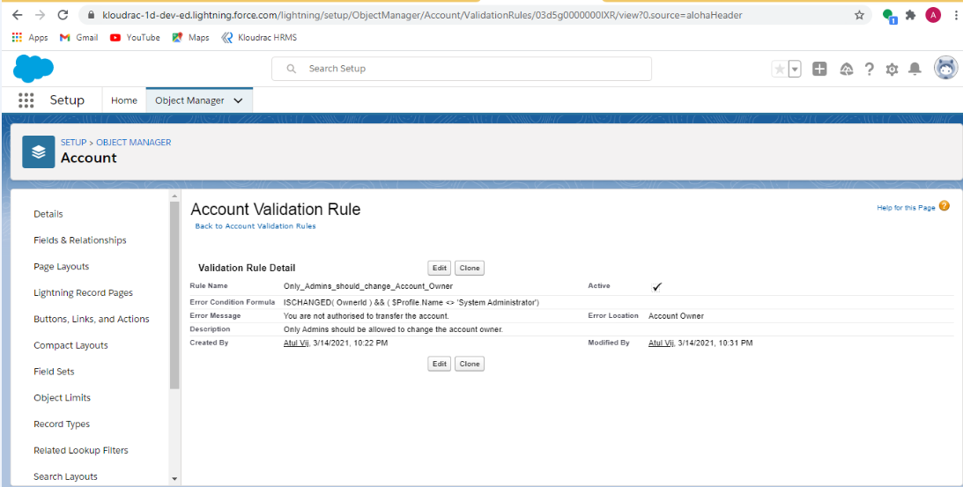

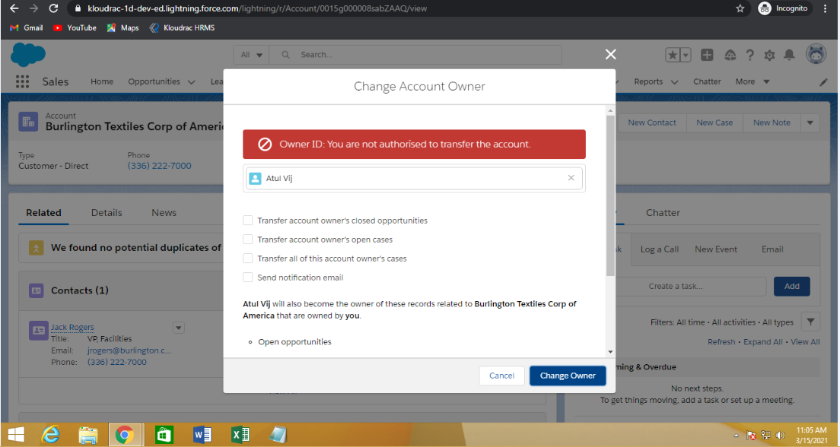

B: While closing the opportunity ( 'Closed Won') , an Opportunity Line Item should be present.

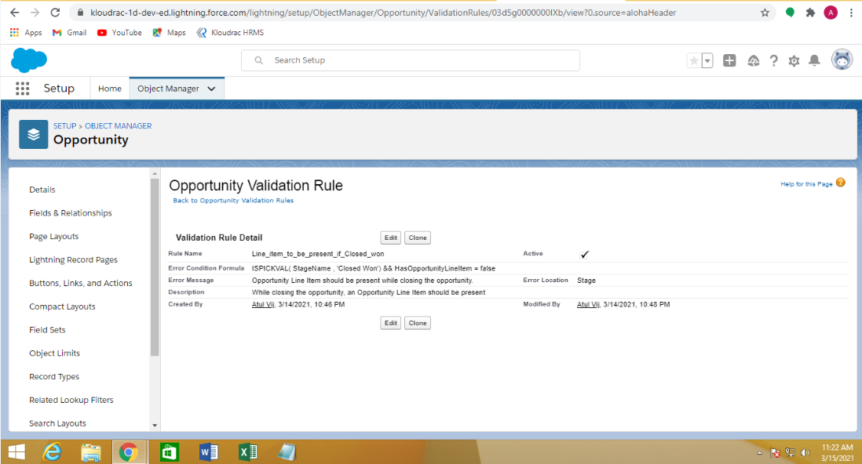

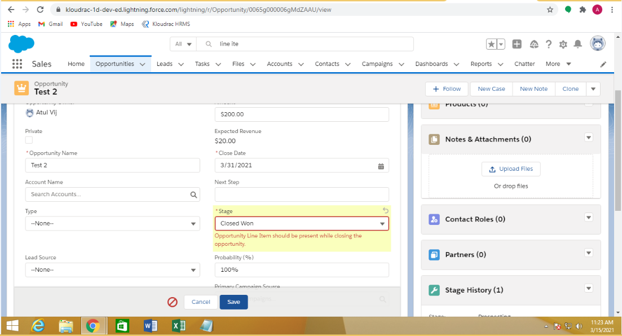

**WorkFlow Rule**

If Amount > $10,000 send an email alert on opportunity closed won (Stage field value) to pgoyal@kloudrac.com and [msharma@kloudrac.com](mailto:msharma@kloudrac.com)

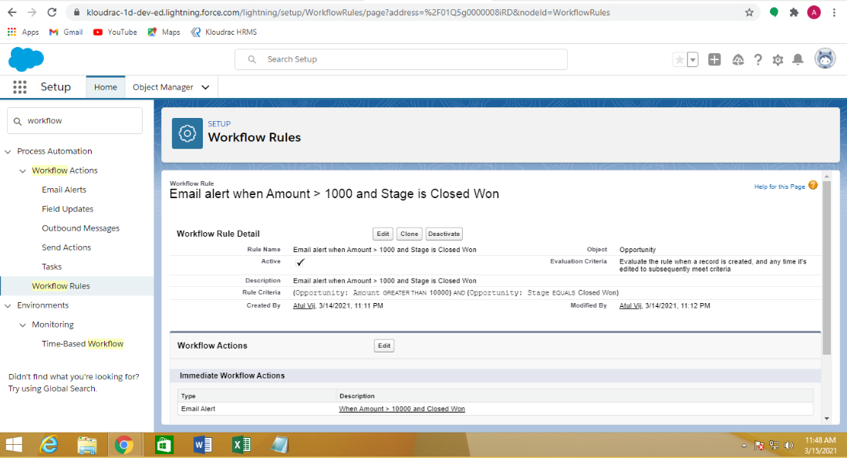

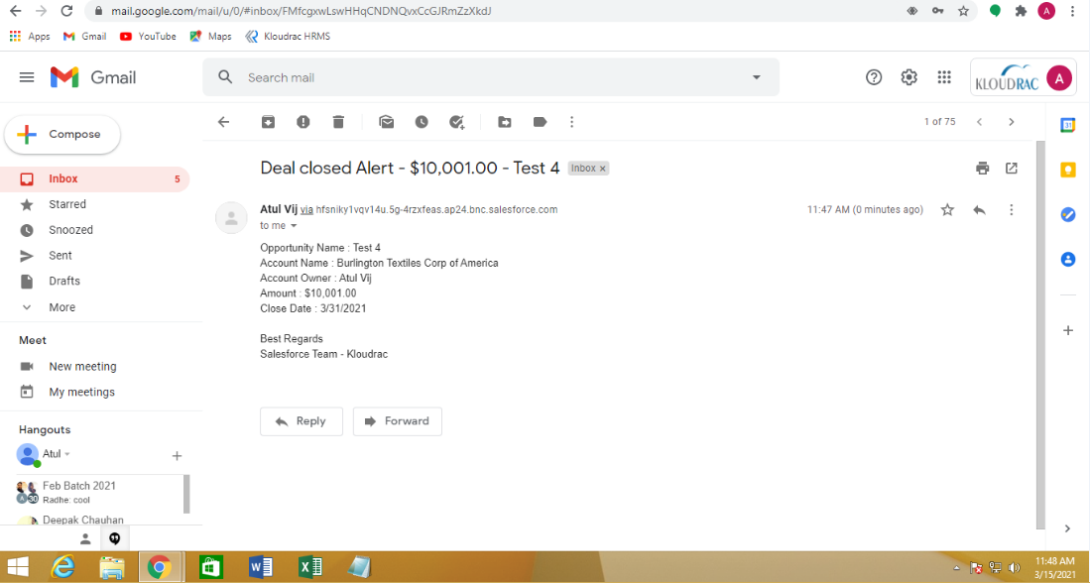

**Process Builder:**

Kloudrac Software would like to set up a process where an event will get created on opportunity creation and an automated approval will go to the opportunity owner's manager whenever discount > 20% on opportunity.

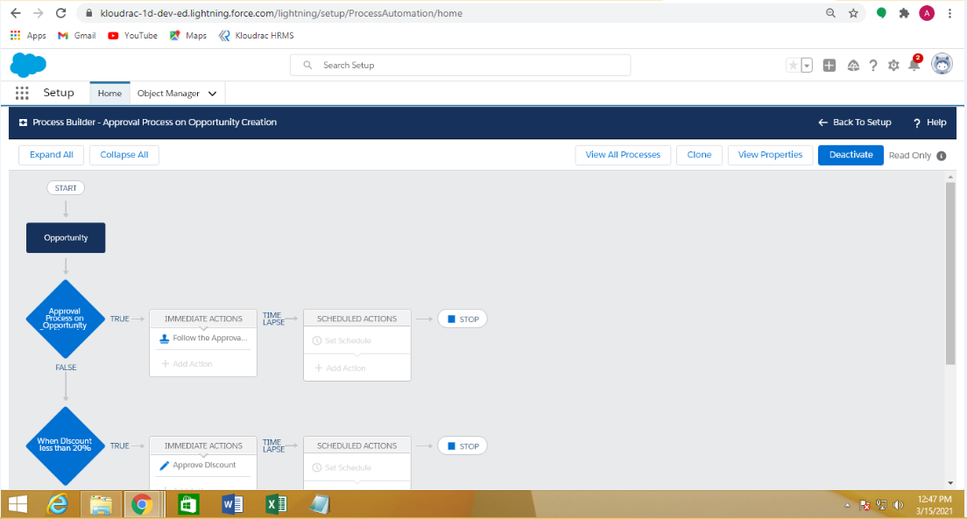

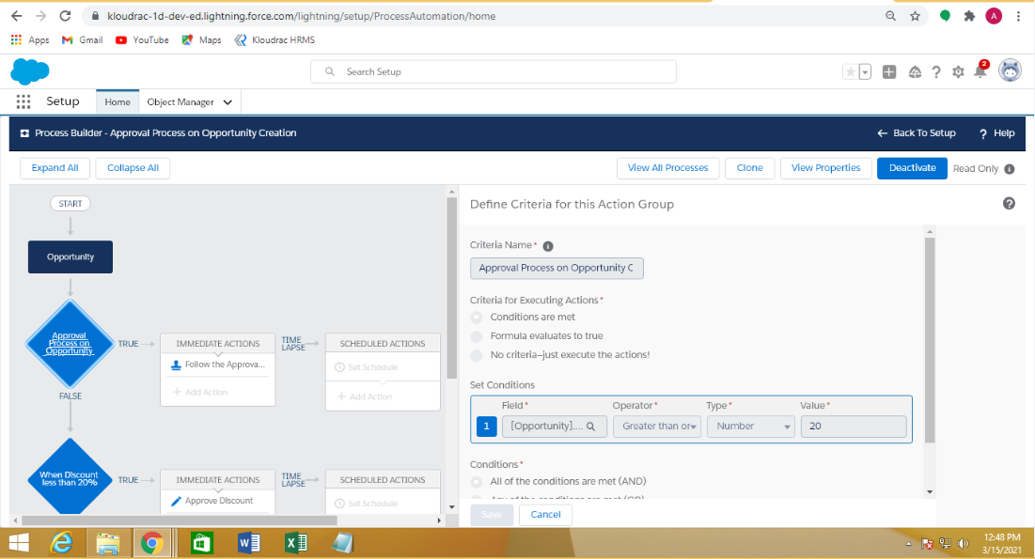

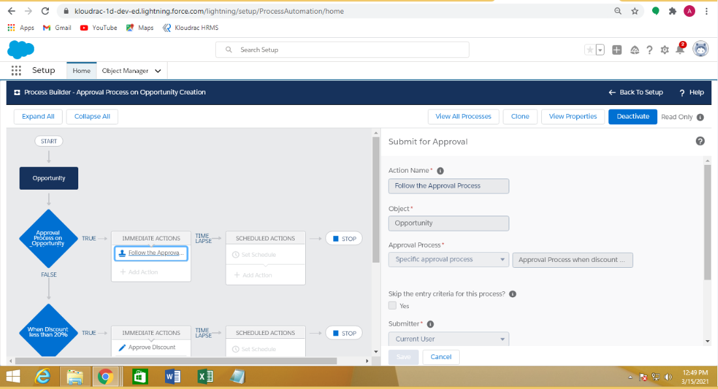

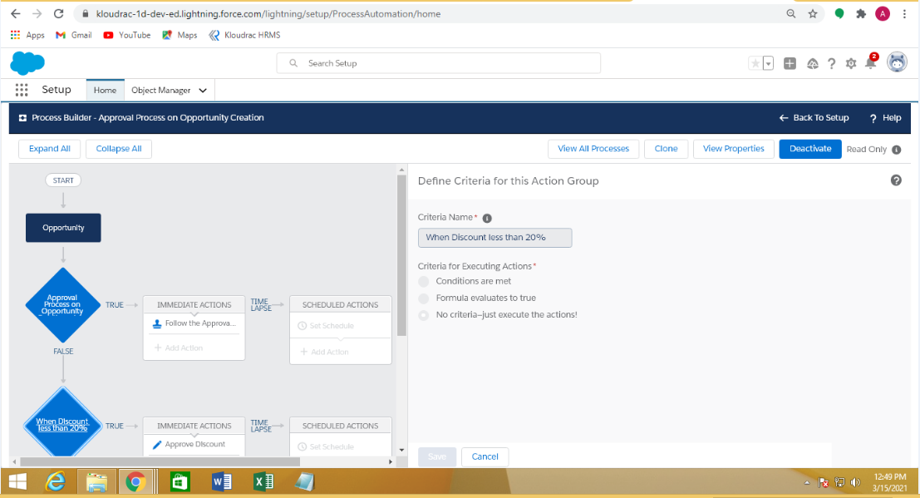

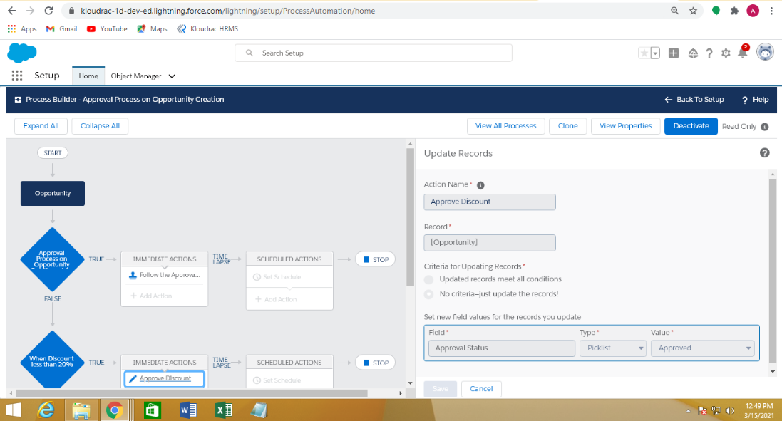

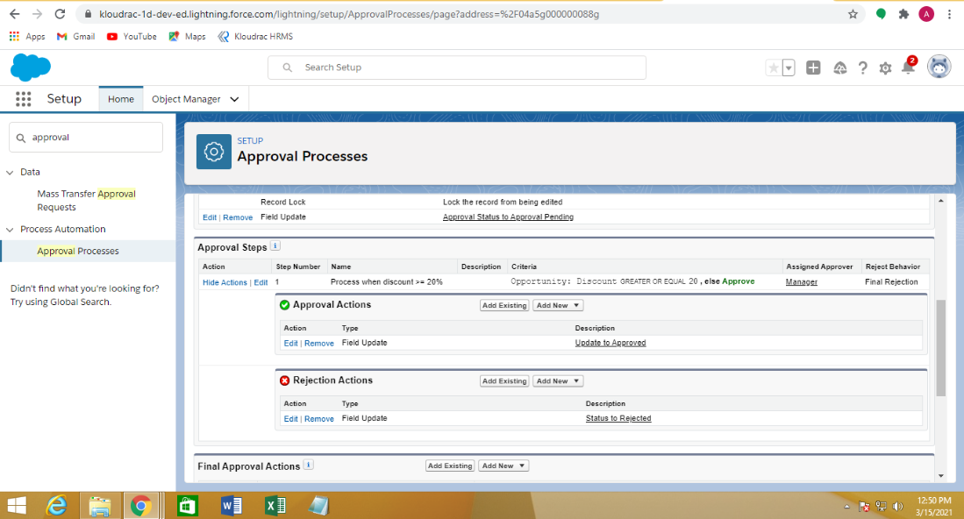

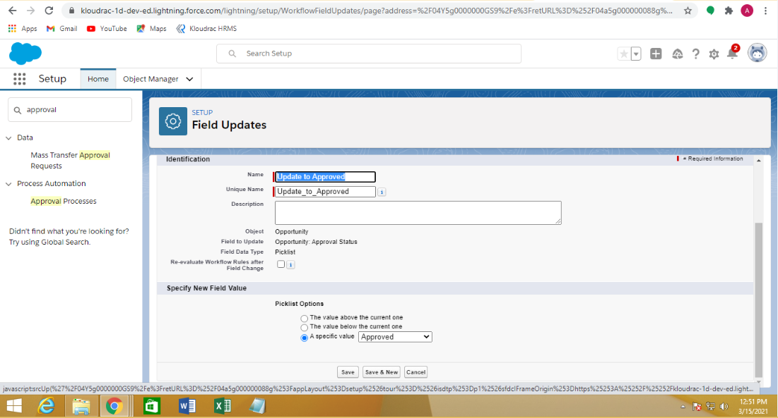

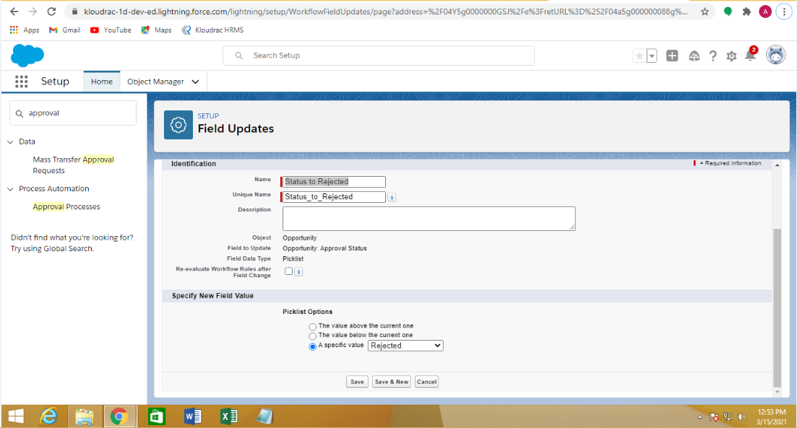

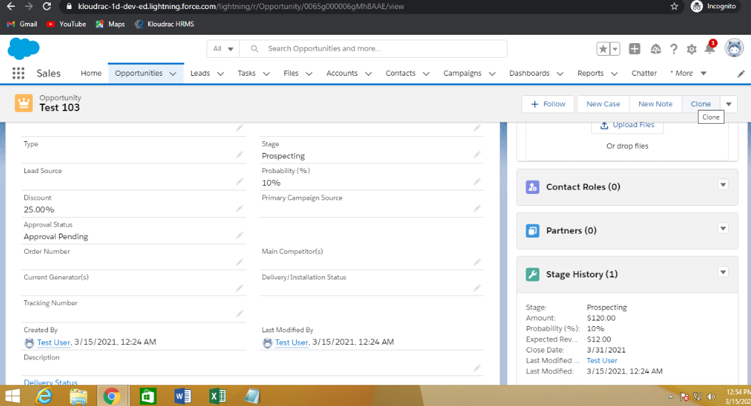

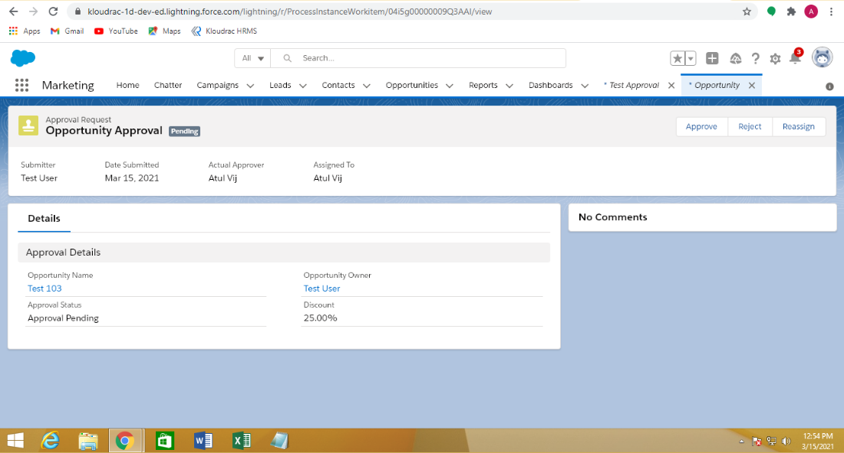

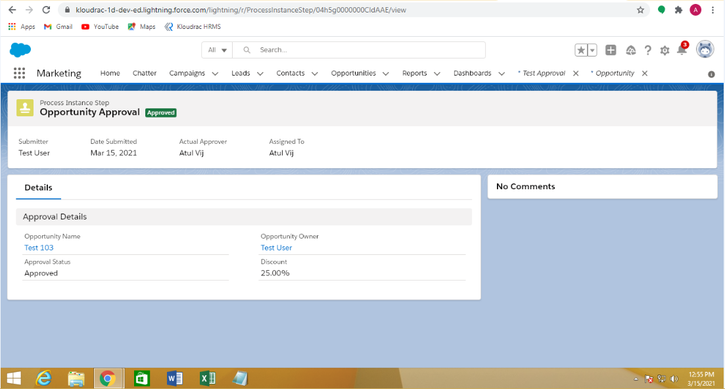

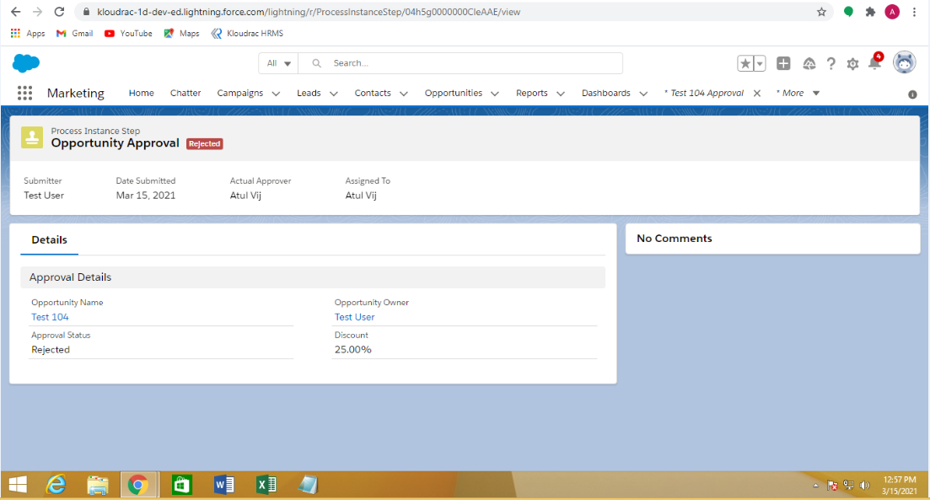

**Triggers:**

1. Write a trigger for showing the Quote Line Item count on the related Quote Account.

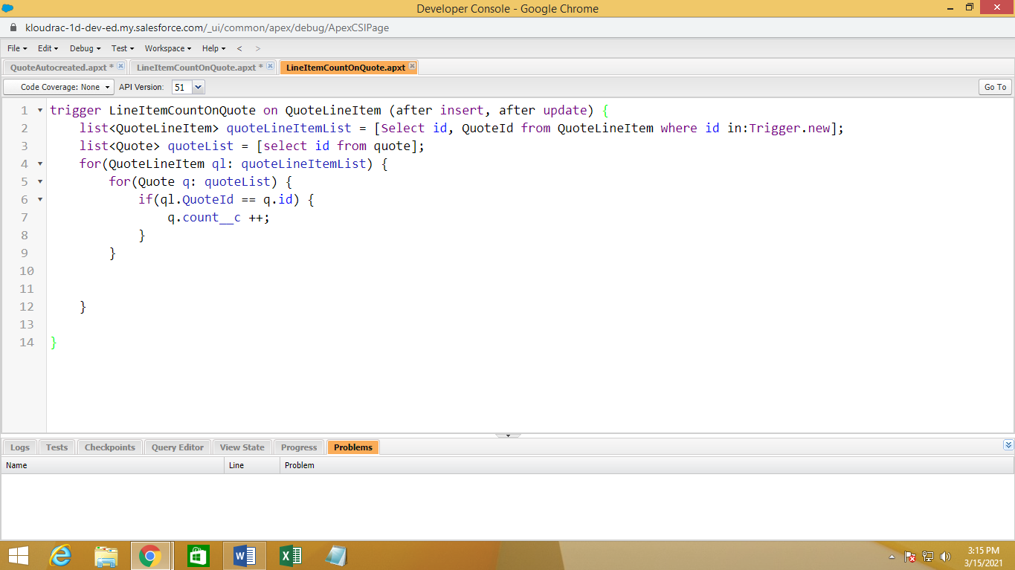

1. Quote and Quote Line Item should get auto created while Opportunity revenue is greater than 100000.

