
PROJECT REPORT
Project 2: Python Programming – Object-Oriented Programming, MongoDB Database Interaction, and Data Analysis & Visualization
Submitted by
VIJAYKUMAR VIGHNE

SRN- 31242065

BBACA

SEM- V

Under the guidance of
Prof- Rupali Taware

Academic Year: [2026– 2027]

Unit 3: Object-Oriented Programming in Python
Program 1: Student class with constructor and percentage method
Question: Create a class Student with attributes name, roll_no, and marks. Use a constructor to initialize the attributes and a method to calculate and display the student's percentage. Create objects for two students and display their details.
Python Code:
class Student:
def __init__(self, name, roll_no, marks):
self.name = name
self.roll_no = roll_no
self.marks = marks # list of subject marks

def percentage(self):
return sum(self.marks) / (len(self.marks) * 100) * 100

def display(self):
print("Name :", self.name)
print("Roll No :", self.roll_no)
print("Marks :", self.marks)
print(f"Percentage: {self.percentage():.2f}%")
print("-" * 30)

s1 = Student("Aarav Sharma", 101, [78, 85, 92, 66, 74])
s2 = Student("Priya Patil", 102, [88, 91, 79, 95, 84])
s1.display()
s2.display()

Logic: The class Student defines a constructor __init__() that stores name, roll_no and a list of subject marks in instance attributes. The method percentage() divides the total of the marks by the maximum possible marks (number of subjects × 100) and multiplies by 100. The method display() prints all the details along with the percentage, formatted to two decimal places. Two objects, s1 and s2, are created with different data, and display() is called on each; each object works on its own copy of the attributes.
Output:
Name : Aarav Sharma
Roll No : 101
Marks : [78, 85, 92, 66, 74]
Percentage: 79.00%
------------------------------
Name : Priya Patil
Roll No : 102
Marks : [88, 91, 79, 95, 84]
Percentage: 87.40%
------------------------------
Program 2: Inheritance using super(): Employee and Manager
Question: Create a base class Employee with attributes name and salary. Create a derived class Manager that adds a department attribute. Use the super() function to initialize the attributes and display the complete details of a manager.
Python Code:
class Employee:
def __init__(self, name, salary):
self.name = name
self.salary = salary

class Manager(Employee):
def __init__(self, name, salary, department):
super().__init__(name, salary) # initialise base-class attributes
self.department = department

def display(self):
print("Name :", self.name)
print("Salary : Rs.", self.salary)
print("Department:", self.department)

m = Manager("Rohan Kulkarni", 85000, "Information Technology")
m.display()

Logic: Employee is the base class holding name and salary. Manager inherits from Employee and its constructor calls super().__init__(name, salary), which reuses the base-class constructor instead of repeating the code, and then adds the new attribute department. The display() method of Manager prints the inherited attributes together with the new one, demonstrating code reuse through single inheritance.
Output:
Name : Rohan Kulkarni
Salary : Rs. 85000
Department: Information Technology
Program 3: Operator overloading: adding Distance objects
Question: Create a class Distance with attributes meters and centimeters. Overload the + operator using the __add__() method to add two distance objects and display the resulting distance.
Python Code:
class Distance:
def __init__(self, meters, centimeters):
self.meters = meters
self.centimeters = centimeters

def __add__(self, other):
total_cm = (self.meters + other.meters) * 100 + self.centimeters + other.centimeters
return Distance(total_cm // 100, total_cm % 100)

def display(self):
print(f"{self.meters} m {self.centimeters} cm")

d1 = Distance(5, 75)
d2 = Distance(3, 60)
print("Distance 1 : ", end=""); d1.display()
print("Distance 2 : ", end=""); d2.display()
d3 = d1 + d2
print("Sum : ", end=""); d3.display()

Logic: The special method __add__() is called automatically when the + operator is used between two Distance objects. Inside it, both distances are converted to centimetres (meters × 100 + centimeters) and added. The total is then converted back using integer division (// 100) for metres and the remainder (% 100) for centimetres, so the carry from centimetres to metres is handled correctly (75 + 60 = 135 cm = 1 m 35 cm). A new Distance object is returned, and d1 + d2 therefore reads naturally.
Output:
Distance 1 : 5 m 75 cm
Distance 2 : 3 m 60 cm
Sum : 9 m 35 cm
Program 4: Class method, static method and dynamic attribute
Question: Create a class Employee with a class attribute company_name and instance attributes name and salary. Define a class method to change the company name and a static method to check whether a salary is greater than ₹30,000. Add a dynamic attribute designation to an object and display all the details.
Python Code:
class Employee:
company_name = "TechSoft Pvt. Ltd." # class attribute

def __init__(self, name, salary):
self.name = name
self.salary = salary

@classmethod
def change_company(cls, new_name):
cls.company_name = new_name

@staticmethod
def is_high_salary(salary):
return salary > 30000

e = Employee("Sneha Joshi", 45000)
print("Before change:", Employee.company_name)
Employee.change_company("InnovateX Solutions")
print("After change :", Employee.company_name)

e.designation = "Software Engineer" # dynamic attribute
print("Name :", e.name)
print("Salary : Rs.", e.salary)
print("Company :", e.company_name)
print("Designation :", e.designation)
print("Salary > Rs.30,000 ?", Employee.is_high_salary(e.salary))
print("Salary 25000 > Rs.30,000 ?", Employee.is_high_salary(25000))

Logic: company_name is a class attribute shared by all objects. The @classmethod change_company(cls, new_name) receives the class itself as the first argument, so changing cls.company_name affects every object. The @staticmethod is_high_salary() needs neither the class nor an object; it simply returns True when the salary passed is greater than 30000. The attribute designation is not declared in the class; it is added to the object e at run time (e.designation = ...), which is possible because Python objects are dynamic. Finally all details are displayed.
Output:
Before change: TechSoft Pvt. Ltd.
After change : InnovateX Solutions
Name : Sneha Joshi
Salary : Rs. 45000
Company : InnovateX Solutions
Designation : Software Engineer
Salary > Rs.30,000 ? True
Salary 25000 > Rs.30,000 ? False
Unit 4: Python Database Interaction with NoSQL (MongoDB)
Program 5: Connect to MongoDB and create CollegeDB / Students
Question: Write a Python program using pymongo to connect to MongoDB, create a database named CollegeDB, and create a collection named Students.
Python Code:
from pymongo import MongoClient

client = MongoClient("mongodb://localhost:27017/")
db = client["CollegeDB"] # created lazily on first insert
students = db["Students"]
students.insert_one({"roll_no": 0, "name": "init"}) # forces creation
students.delete_one({"roll_no": 0})

print("Connected to MongoDB")
print("Database :", db.name)
print("Collection :", "Students")
print("Databases :", client.list_database_names())
print("Collections:", db.list_collection_names())

Logic: MongoClient() connects to the MongoDB server running on localhost at port 27017. Accessing client["CollegeDB"] refers to the database and db["Students"] refers to the collection. MongoDB creates databases and collections lazily, i.e., only when the first document is stored, so a temporary document is inserted and removed to make both appear on the server. The program then lists the database and collection names to confirm creation.
Output:
Connected to MongoDB
Database : CollegeDB
Collection : Students
Databases : ['admin', 'config', 'local', 'CollegeDB']
Collections: ['Students']
Program 6: Insert five student documents and display all records
Question: Write a Python program to insert five student documents containing roll_no, name, course, and marks into a MongoDB collection. Retrieve and display all student records.
Python Code:
from pymongo import MongoClient

students = MongoClient("mongodb://localhost:27017/")["CollegeDB"]["Students"]
students.delete_many({}) # start with an empty collection

data = [
{"roll_no": 1, "name": "Aarav", "course": "BCA", "marks": 82},
{"roll_no": 2, "name": "Priya", "course": "BCA", "marks": 91},
{"roll_no": 3, "name": "Rohan", "course": "BBA", "marks": 68},
{"roll_no": 4, "name": "Sneha", "course": "BSc", "marks": 77},
{"roll_no": 5, "name": "Kunal", "course": "BCA", "marks": 59},
]
result = students.insert_many(data)
print("Inserted documents:", len(result.inserted_ids))

print("\nAll student records:")
for s in students.find({}, {"_id": 0}):
print(s)

Logic: Each student is a Python dictionary (a document) with the fields roll_no, name, course and marks. The list of five documents is stored in one call using insert_many(), which returns the inserted IDs. The find() method with an empty filter {} returns every document; the projection {"_id": 0} hides MongoDB's automatic _id field so that only the required fields are printed. A for loop prints each record.
Output:
Inserted documents: 5

All student records:
{'roll_no': 1, 'name': 'Aarav', 'course': 'BCA', 'marks': 82}
{'roll_no': 2, 'name': 'Priya', 'course': 'BCA', 'marks': 91}
{'roll_no': 3, 'name': 'Rohan', 'course': 'BBA', 'marks': 68}
{'roll_no': 4, 'name': 'Sneha', 'course': 'BSc', 'marks': 77}
{'roll_no': 5, 'name': 'Kunal', 'course': 'BCA', 'marks': 59}
Program 7: CRUD operations on the Employees collection
Question: Write a Python program to insert, display, update, and delete employee records in an Employees collection in MongoDB. Update an employee's salary and delete a record using the employee ID.
Python Code:
from pymongo import MongoClient

emp = MongoClient("mongodb://localhost:27017/")["CollegeDB"]["Employees"]

emp.delete_many({}) # start clean

# INSERT
emp.insert_many([
{"emp_id": 101, "name": "Amit", "salary": 40000},
{"emp_id": 102, "name": "Neha", "salary": 52000},
{"emp_id": 103, "name": "Vijay", "salary": 35000},
])
def show(title):
print(f"\n{title}")
for e in emp.find({}, {"_id": 0}):
print(e)

show("After INSERT:")
# UPDATE
emp.update_one({"emp_id": 102}, {"$set": {"salary": 60000}})
show("After UPDATE (emp_id 102 salary -> 60000):")
# DELETE
emp.delete_one({"emp_id": 103})
show("After DELETE (emp_id 103):")

Logic: Three employee documents are inserted with insert_many(). A helper function show() displays the collection after each step. update_one() takes a filter ({"emp_id": 102}) and an update operator ($set) that changes only the salary field from 52000 to 60000. delete_one() removes the document whose emp_id is 103. Displaying after each operation shows the effect of Create, Read, Update and Delete.
Output:

After INSERT:
{'emp_id': 101, 'name': 'Amit', 'salary': 40000}
{'emp_id': 102, 'name': 'Neha', 'salary': 52000}
{'emp_id': 103, 'name': 'Vijay', 'salary': 35000}

After UPDATE (emp_id 102 salary -> 60000):
{'emp_id': 101, 'name': 'Amit', 'salary': 40000}
{'emp_id': 102, 'name': 'Neha', 'salary': 60000}
{'emp_id': 103, 'name': 'Vijay', 'salary': 35000}

After DELETE (emp_id 103):
{'emp_id': 101, 'name': 'Amit', 'salary': 40000}
{'emp_id': 102, 'name': 'Neha', 'salary': 60000}
Program 8: Retrieve students scoring above 75 in descending order
Question: Write a Python program to retrieve students scoring more than 75 marks from a MongoDB collection and display their records in descending order of marks.
Python Code:
from pymongo import MongoClient, DESCENDING

students = MongoClient("mongodb://localhost:27017/")["CollegeDB"]["Students"]
students.delete_many({})
students.insert_many([
{"roll_no": 1, "name": "Aarav", "course": "BCA", "marks": 82},
{"roll_no": 2, "name": "Priya", "course": "BCA", "marks": 91},
{"roll_no": 3, "name": "Rohan", "course": "BBA", "marks": 68},
{"roll_no": 4, "name": "Sneha", "course": "BSc", "marks": 77},
{"roll_no": 5, "name": "Kunal", "course": "BCA", "marks": 59},
])
print("Students scoring more than 75 (highest first):")
for s in students.find({"marks": {"$gt": 75}}, {"_id": 0}).sort("marks", DESCENDING):
print(s)

Logic: The query filter {"marks": {"$gt": 75}} uses the comparison operator $gt (greater than) so only students with marks above 75 are returned. The result cursor is then sorted using sort("marks", DESCENDING), which arranges the records from the highest to the lowest marks. Students with 59 and 68 marks are filtered out.
Output:
Students scoring more than 75 (highest first):
{'roll_no': 2, 'name': 'Priya', 'course': 'BCA', 'marks': 91}
{'roll_no': 1, 'name': 'Aarav', 'course': 'BCA', 'marks': 82}
{'roll_no': 4, 'name': 'Sneha', 'course': 'BSc', 'marks': 77}
Unit 5: Python for Data Analysis and Visualization
Program 9: NumPy array: scalar operations and statistics
Question: Write a Python program to create a NumPy array containing ten numbers. Perform scalar addition and multiplication, and calculate the sum, mean, maximum, and minimum of the array.
Python Code:
import numpy as np

a = np.array([10, 20, 30, 40, 50, 60, 70, 80, 90, 100])
print("Array :", a)
print("Scalar add (+5):", a + 5)
print("Scalar mul (*2):", a * 2)
print("Sum :", a.sum())
print("Mean :", a.mean())
print("Maximum :", a.max())
print("Minimum :", a.min())

Logic: np.array() creates a one-dimensional array of ten numbers. NumPy uses broadcasting, so a + 5 and a * 2 apply the scalar to every element without any loop. The methods sum(), mean(), max() and min() compute the aggregate statistics: the sum is 550, the mean is 550 / 10 = 55.0, the maximum is 100 and the minimum is 10.
Output:
Array : [ 10 20 30 40 50 60 70 80 90 100]
Scalar add (+5): [ 15 25 35 45 55 65 75 85 95 105]
Scalar mul (*2): [ 20 40 60 80 100 120 140 160 180 200]
Sum : 550
Mean : 55.0
Maximum : 100
Minimum : 10
Program 10: 3 × 3 NumPy array: indexing, slicing and transpose
Question: Create a 3 × 3 NumPy array containing numbers from 1 to 9. Display the first row, last column, a selected subarray, and the transpose of the array.
Python Code:
import numpy as np

m = np.arange(1, 10).reshape(3, 3)
print("Array:\n", m)
print("First row :", m[0])
print("Last column :", m[:, -1])
print("Subarray (rows 0-1, cols 1-2):\n", m[0:2, 1:3])
print("Transpose:\n", m.T)

Logic: np.arange(1, 10) generates the numbers 1 to 9 and reshape(3, 3) arranges them as a matrix. m[0] gives the first row, m[:, -1] selects all rows of the last column, and m[0:2, 1:3] is a slice taking rows 0–1 and columns 1–2. The attribute m.T returns the transpose, in which rows and columns are interchanged.
Output:
Array:
[[1 2 3]
[4 5 6]
[7 8 9]]
First row : [1 2 3]
Last column : [3 6 9]
Subarray (rows 0-1, cols 1-2):
[[2 3]
[5 6]]
Transpose:
[[1 4 7]
[2 5 8]
[3 6 9]]
Program 11: Pandas DataFrame: selection and missing values
Question: Create a Pandas DataFrame containing student names, marks, and attendance. Display selected columns, select students scoring above 70 marks, handle missing values, and drop rows containing missing values.
Python Code:
import pandas as pd
import numpy as np

df = pd.DataFrame({
"Name": ["Aarav", "Priya", "Rohan", "Sneha", "Kunal", "Meera"],
"Marks": [82, 91, np.nan, 77, 59, 68],
"Attendance": [90, 95, 85, np.nan, 70, 88],
})
print("Original DataFrame:\n", df)
print("\nSelected columns (Name, Marks):\n", df[["Name", "Marks"]])
print("\nStudents scoring above 70:\n", df[df["Marks"] > 70])
print("\nMissing values per column:\n", df.isnull().sum())
filled = df.fillna({"Marks": df["Marks"].mean(), "Attendance": df["Attendance"].mean()})
print("\nAfter filling missing values with column mean:\n", filled)
print("\nAfter dropping rows with missing values:\n", df.dropna())

Logic: A DataFrame is created from a dictionary; np.nan marks missing values (Rohan's marks and Sneha's attendance). df[["Name", "Marks"]] selects columns, and the Boolean condition df[df["Marks"] > 70] filters rows (a row with NaN marks evaluates to False and is excluded). isnull().sum() counts missing values per column. fillna() handles missing data by replacing each NaN with the mean of its column, while dropna() removes every row that contains a missing value, leaving four rows.
Output:
Original DataFrame:
Name Marks Attendance
0 Aarav 82.0 90.0
1 Priya 91.0 95.0
2 Rohan NaN 85.0
3 Sneha 77.0 NaN
4 Kunal 59.0 70.0
5 Meera 68.0 88.0

Selected columns (Name, Marks):
Name Marks
0 Aarav 82.0
1 Priya 91.0
2 Rohan NaN
3 Sneha 77.0
4 Kunal 59.0
5 Meera 68.0

Students scoring above 70:
Name Marks Attendance
0 Aarav 82.0 90.0
1 Priya 91.0 95.0
3 Sneha 77.0 NaN

Missing values per column:
Name 0
Marks 1
Attendance 1
dtype: int64

After filling missing values with column mean:
Name Marks Attendance
0 Aarav 82.0 90.0
1 Priya 91.0 95.0
2 Rohan 75.4 85.0
3 Sneha 77.0 85.6
4 Kunal 59.0 70.0
5 Meera 68.0 88.0

After dropping rows with missing values:
Name Marks Attendance
0 Aarav 82.0 90.0
1 Priya 91.0 95.0
4 Kunal 59.0 70.0
5 Meera 68.0 88.0
Program 12: Monthly sales: line chart and bar chart
Question: Create a Pandas DataFrame containing the monthly sales of a shop for six months. Use Matplotlib to draw a line chart and a bar chart. Add suitable titles and axis labels.
Python Code:
import pandas as pd
import matplotlib.pyplot as plt

df = pd.DataFrame({
"Month": ["Jan", "Feb", "Mar", "Apr", "May", "Jun"],
"Sales": [12000, 15000, 14000, 18000, 21000, 19500],
})
print(df)

plt.figure(figsize=(6, 4))
plt.plot(df["Month"], df["Sales"], marker="o", color="tab:blue")
plt.title("Monthly Sales - Line Chart")
plt.xlabel("Month"); plt.ylabel("Sales (Rs.)"); plt.grid(True)
plt.savefig("line_chart.png", dpi=150, bbox_inches="tight"); plt.close()

plt.figure(figsize=(6, 4))
plt.bar(df["Month"], df["Sales"], color="tab:green")
plt.title("Monthly Sales - Bar Chart")
plt.xlabel("Month"); plt.ylabel("Sales (Rs.)")
plt.savefig("bar_chart.png", dpi=150, bbox_inches="tight"); plt.close()

Logic: A DataFrame stores the six months and the sales figures. plt.plot() draws the line chart, with circular markers and a grid to show the trend over time, while plt.bar() draws the bar chart, which makes month-to-month comparison easy. For both, plt.title(), plt.xlabel() and plt.ylabel() add the titles and axis labels. The figures are saved as PNG images and shown below the output; sales rise from January to May and dip slightly in June.
Output:
Month Sales
0 Jan 12000
1 Feb 15000
2 Mar 14000
3 Apr 18000
4 May 21000
5 Jun 19500

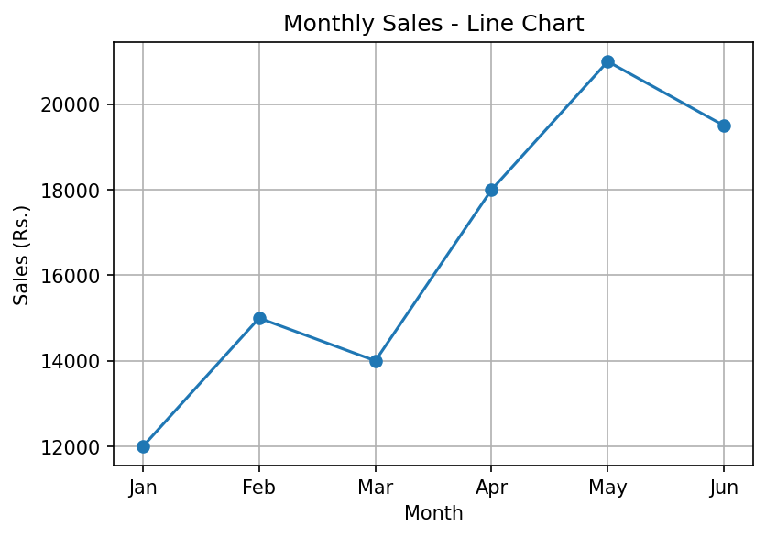
Figure 1: Line chart of monthly sales
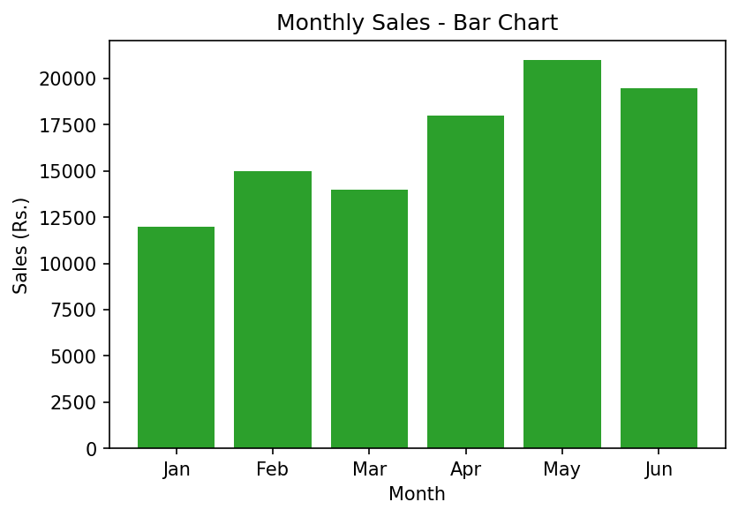
Figure 2: Bar chart of monthly sales

