
Assignment 2
E-Business Model Proposal & Digital Platform Strategy

STUDENT:
VIJAYKUMAR VIGHNE
SRN 31242065

Program: BBA-CA
Course Name: Business Information System
Course Code: BBACA24505
Semester: V

Submitted to: Dr. Monica Pranava
Course Teacher,
Faculty of Commerce and Management
Vishwakarma University, Pune

Date of Submission: Nov 2, 2026

Abstract
This report presents a digital transformation proposal for AgroLink Traders Pvt. Ltd., a hypothetical Pune-based agri-wholesaler that currently works as a traditional pipeline business. The proposal turns the company into an online B2B marketplace connecting farmer groups with verified retail and restaurant buyers. The report classifies the business model, designs a layered platform architecture, details four revenue streams (transaction fees, subscription, advertising and freemium), and explains how direct and indirect network effects help the platform scale and retain users. A phased 24-month roadmap, risks and controls are also included. The company and all figures are hypothetical and illustrative, created to demonstrate the method.
1. Introduction
1.1 Background
A pipeline business creates value in a straight line: it buys inputs, adds value and sells to the customer. Growth depends on adding more staff, stock and trucks. A platform business instead creates value by connecting two or more groups and letting them transact with each other. Companies such as Amazon, Uber and agri-marketplaces show that platforms can grow faster and with less owned inventory than pipelines.
1.2 Problem statement
AgroLink buys produce from about 800 farmers and sells to about 1,500 retailers through agents, phone calls and handwritten ledgers. Prices are opaque, about 12% of produce spoils because supply and demand are matched slowly, buyers take 30 to 45 days to pay, and growth is limited to about 8% a year. The company needs an e-business model that grows without a matching rise in staff and stock.
1.3 Project objectives
- Classify the business model as B2B, B2C, C2C or C2B and justify the choice.
- Design the digital platform architecture and technology stack.
- Define the monetization mechanics and revenue streams.
- Explain direct and indirect network effects and how they support scale and retention.
- Provide a roadmap, risks and controls for the transition.
2. Business Context and Users
2.1 Business context
AgroLink is a wholesaler of vegetables, fruit and grains with about 150 staff and six agents across Pune and Nashik. The legacy value chain relies on agents for sourcing, WhatsApp and calls for ordering, hand-planned truck routes, cash or cheque payment, and Excel sheets with no buyer or price history.
2.2 Target users
- Farmers and farmer producer organizations (FPOs): list produce and get fair, transparent prices.
- Retailers, restaurants and hotels: find, compare and order produce with quality assurance.
- Logistics partners, banks and brands: use the platform to reach farmers and buyers.
- AgroLink operations team: verify users, resolve disputes and manage quality.
3. Business Model Classification
The model is classified by asking who sells and who buys. Table 1 compares the four standard e-business models.
Table 1. Comparison of e-business models
Model | Who transacts | Fit for AgroLink
B2C | Business sells to consumers | Low: retail margins and last-mile delivery cost are high.
C2C | Consumers sell to each other | Not suitable: produce needs grading, trust and bulk logistics.
C2B | Individuals offer value to firms | Partial: farmers supply produce to businesses.
B2B | Business sells to business | Primary model: farmer groups sell to verified retailers and restaurants.

Classification: AgroLink will operate as a two-sided B2B marketplace. Sellers are farmers and FPOs; buyers are kirana stores, restaurants and hotels. AgroLink stops owning most stock and instead owns the matching, trust and payment layer. B2B suits this market because orders are large and repeated, buyers need invoices and credit, and relationships can be measured and rated.
4. Digital Platform Architecture
The platform has three layers on top of cloud infrastructure. The experience layer is where users meet; the core platform creates value by listing, matching and pricing; and the enablers build trust through payments, logistics and data.
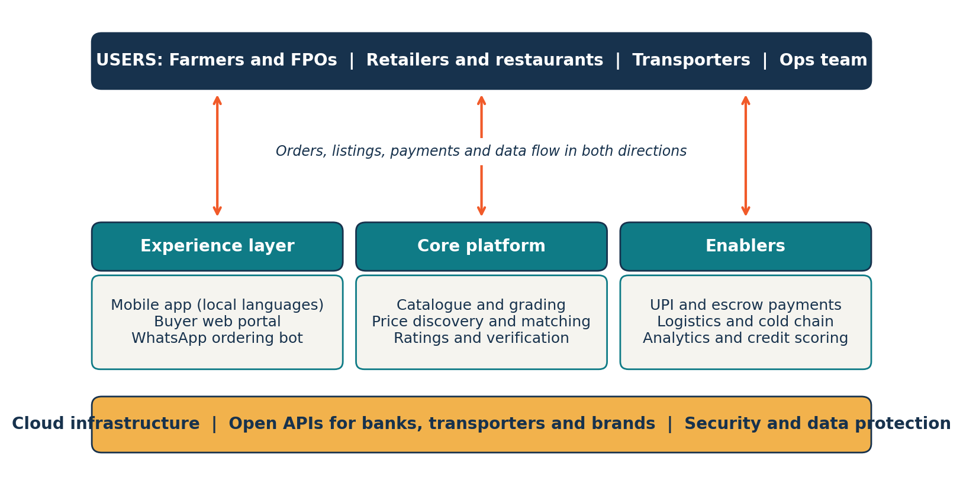
Figure 1. AgroLink digital platform architecture.
Table 2. Technology stack
Component | Choice | Why
Cloud hosting | Public cloud with auto-scaling | Handles harvest-season peaks without idle hardware.
Core services | Modular services with PostgreSQL | Easy to add features and partners.
Payments | UPI, escrow and GST-ready invoices | Safe and compliant settlement.
Data and AI | Price forecasting and demand matching | Improves with every transaction.
Security | MFA, encryption, role-based access | Protects user data under the DPDP Act, 2023.

5. Monetization Mechanics
The platform uses four complementary revenue streams. Transaction fees grow with volume, subscriptions give steady cash, advertising monetizes attention, and freemium keeps the entry barrier at zero.
Table 3. Revenue streams
Stream | How it works | Who pays | Illustrative rate
Transaction fee | Commission on each completed order | Seller and buyer | 1.5% each side
Subscription | Monthly plan with analytics, credit and priority listing | Retailers and FPOs | ₹999 to ₹4,999 a month
Advertising | Sponsored listings by seed, fertilizer and FMCG brands | Brands | Pay per click or slot
Freemium | Free basic listing and ordering; paid premium tools | All users | 5% to 10% upgrade

5.1 Illustrative revenue projection
Figure 2 shows how revenue could grow from ₹44 lakh in Year 1 to ₹460 lakh in Year 3. Transaction fees stay the largest stream but fall from about 68% to 57% of revenue as subscriptions, advertising and premium tools grow. This shows a healthy shift from a single income source to a diversified model.
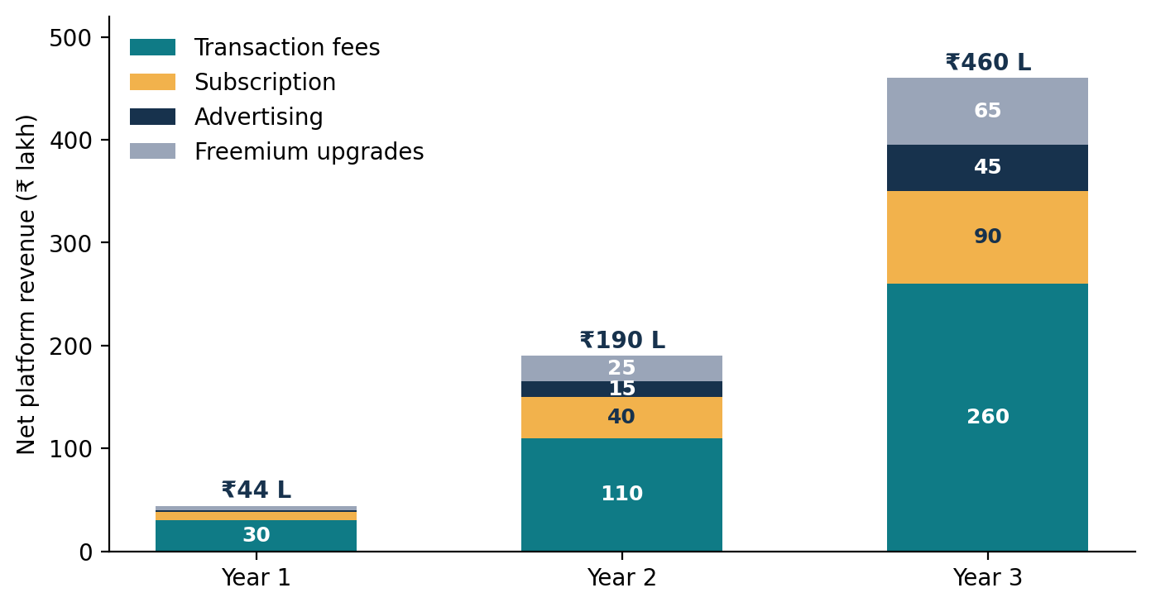
Figure 2. Illustrative revenue mix, Years 1 to 3 (₹ lakh).
6. Ecosystem Dynamics and Network Effects
A network effect exists when a product becomes more valuable as more people use it. Platforms rely on two kinds, shown in Table 4.
Table 4. Network effects on the AgroLink platform
Type | Meaning | AgroLink example
Direct | Value grows as more users of the same kind join. | Retailers share reviews and price alerts; farmers pool produce into large orders; users exchange grading and storage tips.
Indirect (cross-side) | Value grows as the other side of the market grows. | More farmers bring more variety and better prices for buyers; more buyers bring steady demand and faster payment for farmers; more activity attracts transporters, banks and ad brands.

6.1 The platform flywheel
The effects form a flywheel: more farmers list produce, buyers get better choice and prices, more buyers order, higher volume attracts partners and brands, and lower costs and richer data make the platform better again. Cross-side effects are the stronger engine in a B2B market, while direct effects deepen engagement and make switching costly.
6.2 Scaling the platform
- Solve the cold-start problem by seeding one crop in one district first.
- Subsidize the scarce side early (farmers list free) and charge the side that gains most (buyers).
- Use verified badges and ratings to build trust quickly.
6.3 Retaining users
- Payment history unlocks working-capital credit for buyers and FPOs.
- Ratings, price history and order data live on the platform and cannot easily be moved.
- Loyalty tiers reward repeat buyers and reduce off-platform trading.
7. Implementation Roadmap
The transition is phased over 24 months. The legacy pipeline keeps running until the platform is proven, so the company does not face a big-bang switch.
Table 5. 24-month transition plan
Phase | Months | Key activities
Foundation | 1 to 4 | Audit the pipeline, map users, build the MVP and payments, onboard 50 FPOs.
Pilot | 5 to 10 | One crop in one district; free listing with a fee on orders; measure match rate.
Scale | 11 to 18 | Add districts and crops; launch subscriptions; open advertising slots.
Optimize | 19 to 24 | Reduce own stock, open APIs to partners, review unit economics.

8. Targets, Benefits, Risks and Controls
8.1 Target KPIs
Metric | Today | Target after 24 months
Active buyers | 1,500 | 6,000
Spoilage | 12% | Under 5%
Payment cycle | 30 to 45 days | Within 7 days
Repeat order rate | Not tracked | 70% or more
Earnings per order | About 6% margin | 2.5% to 3% fee plus other streams

8.2 Benefits
- Growth without a matching rise in staff and stock.
- Price transparency and less spoilage.
- Faster payments and better use of working capital.
- Data that supports forecasting and credit decisions.
8.3 Risks and limitations
- Chicken-and-egg problem: both sides are needed early.
- Disintermediation: users may trade directly off-platform.
- Low digital skills and trust among some farmers.
- Platform costs arrive before revenue.
- Customer and payment data must be protected under the DPDP Act, 2023.
8.4 Controls
- Seed supply first and reward early users.
- Use escrow payments, ratings and credit benefits to keep trades on-platform.
- Provide local-language support and floor-level onboarding agents.
- Review KPIs monthly through a steering committee.
9. Conclusion
The proposal shows that AgroLink can move from a pipeline to a platform by classifying itself as a B2B marketplace, building a layered architecture, earning through four complementary revenue streams, and growing through direct and indirect network effects. The model meets the Topic 3 requirements by defining the business model, detailing monetization mechanics, and explaining ecosystem dynamics. The main lesson is that a platform wins by growing its ecosystem rather than by owning more inventory.
References
- Laudon, K. C. and Laudon, J. P. Management Information Systems: Managing the Digital Firm. Pearson.
- Parker, G., Van Alstyne, M. and Choudary, S. Platform Revolution. W. W. Norton, 2016.
- Rochet, J.-C. and Tirole, J. Platform Competition in Two-Sided Markets. Journal of the European Economic Association, 2003.
- Rappa, M. Business Models on the Web.
- Katz, M. and Shapiro, C. Network Externalities, Competition and Compatibility. American Economic Review, 1985.
- Digital Personal Data Protection Act, 2023 (India).
AgroLink Traders Pvt. Ltd. and every figure in this report are hypothetical, created to demonstrate the method.

