FPGA-Based Electronic Voting Machine with FSM Control
Abstract:
This work presents an FPGA-based electronic voting machine designed using Finite State Machine (FSM) methodology. The system allows multiple voters to cast votes securely using push-button inputs, maintains accurate vote counts, and displays results in real-time through LEDs. The design is fully synthesizable and optimized for FPGA deployment. The machine incorporates sequential logic, counters, registers, and state transitions to manage voting, result publishing, and security operations, ensuring robustness and reliability.

1. Introduction
Traditional voting systems are prone to human errors and fraud. An FPGA-based electronic voting machine provides a secure, fast, and reliable solution. This system uses push-button inputs to represent voters and candidates, LEDs to display results, and Finite State Machine (FSM) logic for controlling the voting process. The design ensures that votes are counted only during active voting, prevents duplicate votes, and enables safe publishing of results.

2. System Architecture

2.1 Finite State Machine (FSM) Design
The voting machine is implemented using a 3-state FSM, controlling all major operations:
State | Description | Functionality
s5 | Initialization / Reset | Resets counters, registers, and internal variables; prepares the system for voting.
s0 | Voting State | Captures voter input through push-buttons, increments candidate counters, and ensures secure voting.
s1 | Result Publishing | Displays individual candidate vote counts on LEDs when requested.
State Transitions:
- The FSM starts at the initialization state s5 on reset.
- Transitions to the voting state s0 occur when security mode is enabled.
- From voting, it either continues voting, returns to initialization, or moves to result publishing based on mode and security conditions.
- Result publishing state s1 displays votes and returns to voting when mode changes.
This FSM ensures deterministic and secure control of the voting process.

2.2 Hardware Implementation
- Input Interface:
  - push[3:0] signals represent voter selections (P0, P1, P2, P3).
  - mode selects voting or result display mode.
  - security_mode ensures only authorized voting sessions.
- Output Interface:
  - led_output[7:0] displays candidate votes in real-time.
- Registers & Counters:
  - Candidate vote counts stored in count_value0–count_value3.
  - total_votter keeps track of total votes cast.
  - counter generates time delays for voting stabilization (debouncing).
- Sequential Logic:
  - The design uses clocked registers to increment votes securely.
  - Implements a one-second delay mechanism to prevent multiple counting from a single press (debounce logic).

2.3 Key Features
- Secure Voting Mode: Votes are only counted when security mode is active.
- Multi-Candidate Voting: Supports four candidates with dedicated input lines.
- Result Display: Real-time vote counts displayed on LEDs.
- Metastability-Safe Operation: Sequential logic ensures deterministic behavior.
- FPGA-Friendly: Synthesizable Verilog RTL, tested on ZedBoard or similar FPGAs.
- Scalable Design: Easy to extend to more candidates or additional features.

3. Design Flow
- Reset & Initialization: FSM enters s5 state, resetting all counters and outputs.
- Voting State (s0): Sequential logic reads push-button inputs, updates counters, and tracks total voters.
- Result Publishing (s1): Candidate votes are displayed on LEDs.
- Mode & Security Handling: FSM ensures votes are only captured during active security mode, preventing invalid input counting.

4. Verilog RTL Implementation
The Verilog code implements the FSM with always blocks triggered by the clock, sequential counters for vote tracking, and registers for candidate votes. It efficiently handles mode switching, vote counting, and LED display.

5. Conclusion
This FPGA-based electronic voting machine demonstrates a secure, reliable, and hardware-efficient implementation of a digital voting system. The use of FSM, sequential logic, and structured RTL coding ensures accurate voting, real-time result publishing, and robustness for deployment on FPGA platforms. The system can be further extended for larger elections or integrated with display interfaces for broader applications.

6. FPGA Board Mapping and Pin Assignment

6.1 Clock Configuration
The design operates with a primary system clock of 100 MHz, derived from the on-board oscillator. A timing constraint is defined to ensure accurate synthesis and static timing analysis.
- Clock Name: comb_clk
- Clock Frequency: 100 MHz
- Clock Period: 10 ns
- FPGA Pin: Y9
- I/O Standard: LVCMOS18
This clock drives all sequential logic including FSM state transitions, counters, and vote registers.

6.2 Reset Interface
A dedicated push-button input is used to reset the system. When asserted, the FSM returns to the initialization state, and all vote counters and registers are cleared.
- Signal: reset
- FPGA Pin: P16
- I/O Standard: LVCMOS18

6.3 LED Output Mapping
Eight on-board LEDs are used to display vote counts and system status. Each LED corresponds to one bit of the led_output[7:0] signal, enabling real-time visualization of voting results.
LED Bit | FPGA Pin | Function
led_output[7] | U14 | MSB of vote display
led_output[6] | U19 | Vote display
led_output[5] | W22 | Vote display
led_output[4] | V22 | Vote display
led_output[3] | U21 | Vote display
led_output[2] | U22 | Vote display
led_output[1] | T21 | Vote display
led_output[0] | T22 | LSB of vote display
- I/O Standard: LVCMOS18
These LEDs are driven directly from the FSM output logic during both voting confirmation and result-display modes.

6.4 Push-Button Input Mapping
Four push-buttons are used for candidate selection. Each button represents one candidate and is mapped to a dedicated input bit.
Push Button | Signal | FPGA Pin
Candidate-0 | push[0] | T18
Candidate-1 | push[1] | N15
Candidate-2 | push[2] | R16
Candidate-3 | push[3] | R18
- I/O Standard: LVCMOS18
Push-button inputs are sampled synchronously with the system clock to avoid glitches and ensure stable vote counting.

6.5 Mode and Security Control Signals
Two additional control inputs are used to manage the operational mode of the voting machine.

Voting / Result Mode Select
- Signal: mode
- Function:
  - mode = 1 → Voting mode
  - mode = 0 → Result display mode
- FPGA Pin: F22
- I/O Standard: LVCMOS18

Security Enable
- Signal: sequrity_mode
- Function: Enables secure vote entry and prevents unauthorized voting
- FPGA Pin: G22
- I/O Standard: LVCMOS18
These signals control FSM transitions and ensure that votes are accepted only during authorized sessions.

6.6 Summary of FPGA Mapping
The FPGA mapping ensures:
- Reliable clock distribution for all sequential elements
- Secure and controlled vote entry
- Clear visual feedback through LED outputs
- Clean separation between voting and result-display modes
All I/O signals use LVCMOS18 standard, making the design fully compatible with the target FPGA board and suitable for real-time deployment.

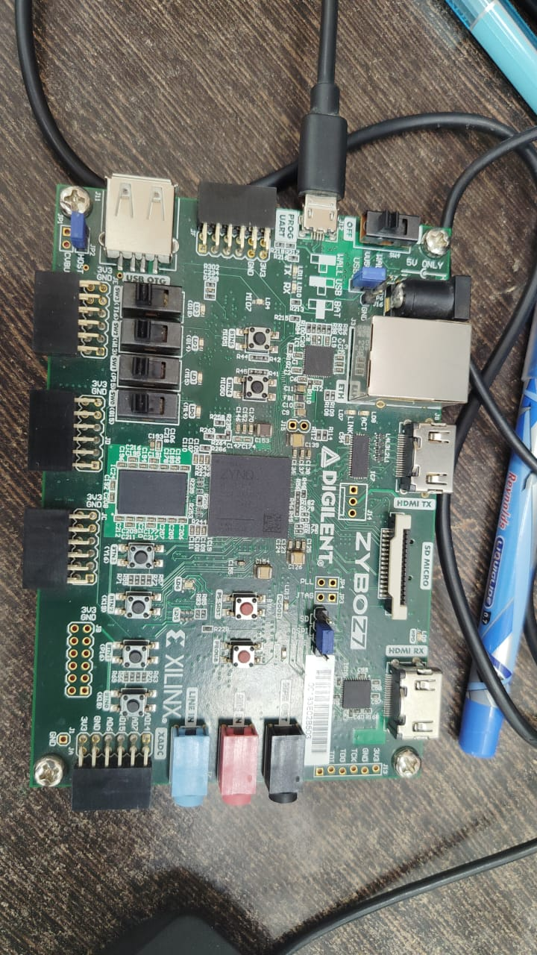
j

