|  |  |
| --- | --- |
| **Technology Hackathon 2025**  Gen AI For Platform Support - Integrated Platform Environment  [Cloud Zone Hack Team] |  |

Contents

Objective 2

Persona 2

Tools & Technologies 2

System High level Components 2

User Flow Diagram End to End Showcase 3

System Component Flow 5

Technology Stack 6

Higl Level User story 7

Actor Interaction sequence 8

Deployment 9

# Objective

To design an integrated platform environment (IPE) for platform teams that simplifies incident/issue management through GenAI and agentic capabilities while using sample operational data from sources like Hugging Face. The prototype will illustrate the end-to-end journey of an incident.

# Persona

Platform Support User: The user responsible for searching incidents and using the Gen AI chat boats to mitigate the issue/incidents.

# Tools & Technologies

* **UI Design:** React or Razor for prototypes.
* **Data Integration:** Use sample datasets from Hugging Face and real-time analytics tools.
* **AI Models:** Leverage GenAI models (e.g., OpenAI or Hugging Face transformers) to power recommendations, predictions, and automated workflows
* **User Interaction:** Browser UI Interface

# System High level Components

The UI will have the following key views and features:

**Dashboard View (Wireframe)**

1. Key Capabilities:
   1. High-level overview of system health, active incidents, and resolved issues.
   2. Customizable widgets for real-time analytics powered by GenAI.
   3. AI-suggested priorities for incidents and predictive trends.
2. Details to Showcase:
   1. A collapsible left-hand navigation bar for switching between views.
   2. Central pane with visualizations (e.g., charts, incident heatmaps).
   3. Notifications pane to alert users of critical issues

**Incident Details View (Working Prototype)**

1. Key Capabilities:
   1. Detailed information about the selected incident, including operational data from external sources (e.g., Hugging Face datasets).
   2. Incident timeline to show step-by-step updates.
   3. Recommendations for resolution strategies from GenAI.
2. Interactive Features:
   1. Editable fields for manual data input.
   2. Auto-generated response suggestions for incident resolution.
   3. AI-powered knowledge base integration for FAQs and related incidents.

**Incident Resolution Wizard (Wireframe)**

1. Key Capabilities:
   1. Step-by-step walkthrough of resolution using agentic capabilities.
   2. Automation of repetitive tasks (e.g., log updates, stakeholder notifications).
   3. “What If” scenarios powered by GenAI to predict outcomes of specific actions.
2. Details to Showcase:
   1. Interactive modal overlay guiding users through each step.
   2. Integration of sample data to validate the process.

**Operational Insights View (Working Prototype)**

1. Key Capabilities:
   1. Analytics and metrics to measure efficiency and resolution times.
   2. AI-powered sentiment analysis of resolution feedback.
   3. Visualizations showing patterns in issue recurrence and escalation.
2. Interactive Features:
   1. User-defined filters for data exploration.
   2. Export options to generate reports for stakeholders.

# User Flow Diagram End to End Showcase

1. No Matching Resumes Found: If the system cannot find any resumes that match the Postcondition

|  |  |
| --- | --- |
| **Incident Detection** | **Trigger:** System monitors operational data (e.g., from Hugging Face datasets) and detects an anomaly.  **Action:**   * Automated notification appears on the Dashboard. * AI assistant flags the anomaly as a   **User Decision Point:** Acknowledge the alert and click on "View Details. "potential incident. |
| **Incident Diagnosis** | **Trigger:** User navigates to the Incident Details View.  **Action:**   * View operational data and GenAI's analysis of the anomaly. * AI Assistant provides root cause suggestions and similar past incidents**.**   **User Decision Point:**Choose to initiate resolution or assign the issue to a team. |
| **Resolution Execution** | **Trigger:** User selects "Resolve Incident" in the Incident Details view.  **Action:**  **Incident Resolution Wizard** guides the user step-by-step:   * Automates repetitive tasks like restarting servers or clearing logs. * AI Assistant predicts outcomes of potential actions   User verifies or modifies AI-suggested actions  **User Decision Point:** Approve the resolution plan or escalate for expert review |
| **Post-Incident Review Action:** | **Trigger:** Incident is marked as resolved.  **Action:**   * Navigate to the Operational Insights View. * View resolution time, team performance, and sentiment analysis from stakeholders. * Identify patterns or recurring issues via predictive insights.   **User Decision Point:** Decide whether to update preventive policies or share the review report. |
| **Continuous Learning** | **Trigger:** Incident data is logged into the AI knowledge base.  **Action:**   * GenAI retrains on the new incident data to improve future recommendations. * Chat Assistant offers improved suggestions based on updated knowledge   **Outcome:** System evolves with more efficient and accurate problem-solving capabilities |

# System Component Flow

Figure 1

# Technology Stack

1. **Frontend (User Interface Layer)**
   * React.js: For building the dynamic and responsive UI.
   * Material-UI (MUI): For pre-built UI components and styling.
   * Chart.js: For creating operational insights and incident visualizations (e.g., heatmaps, timelines).
   * **Package for Chatbot Integration:** React Chatbot Kit: For integrating the AI chat assistant.
2. **Backend (Business Logic Layer)**:
   * **Razor application** with react framework.
   * **Python (FastAPI)** for tasks requiring AI model integration (like incident recommendations or predictions).
   * **Socket.io:** For live notifications and incident updates in the dashboard
3. **Natural Language Processing (NLP) Service**:
   * **Azure OpenAI:** For chatbot interactions and generative AI features. OpenAI provides powerful APIs for language understanding and generation.
   * **Hugging Face Transformers (e.g., BERT):** For analysing operational data, root-cause diagnosis, and sentiment analysis.
   * **Scikit-learn or TensorFlow:** For training models to predict incident trends and issue recurrence.
4. **Data Management (Data Processing Layer)**

**MSQLDB :** For structured data storage (e.g., incident logs, user details).

1. **CI/CD Pipeline**:

* Enterprise pipeline solution provide by wellsfargo.

1. **Deployment Platform**:
   * Azure App Service/Azure Function /AKS Containerization and Orchestration
2. **Development Environment**:
   * Python
   * C#
   * IDE or Text Editor: Visual Studio Code or Visual Studio
3. **DevOps and Monitoring**

**Version Control:** GitHub

**CI/CD Pipeline:** Jenkins

**Monitoring and Logging:** Prometheus and Grafana: For monitoring application health and metrics.

.

# Higl Level User story

|  |  |
| --- | --- |
| Must Have | * **M1:** **Incident Dashboard**   + A centralized view of ongoing incidents, system health, and AI-recommended actions.   + Real-time monitoring and automated alerts based on operational data. * **M2:** **Incident Management System:**   + Ability to create, track, and update incidents with status and priority details.   + Detailed incident information, including timeline, root cause analysis, and assigned team. * **M3:** **AI-Powered Chat Assistant:**   + Real-time support for incident resolution suggestions.   + Automation of repetitive tasks like log generation and notifications. * **M4:** Operational Insights View:   + Analytics and metrics for incident resolution times, efficiency, and patterns.   + Predictive analytics to prevent recurrence of issues. |
| **Should Have** | * **S1:** **Incident Resolution Wizard**   + "What If" scenario predictions to assess potential outcomes of actions. * **S2:** **Customizable Widgets**   + Personalized dashboards to focus on high-priority incidents or specific metrics * **S3:** **Knowledge Base Integration**   + AI-enhanced repository for referencing past incidents and FAQs during resolution. |
| **Could Have** | * **C1:** Proactive Preventive Measures:   + AI recommendations for infrastructure changes based on incident patterns.   + Automated enforcement of preventive policies (e.g., scaling nodes pre-emptively). |
| **Won't Have** | * **W1:** Advanced Custom Development Options   + Allowing users to code and add custom logic to the platform's workflows (deferred for future releases to maintain simplicity). * **W2:** Integration with Legacy Systems   + Compatibility with older, non-cloud systems (prioritize cloud-native systems). |

# Actor Interaction sequence

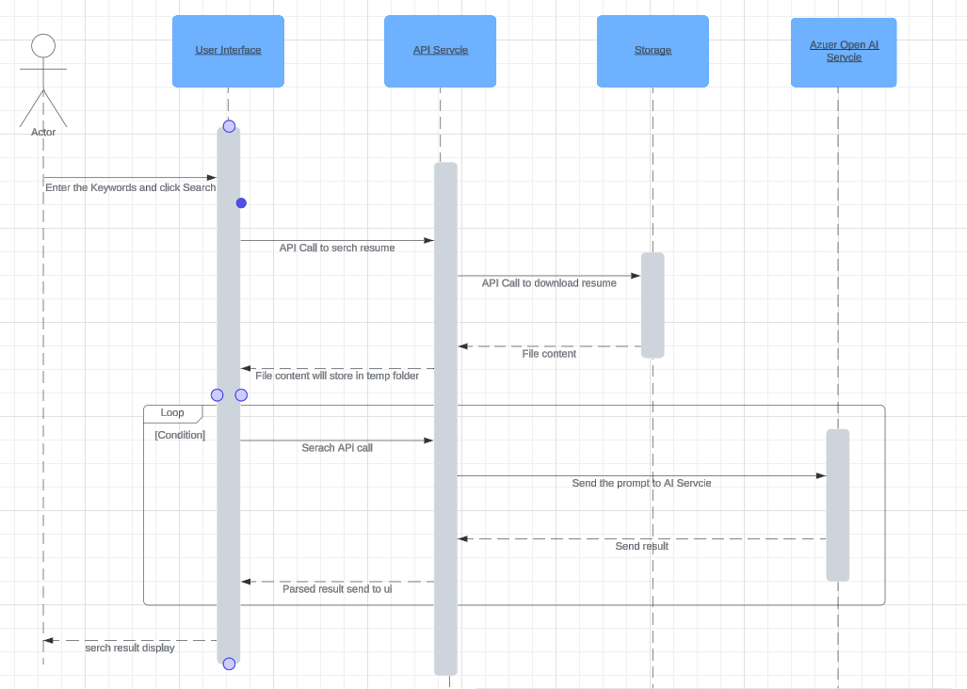

Figure 2

# Deployment

