Cloud Zone Team

PlayRun Book For COMPONENT DeploymeNt

# Fron End Deployment

As outlined in the design document, the enterprise pipeline will be utilized for deployment. However, for the time being, we opted for manual deployment to assess our UI component. Below are the steps we followed to deploy our UI component in the Web App Service

**Step1:** Created the We App Service

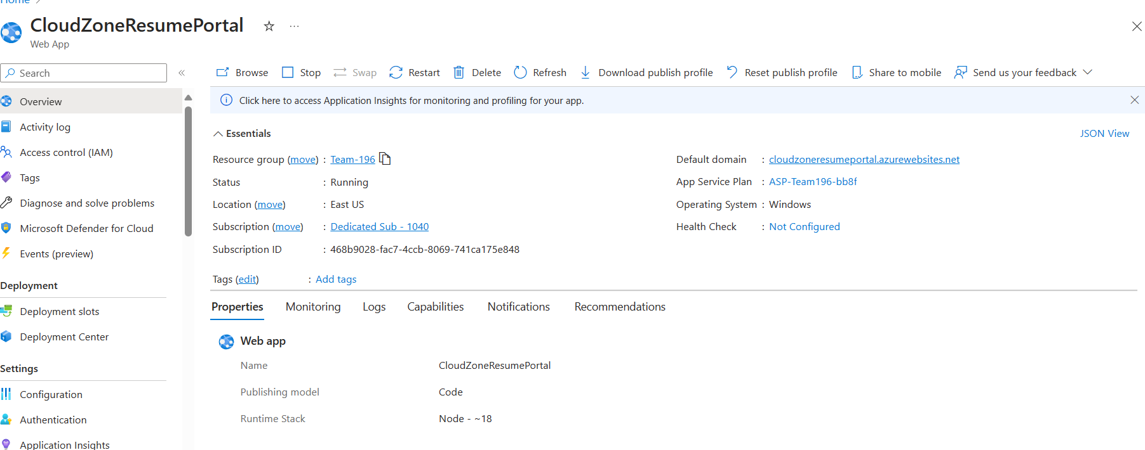

**Step2:** Publish Artifact using visual studio terminal by running **npm run build** command

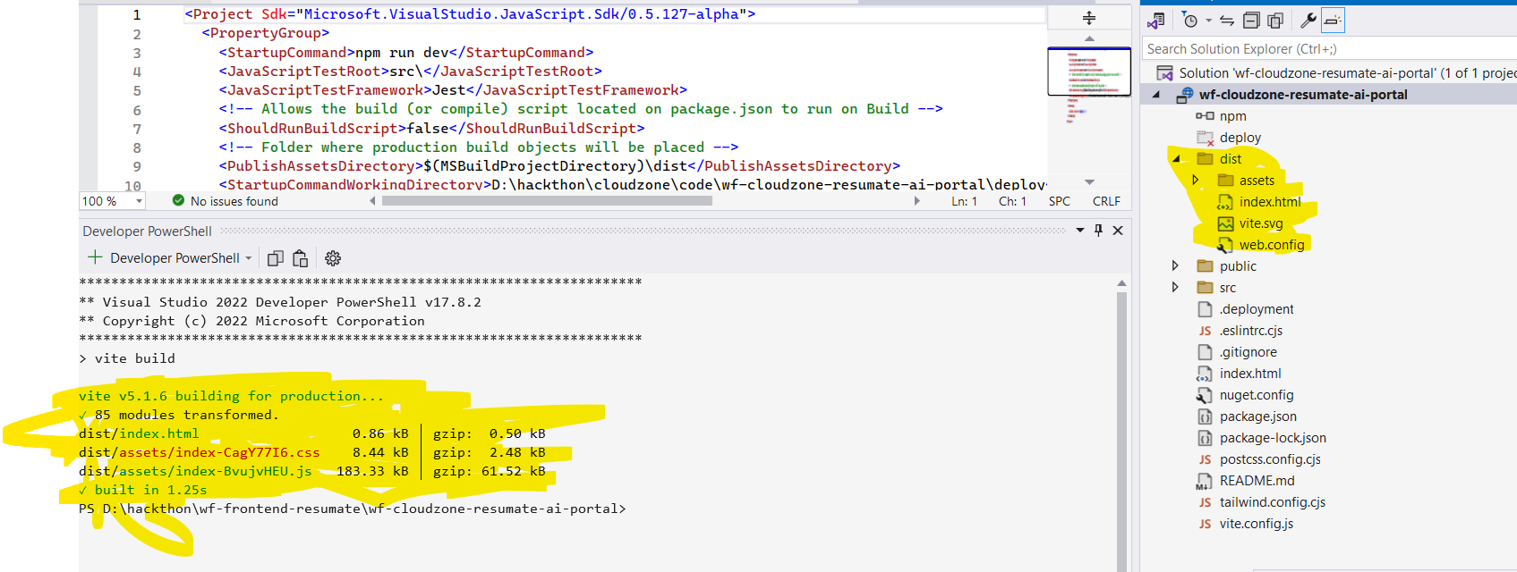

**Steps3:** Zip the folder dist folder as app.zip

**Steps4**: login to azure portal **az login**

**Steps5:** Deploy the a app using following command**.**

**az** webapp deployment source config-zip --resource-group Team-196 --name CloudZoneResumePortal --src dist.zip

**Step6 : Once deploy app started** [CloudZone:Hacthon2024 Resume Best Match Filter (cloudzoneresumeportal.azurewebsites.net)](https://cloudzoneresumeportal.azurewebsites.net/)

**Mock UI Screen**

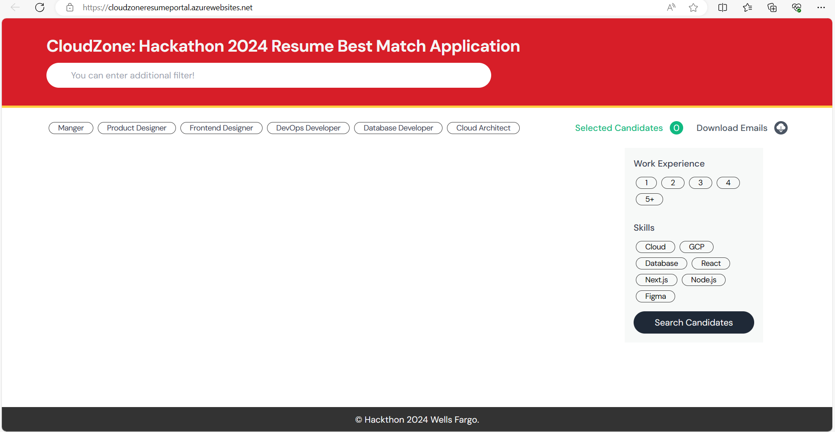

**Steps 6: With Mock resume data UI will show below mock screen**

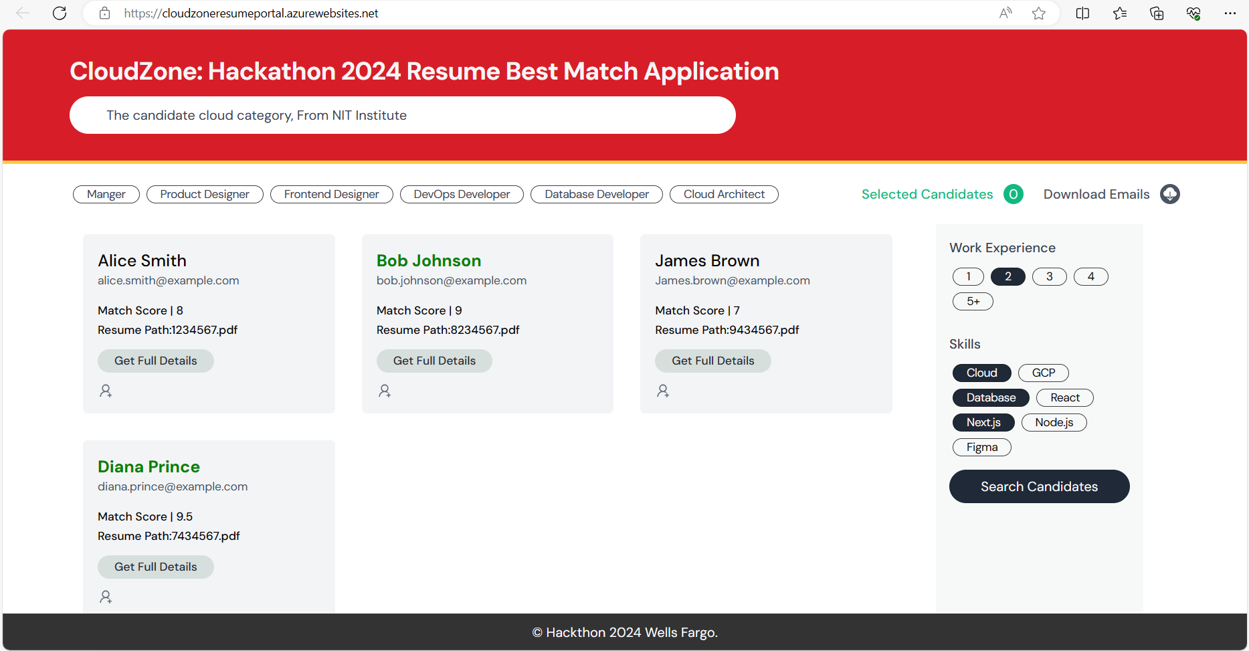

# Back End Deployment

**Steps 1:** Created the We App Service

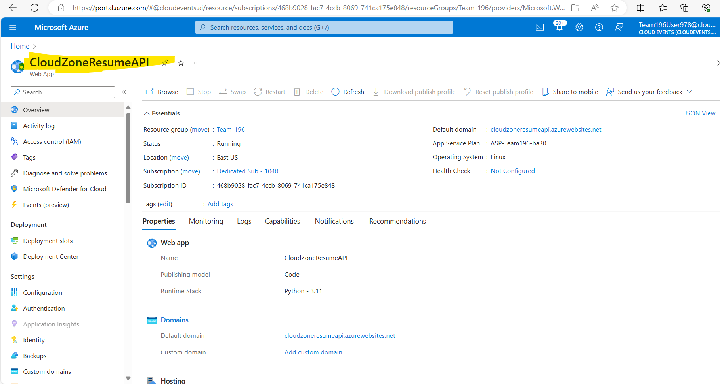

**Steps 2:** Publish Artifact using visual studio publish utility

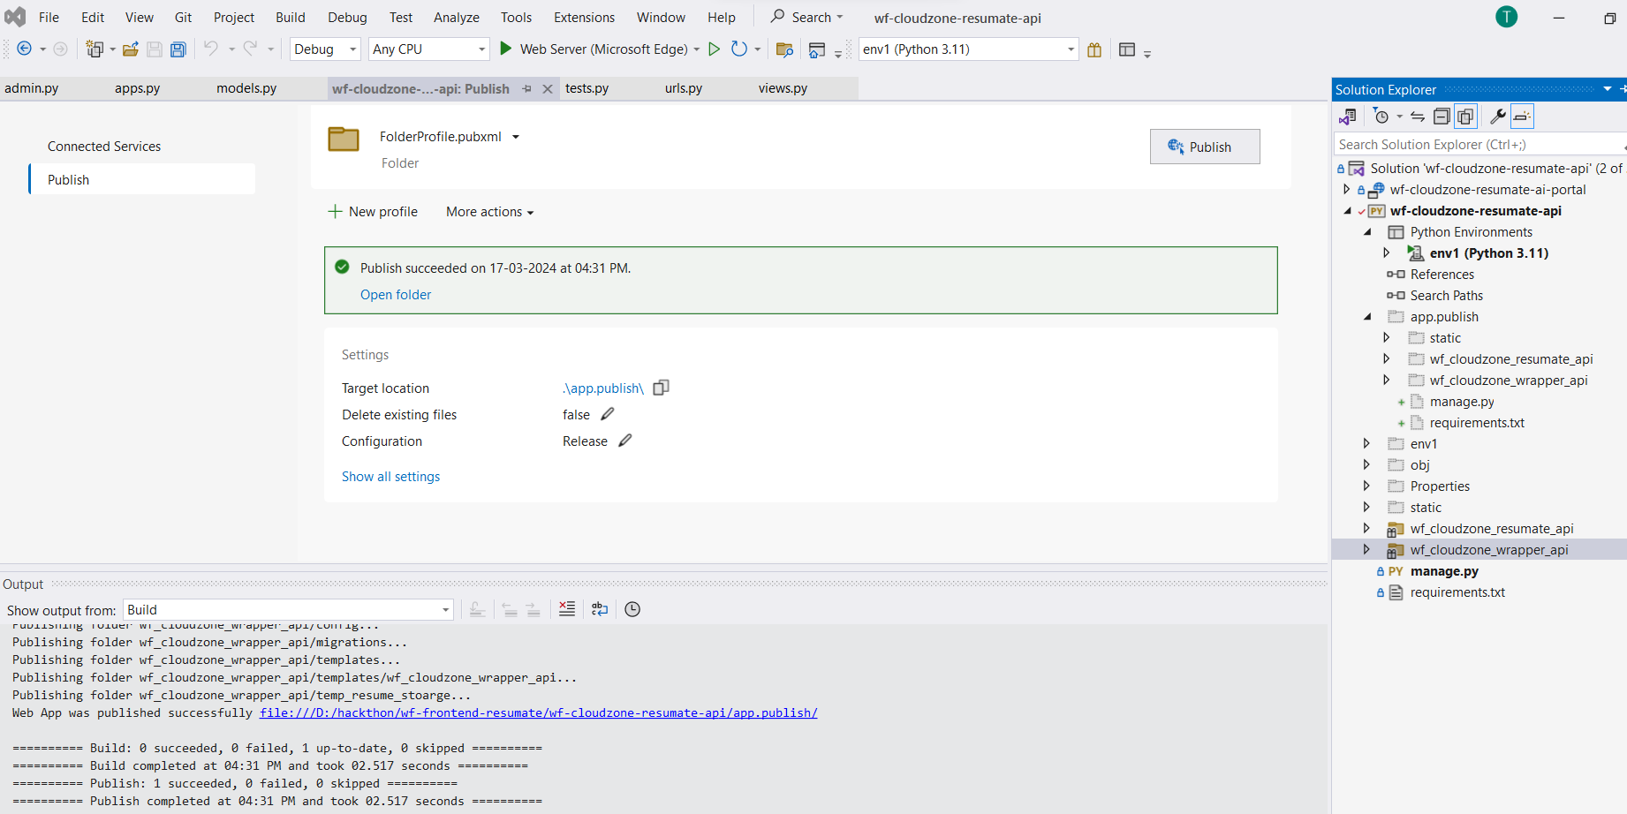

**Steps 3:** Zip the folder publish folder as a app.zip

**Steps 4**: login to azure portal **az login**

**Steps 5:** Deploy the app using following command**.**

**az** webapp deployment source config-zip --resource-group Team-196 --name CloudZoneResumeAPI --src app.zip

**API call with Mock Data**

