Cloud Zone Team

PlayRun Book for testing API Service Response

# Running and Testing Positive Workflow

1. You can test the API using Postman.
   1. Make a POST call to <https://cloudzoneresumeapi.azurewebsites.net/search>.
   2. Add ‘Content-Type: application/json’ in the Header
   3. Add the following Json to the body  
        
      {

    "context": "1. CONSTRUCTION SALES Role \n 2. 10+ years of experience, Operations, Pricing,",

    "category":"resume",

    "threshold":0.7,

    "noOfMatches":4,

    "inputPath": "https://console.cloud.google.com/storage/browser/hackathontestdata2024"

}

* 1. Click to Send request.

1. 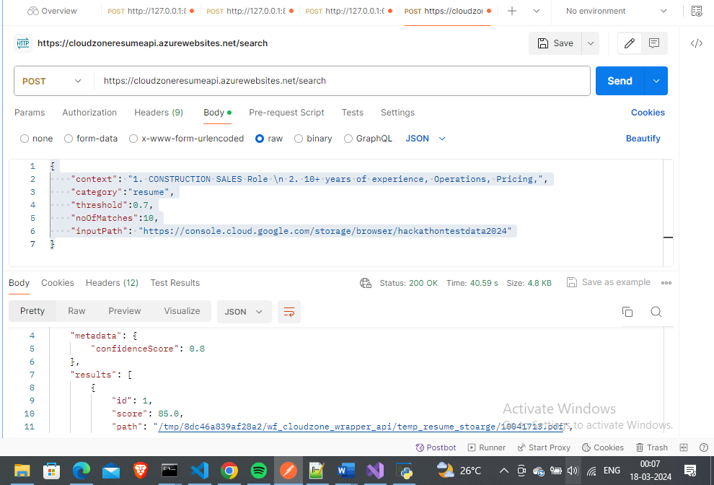
2. The first response in results should give the best resume match and as you can see in the screenshot it gives out 10041713(SR. ESTIMATOR-BAS CONSTRUCTION SALES).pdf resume, which matched with the filter conditions provided in the post request body.  
   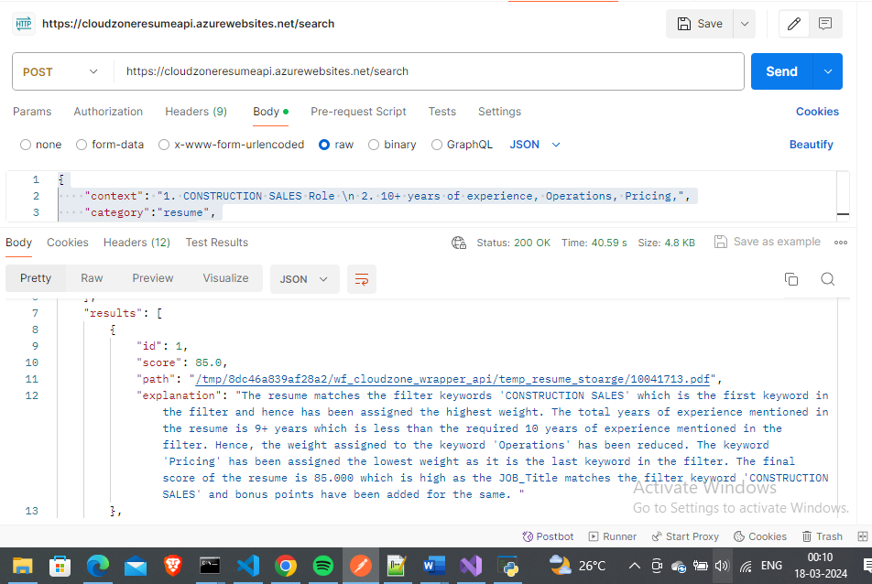
3. The rest of the files don’t pertain to the filter provided so service keeps the overall score low.

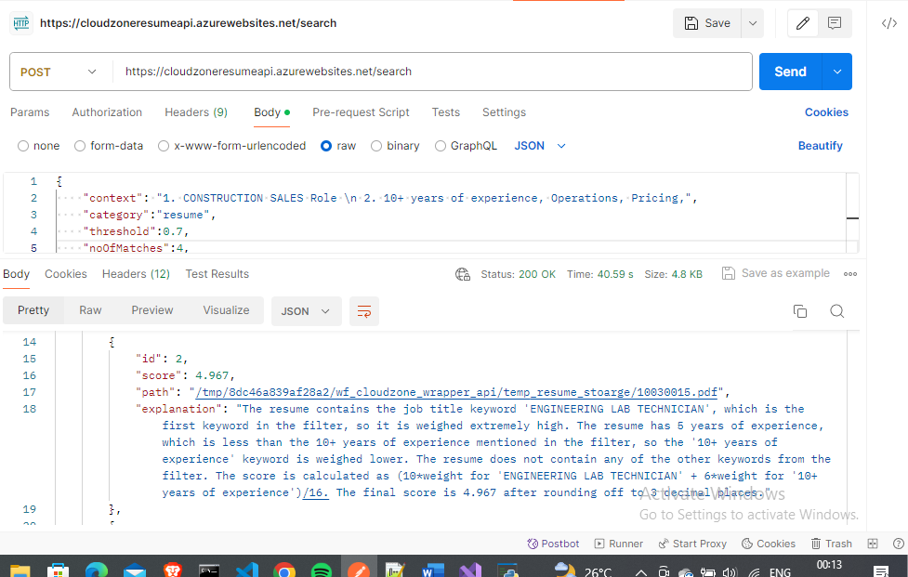

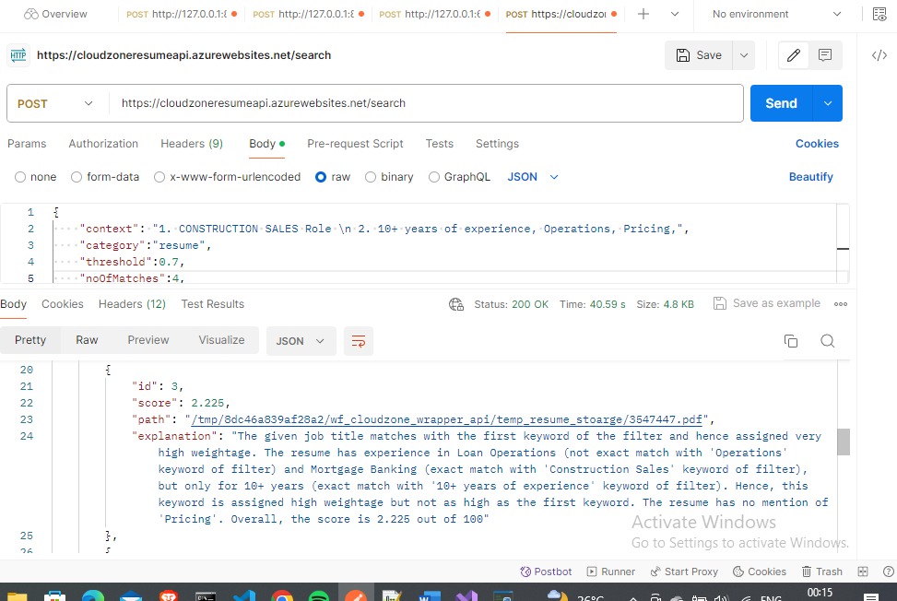

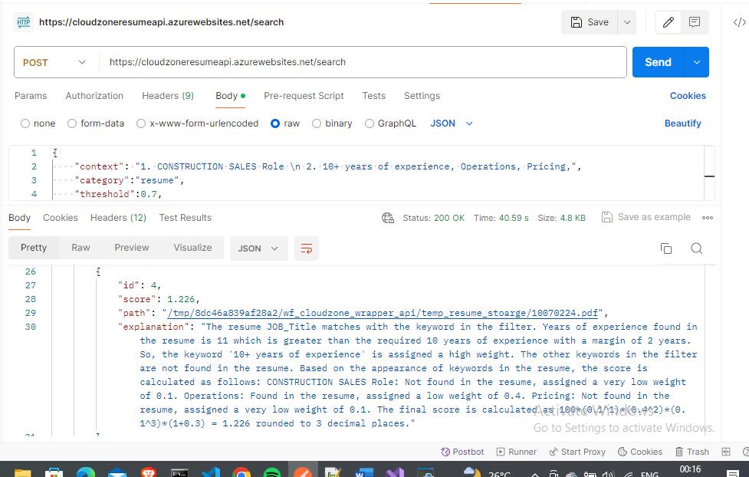

# Running and Testing Negative/Edge Case Workflow

1. Changing the body category to ‘job’  
   