Cloud Zone Team

Play Run Book For DeploymeNt of ComponeNt

# Fron End Deployment

As mentioned in design doc enterprise pipeline going to be used for deployment, but now for time being we followed the manual deployment to test our UI component. following is steps we executed to deploy our UI component in Web App Service.

**Step1:** Created the We App Service

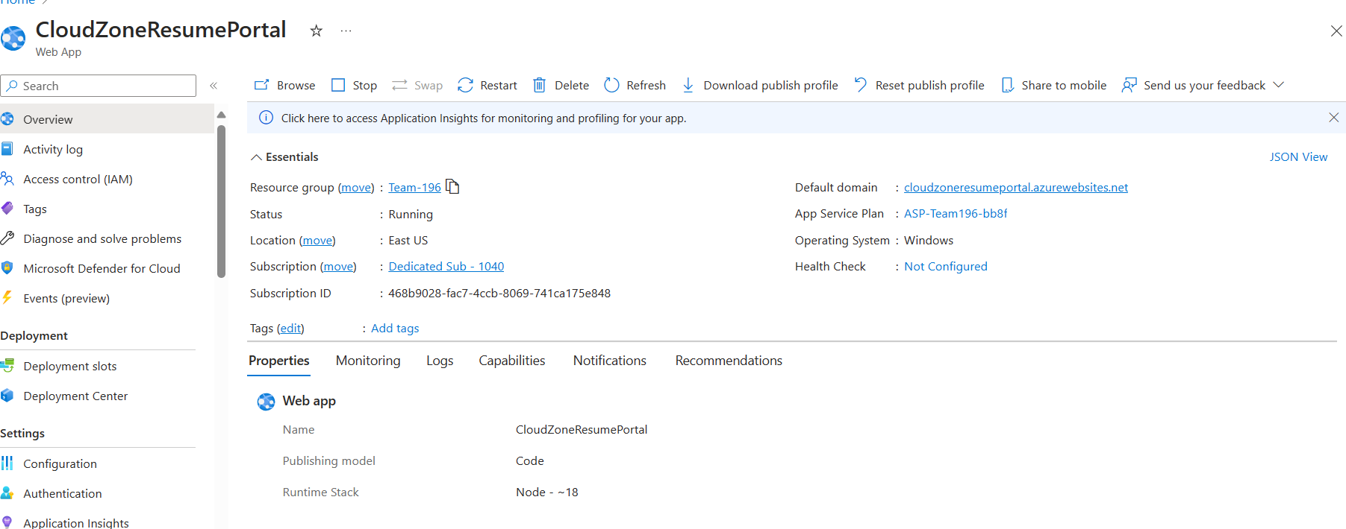

**Step2:** Publish Artifact using visual studio terminal by running **npm run build** command

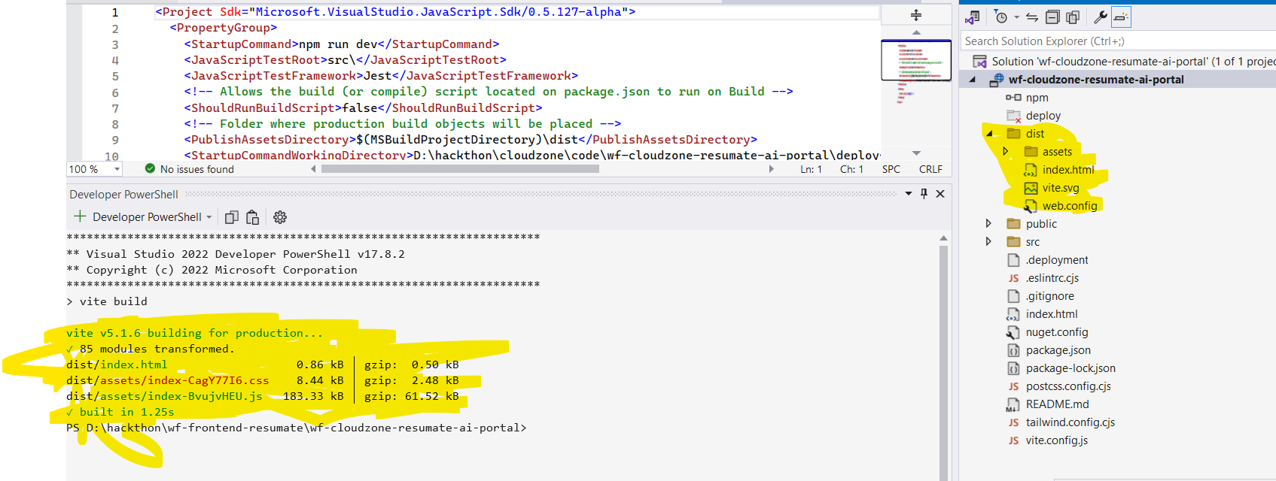

**Steps3:** Zip the folder dist folder as app.zip

**Steps4**: login to azure portal **az login**

**Steps5:** Deploy the a app using following command **.**

**az** webapp deployment source config-zip --resource-group Team-196 --name CloudZoneResumePortal --src dist.zip

**Step6 : Once deploy app started** [CloudZone:Hacthon2024 Resume Best Match Filter (cloudzoneresumeportal.azurewebsites.net)](https://cloudzoneresumeportal.azurewebsites.net/)

**Mock UI Screen**

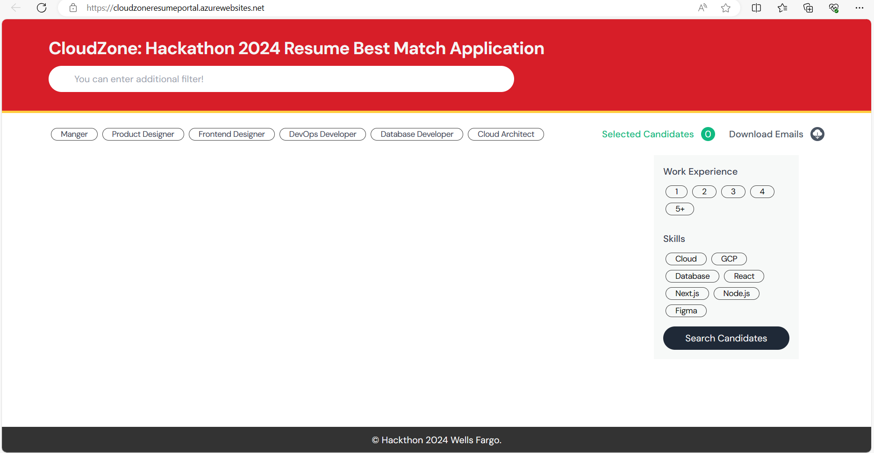

**Steps 6: With Mock resume data UI will show below mock screen**

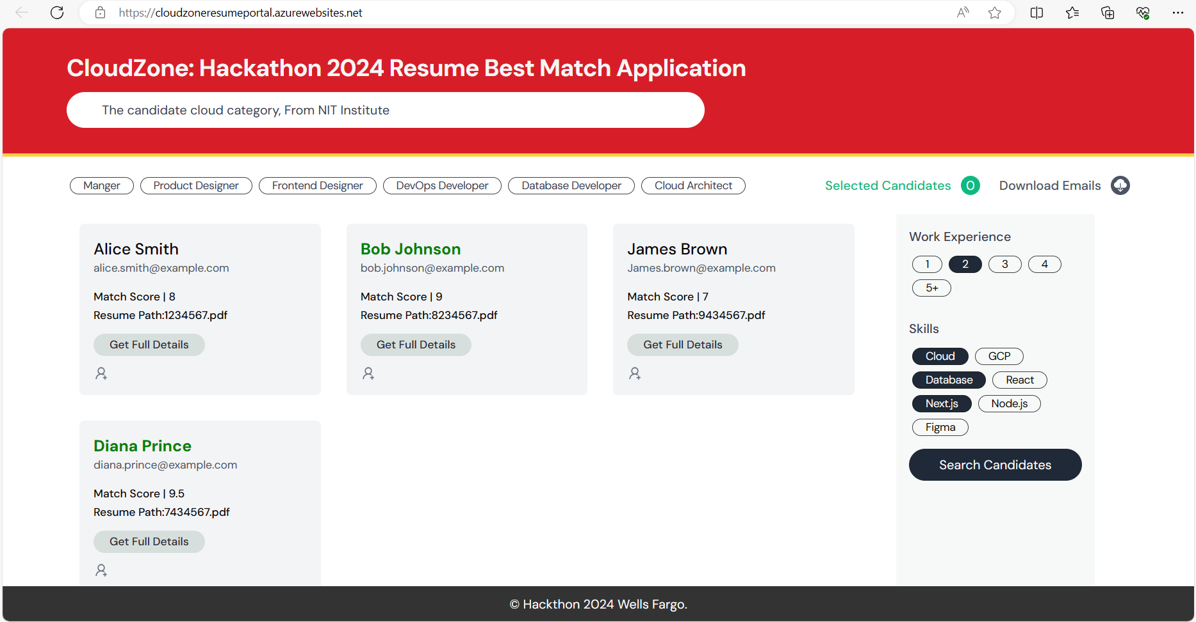

# Back End Deployment

**Steps 1:** Created the We App Service

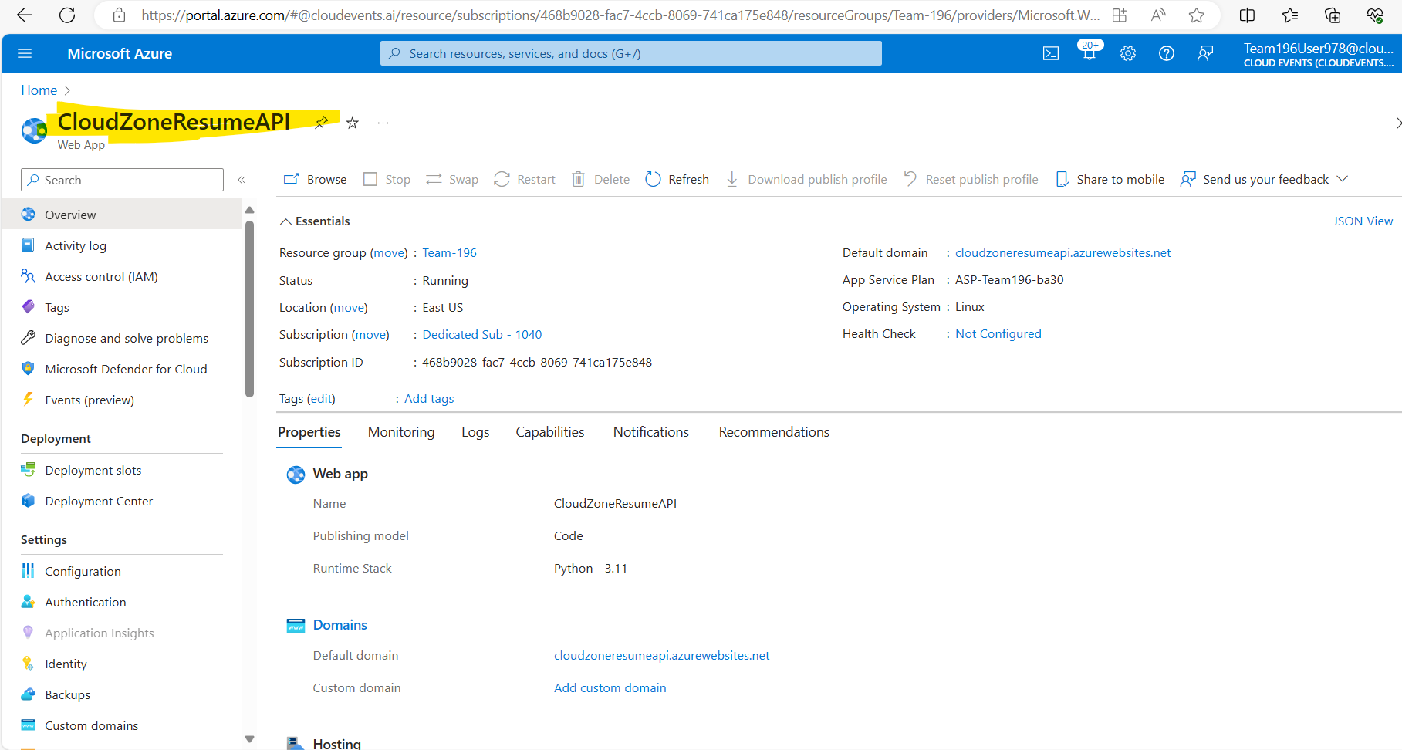

**Steps 2:** Publish Artifact using visual studio publish utility

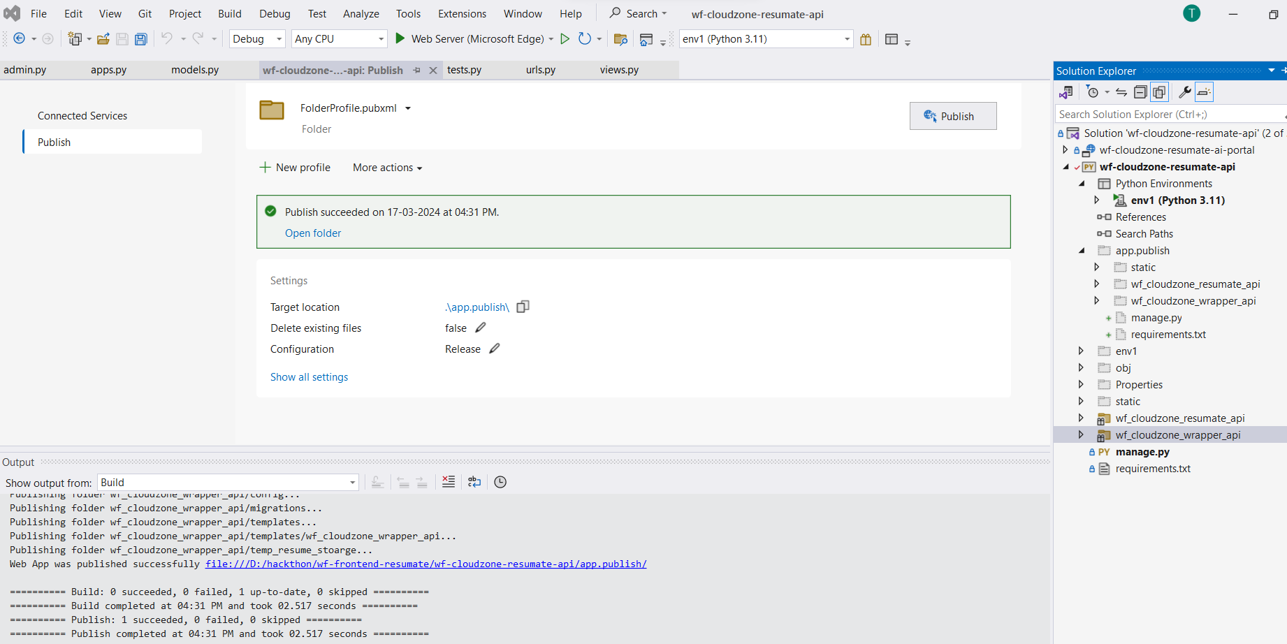

**Steps 3:** Zip the folder publish folder as a app.zip

**Steps 4**: login to azure portal **az login**

**Steps 5:** Deploy the app using following command**.**

**az** webapp deployment source config-zip --resource-group Team-196 --name CloudZoneResumeAPI --src app.zip

**API call with Mock Data**

