

Knowledge-based Expert System

Subject: Knowledge and Expert Systems



19- 04-2024

Durham College

Presented by:

Gayathri Ganesan 100944141

Vijay Kathiravan 100933014

Rupisha Patel 100935688

**ABSTRACT**

This report details the development and deployment of an expert system aimed at assisting tenants in navigating the Ontario Landlord and Tenant Board (LTB) processes. We have created a chatbot by integrating both the perspectives from tenants and landlords. Utilizing the pyknow library and Streamlit for interface design, the system operates as a rule-based chatbot with a focus on tenant advocacy across three modules: Ending Tenancy, Residential Tenancy Act, Application and hearing process and Contacting the LTB. Extracting factual data from the official LTB website, ensures the system's guidance is accurate and reliable. Through a series of rules and logical deductions, the chatbot facilitates informed decision-making for tenants facing various tenancy-related issues. The End the Tenancy module provides tailored guidance on terminating tenancy agreements, outlining legal requirements and potential implications. The Residential Tenancy Act module assists users in navigating paperwork and financial aspects of LTB proceedings, streamlining the process. Additionally, the Contact the LTB module offers information on communication channels with the board for inquiries, complaints, or assistance, ensuring accessibility and support throughout the tenant advocacy journey. This report underscores the importance of leveraging technology to empower tenants with knowledge and resources, promoting fairness and transparency in the landlord-tenant relationship and contributing to a more equitable rental housing landscape in Ontario.

Top of Form

1. **Introduction**

The relationship between landlords and tenants is governed by a complex set of regulations and procedures, particularly within the context of Ontario's rental housing market. The Ontario Landlord and Tenant Board (LTB) plays a central role in adjudicating disputes and enforcing the rights and responsibilities of both parties. However, navigating the intricacies of the LTB processes can be daunting for tenants, who often lack the necessary knowledge and resources to advocate for their rights effectively.

To address this challenge, an expert system has been developed to assist tenants in understanding and navigating the LTB procedures. Leveraging the power of technology, this system operates as a rule-based chatbot, providing tailored guidance and support across key aspects of the tenant advocacy journey. By harnessing factual data extracted from the official LTB website, the system ensures accuracy and reliability in its recommendations, empowering tenants to make informed decisions about their tenancy matters.

This report also explores the implications and potential impact of the expert system on the broader landscape of tenant advocacy and housing rights in Ontario. By providing tenants with accessible and user-friendly tools to navigate the often-complicated LTB processes, the system contributes to levelling the playing field between landlords and tenants. Moreover, the adoption of such technology signifies a progressive step towards modernizing and democratizing access to justice within the realm of rental housing disputes. Through case studies and user feedback, this report evaluates the practical effectiveness of the expert system in empowering tenants and promoting equitable outcomes. Additionally, it discusses potential avenues for further enhancement and expansion of the system to address emerging challenges and evolving needs within the rental housing sector. Overall, the implementation of this expert system represents a significant advancement in tenant advocacy efforts, signalling a commitment to fairness, accessibility, and empowerment for all stakeholders involved in Ontario's rental housing market.

1. **Literature Review**

2.1. Research Paper Name: Building sustainable free legal advisory systems: Experiences from the history of AI & law by Elsevier in April 2018

Authors: Graham Greenleaf, Andrew Mowbray, Philip Chung

The primary goal of this study is to evaluate what lessons can be applied from the DataLex Project to the modern use of "AI and law" by free legal assistance firms, who are compelled to develop and maintain such systems within financial and other constraints. From this experience, we derive fifteen findings that we believe are pertinent to the design of free legal advice service systems. We contend that integrated legal decision-support systems—not "expert systems" or "robot lawyers"— are the intended outcome. We juxtapose our observations with the methodology of the most influential current work in the subject as well as with a critical analysis of the field spanning 25 years. We conclude that the approach taken by the DataLex Project, and now applied to free legal advice services, remains consistent with leading work in field of AI and law.

2.2. Natural Language Processing in CLIME, a multilingual legal advisory sytem published by Cambridge university press in 2008.

Authors: Roger Evans, Paul Piwek, Lynne Cahill, Neil Tipper

This paper presents CLIME, a multilingual natural language interface web-based legal advising system. A "proof-of-concept" system called CLIME provides responses to questions about shipbuilding and ship operation laws. A collection of these principles codified as a conceptual domain model and a set of formalized legal inference rules constitute its fundamental source of knowledge. The system facilitates the retrieval of regulations using the conceptual model and the use of legal inference rules to evaluate the legality of a scenario or activity on a ship. This paper focuses on the natural language aspects of the system, which enable the system to generate comprehensive and coherent responses and explanations, support the entire interaction through a hybrid synchronous/asynchronous dialogue structure, and assist the user in creating semantically complex queries using WYSIWYM technology. English and French multilingualism is simply understood as interface localization: extended or local interactions can be presented in either language at any moment, and the system's basic representations are language-neutral. A significant amount of client input was involved in the creation of CLIME, and this context also includes a discussion of the specification, implementation, and assessment of natural language components.

2.3. Legal Advisory System for the Agricultural Tax Law by Springer in 2012

Authors: Tomsaz Zurek and Emil Kruk

The goal of this study's authors was to create an advice tool that would fall inside the purview of the Agricultural Tax Act. The authors' main goal in this study was to present the results of their work developing an ontology that would enable them to represent specific scenarios and handle situations that aren't specifically covered by the legislation. The concept and structure of the system under investigation will also be described in this study.

1. **Problem Statement**

The absence of a chatbot exacerbates the challenges faced by tenants and landlords navigating the Ontario Landlord and Tenant Board (LTB) website across three critical modules: Ending Tenancy, Residential Tenancy Act, Application and Hearing process and Contacting the LTB. Tenants encountering difficulties in ending their tenancy agreements may struggle with understanding legal requirements, resulting in delays or errors in the process. Completing forms and understanding filing procedures pose additional hurdles, potentially leading to missteps and financial repercussions for both tenants and landlords. Furthermore, contacting the LTB directly without guidance can be intimidating and inefficient, hindering effective communication and resolution of disputes. Without a chatbot to provide tailored guidance and support, tenants and landlords are left to navigate these complex processes independently, increasing the likelihood of misunderstandings, disputes, and adverse outcomes.

1. **Methodology**

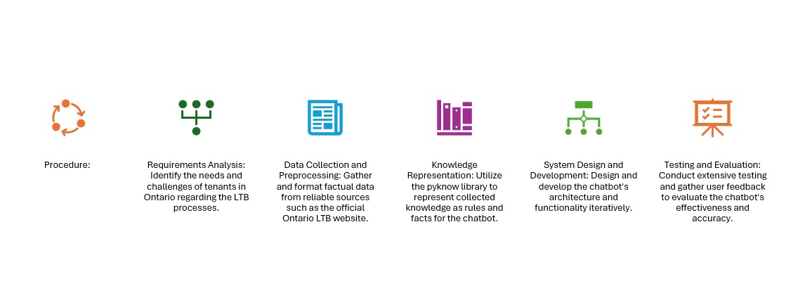

4.1. Requirement Analysis:

Conduct a thorough analysis of the requirements for the chatbot based on the target audience (tenants in Ontario), their needs, and the challenges they face in navigating the Ontario Landlord and Tenant Board (LTB) processes. Identify key functionalities and features required in the chatbot, focusing on the three core modules: Ending Tenancy, Forms, Filing, and Fees, and Contacting the LTB.

4.2. Data Collection and preprocessing:

Gather factual data and information from reliable sources, primarily the official Ontario LTB website and other relevant legal documents. Pre-process the collected data to extract relevant information and format it in a structured manner suitable for integration into the chatbot's knowledge base.

4.3. Knowledge Representation:

Utilize the pyknow library or similar tools to represent the collected knowledge and information as rules and facts within the expert system. Define rules and logical deductions to guide the chatbot's decision-making process and provide accurate and relevant guidance to users.

4.4. System Design and Development:

Design the architecture of the chatbot, including the user interface using Streamlit or similar frameworks, and the backend logic for rule execution and interaction. Develop the chatbot's functionality iteratively, focusing on one module at a time to ensure thorough testing and refinement before moving to the next.

4.5. Testing and Evaluation:

Conduct extensive testing of the chatbot's functionalities, including unit testing, integration testing, and user acceptance testing. Solicit feedback from potential users, including tenants and legal experts, to evaluate the effectiveness, usability, and accuracy of the chatbot's responses.

1. **System Architecture**

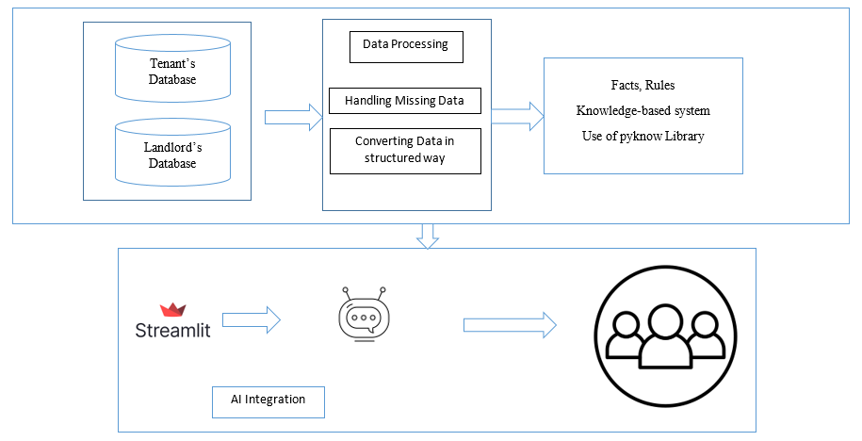

So, our system is consisting of backend and frontend using pyknow and stream-lit library respectively. First of all, the questions and answer for the tenant’s side are stored in the tenant’s database. By doing some data preprocessing will get some structured data and give it as an input for our system. For that we have defined some facts and rules which our chatbot is following.

To create a lucrative UI, we have used streamlit library, where the tenant can use it in very easy way as the UI provides easy to access features in the user interface. So, tenants are accessing the chatbot through streamlit and ask the question to the chatbot, where chatbot provides relevant responses.

1. **Implementation Details**

First, we have defined the class and all the valid variable for taking input from the user.

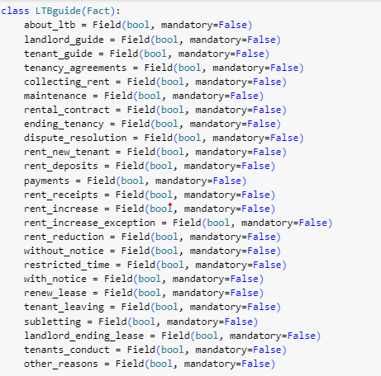

Then, we have defined the facts for each module.

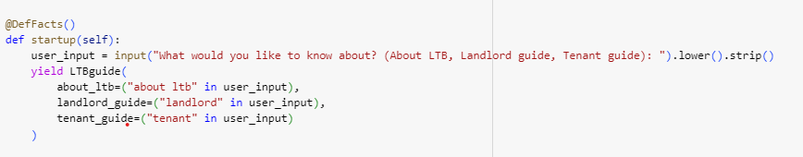

Now, we have put some conditions based on that chatbot follows the flow.

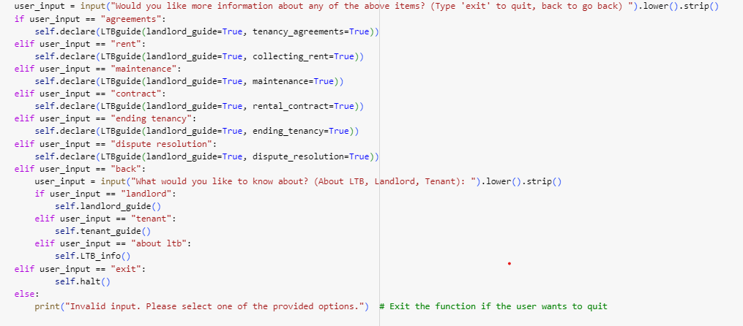

Then, we have defined some rules as follows for each module:

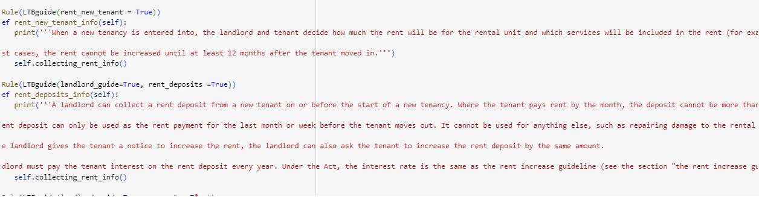

1. **Evaluation**

According to our verification and validation, we can say that our chatbot system has generated coherent and correct responses for all the questions. We have verified it manually and validated using Ontario tribunal’s official website. Also, we have tested our user interface and it is working well on local host and ready to deploy on any server.

1. **Results and Discussion**

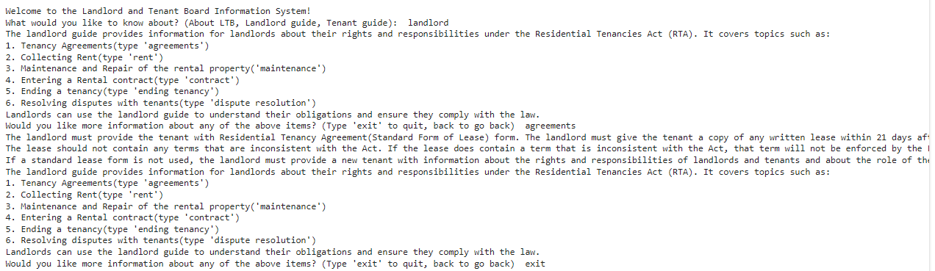

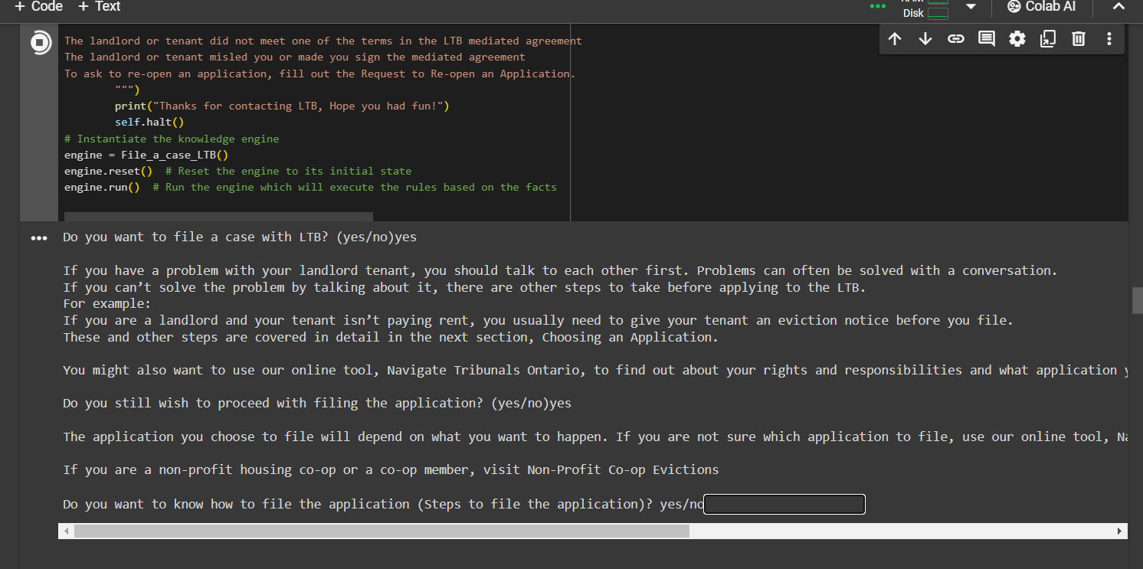

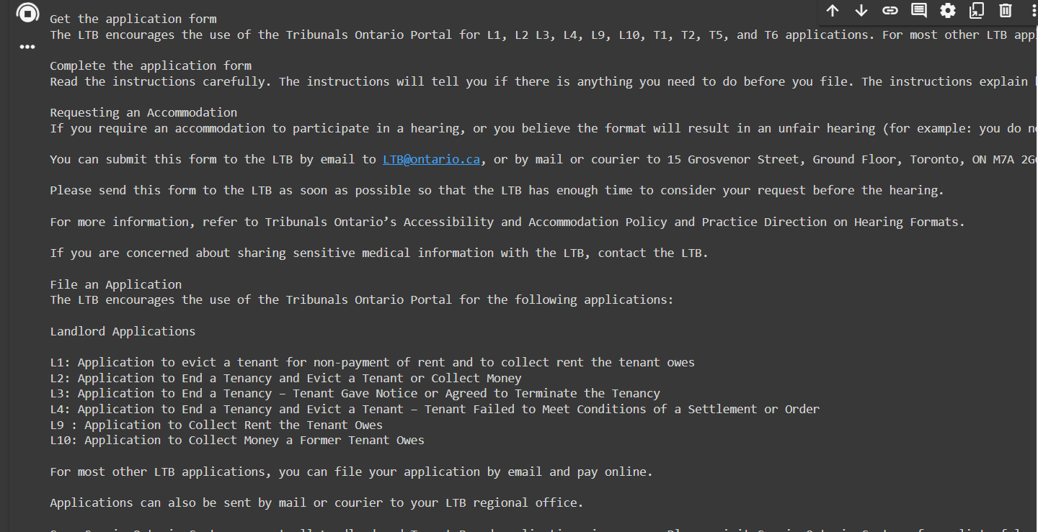

1. **Conclusion**

In conclusion, the development and implementation of the expert system chatbot represent a significant milestone in enhancing accessibility and support for tenants navigating the Ontario Landlord and Tenant Board (LTB) processes. By leveraging technology to provide tailored guidance across key modules such as Ending Tenancy, Residential Tenancy Act, Application and Hearing Process, and Contacting the LTB, the chatbot empowers tenants with the knowledge and resources needed to advocate for their rights effectively. Through its rule-based approach and integration of factual data from reliable sources, the chatbot streamlines the often-complex procedures of the LTB, ultimately fostering fairness, transparency, and efficiency within the landlord-tenant relationship. Moving forward, continuous refinement and updates to the chatbot will ensure its relevance and effectiveness in addressing the evolving needs of tenants in Ontario's rental housing market.

1. **GITHUB Link:**

**https://github.com/vijay-kathiravan/KBES**

1. **References**
2. <https://tribunalsontario.ca/ltb/>
3. <https://tribunalsontario.ca/ltb/forms/>
4. <https://tribunalsontario.ca/ltb/filing-and-fees/>
5. <https://tribunalsontario.ca/ltb/contact/>
6. https://streamlit.io/