**DAY1 : Started :-**

**linux --- top**

**nice - a program to control time usage of (access of ) cpu by a program **(important)** niceness value ranges from -20 to +19 (high pr to low pr ) shared memory - the memory shared by two or more programs**

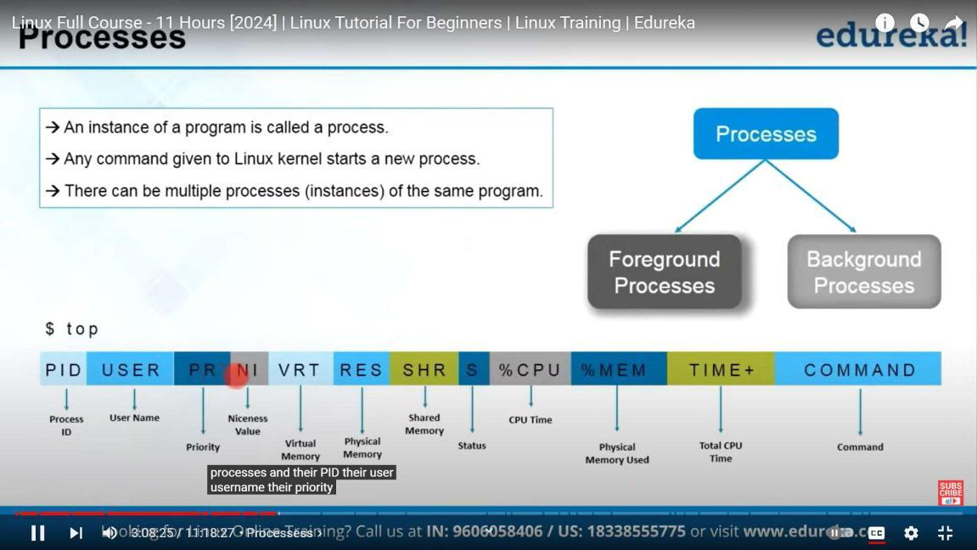

**ps and top list the process**

**ps -ax ---> list all the process**

**ps -ux ---> list the process started by current user**

**ps -ef ----> full format**

**pstree ---> hierrachy format**

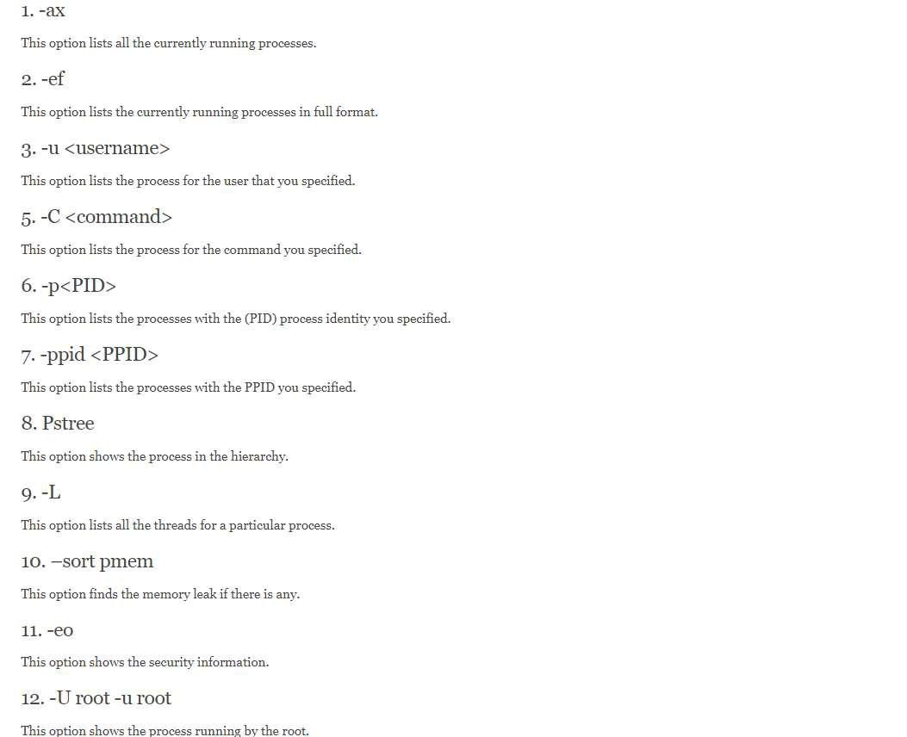

**(**NEW**) pidof - command**

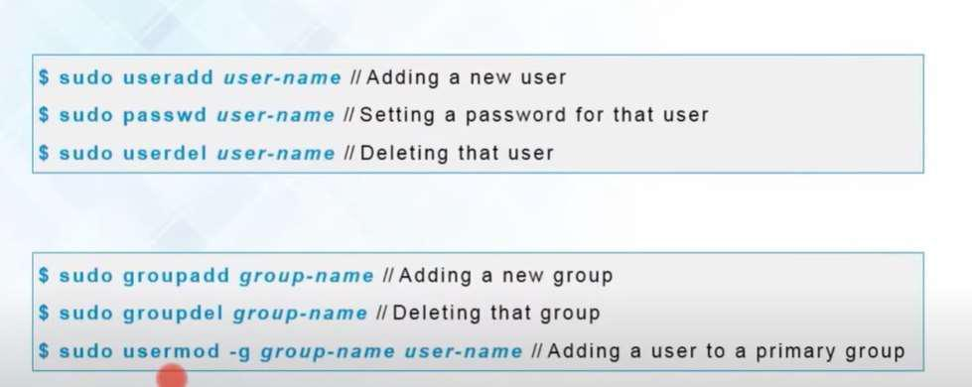

**Completed :**

**------------------------------------------------------------------------------------------------------------------------**

**DAY-2 started**

**(NEW)-ip addr show**

**(Head and tail command)**

**new commands:**

**1.tac (reverse of cat)**

**2.id andgid**

**3. comm**

**4.sed same as tr**

1. **tee used with pipe ----**
2. **uniq -remove duplicates susceeding lines**
3. **wc ---- words,lines,characters**

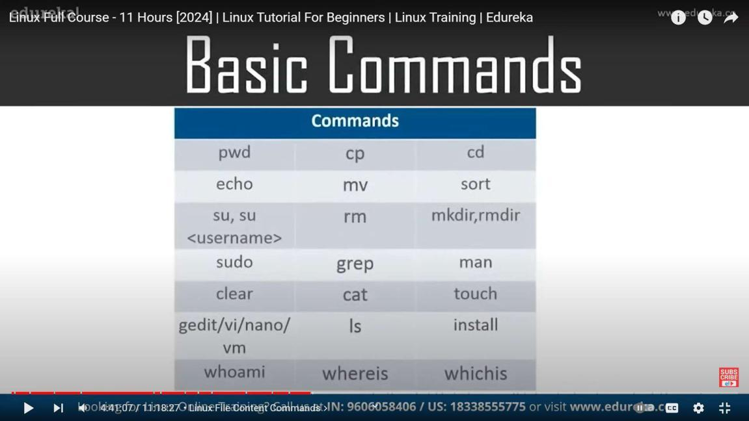

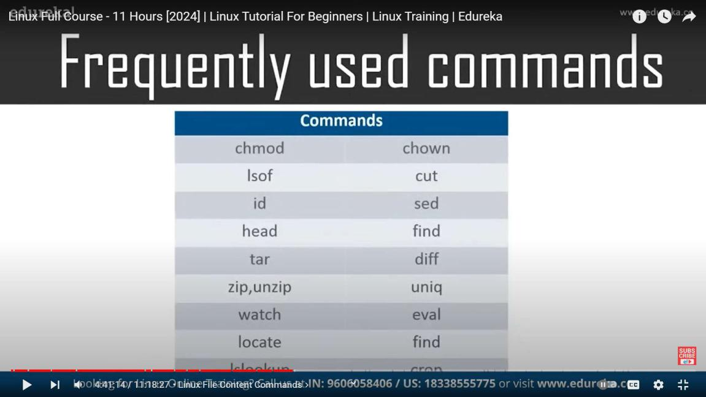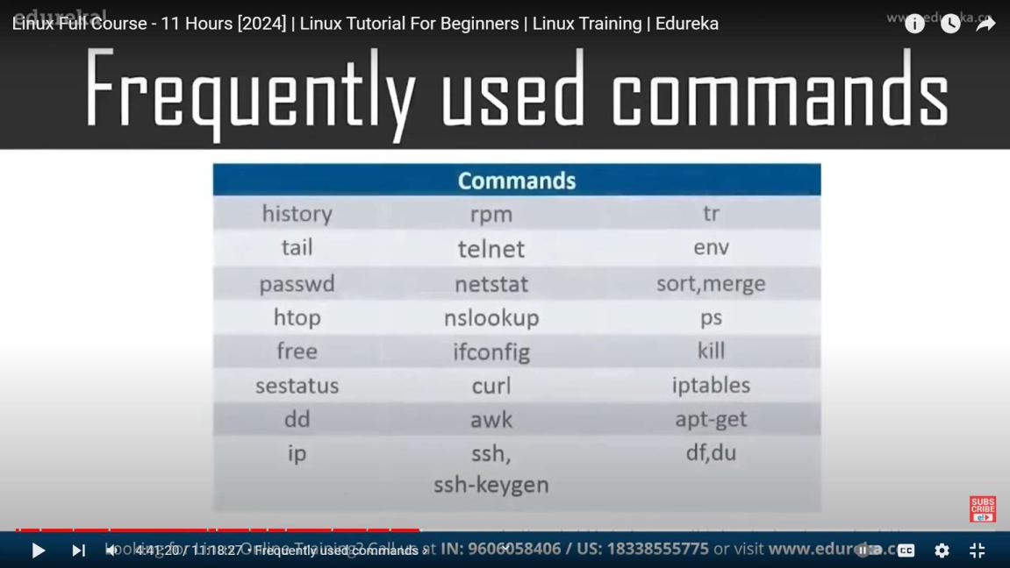

**COMPLETED**

**--------------------------------------------------------------------------------------------------------------------------------**

**DAY3: STARTED**

**different file system**

**1.ext**

**2.jfs-jounaled file system**

**3.raiserfs**

**4.xfs**

**5.swapfs**

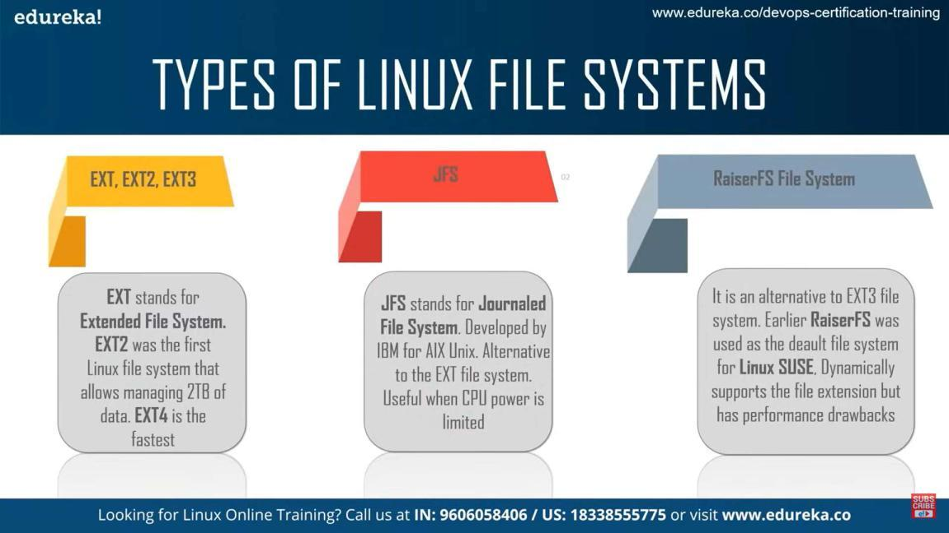

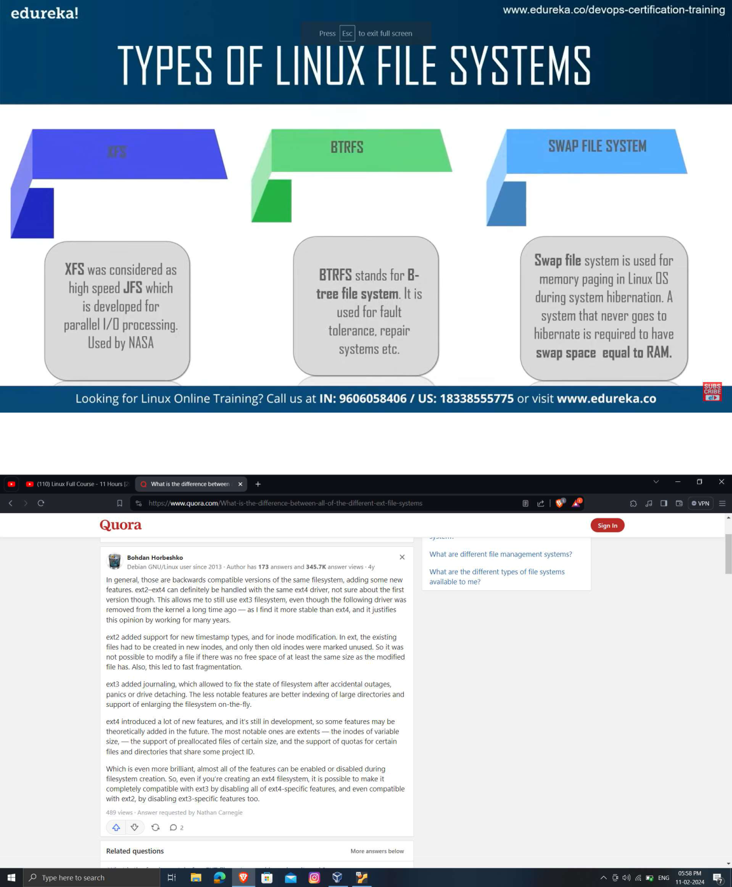

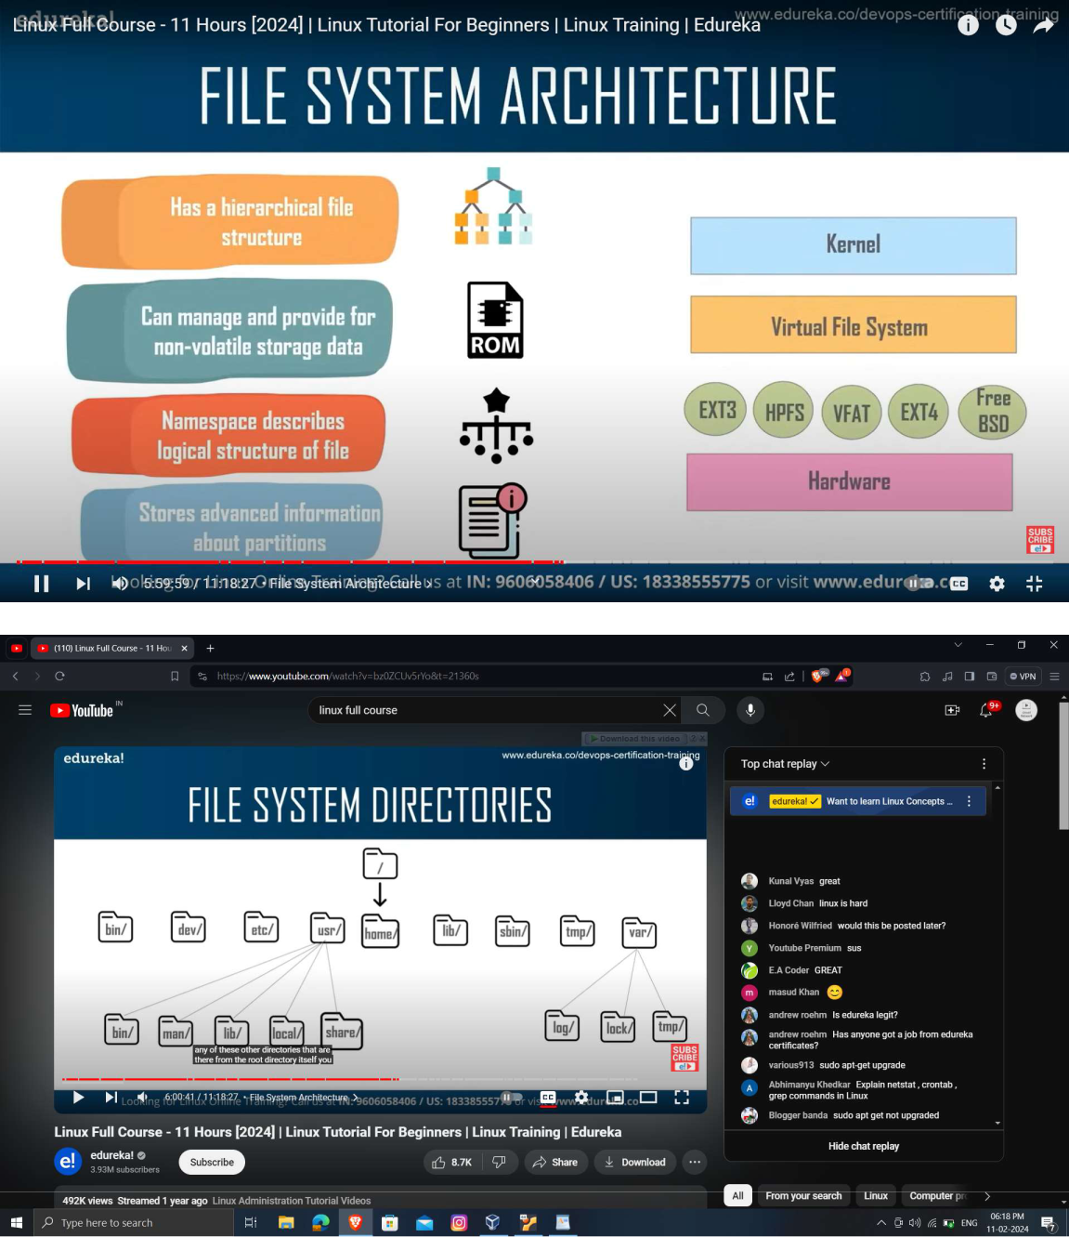

**\*\*(etc-everything to configure)\*\*** **var -log files**

**rpm -i (installing) -h-hash printing**

**-v verbose**

**-q query**

**COMPELTED**

**------------------------------------------------------------------------------------------------------------------------**

**DAY4 : Started**

**--checksig i rpm**

**rpm -qa --last(view last installed file )**

**-e remove**

**completed**

**--------------------------------------------------------------------------------------------------------------------------------**

**DAY5: Started**

**exiftool**