**A Constructive Manipulation of Facial Image Processing**

Prof.K.Narasimhan #1 and S.Vijay Palaniappan #2

Department of ECE, SASTRA University, Tirumalaisamudram 613401, India

E-Mail: 1 [knr@ece.sastra.edu](mailto:knr@ece.sastra.edu) and 2 [palanivijay25@gmail.com](mailto:palanivijay25@gmail.com)

**Abstract - The incessant consequences on the grounds of apparently failing to establish an age restricted software is quite serious. Achieving this objective gives a splendid dimension in the arena of surveillance, access control, face recognition that is requisite and at times goes hand in hand with automating customer relationship electronically. This work falls upon facial processing of images to acquire the age category and gender of the corresponding person. Most of the previous works involves strenuous methodologies. Indeed this is absolutely a tiresome and incredulous task in the offset basis. This work focuses on complying with the same objective in a relatively robust manner. This primitively works upon exploiting simple metrics from the facial image and processing them easily.**

**Index Terms - Face Recognition, Facial Processing, Facial Image.**

**1 INTRODUCTION**

The face images are the most valuable source of information. It is apparently possible to manipulate the images and get the requisite information that we do need. The processing of facial images play a significant role and find applications in fixing the societal issues with ease. We had inculcated a robust approach of estimation methodology in Matlab 2013ra software. As upon age estimation, the criterions like irises distance, distance between the end points of lips and triangle approach of constituting the irises, mouth & nose. A novel ideology is involved by computing the area of nose based rectangle of a person and computing the ratio of eyes and lip corners to figure out the gender. This work holds good in meeting the intended applications with reference to safety societal rapport.

**Samples used in the experiment**

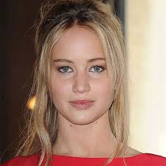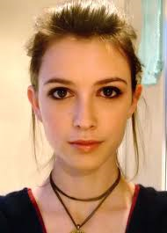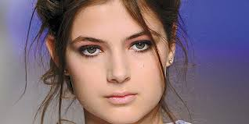

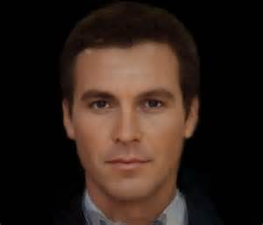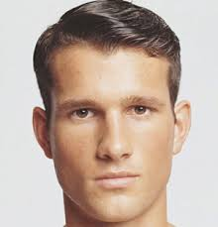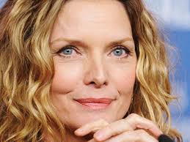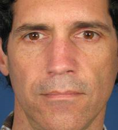

Young Ho K win and Neils da Victoria Lobo [4] did work on locating the facial features and analysing them for age estimation. Andreas Lanitis, Christina Draganova and Chris Christodoulou [10] made a comparison of the performance of various classifiers in age estimation. Thakshila and Anuja [11] worked on extracting the facial features and used Artificial Neural Networks for age classification. Kwon and Niels da Victoria [4] pioneered on the research of age classification with the discrimination of facial features. Wen-Bing Horng et al [12] extended the idea by working on gray scale images and achieved the objective. Raja and Patnaik [5] did the research with ANN classifiers and posterior class probability. Feng Gao and Haizhou Ai [6] had built an algorithm with Gabor feature and a fuzzy version of Linear Discriminant Analysis(LDA). Ramanathan and Chellappa [1] gave a clear picture of the uncontrolled change of the human faces due to age progression.

Ahonen et al [15] proposed a method of gender classification with Local Binary Pattern(LBP). Ravi and Wilson [3] did the research with the conversion of an RGB to a gray scale image and operating it. Jain et al [13] worked on Independent Component Analysis(ICA) and made the classification. Rodrigo Vershchae et al [7] made it with Adaboost and domain partitioning based classifiers. Mayo and Zhang [8] did use a couple of classifiers by working on the misaligned data and proposed a novel methodology of classification. Preeti Rai et al [2] made a significant work by doing feature extraction via wavelets and applied random transforms to enhance the accuracy levels in gender classification. Roberto Brunelli and Tomaso Poggio [14] incorporated geometric features extraction and achieved more accuracy rates.

**2 MATERIALS AND METHODS**

**2.1 Image Samples**

The FG-NET database was taken as the key source of sample images for the incorporation of the metrics unleashed. The FG-NET database constitutes many images that are intended to be used for building automated systems. Forty random images from all the categories was extracted from the database for the experiment.

As in a supplementary basis, fifty facial google images were taken as samples for consideration. The images are typical that they fall on to each category of age. They are basically colour images and made compatible with the requirements of the protocol.

In addition, ten images were captured from a digital camera to see through the optimum performance and accuracy of the proposed methodology.

**2.2 METHODOLOGY**

**2.2a Process Flow Diagram**

|  |
| --- |
| Irises Distance |
| Lip Corners Distance |
| Irises – Mouth Angle |
| Irises – Nose Tip Angle |

|  |
| --- |
| ESTIMATE AGE |

|  |
| --- |
| Face Detection |
| Histogram Equalization |
| Filtering |
| Image Resizing |

|  |
| --- |
| NN Classifier |

INPUT

IMAGE **AGE METRICS**

|  |
| --- |
| Nose Area |
| Eye – Lip Corners Ratio |

|  |
| --- |
| CLASSIFY GENDER |

**CLASSIFIER**

**PRE - PROCESSING**

**GENDER METRIC**

**2.2b Steps Involved**

**Pre-Processing**

Initially before processing the images, it is far recommended to do the pre-requisites that would make a real difference with reference to the performance. In the first place, face detection is to be done since the image might constitute a background or other objects. In order to do this, cropping was done and the requisite face image should be extracted.

Histogram normalization was done as it is the most supported step in the process. The image might be exposed to blurring or subjected to noise. Thereby filtering was done to remove such effects at once. Finally as the last step of preprocessing, image resizing is done. The suggested resizable resolution is 300 * 250 pixels which literally gives optimum results.

**Operating Facial Features**

Any work involving the processing of facial images would definitely compose feature extraction in order to do the desired operation with ease. In our work too, feature extraction happens out to be an important task.

1. **Irises Distance**

The first metric is to find the distance between the irises of the eyes. This measure is taken as a factor for the age classification.

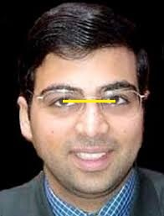

1. **Lip corners Distance**

The second metric is to compute the distance between the corners of the lip in the mouth. This could also be taken as a measure for age classification.

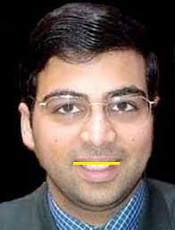

1. **Irises - Mouth Triangle**

As in the third metric, angle computation is done by considering a triangle in the facial image. The triangle is based upon the two irises and the centre of the mouth. The angle is to be measured by the side of the mouth centre in the considered triangle.

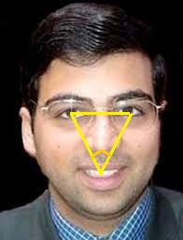

1. **Irises – Nose tip triangle**

The fourth metric is little relevant to the third metric where nose tip is to be taken as the third point of the triangle. The angle is to be measured by the side of the nose tip.

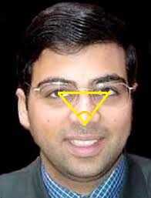

1. **Nose Area Calculation**

Nose area computation is the first metric in terms of classifying the gender. The nose was taken out to be the region of operation and boundary box should be drawn surrounding the regions of nose. The area of the boundary box should be calculated.

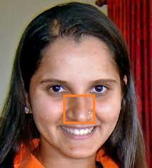

1. **EYE-LIP CORNERS RATIO**

This is the second metric to be processed in the classification of gender. The two features involved in the operation constitutes the eyes and the lip. The end points of both the lip and mouth is to be connected by a line to measure the distance between them. Then the ratio of both the computed distance measures should be calculated.

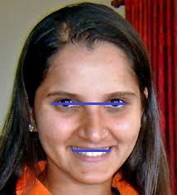

**2.2c Algorithm**

The algorithm holds well in the age classification where the persons are categorized into five categories:

|  |  |
| --- | --- |
| **CATEGORY** | **AGE RANGE** |
| Kids | Less than 18 years |
| Youth | 18 – 25 years |
| Adult | 26 – 35 years |
| Middle Age | 35 – 50 years |
| Old | Above 50 years |

The best part of it is that the metrics and easy and commendable enough to pull out a promising performance in terms of the accurate results.

The algorithm falls into the following steps:

1. After the preprocessing of the intended facial image, the first metric is to be incorporated.
2. The irises are to be located by the phenomenon of iris recognition and the distance between them is to be measured.
3. The lip corners should be located by implementing the edge detection technique and the distance between them is measured. This is taken to be the second metric of the age classification.
4. As in the third metric which includes the irises alongside with the centre of the mouth which should be identified by the detecting principle. The three points are to be to be connected to make a triangle. Then the angle is to be measured by the side of the mouth centre.
5. In the fourth metric, the triangle is formed between the irises and the tip of the nose. The angle is to be measured by the side of the nose tip.
6. The outcomes of all the four metrics is to be given to the NN Classifier for a robust estimate of age. After going through the training and testing phases of the classifier tool, the optimized output would get generated.
7. As for the gender, the first metric is to make a bounding box of the nose and compute the area of it.
8. The second metric is to compute the distance of the eye and lip corners whereby initially the features should be located by the edge detection principle. Then the ratio of the distances is to be computed and its value should be taken into consideration.
9. The outcomes of both the metrics should be given to the NN classifier and eventually a robust estimate of gender could be determined.

**2.3 Categorical Metrics Range**

**2.3a Age Classification**

|  |  |  |  |  |
| --- | --- | --- | --- | --- |
| **CATEGORY** | **IRISES DISTANCE** | **LIP CORNER DISTANCE** | **IRISES – MOUTH ANGLE** | **IRISES – NOSE TIP ANGLE** |
| Kids | 35 - 53 | 30 – 43.5 | < 44 | < 34 |
| Youth | 54 - 57 | 43.6 – 45.6 | 44 - 48 | 34 - 38 |
| Adult | 58 - 62 | 46 - 55 | 49 - 54 | 39 - 44 |
| Middle Age | 63 - 69 | 49 – 57.5 | 55 - 60 | 45 - 50 |
| Old | 70 - 100 | 57.6 - 80 | > 60 | > 50 |

**2.3b Gender Classification**

|  |  |  |
| --- | --- | --- |
| **GENDER** | **NOSE AREA** | **EYE-LIP CORNERS RATIO** |
| Male | > 120(Other Age Categories)  > 170(Old Aged) | < 1.85 |
| Female | < 120(Other Age Categories)  < 170(Old Aged) | > 1.85 |

**3 RESULTS AND DISCUSSION**

On evaluating the simple metrics incorporated in the work, the objective happens out to be pretty accurate and generates robust results. The active combination of the outcomes of the metrics make a real difference to the previously existing ideologies and protocols.

The proposed algorithm is quite simple and gives out effective results relative to any techniques explored previously. The

accuracy levels clearly depicts that the proposed algorithm works quite well and the method could be adopted to meet the requirements of fixing the societal issues.

**Performance Evaluation**

**Age Estimation**

|  |  |  |  |
| --- | --- | --- | --- |
| **CATEGORY** | **NUMBER OF SAMPLES** | **ACCURACY** | **CUMULATIVE ACCURACY** |
| Training Samples | Male – 42  Female – 48 | Male – 84.26%  Female – 82.69% | 83.5% |
| Testing Samples | Male – 7  Female – 3 | Male – 84.63%  Female – 75% | 80% |
| Total Samples | Male – 49  Female – 51 | Male – 83.32%  Female – 81.24% | 82.27% |

**Gender Estimation**

|  |  |  |  |
| --- | --- | --- | --- |
| **CATEGORY** | **NUMBER OF SAMPLES** | **ACCURACY** | **CUMULATIVE ACCURACY** |
| Training Samples | Male – 42  Female – 48 | Male – 87.42%  Female – 81.57% | 84.5% |
| Testing Samples | Male – 7  Female – 3 | Male – 86.81%  Female – 100% | 93.4% |
| Total Samples | Male – 49  Female – 51 | Male – 85.73%  Female – 84.14% | 85% |

**4 CONCLUSION**

The experiment was performed for evaluating the age and gender classification. In accordance with the experimental results, multiple metrics which are quite simplistic for the

implementation makes a huge difference in apparently producing better results. Despite being a phenomenal algorithm to achieve the objective, this work could be rather expanded in future in terms of integrating the protocol with FPGA and DSP processor.

**REFERENCES**

**[1]** N.Ramanathan and R.Chellappa, “Modelling age progression in young faces,” *in Proc. IEEE Conf. CVPR*, 2006, pp. 387–394. [online] Available: (http://ieeexplore.ieee.org/xpls/abs_all.jsp?arnumber=1640784)

**[2]** Preeti Rai and Pritee Khanna, “Gender Classification using Randon and Wavelet Transform*,” in proc. IEEE International Conference on Industrial and Information Systems*, pp. 448 – 451, 2010. [online] Available:(http://www.sersc.org/journals/IJSIP/vol4_no4/12)

**[3]** S.Ravi, S.Wilson., “Face Detection with Facial Features and Gender Classification Based On Support Vector Machine*.” in proc. IEEE International Conference on Computational Intelligence and Computing Research*, pp. 2328. 2010. [online] Available:(http://www.itfrindia.org/ICCIC/Vol2/9018ICCIC)

**[4]** Y. H. Kwon and N. d. Vitoria Lobo, “Age classification from facial images," *Comput. Vis. Image Underst.,* vol. 74, pp. 1-21, April 1999. [online] Available: (http:// dl.acm.org/citation.cfm?id=311845)

**[5]** K. B. Raja and L. M. Patnaik, “Feature extraction based face recognition, gender and age classification," *2008 International*

*Symposium on Computer Science and Computational Technology*, vol. 02, no. 01, pp. 14-23,2010. [online] Available: (http:// citeseerx.ist.psu.edu/viewdoc/summary?doi=10.1.1.163.4518)

**[6]** F. Gao and H. Ai, “Face age classification on consumer images with gabor feature and fuzzy LDA method." *In ICB, ser. Lecture Notes in Computer Science, M. Tistarelli and M. S. Nixon, Eds.,* vol. 5558. Springer, 2009, pp. 132-141. [online] Available: (http://link.springer.com/chapter/10.1007%2F978-3-642-01793-3_14)

**[7]** R. Verschae, J. R. del solar, and M. Correa, “Gender classification of faces using Ada-boost," *in Lecture Notes in Computer Science (CIARP 2006) 4225. Springer*, 2006, p. 78. [online] Available: (http://link.springer.com/chapter/10.1007%2F11892755_7)

**[8]** Mayo, M., & Zhang, E. (2008)., “Improving face gender classification by adding deliberately misaligned faces to the training data”. *Image and Vision Computing New Zealand*. [online] Available:(http://ieeexplore.ieee.org/xpls/abs_all.jsp?arnumber=4762066&tag=1)

**[9]** W. Gao and H. Ai, “Face gender classification on consumer images in a multiethnic environment," *Advances in Biometrics*, pp. 169-178, 2009. [online] Available:(http://link.springer.com/chapter/10.1007%2F978-3-642-01793-3_18)

**[10]** Andreas Lanitis, Christina Draganova and Chris Christodoulou, ”Comparing Different Classifiers for Automatic Age Estimation”, *in IEEE Transactions on Systems, Man and Cybernetics*, vol. 34, no. 01, February 2004. [online] Available:(http://ieeexplore.ieee.org/iel5/3477/28229/01262530)

**[11]** Thakshila R.Kalansuriya and Anuja T.Dharmaratne, “Facial Image Classification Based on Age and Gender”, in proc. International Conference in ICT for Emerging Regions, pp. 44-50, 2013. [online] Available: (http:// ieeexplore.ieee.org/xpl/articleDetails.jsp?reload=true&arnumber=6761153)

**[12]** W. Bing Horng, C. ping Lee, and C. wen Chen, “Classification of age groups based on facial features", *Tamkang Journal of Science and Engineering*, Vol. 4, No. 3, 2001, pp. 183-192. [online] Available: (http://www2.tku.edu.tw/~tkjse/4-3/4-3-5)

**[13]** Amit Jain, Jeffrey Huang and Shiaofen Fang., “Gender Identification Using Frontal Facial Images.” *in proc. IEEE International Conference on Pattern Recognition*, pp. 1-4, 2008. [online] Available: (http:// ieeexplore.ieee.org/iel5/10203/32544/01521613)

**[14]** R.Brunelli, T.Poggio, “HyberBF networks for gender classification”, *Proceedings DARPA image understanding workshop*, pp. 311-314. August 1995. [online] Available: (http:// citeseerx.ist.psu.edu/viewdoc/summary?doi=10.1.1.54.2814)

**[15]** T.Ahonen, A.Hadid, and M.Pietikainen, “Face Description with local binary patterns: application to face recognition.” *IEEE Transactions on Pattern Analysis and Machine Intelligence*, vol. 30, pp. 2037 – 2041, 2006. [online] Available: (http://ieeexplore.ieee.org/iel5/34/36130/01717463.pdf?arnumber=1717463)