1)Cat and tac
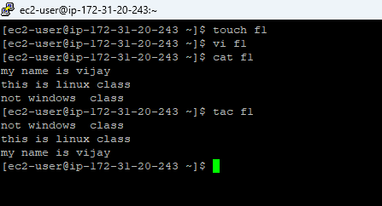
2) lsblk
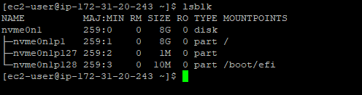

3) adding a user and providing sudo privilages
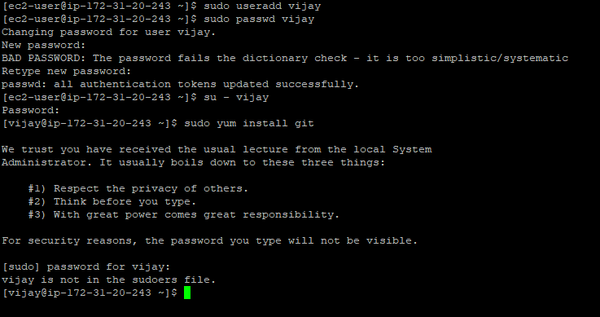
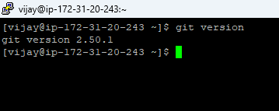

4)last and last -n 1
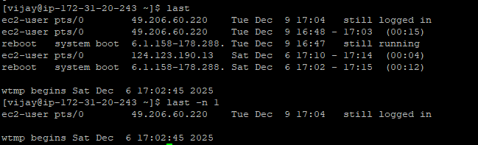

5) extending the password for 30 days
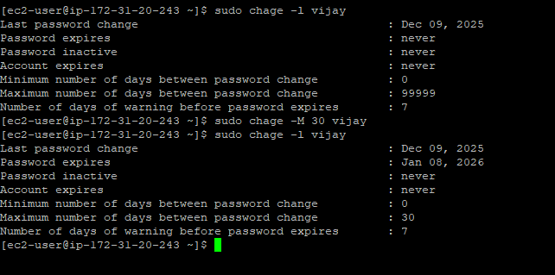

6) stickey bit: used to avoid the deletion and rename of files and directories. Generally applied on directories.
Chmod +t <directoryname>
Chmod 1777 <directoryname>

