7-Model Comparison — Train & Test Flow
How each of the 7 models is trained, tested, and scored — the exact sequence, what gets measured, and when.

Plain-Language Summary
Think of it like 7 students taking the same exam, one at a time, in a fixed order — not all at once. Each student (model) studies from the same textbook (same 17 features, same data), sits the same 5 practice rounds (5-fold cross-validation), and gets graded by the same external examiner (scikit-learn's scoring functions) so no one grades their own paper. Only once a student's full exam — study, test, grading — is completely finished does the next student begin. At the end, all 7 report cards are collected into one file.
The one nuance: while it's a given student's turn, some of them are allowed to “use both hands” internally (multiple CPU cores) to work faster — XGBoost, LightGBM, Random Forest, and CatBoost do; Logistic Regression, SVM, and KNN work with “one hand” (a single core). That's worth knowing before reading too much into the raw training-time numbers.

Technical Summary
The 7 models are NOT trained or tested in parallel with each other. They run one at a time, in a fixed order, and each model fully completes its own training + testing + scoring cycle before the next model starts. All 7 models are evaluated on identical inputs (same features, same 5-fold cross-validation splits) so the comparison is apples-to-apples.

Pictorial Flow Diagram
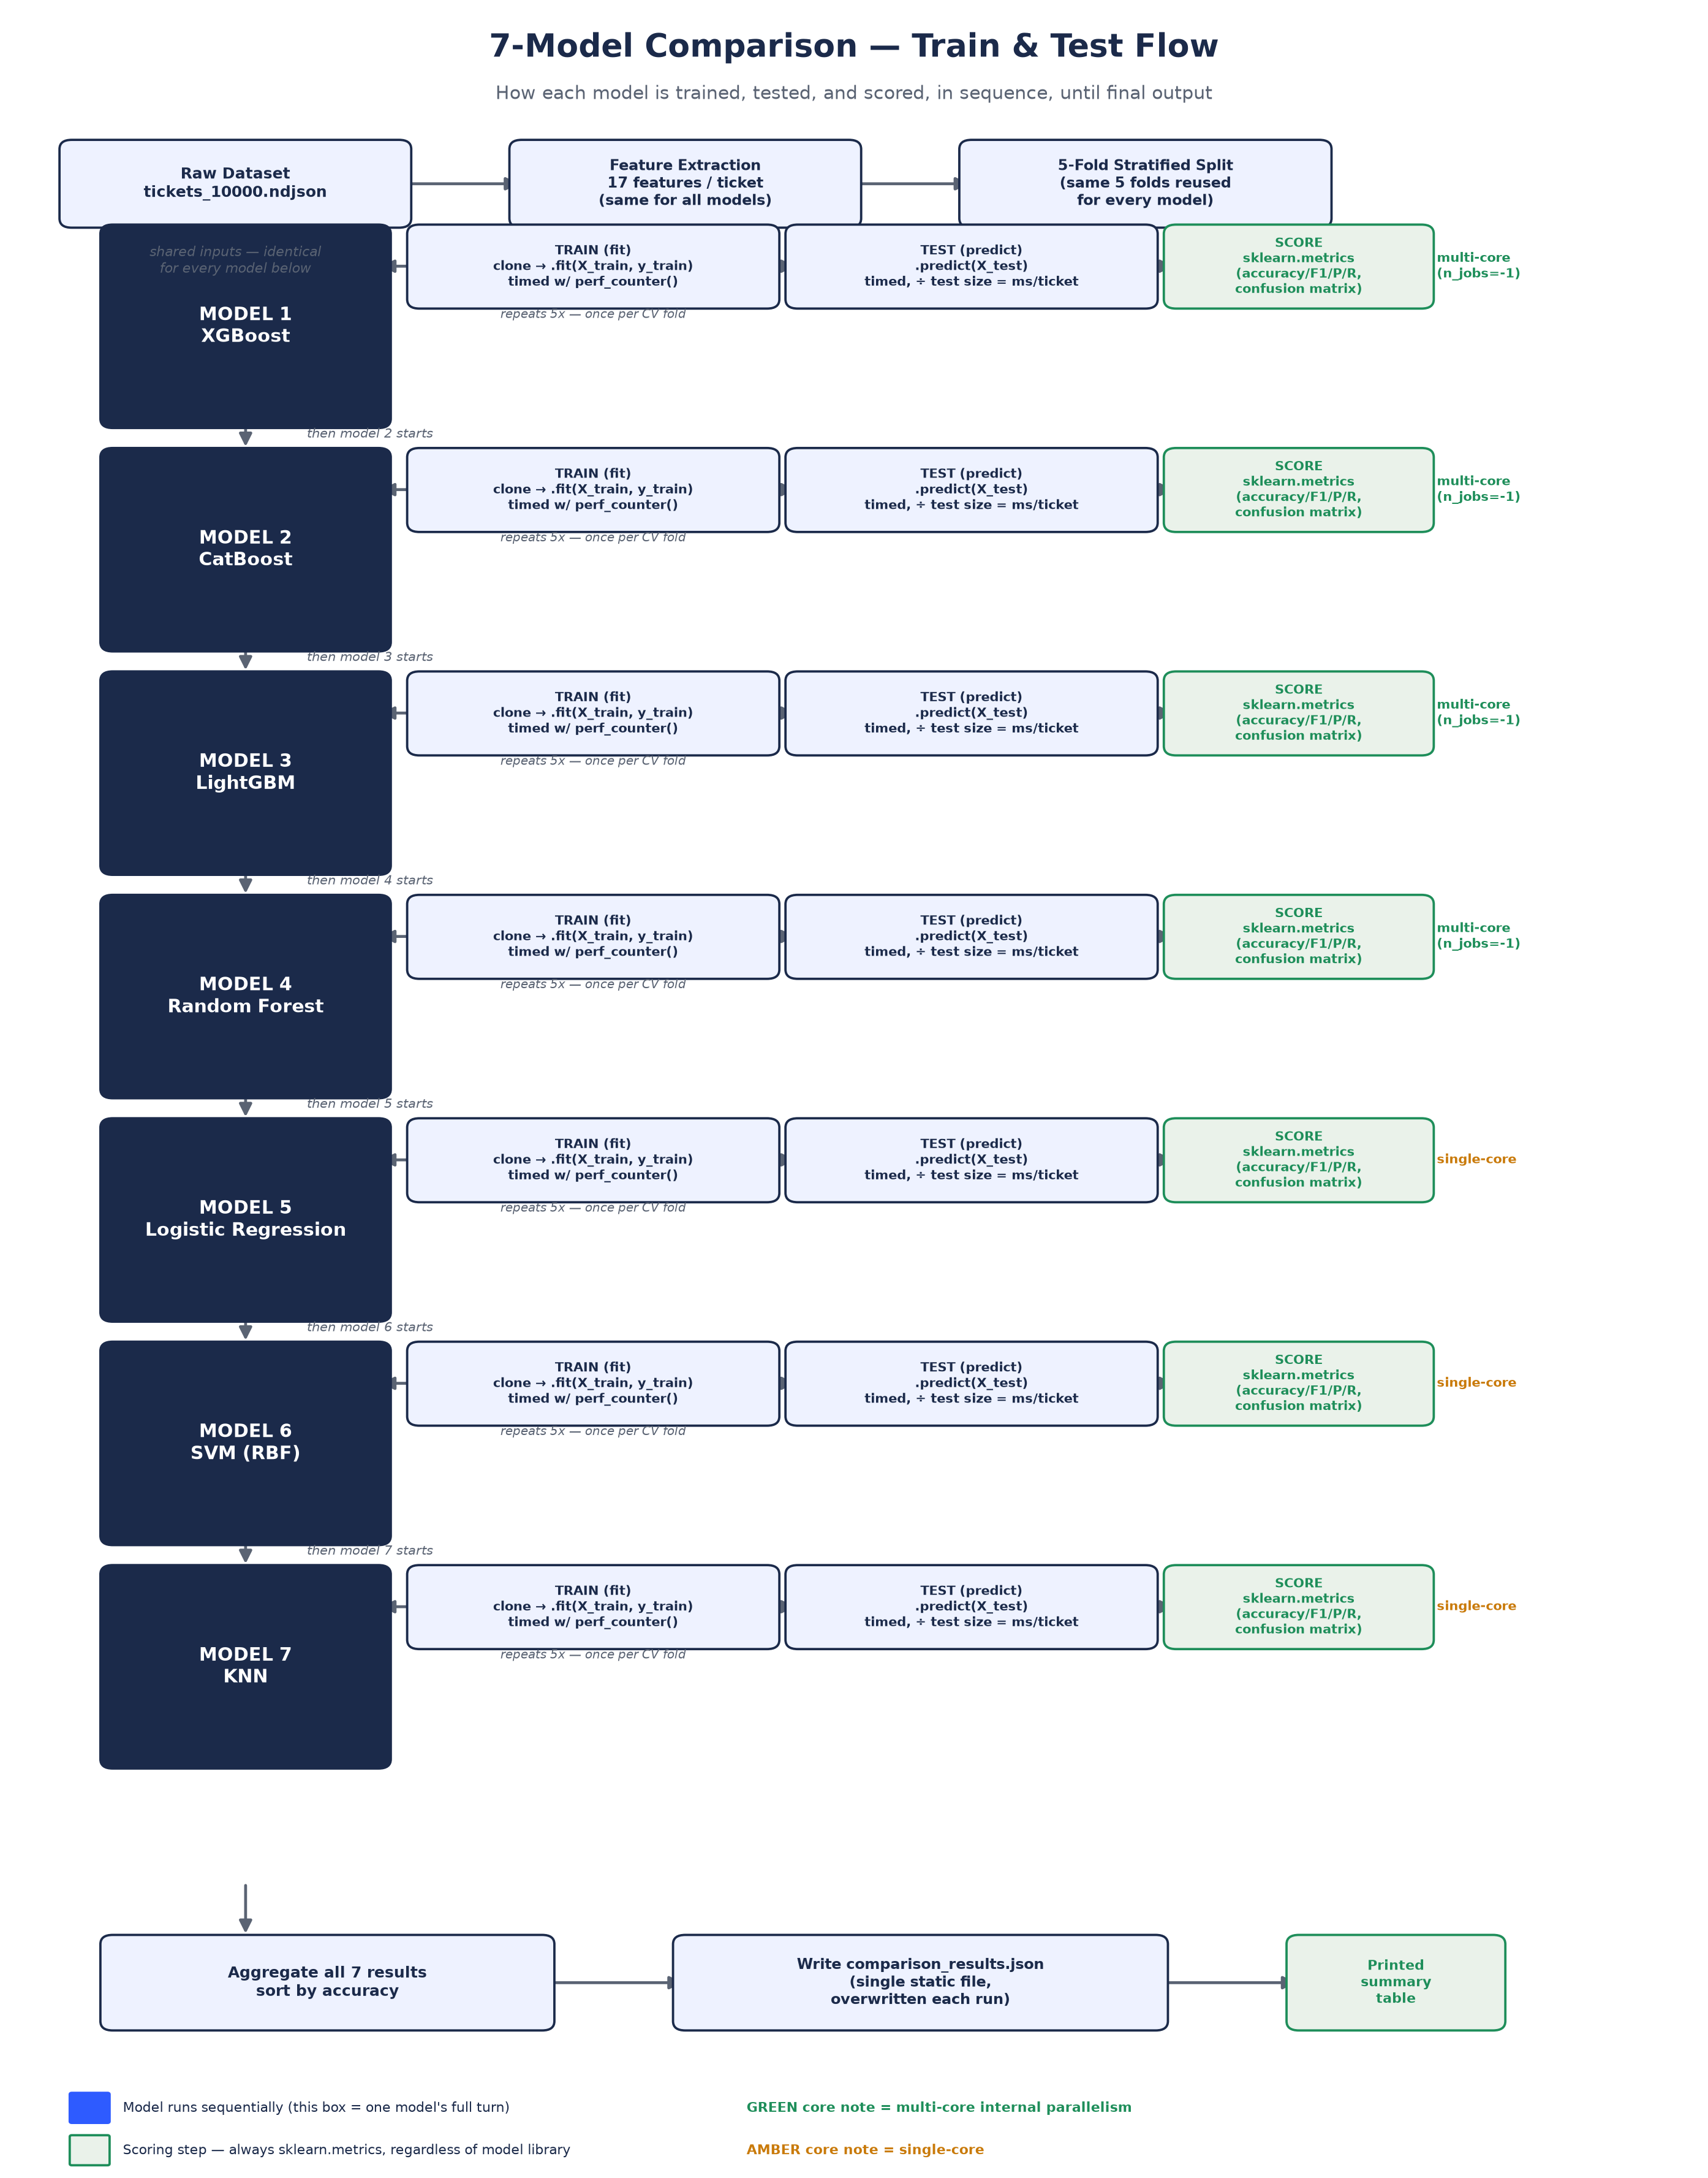

Step-by-Step Walkthrough

1. Shared setup (runs once, before any model)
IN PLAIN TERMS
Everyone gets handed the exact same study material before the exam starts — nobody's version of the data is easier or harder.
- Load the raw dataset — tickets_10000.ndjson
- Extract the same 17 engineered features for every ticket (identical for all 7 models)
- Build one 5-fold Stratified K-Fold split — the same 5 train/test partitions are reused for every model, so no model gets easier or harder data

2. Model loop (runs 7 times, sequentially)
Order: XGBoost → CatBoost → LightGBM → Random Forest → Logistic Regression → SVM (RBF) → KNN.
For each model, in that order, this happens:
- TRAIN: clone a fresh, untrained copy of the model, then call .fit(X_train, y_train) on the training fold. Wall-clock time is captured with Python's time.perf_counter().
- TEST: call .predict(X_test) on the held-out fold. Time is captured the same way, then divided by the number of test tickets to get a per-ticket inference time in milliseconds.
- This train/test step repeats 5 times — once per cross-validation fold — and the predictions from all 5 folds are pooled together.
- SCORE: the pooled predictions are passed to scikit-learn's metrics functions — precision_recall_fscore_support(average="macro") for accuracy/precision/recall/F1, and confusion_matrix() for the confusion matrix (source of TP/FP/FN/TN per class).
- Only after scoring is complete does the loop move to the next model.
WORKED EXAMPLE — XGBOOST'S TURN, CONCRETELY
Fold 1: XGBoost trains on 8,000 tickets, is tested on the other 2,000 it's never seen, and both times are stopwatched. This repeats for folds 2 through 5, each time holding out a different 2,000. By the end, XGBoost has produced a prediction for every one of the 10,000 tickets — each one made by a version of XGBoost that never trained on it — which get pooled and scored as a single set. Only then does CatBoost get its turn, starting from zero.

3. Why this works identically for XGBoost / LightGBM / CatBoost
XGBoost, LightGBM, and CatBoost are not part of scikit-learn — but each library ships its own class (XGBClassifier, LGBMClassifier, CatBoostClassifier) built to mimic scikit-learn's .fit()/.predict() interface. So the training loop calls model.fit(...) and model.predict(...) generically without needing to know which library is underneath. Once predictions come back as a plain array, scikit-learn's scoring functions take over — they only ever compare two arrays (true labels vs. predicted labels), so it makes no difference which model produced them. The one exception: CatBoost returns predictions shaped (n, 1) instead of flat (n,), so the code applies a single .ravel() step to flatten it before scoring — otherwise the accuracy calculation would silently come out wrong.
IN PLAIN TERMS
Even though XGBoost, LightGBM, and CatBoost come from three completely different companies' code, they all agreed to answer questions the same standardized way — so the same grading rubric (scikit-learn's scoring) works on all of them without needing a special version for each. CatBoost just hands back its answer sheet folded differently, so it gets unfolded (.ravel()) before grading.

4. CPU usage while each model trains
The 7 models run one after another (sequential) — but while it is a given model's turn, some of them use multiple CPU cores internally to speed up their own training:
- XGBoost, LightGBM, Random Forest — multi-core (n_jobs=-1), using all available CPU cores for that one model's fit
- CatBoost — multi-core by default
- Logistic Regression, SVM (RBF), KNN — single-core
This means training-time comparisons across models aren't perfectly apples-to-apples on a per-core basis — the boosting/forest models get a speed advantage from parallel CPU usage that the simpler models don't.
WHY RUN THE 7 MODELS SEQUENTIALLY INSTEAD OF IN PARALLEL?
Running one model at a time — rather than 7 at once — keeps the train-time and inference-time numbers trustworthy. If several models trained simultaneously, they'd compete for the same CPU cores and memory, and the timing numbers would reflect that traffic jam rather than each model's true speed. Sequential execution is slower overall, but it's what makes the “111.7ms vs 408.1ms” train-time comparisons in the results table fair and repeatable.

5. Final output
- All 7 models' results (accuracy, F1 macro, precision, recall, confusion matrix, train time, inference time, model size) are collected into one list
- Sorted by accuracy
- Written to a single static file: model_comparison/data/comparison_results.json — this file is overwritten every time the script runs; there is no history kept across runs
- A summary table is also printed to the console

Per-Model Metric Capture Reference
Same underlying mechanism for every model — only the training engine differs.
Model | Training Engine | Train/Inference Timing | Accuracy / F1 / Precision / Recall | Confusion Matrix
XGBoost | xgboost library (own backend) | time.perf_counter(), generic | sklearn.metrics.precision_recall_fscore_support | sklearn.metrics.confusion_matrix
CatBoost | catboost library (own backend) | time.perf_counter() + .ravel() fix | sklearn.metrics (same call) | sklearn.metrics (same call)
LightGBM | lightgbm library (own backend) | time.perf_counter(), generic | sklearn.metrics (same call) | sklearn.metrics (same call)
Random Forest | scikit-learn (native) | time.perf_counter(), generic | sklearn.metrics (same call) | sklearn.metrics (same call)
Logistic Regression | scikit-learn (native) | time.perf_counter(), generic | sklearn.metrics (same call) | sklearn.metrics (same call)
SVM (RBF) | scikit-learn (native) | time.perf_counter(), generic | sklearn.metrics (same call) | sklearn.metrics (same call)
KNN | scikit-learn (native) | time.perf_counter(), generic | sklearn.metrics (same call) | sklearn.metrics (same call)

Note: there is currently no time-series database, Langfuse, MLflow, or similar tool capturing these metrics over time — each run of compare.py produces a fresh snapshot that overwrites the previous one.

Why This Sequence Matters for Trusting the Results
This entire flow exists to answer one question fairly: which model actually performs best, not which one got an easier test. Because every model sees the same features, the same 5 folds, the same scoring code, and runs its full cycle in isolation before the next one starts, any difference in the final accuracy or F1-macro numbers can be attributed to the model itself — not to a stacked deck, a lucky data split, or a biased scorer. The one caveat worth remembering when comparing raw speed: some models get to use more CPU cores than others during their own turn, so train-time numbers should be read as “this model's speed under its normal operating conditions,” not a perfectly controlled hardware benchmark.

