SOC Triage AI — Full Pipeline Walkthrough
This walks through how the 7 comparison models actually train and test, and how the live pipeline's ML classifier, knowledge base, and LLM work together to land on a final verdict — with real code and pictures the whole way, including what it looks like when they agree, and when they don't.
HOW TO READ THIS DOCUMENT
Part 1 is the offline 7-model comparison — just models being trained and scored against each other, no LLM or knowledge base involved. Part 2 is the live pipeline that actually triages real tickets, where the ML classifier, the knowledge base, and the LLM all work together, and where you'll see exactly when the LLM agrees with the ML classifier and when it overrules it. One thing worth knowing upfront: these are two separate systems in the codebase — they don't talk to each other.

PART 1
7-Model Comparison — Train & Test Flow
Here's the flow again, this time with the actual code sitting right next to each step, so you can see exactly what runs — not just what it's supposed to do.

Pictorial Flow Diagram
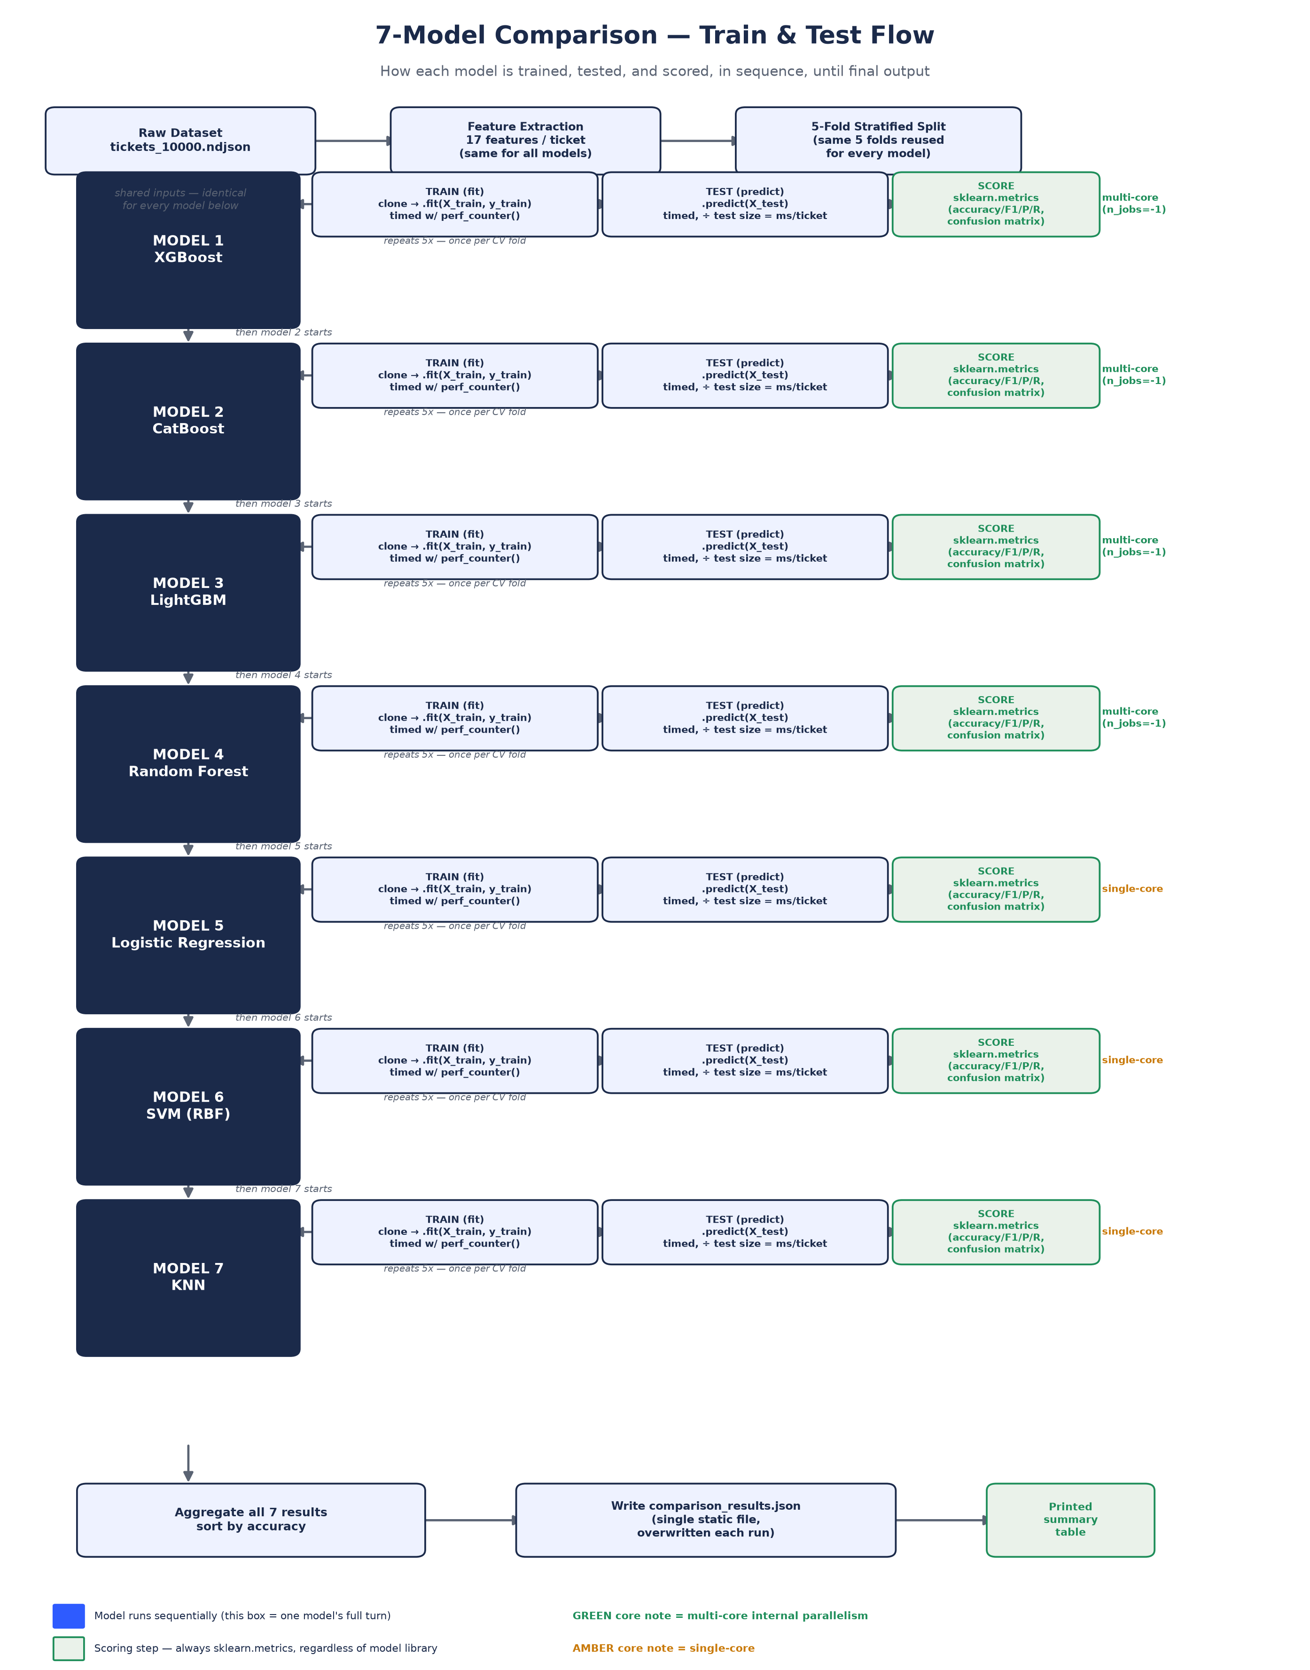

The Code Behind It

1. One fold, start to finish
This is the loop that runs 5 times per model (once per cross-validation fold). It trains on 4/5 of the data, tests on the held-out 1/5, and times both steps.
CODE — MODEL_COMPARISON/COMPARE.PY · EVALUATE_MODEL()
cv = StratifiedKFold(n_splits=5, shuffle=True, random_state=42)

for train_idx, test_idx in cv.split(X, y):
X_train, X_test = X[train_idx], X[test_idx]
y_train, y_test = y[train_idx], y[test_idx]

fold_model = clone(model) # fresh, untrained copy — no leakage between folds

# partial class-balanced sample weighting (every model except KNN)
if name not in NO_SAMPLE_WEIGHT_SUPPORT:
full_balance = compute_sample_weight("balanced", y_train)
sample_weight = 1.0 + SAMPLE_WEIGHT_POWER * (full_balance - 1.0)
fit_kwargs["sample_weight"] = sample_weight

t0 = time.perf_counter()
fold_model.fit(X_train, y_train, **fit_kwargs) # TRAIN
train_time = time.perf_counter() - t0

t0 = time.perf_counter()
y_pred = fold_model.predict(X_test) # TEST
per_ticket_ms = (time.perf_counter() - t0) / len(X_test) * 1000

y_pred = np.asarray(y_pred).ravel() # CatBoost shape fix
fold_accuracies.append((y_pred == y_test).mean())
IN PLAIN TERMS
clone(model) hands the fold a brand-new, blank copy — nobody carries over anything learned from a previous fold. sample_weight nudges the model to pay a little extra attention to the rarer verdict classes, but only a little (power=0.3), so it doesn't overcorrect. The .ravel() line exists purely because CatBoost hands back its predictions in a different shape than everyone else.

2. The sample-weight formula, isolated
CODE — MODEL_COMPARISON/MODELS.PY
SAMPLE_WEIGHT_POWER = 0.3
NO_SAMPLE_WEIGHT_SUPPORT = {"KNN"}

# full_balance = pure class-balanced weights (scikit-learn's own formula)
full_balance = compute_sample_weight("balanced", y_train)
sample_weight = 1.0 + SAMPLE_WEIGHT_POWER * (full_balance - 1.0)
IN PLAIN TERMS
0.0 would mean “ignore class imbalance completely”; 1.0 would mean “fully correct for it.” 0.3 sits close to the “ignore it” end — a light nudge, not a heavy-handed rebalancing — which is why this doesn't push the models toward overfitting on the rare classes.

3. Final scoring, after all 5 folds
CODE — MODEL_COMPARISON/COMPARE.PY · EVALUATE_MODEL() (CONTINUED)
precision, recall, f1, _ = precision_recall_fscore_support(
all_y_true, all_y_pred, average="macro", zero_division=0
)
cm = confusion_matrix(all_y_true, all_y_pred).tolist()

# fit once more on the FULL dataset just to measure realistic on-disk size
full_model = clone(model)
full_model.fit(X, y)
size_bytes = _model_size_bytes(full_model) # writes to temp file, measures, deletes
IN PLAIN TERMS
By this point every model has produced a prediction for all 10,000 tickets (pooled across the 5 folds), so precision/recall/F1/confusion-matrix are computed once, on the full pooled set — not averaged per-fold. The extra full-dataset fit at the end exists only to measure model size; that model is never saved.
PART 2
Production Pipeline — Ticket → ML → Knowledge Base → LLM → Verdict

Plain-Language Summary
Think of it as three colleagues looking at the same alert. First, a fast junior analyst (the XGBoost classifier) glances at it and gives a quick first read — true positive, false positive, or needs review — in milliseconds. While that's happening, a case-file clerk (the knowledge base) pulls the 3 most similar tickets from history and how they were resolved. Then a senior analyst (the LLM, GPT-4o-mini) reviews everything — the alert, the junior analyst's read, and the case files — and makes the call that actually goes on record. Most of the time the senior analyst agrees with the junior one and just adds the write-up. Sometimes the case files or the details change their mind, and they overrule it.
Two guardrails bookend the whole thing: one strips personal data and screens for prompt-injection attempts before anything reaches the LLM, and one double-checks the LLM's final answer is actually one of the three valid verdicts before it's allowed out.

Pictorial Flow Diagram — Part A: Ticket to LLM Triage
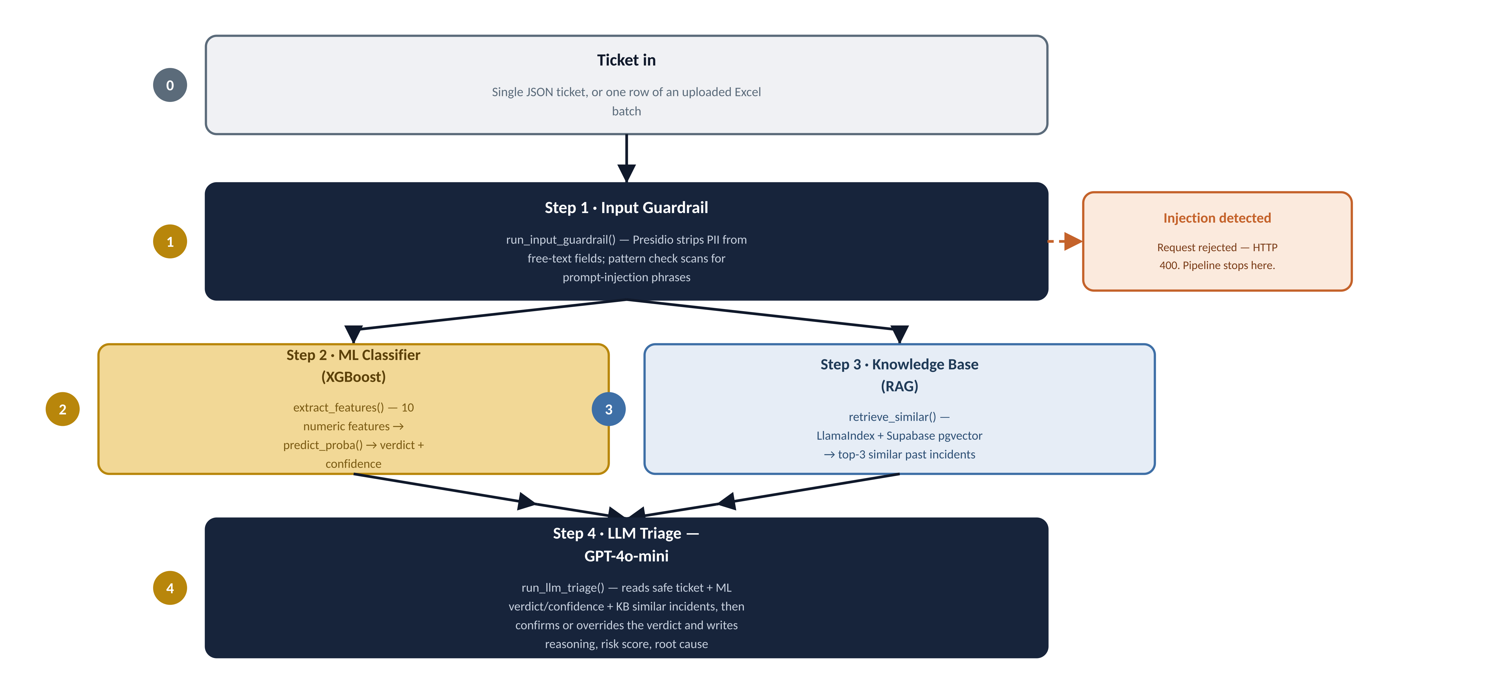

Pictorial Flow Diagram — Part B: Decision to Final Result
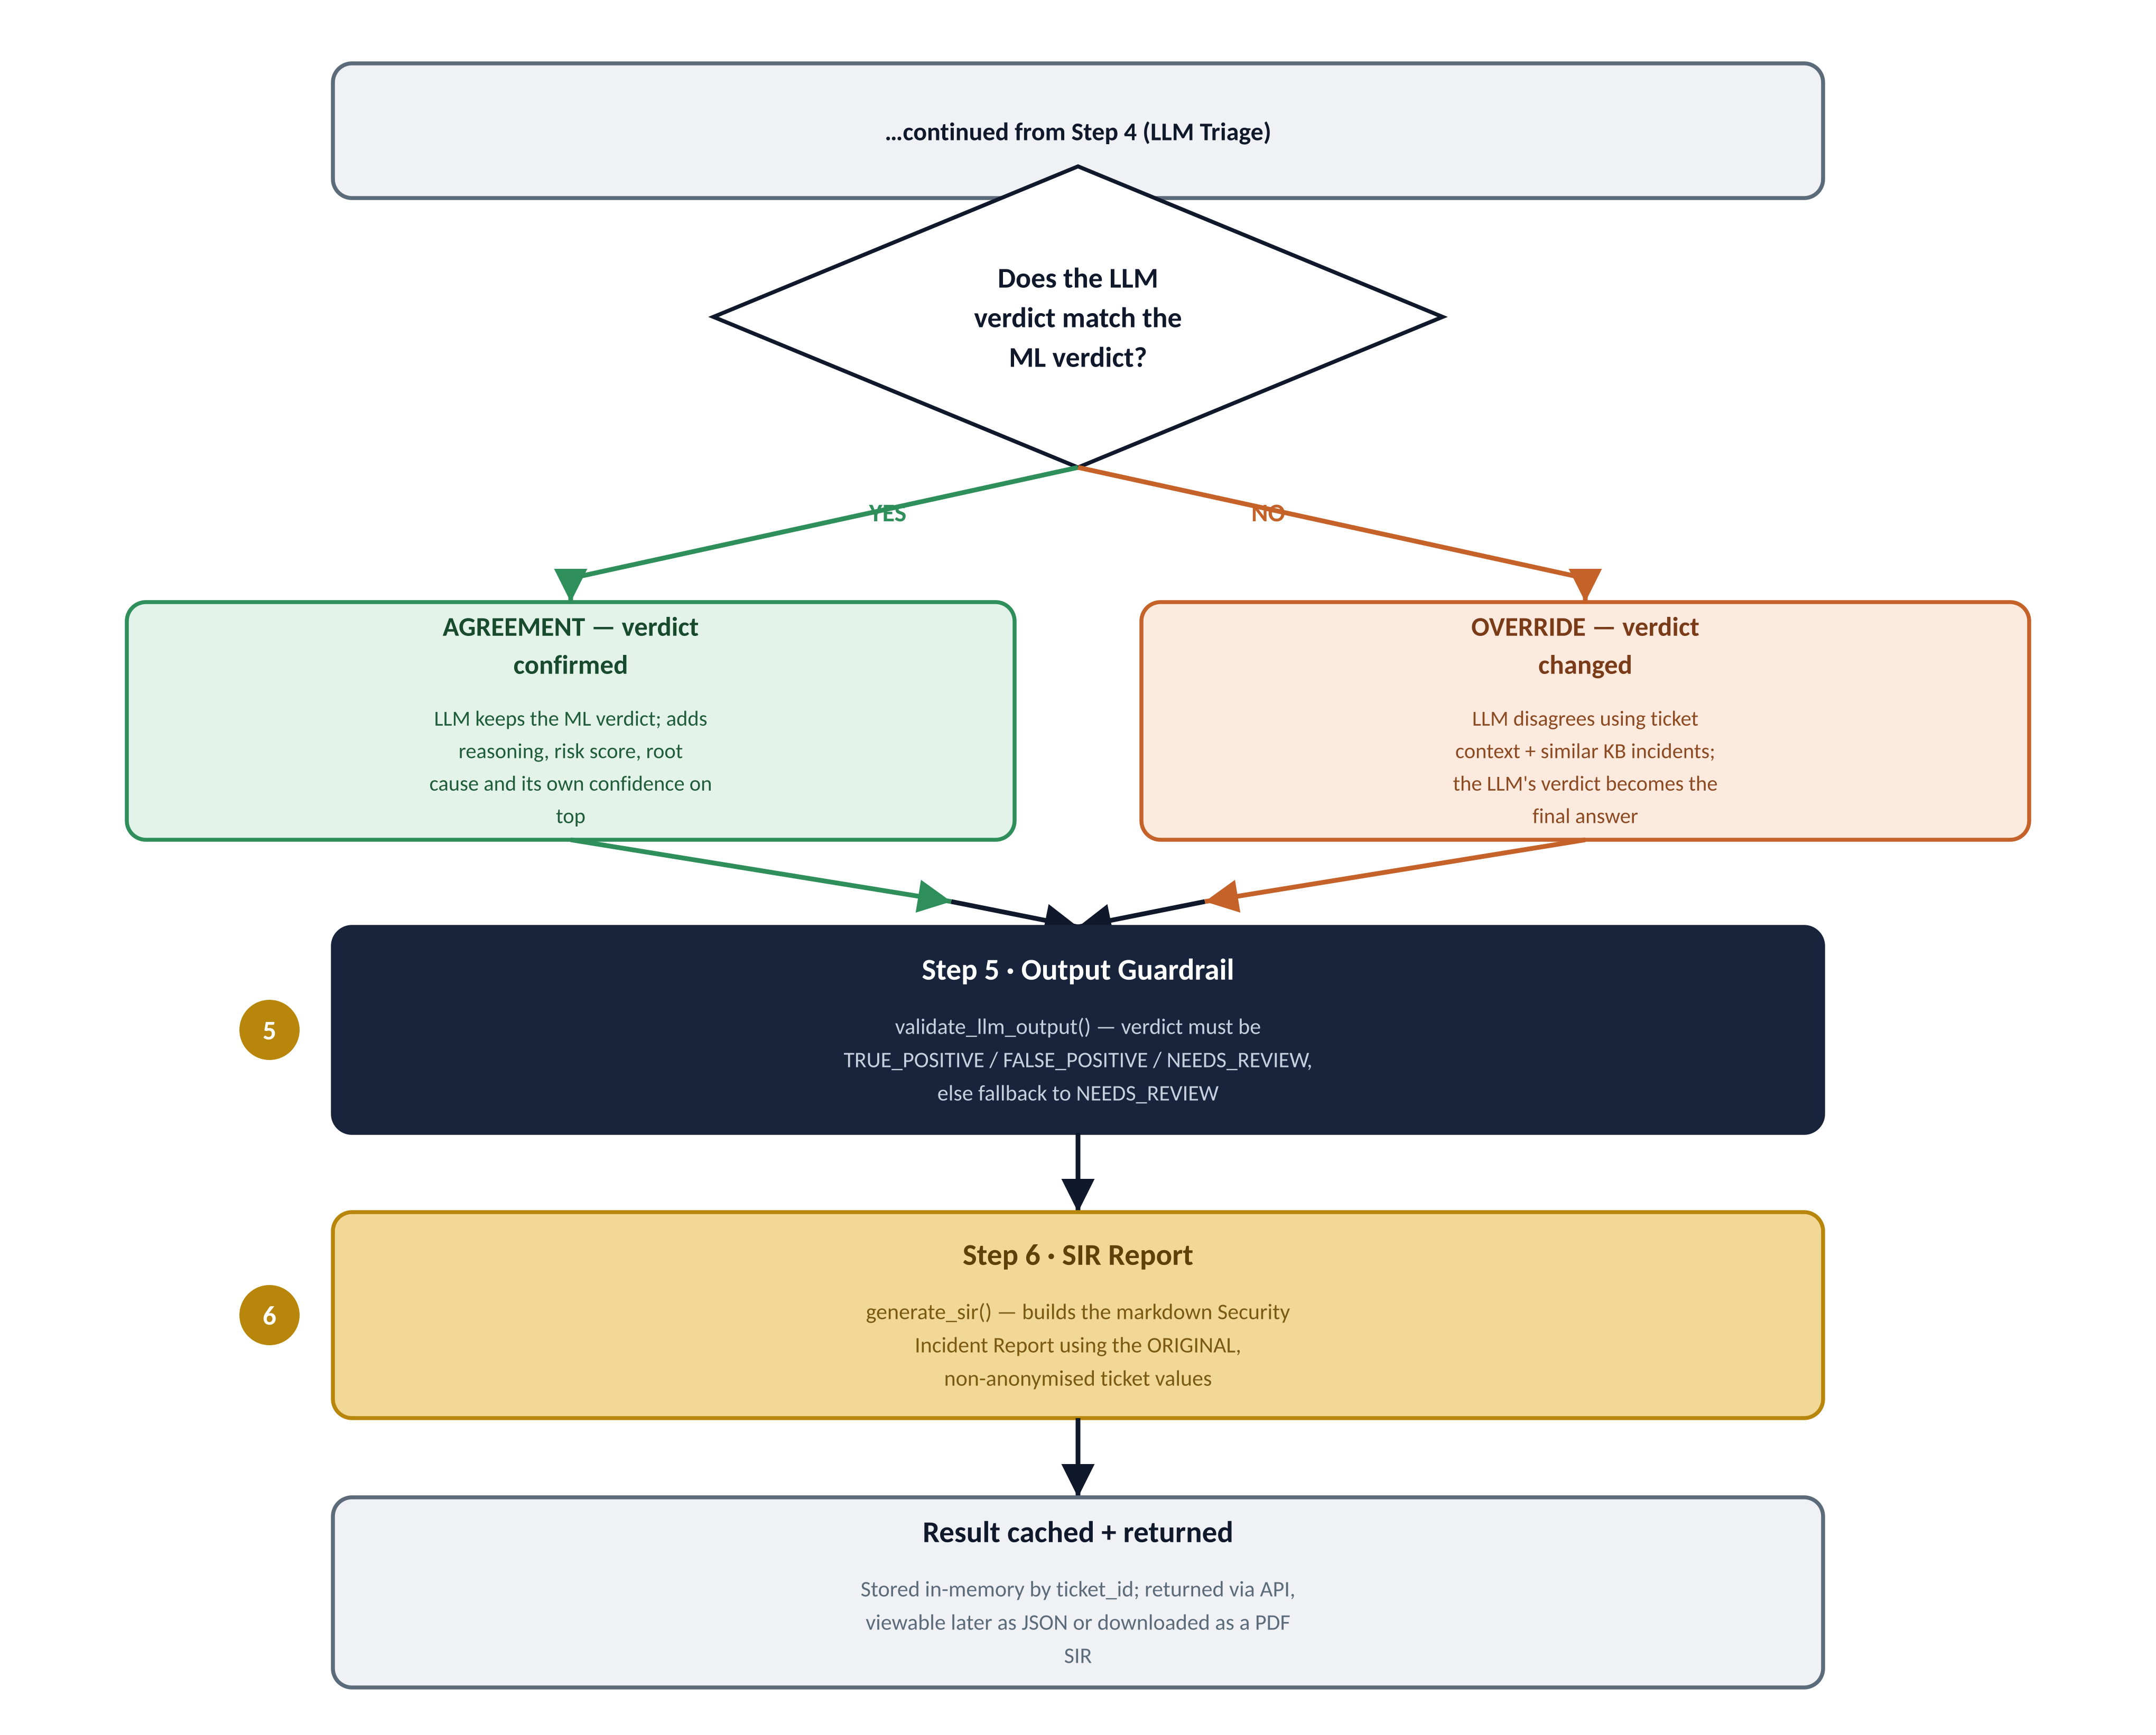

The Orchestration Code — One Function, Every Step
This single function runs for every ticket, whether it arrives as a single API call or as one row of an uploaded Excel sheet. It calls each of the 6 steps in this exact order.
CODE — BACKEND/MAIN.PY · _RUN_PIPELINE()
def _run_pipeline(ticket: TicketIn) -> dict:
# Step 1: Guardrail — PII strip + injection check
guard = run_input_guardrail(ticket)
if guard["blocked"]:
raise HTTPException(400, "blocked by input guardrail")

safe_ticket = guard["safe_ticket"]
guardrail_status = guard["guardrail_status"]

# Step 2: XGBoost classifier
ml_result = predict(ticket)

# Step 3: RAG — similar incidents from the knowledge base
ticket_text = ticket_to_text(ticket.model_dump(mode="json"))
similar = retrieve_similar(ticket_text)

# Step 4: LLM triage — confirms or overrides the ML verdict
llm_result = run_llm_triage(safe_ticket, ml_result, similar)

# Step 5: Output guardrail — validates the LLM's verdict
llm_result, output_rail_status = validate_llm_output(llm_result)
guardrail_status["nemo_output_rail"] = output_rail_status

# Step 6: SIR report — human-readable incident report
sir = generate_sir(
ticket=ticket.model_dump(mode="json"),
llm_result=llm_result, ml_result=ml_result,
similar_incidents=similar, guardrail_status=guardrail_status,
)

Step-by-Step — What Each One Actually Runs

Step 1 — Input Guardrail
Strips PII (names, IPs, etc.) from free-text fields before anything reaches an LLM, and blocks the request outright if it detects a prompt-injection attempt (phrases like “ignore previous instructions”).
CODE — BACKEND/PIPELINE/GUARDRAIL.PY
INJECTION_PATTERNS = ["ignore previous instructions", "disregard",
"you are now", "forget everything", "jailbreak",
"act as", "do anything now", "dan mode"]

def run_input_guardrail(ticket: TicketIn) -> dict:
for field_val in [ticket.command_line, ticket.decoded_command, ticket.user]:
if _check_injection(field_val):
return {"safe_ticket": None, "blocked": True, ...} # rejected, HTTP 400

safe = ticket.model_dump(mode="json")
for field in ("command_line", "decoded_command", "user", "source_ip", "target_ip"):
safe[field] = _strip_pii(str(safe.get(field, ""))) # Presidio anonymizer

return {"safe_ticket": safe, "blocked": False, ...}

Step 2 — ML Classifier (XGBoost)
Turns the ticket into 10 numeric features (severity, user type, hour of day, weekend flag, historical TP/FP counts, MITRE tactic, external IP, known-tool flag, domain-controller flag) and runs the trained XGBoost model's predict_proba().
CODE — BACKEND/PIPELINE/CLASSIFIER.PY
def predict(ticket: TicketIn) -> dict:
features = extract_features(ticket)
proba = _model.predict_proba(features)[0]
class_idx = int(proba.argmax())
confidence = float(proba[class_idx])
verdict = LABEL_NAMES.get(class_idx, "NEEDS_REVIEW")

return {"verdict": verdict, "confidence": round(confidence, 4),
"xgboost_score": round(confidence, 4)}
WORTH KNOWING
This is a DIFFERENT, smaller feature set (10 features) than the 7-model comparison harness in Part 1 (17 features). They're two separate feature-engineering pipelines living in two separate parts of the codebase — model_comparison/features.py vs. pipeline/classifier.py.

Step 3 — Knowledge Base (RAG retrieval)
Converts the ticket to a short text description, then retrieves the 3 most similar past incidents using vector similarity search (LlamaIndex + Supabase pgvector, OpenAI text-embedding-3-small). This step does not see the ML verdict — it runs off the ticket's own content.
CODE — BACKEND/PIPELINE/RAG.PY
def retrieve_similar(ticket_text: str) -> list[dict]:
if _retriever is None:
return _mock_similar_incidents(ticket_text) # deterministic fallback

nodes = _retriever.retrieve(ticket_text) # top-3, by embedding similarity
return [
{
"ticket_id": node.metadata.get("ticket_id", "UNKNOWN"),
"similarity": round(float(node.score or 0.0), 4),
"verdict": node.metadata.get("verdict", "UNKNOWN"),
}
for node in nodes
]

Step 4 — LLM Triage (GPT-4o-mini)
Receives the anonymised ticket, the ML verdict + confidence, and the 3 similar incidents. Its job, in its own system prompt: confirm or override the ML verdict, explain why in plain English, assign a risk score, and name a root cause — grounded only in what it was given, never invented.
CODE — BACKEND/PIPELINE/LLM.PY · SYSTEM_PROMPT (JOB LIST)
# Your job is to:
# 1. Confirm or override the ML verdict (TRUE_POSITIVE / FALSE_POSITIVE / NEEDS_REVIEW)
# 2. Explain your reasoning in 2-3 plain English sentences
# 3. Assign a risk score from 0-100 (0=harmless, 100=critical breach in progress)
# 4. State the single most likely root cause, grounded only in the ticket data,
# ML verdict, and similar incidents provided — never invent details
# 5. List 2-4 short contributing factors that support the root cause
# 6. Return ONLY valid JSON
CODE — BACKEND/PIPELINE/LLM.PY · RUN_LLM_TRIAGE() (THE CALL + THE RESULT)
response = client.chat.completions.create(
model="gpt-4o-mini",
messages=[{"role": "system", "content": SYSTEM_PROMPT},
{"role": "user", "content": user_msg}], # ticket + ML verdict + KB incidents
temperature=0.1,
response_format={"type": "json_object"},
)
parsed = json.loads(response.choices[0].message.content)

return {
"verdict": parsed.get("verdict", ml_result["verdict"]), # <- the LLM's call wins
"confidence": _normalise_confidence(parsed.get("confidence", ml_result["confidence"])),
"risk_score": int(parsed.get("risk_score", 50)),
"reasoning": parsed.get("reasoning", "No reasoning provided."),
"root_cause": parsed.get("root_cause", "Not determined from available data."),
"contributing_factors": parsed.get("contributing_factors", []),
}

Step 5 — Output Guardrail
A last sanity check: is the LLM's verdict actually one of the three valid values? If the LLM ever returns something malformed, the pipeline doesn't crash or pass junk downstream — it falls back to a safe NEEDS_REVIEW.
CODE — BACKEND/PIPELINE/GUARDRAIL.PY
def validate_llm_output(llm_response: dict) -> tuple[dict, str]:
valid_verdicts = {"TRUE_POSITIVE", "FALSE_POSITIVE", "NEEDS_REVIEW"}
verdict = llm_response.get("verdict", "")

if verdict not in valid_verdicts:
fallback = {"verdict": "NEEDS_REVIEW", "confidence": 0.5, "risk_score": 50,
"reasoning": "LLM output guardrail triggered — verdict was invalid."}
return fallback, "BLOCKED"

return llm_response, "PASSED"

Step 6 — SIR Report
Builds a full markdown Security Incident Report — using the ORIGINAL, non-anonymised ticket values (the guardrail's anonymised copy was only ever for the LLM's eyes) — including the ML verdict, the KB's similar incidents, and the LLM's final reasoning, side by side.

When the ML Verdict and the LLM Verdict Agree — and When They Don't
The whole point of Step 4 is that the LLM doesn't just rubber-stamp the ML classifier. It has its own vote, informed by richer context (the actual ticket details, plus real historical precedent from the knowledge base) than the 10 numeric features XGBoost sees. Two things can happen:
- AGREEMENT — the LLM's verdict matches the ML classifier's verdict. The ML call stands; the LLM adds reasoning, a risk score, and a root cause on top of it.
- OVERRIDE — the LLM's verdict differs from the ML classifier's verdict. The LLM's call becomes the final answer that gets reported, escalated, or auto-closed — not the ML classifier's.

Worked Example — Both Cases, Side by Side
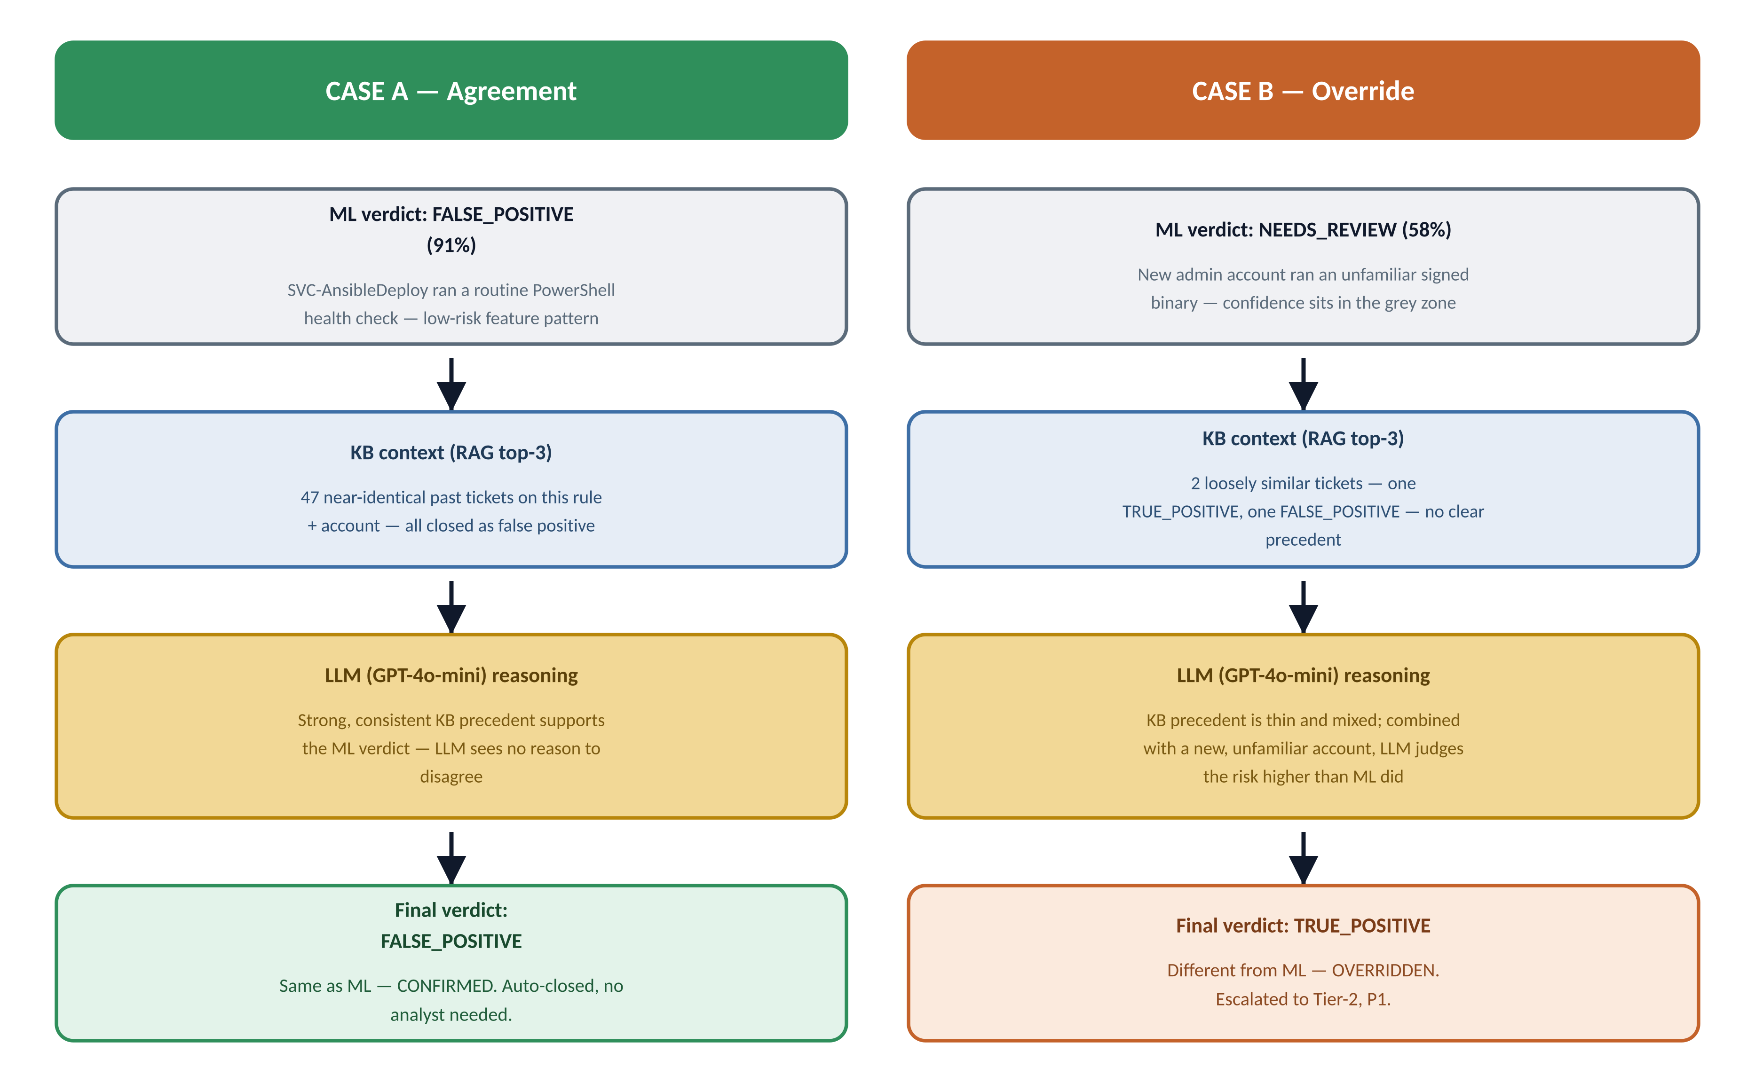

Where This Shows Up in the Code
The final result dict that gets returned to the API always takes its verdict field from the LLM's result — never from the ML result directly. The ML classifier's own call is kept alongside it, under a different key, purely so the two can be compared:
CODE — BACKEND/MAIN.PY · _RUN_PIPELINE() (BUILDING THE RESPONSE)
result = {
"ticket_id": ticket.ticket_id,
"verdict": llm_result["verdict"], # <- FINAL answer: always the LLM's call
"confidence": llm_result["confidence"],
"xgboost_score": ml_result.get("xgboost_score", ml_result["confidence"]), # ML's original call, kept for comparison
"llm_reasoning": llm_result["reasoning"],
"root_cause": llm_result.get("root_cause", ""),
"risk_score": llm_result["risk_score"],
...
}
IN PLAIN TERMS
There is no separate “agreed” flag stored anywhere in the code — agreement vs. override is something you can only see by comparing the two fields yourself: was llm_result["verdict"] the same as ml_result["verdict"], or different? The pipeline always trusts the LLM's final word, but keeps the ML's original opinion visible right next to it, in every stored result and every SIR report, so nothing is hidden.

Guardrail Status — What Gets Recorded Either Way
Every single ticket, whether the ML and LLM agree or not, carries a 3-part guardrail status in its result and SIR report:
Rail | What it checks | Typical values
presidio_pii_scan | Was any PII found and redacted in free-text fields before the LLM saw them? | PASSED / REDACTED
nemo_input_rail | Did any field contain a prompt-injection pattern? | PASSED / BLOCKED (ticket rejected, HTTP 400)
nemo_output_rail | Was the LLM's returned verdict one of the 3 valid values? | PASSED / BLOCKED (falls back to NEEDS_REVIEW)

Why This Design Matters
Each layer covers a different weakness. XGBoost is fast and consistent but only ever sees 10 numbers — it has no idea what happened on similar tickets before, and it can't explain itself in words. The knowledge base adds institutional memory — what actually happened last time something like this came in — without which even a very confident ML verdict might be repeating an old mistake. The LLM is the one piece that can weigh all of that together in context and write a human-readable justification, which is also the one place a second opinion can catch something the classifier's narrow feature set missed. The two guardrails exist so that neither end of this chain is a blind spot: nothing sensitive reaches the LLM unfiltered, and nothing malformed leaves it unfiltered either.

