**Download and install the compatible Node.js version:**

Visit the Node.js website (<https://nodejs.org/en/download/>) and download the installer for your operating system and architecture.

**Verify the Node.js version:**

* Open a new terminal or command prompt and run *node -v*. You should see the newly installed Node.js version.

**Install Cypress globally:**

* Open your terminal or command prompt.
* Type the following command:Bash

**npm install -g cypress**

**Install Cypress locally:**

You can also install Cypress locally for a specific project by running **npm install cypress --save-dev** in your project's directory.

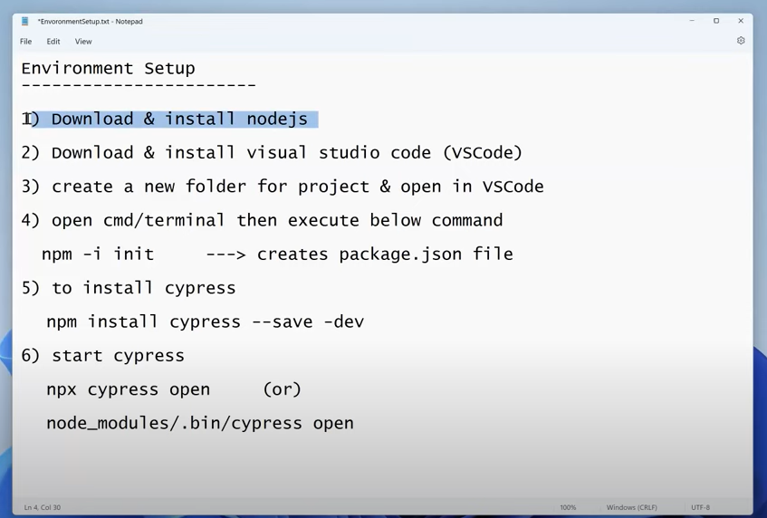

**Different comment used to run the project :**

* Npx cypress open
* Npx cypress run
* Npx cypress run –headed