**GROUP CHAT ASSIGNMENT**

DATABASE ARCHITECTURE:

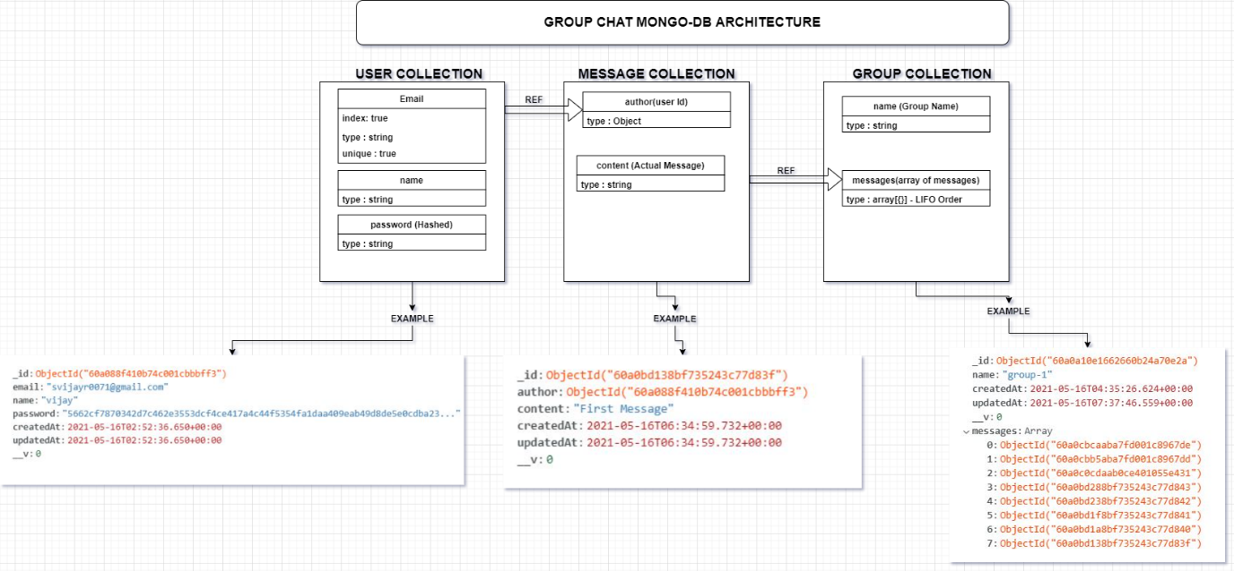

HEROKU URL : <https://yellow-class-assignment.herokuapp.com>

POSTMAN API DOCUMENTATION WITH RESPONSE : [POSTMAN API](https://documenter.getpostman.com/view/13994938/TzRX7jrc)

TECH STACK :

1. NODE.JS

2. TypeScript

3. JWT - jsonwebtoken

4. Express.js

5. Mongo DB – Atlas (AWS ap-south-1 shared cluster)-free

6. Universal Error Handling.

7.Pagination for getting all groups.

8.Graph like retrieve using mongo DB $lookup aggregation pipeline.

9. Clean and maintainable code.

10. Password Hashing.

11. Node - 15.9.0

12. Session inside cookie based authentication.

13. Tools – Git, Postman, WebStorm

Dependencies:

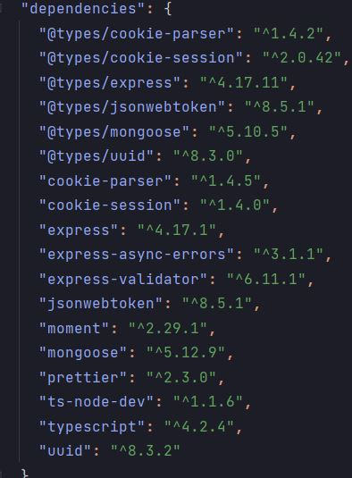

FILE STRUCTURE:

