**Ex. No: 9 - 15 PL/SQL QUERIES**

**Date: 08-03-2022 - RA1911003010764**

**AIM:**

To write the SQL queries such as PL SQL Functions & Triggers to execute PL/SQL queries in SQL.

**OUTPUT:**

**Write a PL/SQL coding for addition of two numbers.**

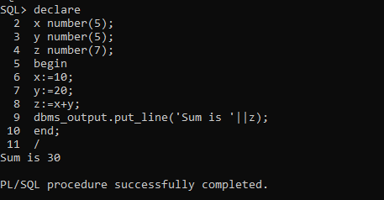

**Using PL/ SQL general syntax for if condition, declare two variables b and c and print which among them is maximum.**

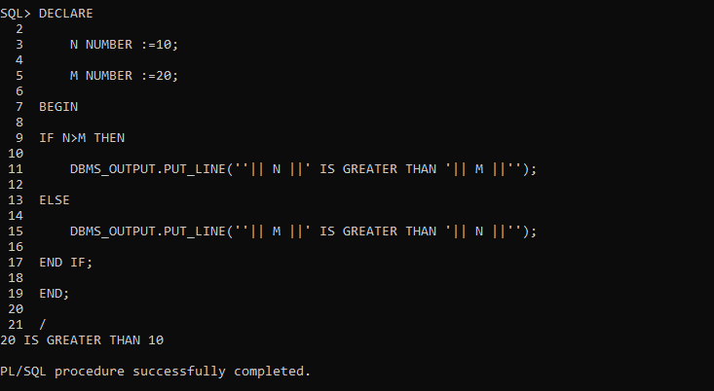

**Using, PL/ SQL general syntax for if and else condition, get a number and print if it is less than 5 or greater than 5.**

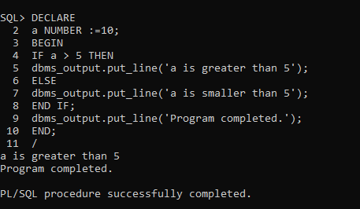

**Using, PL/ SQL general syntax for nested if, get three numbers as input and print which is maximum.**

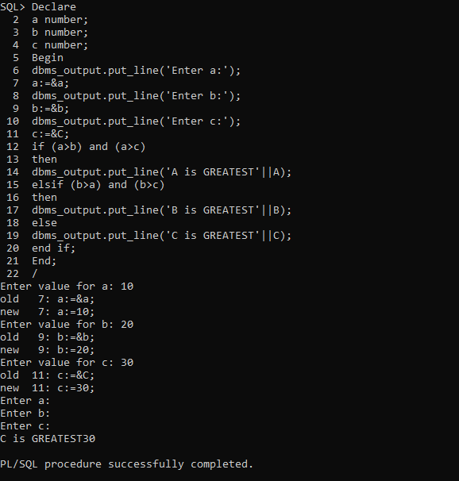

**Using, PL/ SQL general syntax for looping statement (while), find the sum of ODD NUMBERS till a given value and print it.**

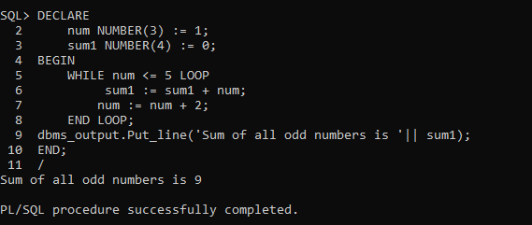

**TRIGGER**

**7.a. TRIGGER AFTER UPDATE.**

**Create a table emp with empno,name,income,basicpay,hra;**

**Using TRIGGER AFTER UPDATE,**

**IF UPDATING THEN print, 'TABLE IS UPDATED';**

**ELSIF INSERTING THEN print 'TABLE IS INSERTED';**

**ELSIF DELETING THEN print 'TABLE IS DELETED';**

**7b. Perform the above using TRIGGER BEFORE UPDATE.**

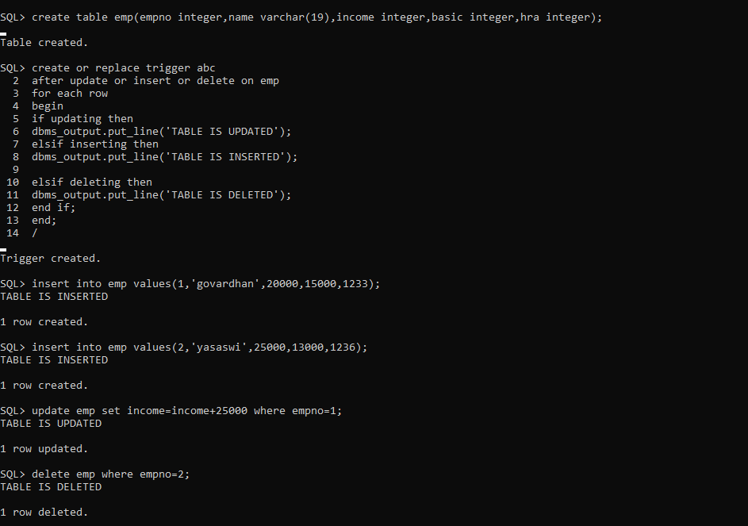

**Write a procedure using positional parameters.**

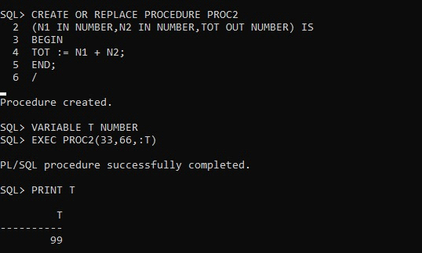

**Write a procedure using notational parameters.**

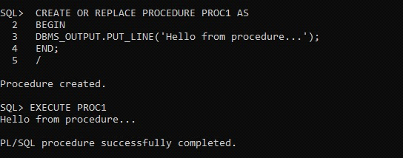

**Find the factorial of a number using function.**

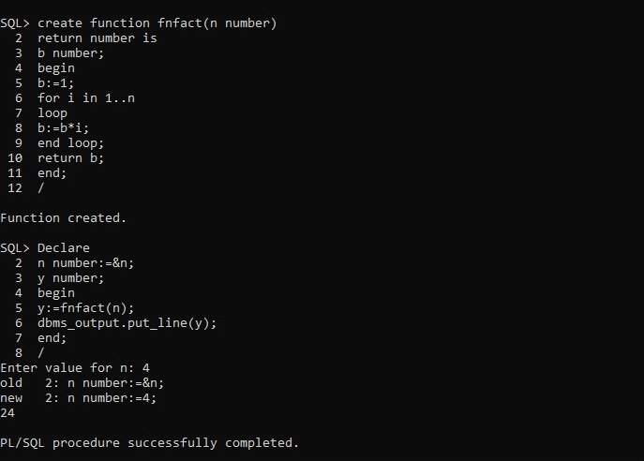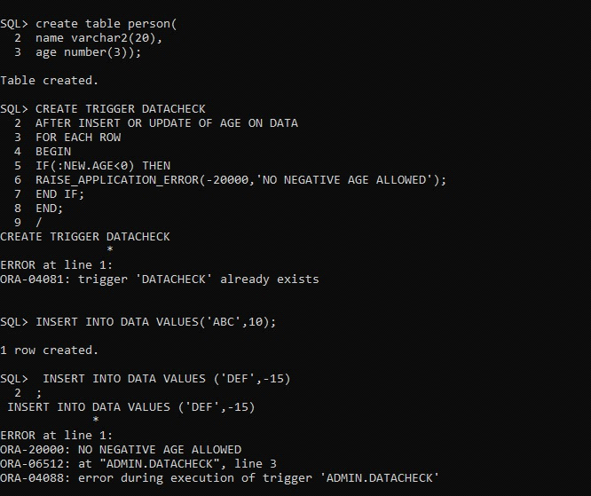

**7c. Create table person as:**

**NAME AGE**

**abc 15**

**xyz -12**

**create table person(**

**name varchar2(20),**

**name number(3));**

**Create a Trigger to check the age valid or not Using Message Alert.**

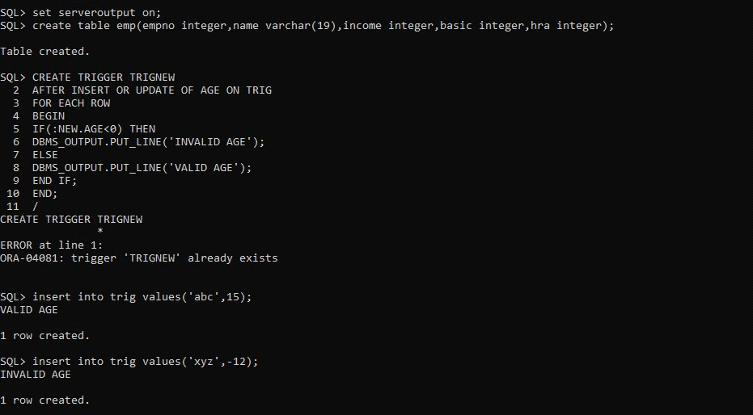

**PL SQL FUNCTIONS:**

**Write a pl/sql function program that finds the total sum of salary of customers whose salary is greater than 4000.00**

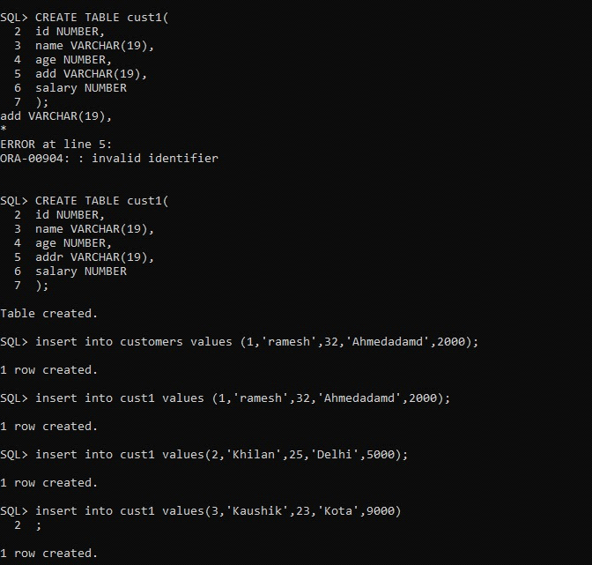

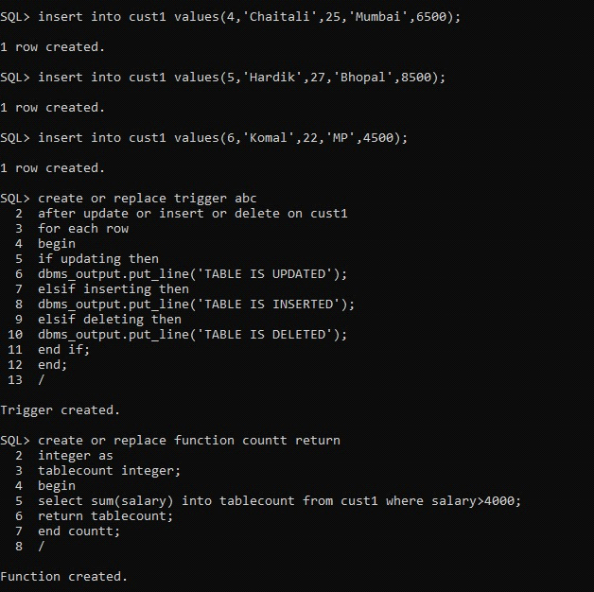

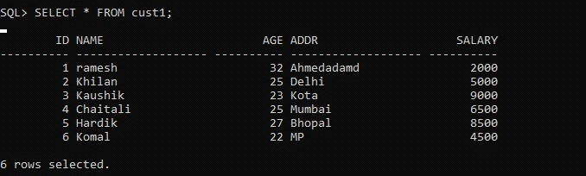

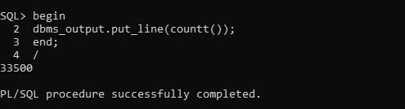

**Write a pl/sql function program to calculate the sum of first natural numbers**

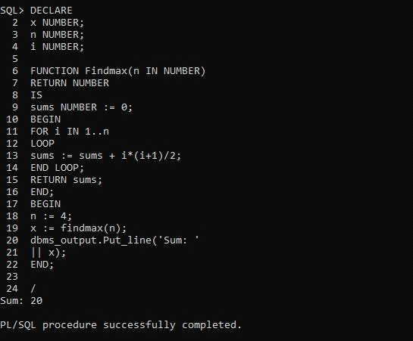

**PL SQL TRIGGERS:**

**1. Create a row-level trigger for the EMPLOYEE table that would get**

**executed by the DML statement like UPDATE OR INSERT on that**

**table.**

**2. The trigger will compute and show the SALARY difference between**

**current and previous values.(Hint: previous salary: , current**

**salary: , salary difference: )**

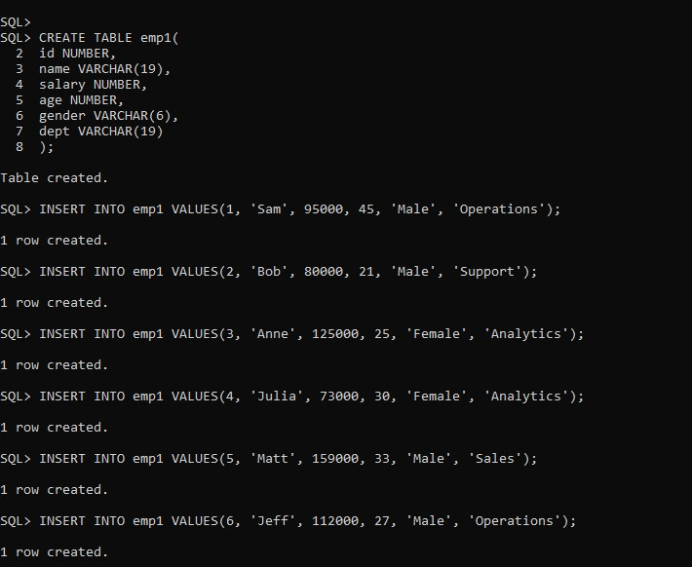

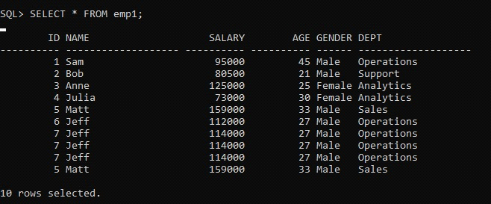

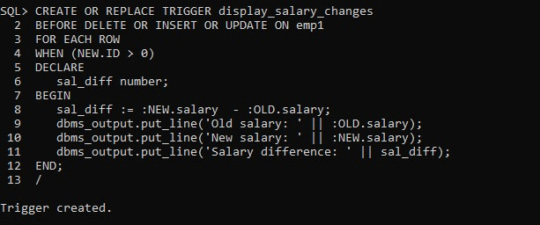

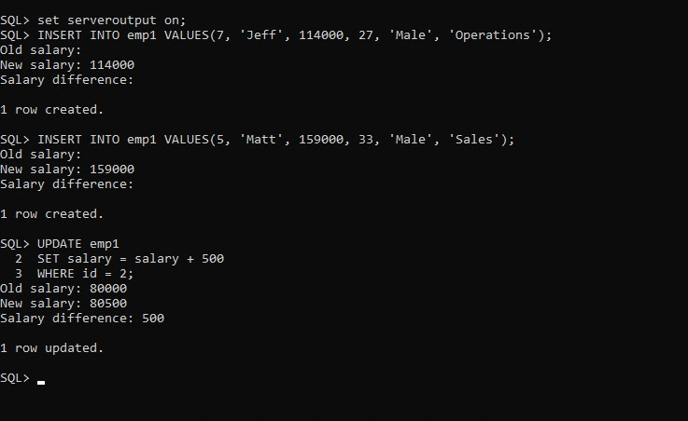

**1. Create a trigger for the STUDENT table that would get executed by**

**the DML statement like UPDATE OR INSERT on that table.**

**2. The trigger will compute and show the message “Department does not**

**exist if the department_ id is greater than 5”.**

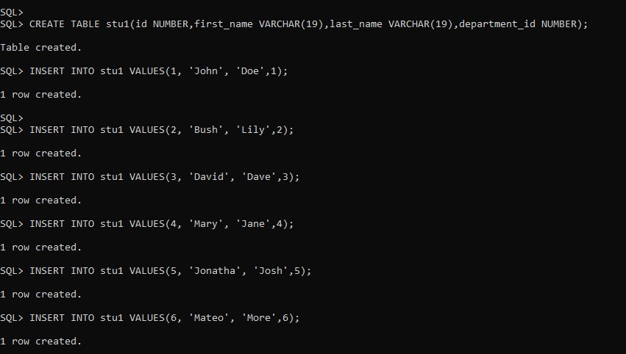

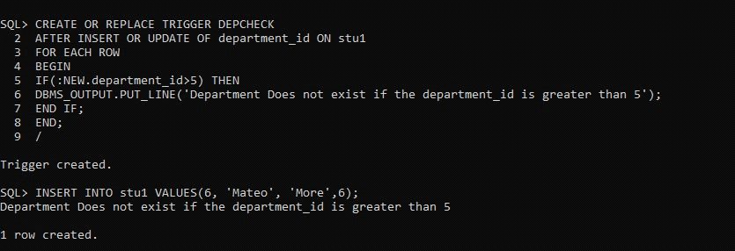

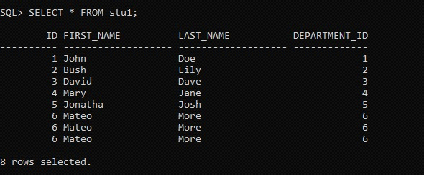

**PL SQL CURSORS:**

**Write a PL/SQL Procedure to print id, name, address FROM customers using explicit cursors;**

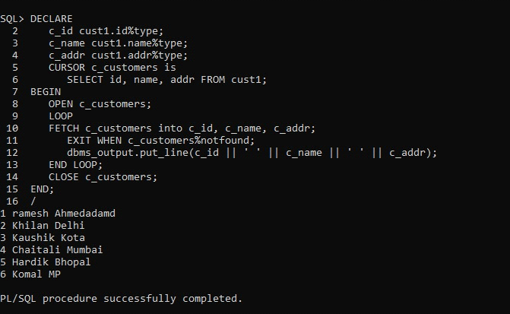

**PL SQL EXCEPTION HANDLING:**

**Write a PL/SQL Procedure to print name, address FROM customers. Use**

**exception handling and If data not found, print no data found using**

**exception.**

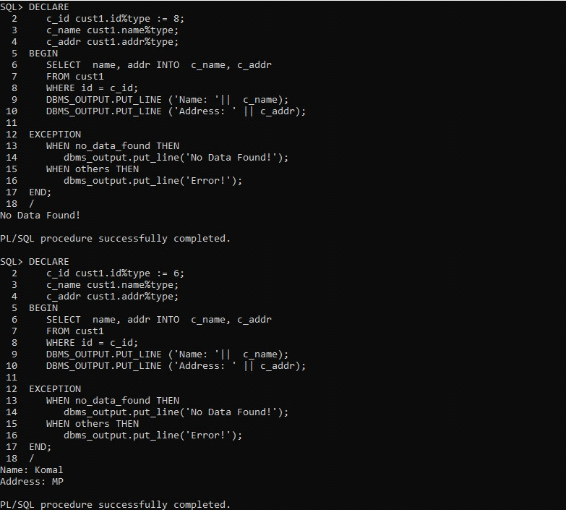

**RESULT:** Thus, the SQL queries to execute PL/SQL commands are implemented successfully.