SIMATS ENGINEERING
Department of Information Technology
CSA15 – CLOUD COMPUTING AND BIG DATA ANALYTICS
ASSIGNMENT 2 – CO2
Analyse, Evaluate and Validate a Virtualization Architecture for a Multi-Tenant University Private Cloud
CO2: Analyze virtualization architectures to identify performance and security issues in cloud computing environments.

Field | Details | Field | Details
Student Name | Vijay A | Register Number | 192511030
Department / Section | Computer Science and Engineering | Academic Year / Semester | 2026
Faculty Name | Dr.R.Latha | Nature of Assignment | Individual
Duration | 1 Week | Total Marks | 50
Submission Date | 4/11/2026 | Evaluation Date

MARK SHEET (Rubric-based evaluation)

Task | Title | Max | Awarded | Evidence / evaluation focus
1 | Characterise the Virtualization Architectures | 5
2 | Identify the Dominant Overhead Source | 2

Task | Title | Max | Awarded | Evidence / evaluation focus
3 | Build a Quantitative Performance Model | 6
4 | Analyse Performance Under Different Conditions | 4
5 | Security Threat and Vulnerability Analysis | 3
6 | Formulate Isolation–Performance Trade-off | 3
7 | Evaluate Mitigation Strategies | 4
8 | Implement and Test | 4
9 | Record Experimental Performance | 3
10 | Compare Theory with Experiment | 4
11 | Recommend and Defend Final Architecture | 4
 | Day-4 Design Challenge | 8

TOTAL
50

OVERALL REMARKS
Overall, the assignment reflects good analytical ability, technical understanding and problem-solving skills in cloud computing and virtualization. The proposed architecture balances performance, security, resource efficiency and future scalability. The work can be further strengthened through verified experimental results, consistent benchmark comparisons and practical validation of the recommended security controls.

Student Signature | Faculty Signature | Program Director

MANDATORY SUBMISSION EVIDENCE CHECK
✓ = Present in documented answer; P = Partly present; X = Missing / not satisfied

Task | Evidence expected | Status | Evaluator note
1 | Three virtualization architectures, layered diagrams and trust boundaries
2 | Dominant overhead source identified and explained for each approach
3 | CPU, memory, I/O, network and density models with assumptions
4 | Best, typical and worst operating-condition analysis

Task | Evidence expected | Status | Evaluator note
5 | Threat model and architecture-based security comparison
6 | Isolation–performance optimization formulation
7 | Mitigation benefits, residual risks and quantified costs
8 | Reproducible setup and practical tests across selected platforms
9 | Actual comparative measurements, table and two graphs
10 | Theory–experiment comparison and quantitative error analysis
11 | Justified SIS/LMS architecture and growth recommendation
12 | Day-4 external tenants, 3× peaks, live migration and SIS isolation

IMPLEMENTATION EVIDENCE CHAIN

Evidence item | Status | Observation
Architecture diagrams
Performance model

Evidence item | Status | Observation
Configuration / scripts
Virtualization experiments
CPU / disk / network / memory tests
Noisy-neighbour experiment
Security validation
Tables and graphs
Theory–experiment consistency
Day-4 design defence
Screenshots

SUBMISSION CHECKLIST (Not Separately Marked)

Requirement | Status
All 12 tasks answered | - Yes ☐ Partly ☐ No
Three virtualization approaches compared | - Yes ☐ Partly ☐ No
Layered diagrams and trust boundaries included | - Yes ☐ Partly ☐ No
Quantitative virtualization models included | - Yes ☐ Partly ☐ No
Threat analysis and mitigations included | - Yes ☐ Partly ☐ No

CLOUD COMPUTING AND BIG DATA

ASSIGNMENT 2
CO2: Analyze virtualization architectures to identify performance and security issues in cloud computing environments.

Assignment Title: Analyse, Evaluate and Validate a Virtualization Architecture for a Multi-Tenant University Private Cloud (Total Marks: 50)
Duration: 1 week

Scenario: EduCloud Virtualization Platform
A university runs a private cloud, EduCloud, in its data centre. EduCloud currently consists of:
- 16 physical hosts, each with 64 CPU cores, 512 GB RAM, NVMe SSD storage and 2 × 25 Gbps NICs
- About 400 virtual machines (VMs) running the Student Information System (SIS), the Learning Management System (LMS), the examination portal, and departmental research workloads
- A shared storage backend and a software-defined virtual network
During semester registration week, users report slow response times and failed logins. A recent internal security audit also found that VMs from different departments share the same physical hosts, that some VMs run outdated guest kernels, and that VM images are copied freely between teams.
You are the cloud architect. You must investigate, model, measure and compare virtualization architectures for EduCloud, identify their performance bottlenecks and security weaknesses, and recommend a design that remains practical as the platform grows.

Design Challenge:
The university now plans to host external research collaborators' big-data workloads (Spark/Hadoop clusters) on the same infrastructure as the SIS. Re-evaluate your design under these new multi-tenant conditions.

TASK 1: Characterise the Virtualization Architectures (5 Marks)
Select at least three meaningfully different virtualization approaches from the following, or justify others:
- Type-1 (bare-metal) hypervisor with full virtualization
- Type-2 (hosted) hypervisor
- Hardware-assisted virtualization vs. paravirtualization
- OS-level virtualization (containers)
- Lightweight/micro-VM or sandboxed container runtimes
Two configurations of the same hypervisor will not count as different approaches. Your selection must include at least one VM-based and at least one container-based approach.
For each approach, provide:
- A layered architecture diagram showing the hardware, host OS or hypervisor, guest OS, runtime and application
- The trust boundaries and the component that enforces isolation
- How CPU, memory, storage and network are virtualized
- A brief justification for why this approach is relevant to EduCloud
Evidence expected: Three architecturally distinct approaches with labelled diagrams, resource-virtualization mechanisms, trust boundaries, and justification of selection.

TASK 2: Identify the Dominant Overhead Source (2 Marks)
For each approach, identify the primary source of performance overhead that predominantly limits its performance (for example VM exits/traps, nested or extended page-table walks, virtual I/O emulation, virtual switch processing, or system-call interception).
Discuss:
- What the overhead source is
- Where in the architecture it occurs
- Why it is appropriate as the focus of performance analysis
- How its frequency or cost changes as the number of co-located VMs/containers or the I/O rate increases
Do not simply name a mechanism. Relate it to the behaviour of the architecture.

Evidence expected: A justified dominant-overhead identification for each approach, linked to its resource-virtualization path.

TASK 3: Build a Quantitative Performance Model (6 Marks)
Using the following host parameters, develop an analytical performance model for each approach.

Parameter | Value
Physical cores per host | 64
vCPU:pCPU overcommit ratio | 1:1, 2:1, 4:1, 8:1
RAM per host | 512 GB
Average VM memory demand | 8 GB
Cost of one VM exit (assume) | 1.5 µs
Native system-call cost (assume) | 0.2 µs
Network line rate | 25 Gbps

State and justify any additional assumptions. Derive expressions for:
- CPU: effective per-VM CPU capacity as a function of overcommit ratio and virtualization overhead (including steal time)
- Memory: the maximum number of VMs per host before ballooning, swapping or page-sharing becomes necessary
- I/O and network: effective throughput as a function of the number of VMs sharing the physical device
- Density: the number of VMs/containers a host can support while meeting a stated service-level target (for example, ≤ 10% performance degradation)
Show the mathematical reasoning. Merely quoting overhead percentages from the literature will not receive full credit.
Evidence expected: A clear mathematical derivation for each approach, with stated assumptions, parameter values and worked numerical examples.

TASK 4: Analyse Performance Under Different Operating Conditions (4 Marks)
Analyse how each approach behaves under three conditions:
- Best case: what workload and placement conditions minimise overhead?
- Typical case: for example, registration-week mixed web and database load
- Worst case: for example, noisy-neighbour interference, memory overcommit with swapping, live migration during peak load, or I/O storms
For each, explain what happens inside the virtualization layer, why the overhead changes, and how latency and throughput are affected. A table of numbers alone will not be accepted.
Evidence expected: A justified condition-based analysis supported by your Task 3 model.

TASK 5: Security Threat and Vulnerability Analysis (3 Marks)
Construct a threat model for each approach. Discuss:
- The attack surface (hypervisor, device emulation, shared kernel, management plane, VM images and snapshots, virtual network)
- At least four distinct threat categories, such as VM escape, cross-VM side-channel attacks, hypervisor or container-runtime vulnerabilities, VM sprawl and unpatched guests, image tampering, insecure live migration, and virtual-network sniffing or spoofing
- For each threat, which approach is more or less exposed and why, referring to its architecture and trust boundaries
- The likely impact on the confidentiality, integrity and availability of student records
Evidence expected: A structured threat model mapped to architectural features, with a justified comparison across approaches.

TASK 6: Formulate the Isolation–Performance Trade-off (3 Marks)
Formalise the trade-off between isolation strength and performance/density for EduCloud.
Clearly identify:
- The decision variables (for example, approach chosen, VMs per host, dedicated vs. shared hosts, SMT on/off)

- The objective(s), such as maximising density or minimising cost
- The constraints (for example, performance degradation limit, isolation requirement for SIS, available hosts)
- How these components combine into a cost or decision function
The formulation must follow from your own analysis in Tasks 3 and 5, not from a generic template.
Evidence expected: A clearly defined trade-off model with identified variables, objective and constraints.

TASK 7: Evaluate Mitigation Strategies (4 Marks)
Propose at least three mitigations for the vulnerabilities identified in Task 5. Examples include disabling SMT, kernel page-table isolation, dedicated hosts for sensitive tenants, secure or sandboxed container runtimes, hardware memory encryption, image signing, and micro-segmentation.
For each mitigation, discuss:
- Why it is applicable to the threat
- What residual risk remains
- The performance or density cost, estimated using your Task 3 model
- Whether the trade-off is acceptable for the SIS
Evidence expected: Mitigations evaluated analytically, with their security benefit and quantified performance cost.

TASK 8: Implement and Test (4 Marks)
Build a test environment and experimentally test all selected approaches.
- Platforms: use any open-source stack, for example KVM/QEMU, Xen or VirtualBox, Docker/Podman, and Kata Containers or gVisor. Nested virtualization on a laptop is acceptable if documented.
- Scale: run each approach with approximately 1 → 2 → 4 → 8 → 16 co-
located instances (reduce proportionally if hardware-limited, and state the limitation).
- Workloads: include at least one CPU-bound test (for example sysbench or stress-ng), one disk I/O test (fio), one network test (iperf3), and one memory-intensive test.
- Interference test: run at least one noisy-neighbour experiment.

- Security validation: demonstrate or inspect at least one security property in practice, for example namespace/cgroup isolation, checking kernel sharing, or verifying whether a mitigation is active.
Ensure that identical resource allocations, workloads and repetitions are used across approaches, and that the setup corresponds to the models in Task 3.
Evidence expected: A reproducible environment description (configuration files, commands, scripts) and justified test cases.

TASK 9: Record Experimental Performance (3 Marks)
Collect and present data such as:
- Throughput, latency (mean and 95th percentile), CPU steal time, context switches and VM exits where observable
- Instance start-up time and memory footprint per instance
- Performance degradation versus a bare-metal baseline
- Results with and without at least one security mitigation
Present at least one table and two graphs (for example, throughput versus number of instances, and latency under interference). Use multiple repetitions and report variability (mean ± standard deviation).
Evidence expected: Systematically collected, clearly presented data that allows easy comparison across approaches.

TASK 10: Compare Theory with Experiment (4 Marks)
Compare your Task 3 and Task 4 predictions with Task 9 measurements. Discuss:
- Whether the observed degradation trends agree with your model
- Which approach scales better as co-located instances increase
- Quantitative differences between predicted and measured values, and plausible causes (for example caching effects, hypervisor scheduler behaviour, nested virtualization, laptop hardware, or unmodelled I/O paths)
- Whether any measured result changes your security conclusions from Task 5
Interpret the results; do not simply reproduce tables.
Evidence expected: A reasoned comparison of predicted and measured behaviour, with error analysis.

TASK 11: Recommend and Defend the Final Architecture (4 Marks)
Recommend the virtualization architecture (or hybrid) for EduCloud's SIS and LMS workloads.
Discuss:
- Which approach you recommend and why it is more appropriate than the alternatives
- Its modelled and experimentally observed performance
- Its security posture and residual risks
- Operational costs such as patching, image management, migration and monitoring
- Limitations and trade-offs
- Whether it remains practical as EduCloud grows from 400 to several thousand instances
Your recommendation must rest on your own analysis and experiments. Choosing "the most secure" or "the fastest" option alone is not sufficient.
Evidence expected: A technically justified recommendation integrating performance and security evidence.

DAY-4 DESIGN CHALLENGE

TASK 12: Re-evaluate and Adapt the Design (8 Marks)

Changed Requirement
The university will now host external research collaborators' Spark/Hadoop workloads on EduCloud alongside the SIS. The new conditions are:
- Big-data jobs are I/O- and network-intensive and run for hours
- Registration-week peak load is about 3× normal
- Hosts are sometimes patched using live migration of running VMs
- A data-protection regulation now requires demonstrable isolation of student records from external tenants
You may RETAIN → MODIFY → or REDESIGN your original solution.

Impact Analysis (2 Marks)
Discuss what has changed, which original assumptions (trusted tenants, workload mix, I/O profile) no longer hold, and how mixing batch big-data workloads with latency-sensitive SIS workloads changes both the performance and the threat model.

Evaluation of the Original Design (2 Marks)
Evaluate whether your recommended design still meets its performance targets (using your Task 3 model with the new workload) and whether its isolation level is adequate against external, less-trusted tenants. Consider whether another architecture could do better overall.

Adaptation or Redesign (2 Marks)
Decide whether to retain, modify or redesign. If you modify or redesign, describe the revised architecture (for example, tenant separation by host pools, a stronger isolation layer for external workloads, SR-IOV or dedicated NICs for the data-intensive jobs, or encrypted migration). Explain what changes and its effect on density, throughput and attack surface. If you retain, justify why no change is required.

Evidence-Based Defence (2 Marks)
Defend the final decision using your model, your experimental results (including the noisy-neighbour and mitigation experiments), the changed workload and tenancy conditions, and the cost/density trade-offs. The decision must follow logically from the analysis.

MARK DISTRIBUTION

Task | Marks
Task 1 – Architecture Characterisation | 5
Task 2 – Dominant Overhead Identification | 2
Task 3 – Quantitative Performance Model | 6
Task 4 – Performance Under Operating Conditions | 4
Task 5 – Security Threat and Vulnerability Analysis | 3

Task 6 – Isolation–Performance Trade-off Formulation | 3
Task 7 – Mitigation Evaluation | 4
Task 8 – Implementation and Testing | 4
Task 9 – Experimental Performance | 3
Task 10 – Theory vs. Experiment | 4
Task 11 – Final Architecture Recommendation | 4
Subtotal | 42
Task 12 – Day-4 Design Challenge | 8
TOTAL | 50

TASK 1 – Characterise the Virtualization Architectures

Introduction
EduCloud is a university private cloud infrastructure consisting of 16 physical servers and approximately 400 virtual machines. Each server is equipped with 64 CPU cores, 512 GB RAM, NVMe SSD storage and dual 25 Gbps network interfaces.
The infrastructure supports the Student Information System (SIS), Learning Management System (LMS), Examination Portal and departmental research applications.
Virtualization allows multiple workloads to share physical hardware while maintaining logical isolation. Three important virtualization architectures suitable for EduCloud are Type-1 Hypervisor Virtualization, OS-Level Container Virtualization and Lightweight Micro-VM Virtualization.

Type-1 Hypervisor-Based Virtualization
A Type-1 hypervisor runs directly on physical hardware and manages multiple independent virtual machines. Each virtual machine has its own guest operating system, allocated resources and applications.
Examples: VMware ESXi, Microsoft Hyper-V and Xen.

Architecture Diagram

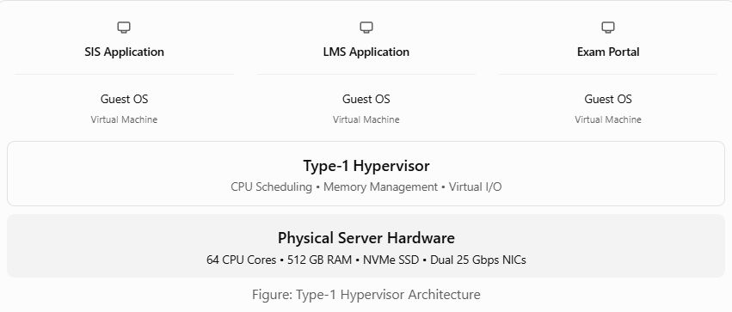
Resource Virtualization
- CPU: Physical CPU cores are shared among virtual machines using virtual CPU scheduling.
- Memory: Each VM receives its own virtual memory, mapped to physical RAM.
- Storage: Virtual disks are created using the physical NVMe SSD storage.
- Network: Virtual network interfaces and virtual switches provide communication between VMs.
Trust Boundary and Isolation
The hypervisor provides the primary security boundary between virtual machines. Each VM operates with an independent guest operating system, helping prevent one VM from directly accessing another VM's memory and processes.
Suitability: This architecture is recommended for SIS and examination databases because they handle sensitive student information and require strong isolation.

OS-Level Virtualization Using Containers
OS-level virtualization allows multiple isolated applications to run on the same host operating system. Unlike traditional VMs, containers share the host kernel, reducing resource consumption.
Examples: Docker, Podman and Linux Containers (LXC).
Architecture Diagram
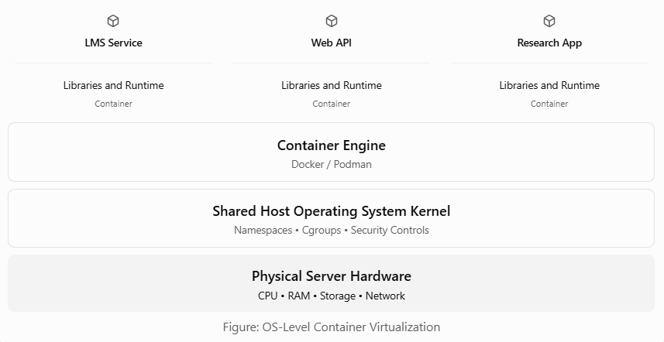
Resource Virtualization
- CPU: Control groups (cgroups) manage CPU usage and resource limits.
- Memory: Containers receive memory limits to prevent excessive consumption.
- Storage: Layered filesystems and volumes provide application storage.
- Network: Network namespaces and virtual interfaces isolate container communication.

Trust Boundary and Isolation
Containers use namespaces, cgroups and kernel security controls to isolate applications. However, all containers share the same host kernel, so a kernel vulnerability may affect multiple containers.
Suitability: Containers are recommended for LMS services, web applications and REST APIs because they provide fast startup, efficient resource utilization and high application density.

Lightweight Micro-VM Virtualization
Micro-VMs combine the lightweight nature of containers with the stronger isolation provided by virtual machines. Each micro-VM runs a minimal guest operating system and uses hardware-assisted virtualization.
Examples: Firecracker and Kata Containers.

Architecture Diagram
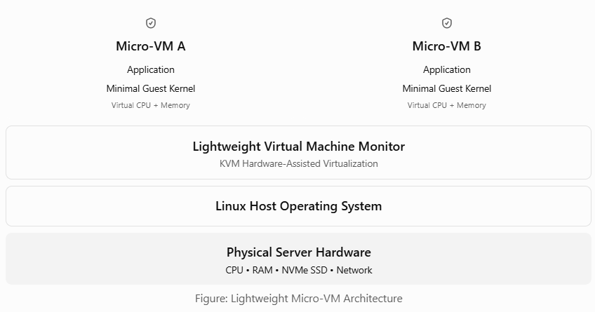
Resource Virtualization
- CPU: Hardware-assisted virtualization provides isolated virtual CPUs.
- Memory: Each micro-VM receives separate guest memory.
- Storage: Virtual block devices provide access to storage.
- Network: Virtual network interfaces enable communication with external services.
Trust Boundary and Isolation
Each micro-VM has its own minimal guest kernel and hardware-enforced virtualization boundary. This provides stronger isolation than ordinary shared-kernel containers while maintaining relatively low overhead.
Suitability: Micro-VMs are suitable for departmental research applications and workloads belonging to different users or departments that require improved security isolation.
Comparison of Virtualization Architectures
Feature | Type-1 Hypervisor | Containers | Micro-VMs
Operating System | Separate guest OS | Shared host kernel | Minimal guest OS
Isolation | Strong | Moderate | Strong
Startup Time | Generally slower | Very fast | Fast
Resource Overhead | Higher | Low | Low to moderate
Application Density | Moderate | High | Moderate to high
Security Boundary | Hypervisor | Host kernel | Hardware-assisted VM
Suitable Workload | SIS, Exam Portal | LMS, APIs | Research workloads
Recommended Architecture for EduCloud
EduCloud should adopt a mixed virtualization approach based on the security and performance requirements of individual applications.
- Type-1 Hypervisor: For sensitive university systems such as SIS and examination databases.
- Containers: For LMS services, web applications and APIs that require fast deployment and efficient scaling.
- Micro-VMs: For departmental research workloads that need stronger separation between users and departments.
This combination improves infrastructure utilization while maintaining appropriate security boundaries. It also allows EduCloud to support its approximately 400 existing virtual machines and future application growth more efficiently.
Conclusion
Virtualization is essential for efficient management of EduCloud's private cloud infrastructure. Type-1 hypervisors provide strong VM isolation, containers enable lightweight application deployment, and micro-VMs combine efficient execution with hardware-based security.
Using these architectures according to workload requirements helps the university improve performance, reduce resource wastage and protect sensitive academic information.

TASK 2 – Identify the Dominant Overhead Source

Introduction
Virtualization allows multiple virtual machines and containers to share the same physical server. However, additional processing is required to manage CPU, memory, storage and network resources.
This extra processing is called virtualization overhead. It can increase response time and reduce system performance, especially when many workloads share the same physical host.
For EduCloud, identifying the dominant overhead source is important because the university experiences slow responses and failed logins during semester registration.
Dominant Overhead Sources in Different Virtualization Architectures
Virtualization Approach | Dominant Overhead Source | Where It Occurs
Type-1 Hypervisor | VM exits and virtual I/O processing | Between guest VMs and the hypervisor
OS-Level Containers | Kernel scheduling and network processing | Shared host kernel
Lightweight Micro-VMs | VM exits and virtual device processing | Between micro-VMs and the lightweight VMM
Type-1 Hypervisor Overhead
In Type-1 virtualization, the hypervisor manages CPU execution, memory access and virtual devices.
- Main overhead: VM exits and virtual I/O processing.
- Location: Between the guest operating system and hypervisor.
- Reason: Certain guest operations require additional processing by the hypervisor, increasing execution time.
- Effect of increasing VMs: More active VMs create greater scheduling contention and virtual I/O activity, potentially increasing latency.
For EduCloud, this overhead may affect SIS database requests during registration periods.
OS-Level Container Overhead
Containers share the host operating system kernel and do not require separate guest operating systems.
- Main overhead: Kernel scheduling and virtual network processing.
- Location: Within the shared host kernel.
- Reason: Multiple containers compete for CPU time and network resources.
- Effect of increasing containers: Higher container density can increase context switching, resource contention and network processing delays.
For EduCloud, these delays may affect LMS web services when many students access learning materials simultaneously.
Lightweight Micro-VM Overhead
Micro-VMs use hardware-assisted virtualization with a minimal guest operating system.
- Main overhead: VM exits and virtual device processing.
- Location: Between the micro-VM, lightweight virtual machine monitor and host kernel.
- Reason: Virtual device operations and certain privileged instructions require additional processing.
- Effect of increasing micro-VMs: More active micro-VMs can increase CPU scheduling pressure and virtual I/O contention.
For EduCloud, this overhead is relevant when multiple research workloads run on the same host.
Comparison and Analysis
Type-1 hypervisors provide strong isolation but introduce overhead through virtualization transitions and device handling. Containers generally have lower virtualization overhead because they share the host kernel, although heavy resource contention can still reduce performance. Micro-VMs provide stronger isolation than ordinary containers but introduce additional virtualization processing.
The actual dominant overhead depends on workload characteristics. CPU-intensive workloads may be affected by scheduling and VM exits, while network-intensive workloads may be limited by virtual switching and I/O processing.
Conclusion
The main overhead sources in EduCloud are VM exits and virtual I/O processing for hypervisors, shared-kernel scheduling and network processing for containers, and VM exits and virtual device processing for micro-VMs.
Understanding these overhead sources helps the university select suitable virtualization architectures, reduce resource contention and improve application performance during peak usage.

TASK 3 – Build a Quantitative Performance Model

Introduction
A quantitative performance model is used to estimate how efficiently virtual machines utilize physical resources in the EduCloud private cloud.
EduCloud consists of 16 physical servers supporting approximately 400 virtual machines. The performance model considers CPU allocation, memory capacity, virtualization overhead and network throughput.
The main objective is to identify the maximum number of virtual machines that can operate on each server without exceeding the acceptable 10% performance degradation limit.

Given System Parameters
Parameter | Value
Physical servers | 16
CPU cores per server | 64
RAM per server | 512 GB
Average memory per VM | 8 GB
CPU overcommit ratios | 1:1, 2:1, 4:1, 8:1
VM exit cost | 1.5 microseconds
Native system call cost | 0.2 microseconds
Network line rate | 25 Gbps per NIC
Network interfaces | 2 × 25 Gbps
Acceptable performance degradation | Maximum 10%

CPU Performance Model
CPU overcommitment allows more virtual CPUs to be assigned than the number of available physical CPU cores.
Formula:
Maximum allocated vCPUs = Physical CPU cores × Overcommit ratio
For a server with 64 CPU cores:
Overcommit Ratio | Maximum Allocated vCPUs
1:1 | 64
2:1 | 128
4:1 | 256
8:1 | 512
As the overcommit ratio increases, more virtual CPUs share the available physical CPU cores.
Effective CPU Capacity Formula:
Effective CPU capacity per vCPU = (1 − virtualization overhead) × (1 − steal-time fraction) × physical-core capacity
For a simplified model where all allocated vCPUs are continuously demanding CPU time:
Effective CPU capacity per vCPU ≈ (1 − overhead) / overcommit ratio

Worked Example
Assume virtualization overhead is 5%, and all allocated vCPUs are fully utilized.
Overcommit Ratio | Effective CPU Capacity per vCPU | Estimated Degradation
1:1 | 95% | 5%
2:1 | 47.5% | 52.5%
4:1 | 23.75% | 76.25%
8:1 | 11.875% | 88.125%
These are theoretical estimates under continuous full CPU demand, not measured EduCloud results.
In real environments, overcommitment can perform better when some virtual CPUs are idle.

Virtualization Overhead Calculation
VM exits occur when certain guest operations require processing by the hypervisor.
Formula:
VM exit overhead = Number of VM exits × Cost per exit
Assume a VM performs 10,000 VM exits per second.
VM exit overhead = 10,000 × 1.5 microseconds
VM exit overhead = 15,000 microseconds = 15 milliseconds per second
Therefore, approximately 1.5% of one CPU core's time is consumed by VM exit handling under this assumption.
For comparison, 10,000 native system calls at 0.2 microseconds each require:
10,000 × 0.2 = 2 milliseconds
The difference is 13 milliseconds per second. This comparison illustrates the supplied operation costs; not every native system call causes a VM exit.

Memory Capacity Model
Each physical server contains 512 GB RAM, and each virtual machine requires an average of 8 GB.
Formula:
Maximum VMs per host = Total RAM / RAM per VM
Maximum VMs = 512 / 8
Theoretical memory capacity
64 VMs per host
Across 16 servers:
Total theoretical capacity = 16 × 64 = 1,024 VMs
However, this calculation does not reserve memory for the hypervisor, host services or management processes.
Assuming 32 GB RAM is reserved per host:
Available VM memory = 512 − 32 = 480 GB
Maximum VMs = 480 / 8 = 60 VMs per host
Therefore, 60 VMs per host is a more practical memory-based estimate under the stated reservation assumption, before considering CPU and I/O limits.

Network Throughput Model
EduCloud uses two 25 Gbps network interfaces per physical server.
For a simplified equal-sharing model:
Effective network throughput per VM = Available network bandwidth / Number of active VMs
Assume one 25 Gbps NIC is shared equally and no bandwidth is lost to network processing.
Active VMs | Theoretical Bandwidth per VM
1 | 25 Gbps
2 | 12.5 Gbps
4 | 6.25 Gbps
8 | 3.125 Gbps
16 | 1.5625 Gbps
32 | 0.78125 Gbps
64 | 0.390625 Gbps
Theoretical Network Bandwidth per VM
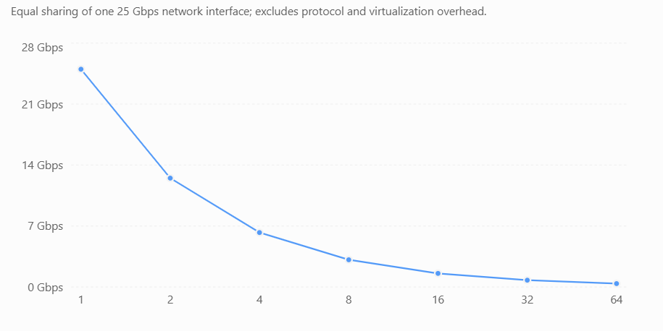
The actual throughput will be lower when network virtualization overhead, protocol overhead and competing workloads are considered.
For storage, a similar sharing model can be applied:
Effective storage throughput per VM ≈ Available storage throughput / Number of simultaneously active I/O workloads

Performance SLA and VM Density
EduCloud requires performance degradation to remain within 10%.
SLA Condition:
Performance degradation ≤ 10%
Therefore:
Effective performance ≥ 90% of the baseline performance
Assume each active VM needs one full physical CPU core, virtualization overhead is 5%, and 32 GB RAM is reserved for the host.
The maximum CPU-supported density without CPU contention is approximately 64 single-vCPU VMs per server.
The memory-supported density is 60 VMs per server.
Therefore:
Maximum estimated density = Minimum (CPU capacity, memory capacity, network capacity)
Ignoring additional network and storage workload constraints:
Maximum estimated density = Minimum (64, 60) = 60 VMs per host
This density satisfies the simplified CPU and memory model only when workloads do not introduce additional contention that violates the 10% SLA.
For EduCloud's existing 400 VMs:
Average VMs per host = 400 / 16 = 25 VMs per host
This is below the estimated memory limit of 60 VMs per host. However, CPU utilization, database I/O and network congestion must still be monitored because VM count alone does not guarantee performance.

Conclusion
The quantitative performance model shows that EduCloud's virtualization performance depends on CPU overcommitment, VM exit overhead, memory allocation and network sharing.
Based on the simplified assumptions, a physical server can support approximately 60 VMs with 8 GB RAM each after reserving 32 GB for host operations. Higher CPU overcommit ratios increase resource allocation flexibility but may significantly reduce performance when workloads are simultaneously active.
To maintain the 10% performance degradation limit, EduCloud should monitor CPU steal time, memory pressure, network throughput and storage I/O before increasing virtual machine density.
Note: All numerical results are theoretical estimates based on the given parameters and stated assumptions. Actual performance must be validated through the experiments in Tasks 8–10.

TASK 4 – Analyse Performance Under Different Operating Conditions

Introduction
The performance of EduCloud's virtualization infrastructure changes depending on the number of active virtual machines, resource utilization and workload intensity.
EduCloud operates 16 physical servers supporting approximately 400 virtual machines for the Student Information System (SIS), Learning Management System (LMS), Examination Portal and research applications.
To evaluate virtualization performance, three operating conditions are considered: Best Case, Typical Case and Worst Case.

Best-Case Operating Condition
The best-case condition occurs when the system has minimal resource contention and sufficient CPU, memory, storage and network resources.
Conditions:
- Fewer active virtual machines are competing for resources.
- CPU utilization remains low, reducing scheduling delays.
- Sufficient physical RAM is available without swapping.
- Network and storage operations experience minimal congestion.
- No live migration or resource-intensive background operations occur.
Performance Analysis:
Under these conditions, the hypervisor can schedule virtual CPUs with minimal waiting time. Memory accesses remain efficient, and virtual I/O requests are processed without significant delays.
Using the Task 3 model, assume virtualization overhead is 5% and CPU steal time is negligible.
Effective CPU performance = (1 − 0.05) × 100 = 95%
Therefore, the estimated performance degradation is only 5%, which satisfies EduCloud's 10% performance SLA.
Impact on EduCloud: SIS login, LMS access and examination services are expected to respond quickly because resources are readily available.

Typical Operating Condition
The typical condition occurs during university registration periods when many students simultaneously access SIS, LMS and database services.
Conditions:
- Multiple virtual machines actively share CPU resources.
- SIS web servers and databases generate frequent I/O requests.
- CPU scheduling and context switching increase.
- Virtual switches process more network traffic.
- Shared storage experiences increased read/write operations.
Performance Analysis:
During registration, the hypervisor must distribute CPU time among competing VMs. If the number of runnable virtual CPUs exceeds available physical cores, CPU steal time increases.
Using the Task 3 formula:
Effective CPU performance = (1 − virtualization overhead) × (1 − steal-time fraction) × 100
Assume 5% virtualization overhead and 4% CPU steal time.
Effective CPU performance = 0.95 × 0.96 × 100 = 91.2%
Estimated performance degradation = 100 − 91.2 = 8.8%
This theoretical example remains within the 10% SLA, but further contention could cause a violation.
Impact on EduCloud: SIS logins may take longer, database queries may experience delays, and LMS pages may load more slowly during peak usage.

Worst-Case Operating Condition
The worst-case condition occurs when multiple resource-intensive workloads compete for the same physical resources.
Conditions:
- A noisy-neighbour VM consumes excessive CPU, memory or disk I/O.
- Memory pressure causes ballooning or swapping.
- Multiple applications generate heavy storage and network traffic.
- Live migration occurs during peak registration hours.
- CPU overcommitment creates long scheduling delays.
Performance Analysis:
A noisy-neighbour workload can occupy physical CPU cores and delay other VMs. Memory swapping introduces additional disk operations, while live migration consumes CPU and network bandwidth.
Assume 5% virtualization overhead and 20% CPU steal time.
Effective CPU performance = 0.95 × 0.80 × 100 = 76%
Estimated performance degradation = 100 − 76 = 24%
This exceeds the maximum allowed degradation of 10%.
If 32 VMs simultaneously share one 25 Gbps network interface, the ideal equal-share bandwidth from Task 3 is:
Bandwidth per VM = 25 / 32 = 0.78125 Gbps
Actual throughput may be lower because of network processing overhead and competing traffic.
Impact on EduCloud: SIS logins may time out, examination services may become unresponsive, and database transactions may experience severe delays.

Comparison of Operating Conditions
Parameter | Best Case | Typical Case | Worst Case
CPU Contention | Minimal | Moderate | High
Memory Pressure | Low | Moderate | High, possible swapping
Network Traffic | Low | Increased | Heavy congestion
Storage I/O | Minimal | Frequent requests | I/O storm
CPU Steal Time (assumed) | 0% | 4% | 20%
Estimated CPU Performance | 95% | 91.2% | 76%
Performance Degradation | 5% | 8.8% | 24%
SLA Status | Satisfied | Satisfied | Violated
Estimated CPU Performance Under Different Conditions
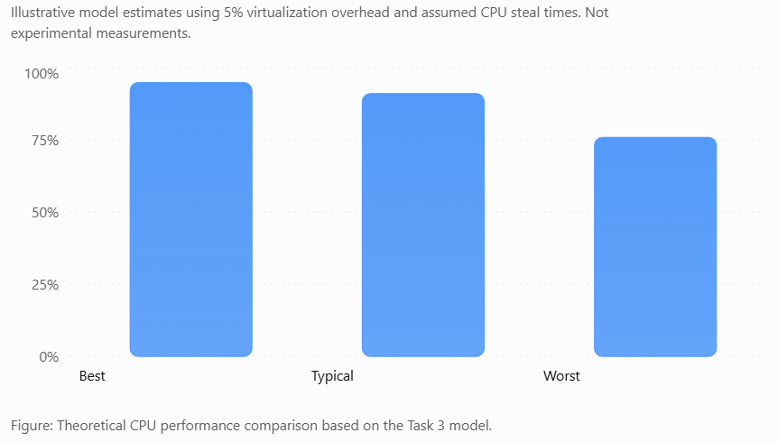
Figure: Theoretical CPU performance comparison based on the Task 3 model.
Effect of Virtualization Architecture
Type-1 Hypervisor: Provides strong isolation, but CPU scheduling delays, VM exits and virtual I/O contention can reduce performance during peak workloads.
OS-Level Containers: Generally have lower virtualization overhead, but shared-kernel resource contention can affect multiple containers simultaneously.
Lightweight Micro-VMs: Provide stronger workload isolation than ordinary containers, although CPU scheduling and virtual device overhead can still affect performance.
Recommended Performance Improvements
- Reserve sufficient CPU and memory resources for critical SIS applications.
- Apply CPU and memory limits to research workloads to reduce noisy-neighbour effects.
- Monitor CPU steal time, storage latency and network utilization.
- Avoid unnecessary live migration during registration and examination periods.
- Distribute workloads across the 16 physical servers to reduce resource contention.
Conclusion
EduCloud performs efficiently under best-case conditions because resource contention is minimal. During typical registration workloads, performance may decrease due to CPU scheduling and increased I/O operations.
In worst-case conditions, noisy neighbours, memory swapping, live migration and network congestion can cause serious performance degradation.
Based on the illustrative model, effective CPU performance decreases from 95% in the best case to 76% in the worst case. Proper resource allocation, monitoring and workload isolation are therefore essential to maintain EduCloud's 10% performance SLA.

TASK 5 – Security Threat and Vulnerability Analysis

Introduction
Security is an important requirement for EduCloud because it stores sensitive student information, examination records, academic results and departmental research data.
EduCloud uses multiple virtual machines on shared physical servers. Although virtualization provides logical isolation, security threats may arise from hypervisor vulnerabilities, shared operating system kernels, insecure VM images and virtual network attacks.
The security analysis focuses on three virtualization approaches: Type-1 Hypervisors, OS-Level Containers and Lightweight Micro-VMs.

Security Threats in Different Virtualization Architectures
Type-1 Hypervisor-Based Virtualization
Type-1 hypervisors provide strong isolation between virtual machines. However, vulnerabilities in the hypervisor or virtual devices can affect multiple VMs.
Major Security Threats:
- VM Escape: An attacker exploits a hypervisor vulnerability to access resources outside their VM.
- Side-Channel Attacks: Attackers may attempt to infer sensitive information through shared CPU caches or other hardware resources.
- Insecure Live Migration: VM memory or data may be exposed if migration traffic is not properly protected.
- Unpatched Guest Operating Systems: Outdated guest kernels can allow unauthorized access or malware infection.
Trust Boundary: The hypervisor separates individual guest operating systems and controls access to physical hardware.
Impact on EduCloud: A successful attack could expose student records, modify examination results or interrupt SIS operations.

OS-Level Container Virtualization
Containers use the host operating system kernel to provide application isolation. Since all containers share the same kernel, kernel vulnerabilities represent a significant security risk.
Major Security Threats:
- Container Escape: An attacker exploits a kernel or runtime vulnerability to access the host system.
- Shared-Kernel Vulnerabilities: A compromised kernel can affect multiple containers.
- Insecure Container Images: Unverified images may contain malware or outdated software.
- Network Attacks: Improper network configuration can allow unauthorized communication between containers.
Trust Boundary: Linux namespaces, cgroups and kernel security mechanisms enforce container isolation.
Impact on EduCloud: A compromised LMS container could threaten other applications if isolation controls are weak.

Lightweight Micro-VM Virtualization
Micro-VMs provide hardware-assisted isolation with minimal guest operating systems. They reduce some risks associated with shared-kernel containers but do not eliminate virtualization attacks.
Major Security Threats:
- Micro-VM Escape: Vulnerabilities in the virtual machine monitor may allow an attacker to cross the isolation boundary.
- Side-Channel Attacks: Shared physical CPU resources may leak information between tenants.
- Image Tampering: Modified micro-VM images may introduce malicious software.
- Virtual Network Misconfiguration: Incorrect network rules may permit unauthorized access between tenants.
Trust Boundary: Each micro-VM has a separate guest kernel and a hardware-enforced VM boundary.
Impact on EduCloud: Research workloads may expose sensitive data or interfere with other departments if security controls are insufficient.
Comparison of Security Threats

Security Threat | Type-1 Hypervisor | Containers | Micro-VMs
VM or Container Escape | Possible through hypervisor vulnerabilities | Possible through kernel/runtime vulnerabilities | Possible through VMM vulnerabilities
Shared-Kernel Risk | Separate guest kernels | Higher risk due to shared kernel | Separate guest kernels
Side-Channel Attacks | Possible | Possible | Possible
Image Tampering | VM images | Container images | Micro-VM images
Network Attacks | Virtual switch vulnerabilities or misconfiguration | Container network misconfiguration | Virtual network misconfiguration
Isolation Strength | Strong | Comparatively weaker | Strong
Confidentiality, Integrity and Availability Analysis
Security threats can affect EduCloud's three main information security requirements.
Security Requirement | Possible Threat | Impact on EduCloud
Confidentiality | VM escape, side-channel attacks, network sniffing | Unauthorized disclosure of student personal information
Integrity | Image tampering, malware, unauthorized access | Modification of examination marks and academic records
Availability | Resource exhaustion, denial-of-service attacks | SIS downtime, failed logins and examination portal disruption
Recommended Security Measures
- Regular Patching: Update hypervisors, guest operating systems, container runtimes and micro-VM components.
- Image Verification: Use trusted, digitally signed VM and container images to prevent unauthorized modifications.
- Network Microsegmentation: Restrict communication between SIS, LMS and departmental research workloads.
- Strong Access Control: Apply role-based access control and least-privilege permissions to management systems.
- Secure Migration: Protect live migration traffic using encryption and authenticated connections.
- Workload Isolation: Place sensitive SIS databases on dedicated or strongly isolated infrastructure.

Conclusion
EduCloud faces security threats such as VM escape, shared-kernel vulnerabilities, side-channel attacks, image tampering and insecure network communication.
Type-1 hypervisors and micro-VMs provide stronger workload isolation, while containers offer better resource efficiency but rely on a shared kernel.
By implementing regular patching, image verification, network segmentation and strong access controls, EduCloud can reduce security risks and protect the confidentiality, integrity and availability of university data.

TASK 6 – Formulate the Isolation–Performance Trade-off

Introduction
In EduCloud, virtualization allows multiple applications to share physical servers, improving resource utilization and reducing infrastructure costs.
However, increasing the number of virtual machines on a server can reduce performance and increase security risks. Stronger isolation provides better protection for sensitive student information but may require additional hardware resources.
The main objective is to achieve a balance between security isolation, application performance and virtual machine density while maintaining EduCloud's 10% performance degradation limit.

Decision Variables
The following variables are considered when selecting the best virtualization architecture.
Decision Variable | Description
Virtualization Approach | Type-1 Hypervisor, Containers or Micro-VMs
VM Density | Number of virtual machines running on each physical server
Resource Allocation | CPU cores, RAM, storage and network bandwidth assigned to workloads
Host Allocation | Dedicated or shared physical servers
SMT Configuration | Simultaneous Multithreading enabled or disabled
Security Isolation | Level of separation between SIS and other workloads

Mathematical Performance Model
The objective is to maximize VM density while minimizing infrastructure cost and maintaining security.
Objective Function:
Maximize VM Density = Total Number of VMs / Number of Physical Hosts
For EduCloud:
Total VMs = 400
Physical Hosts = 16
Average VM Density = 400 / 16 = 25 VMs per host
From Task 3, the estimated memory-based capacity is 60 VMs per host when 32 GB RAM is reserved for host operations.
Therefore, the existing average density of 25 VMs per host is below the estimated memory capacity.
However, memory availability alone does not guarantee that CPU, storage and network performance requirements are satisfied.

Performance Constraints
EduCloud must maintain a maximum performance degradation of 10%.
Performance SLA Constraint:
Performance Degradation ≤ 10%
Effective CPU Performance ≥ 90%
Using the Task 3 model:
Effective CPU Performance = (1 − Virtualization Overhead) × (1 − CPU Steal Time)
Assuming virtualization overhead is 5%:
0.95 × (1 − CPU Steal Time) ≥ 0.90
CPU Steal Time ≤ 1 − (0.90 / 0.95)
Maximum allowable CPU steal time ≈ 5.26%
This means CPU scheduling contention must remain sufficiently low to satisfy the performance SLA under the assumed model.
Memory Constraint:
VM Density × 8 GB ≤ 480 GB
Therefore:
VM Density ≤ 60 VMs per host
Infrastructure Constraint:
Total number of available physical hosts = 16.
All allocated workloads must fit within these 16 servers while satisfying their resource and isolation requirements.

Security Isolation Constraints
EduCloud stores confidential student records and examination information. Therefore, sensitive workloads require stronger isolation.
- SIS databases should run in dedicated or strongly isolated virtual machines.
- Untrusted research workloads should not share the same host pool as sensitive SIS databases when strict physical separation is required.
- Containers should be used for trusted applications with suitable kernel security controls.
- Micro-VMs can provide additional isolation for departmental research applications.
- SMT may be disabled on sensitive hosts when the side-channel threat model justifies the performance cost.

Isolation–Performance Trade-off Analysis
Architecture | Isolation Strength | Performance Overhead | Resource Density | Suitable Workload
Type-1 Hypervisor | Strong | Moderate | Moderate | SIS and Exam Portal
Containers | Lower than hardware-isolated VMs | Low | High | LMS and Web APIs
Micro-VMs | Strong | Low to moderate | Moderate to high | Research Workloads
Dedicated Physical Hosts | Strong physical separation between host pools | May reduce utilization | Lower flexibility | Sensitive SIS Databases
Trade-off Explanation:
- Increasing VM density improves resource utilization but can increase CPU steal time, memory pressure and I/O contention.
- Stronger isolation reduces cross-tenant security risks but may increase resource consumption.
- Dedicated SIS hosts reduce exposure to untrusted workloads but leave fewer resources available for other applications.
- Disabling SMT can reduce certain shared-core side-channel risks but may reduce CPU throughput.

Recommended Decision for EduCloud
EduCloud should use a hybrid virtualization architecture to balance security and performance.
- Allocate dedicated Type-1 hypervisor hosts for sensitive SIS and examination workloads.
- Use containers for trusted LMS services and lightweight university applications.
- Use micro-VMs for research workloads requiring stronger tenant separation.
- Maintain sufficient CPU and memory headroom to keep performance degradation within 10%.
- Monitor CPU steal time, memory usage and network congestion before increasing workload density.
The final VM density should be selected using both the theoretical performance model and actual experimental results rather than relying only on maximum hardware capacity.

Conclusion
The isolation–performance trade-off in EduCloud involves balancing virtual machine density, infrastructure cost and security requirements.
The existing average density is 25 VMs per host, while the estimated memory-based maximum is 60 VMs per host. Under the assumed 5% virtualization overhead, CPU steal time must remain at or below approximately 5.26% to satisfy the 10% performance degradation limit.
A hybrid architecture using dedicated Type-1 hypervisor hosts, containers and micro-VMs provides a practical balance between resource efficiency and security isolation.

TASK 7 – Evaluate Mitigation Strategies

Introduction
EduCloud faces security risks such as VM escape, side-channel attacks, unauthorized access, insecure VM images and network attacks.
To protect sensitive student records while maintaining good performance, EduCloud must implement suitable security mitigation strategies.
The main objective is to reduce security vulnerabilities while keeping performance degradation within the 10% SLA limit.
Dedicated Physical Hosts for SIS
Dedicated hosting separates sensitive Student Information System (SIS) workloads from other university applications and research workloads.
Implementation:
- Allocate separate physical servers for SIS and examination databases.
- Prevent research workloads from running on SIS hosts.
- Apply strict access controls and network isolation.
- Monitor dedicated hosts for unauthorized activity.
Performance and Density Cost:
Assume 4 of EduCloud's 16 physical servers are reserved for SIS.
- Dedicated SIS hosts = 4 servers (25% of infrastructure).
- Remaining shared hosts = 12 servers.
- Estimated memory-based capacity per host = 60 VMs.
- SIS pool capacity = 4 × 60 = 240 VMs.
- Shared pool capacity = 12 × 60 = 720 VMs.
The theoretical total remains 960 VMs, but unused resources in the SIS pool cannot be freely assigned to other workloads without weakening the separation policy.
Residual Risk: Hypervisor vulnerabilities, compromised administrator accounts and attacks within the SIS host pool remain possible.
Sandboxed Containers and Micro-VMs
Micro-VMs provide stronger isolation than ordinary containers by using separate guest kernels and hardware-assisted virtualization.
Implementation:
- Use Kata Containers or Firecracker for research applications.
- Run different tenants inside separate micro-VMs.
- Restrict privileged access to the host system.
- Regularly update guest kernels and virtualization components.
Performance Cost:
For an illustrative comparison, assume:
- Ordinary container overhead = 2%.
- Micro-VM overhead = 5%.
Effective performance without contention:
Container = 100 − 2 = 98%
Micro-VM = 100 − 5 = 95%
The micro-VM introduces an additional 3 percentage points of estimated performance degradation, but both approaches satisfy the 10% SLA when CPU contention is negligible.
Residual Risk: Micro-VM escape vulnerabilities, shared-hardware side channels and insecure management configurations may still affect security.
Network Microsegmentation
Network microsegmentation divides EduCloud's virtual network into smaller security zones and restricts communication between applications.
Implementation:
- Create separate network segments for SIS, LMS and research workloads.
- Use virtual firewalls and access control rules.
- Allow only authorized communication between departments.
- Monitor suspicious network traffic.
Performance Cost:
From Task 3, the network line rate is 25 Gbps per NIC.
Assume security filtering introduces 2% throughput overhead.
Effective throughput = 25 × (1 − 0.02)
Effective throughput = 24.5 Gbps
Estimated throughput reduction = 0.5 Gbps per NIC.
This is an illustrative estimate; actual filtering overhead depends on the firewall configuration and traffic patterns.
Residual Risk: Incorrect firewall rules, compromised authorized services and attacks within the same network segment remain possible.
Digital Image Signing and Verification
VM and container images should be verified before deployment to prevent unauthorized modifications and malware infections.
Implementation:
- Use digitally signed VM and container images.
- Verify signatures before deployment.
- Store approved images in a controlled registry.
- Reject untrusted or modified images.
Performance Cost:
Assume signature verification requires 0.2 seconds per image during startup.
For 100 image launches:
Total verification time = 100 × 0.2 = 20 seconds
This represents cumulative verification time, not necessarily additional wall-clock time when launches occur in parallel. The simplified model assumes negligible ongoing runtime overhead after verification.
Residual Risk: Compromised signing keys, vulnerable trusted images and insecure deployment permissions may still create security risks.
Comparison of Mitigation Strategies
Mitigation Strategy | Security Benefit | Estimated Performance Cost | Residual Risk
Dedicated SIS Hosts | Stronger physical workload separation | 25% of hosts reserved for SIS in the example | Hypervisor and administrator attacks
Micro-VM Isolation | Stronger tenant isolation | 3 percentage points additional assumed overhead | VMM vulnerabilities and side channels
Network Microsegmentation | Restricts unauthorized communication | 2% assumed network throughput reduction | Misconfigured firewall rules
Digital Image Signing | Prevents deployment of modified or untrusted images | 0.2 seconds assumed per image verification | Compromised signing keys
Recommended Mitigation Strategy for EduCloud
EduCloud should combine multiple security measures instead of depending on a single solution.
- Use dedicated Type-1 hypervisor hosts for sensitive SIS and examination databases.
- Deploy micro-VMs for departmental research workloads requiring stronger isolation.
- Implement network microsegmentation to prevent unauthorized communication.
- Enforce digital image signing to verify VM and container images before deployment.
The university should monitor CPU steal time, memory utilization, network throughput and application latency after applying these security controls.
Conclusion
Security mitigation strategies help EduCloud protect sensitive student information while maintaining acceptable performance.
Dedicated SIS hosts provide stronger separation, micro-VMs improve tenant isolation, network microsegmentation restricts unauthorized communication, and digital image signing prevents the deployment of tampered images.
Although these measures introduce some performance or resource-utilization costs, they reduce important security risks. EduCloud should select and validate the combination that maintains its 10% performance degradation SLA.

TASK 8 – Implement and Test

Introduction
The implementation and testing phase evaluates the performance and security of different virtualization architectures used in EduCloud.
The experiment compares Type-1 Hypervisor Virtualization, OS-Level Containers and Lightweight Micro-VMs using open-source tools.
The main objective is to measure CPU performance, memory utilization, disk I/O, network throughput and workload isolation under different operating conditions.

Tools and Technologies Required
Tool | Purpose
KVM/QEMU | Create and test traditional virtual machines
Docker | Deploy and manage containers
Kata Containers | Test hardware-isolated lightweight micro-VMs
Ubuntu Linux | Host and guest operating system
Sysbench | Measure CPU performance
Stress-ng | Generate CPU and memory workloads
Fio | Measure disk read/write performance
Iperf3 | Measure network throughput
Linux System Monitoring | Observe CPU, memory and process utilization
Experimental Architecture
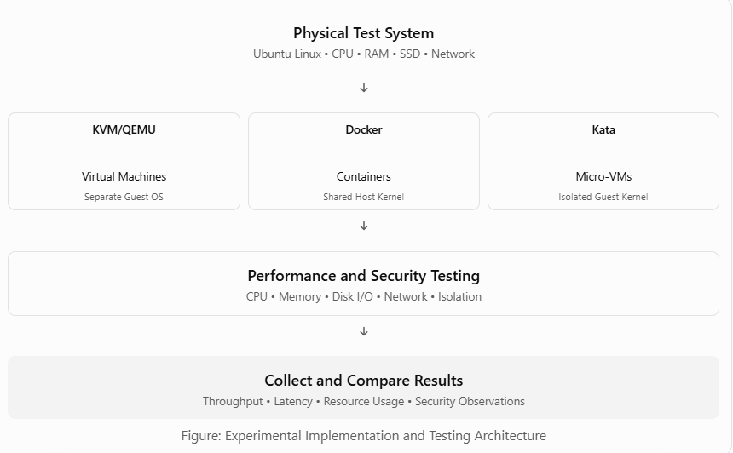

Implementation Procedure
Environment Setup
Install Ubuntu Linux on a physical computer or a virtualized test environment.
Install KVM/QEMU, Docker, Kata Containers and the required benchmarking tools.
Create three separate test environments:
- KVM/QEMU: Run applications inside traditional virtual machines.
- Docker: Run the same applications inside containers.
- Kata Containers: Run applications inside lightweight micro-VMs.
Use equivalent CPU, memory and workload settings wherever possible to maintain a fair comparison.

Workload Configuration
Execute identical workloads under each virtualization architecture.
Test | Workload | Measurement
CPU Test | Sysbench CPU benchmark | Execution time and throughput
Memory Test | Stress-ng memory workload | Memory utilization and performance
Storage Test | Fio read/write operations | IOPS, throughput and latency
Network Test | Iperf3 client/server traffic | Network throughput
Security Test | Inspect namespaces, cgroups and kernel isolation | Isolation characteristics

CPU Performance Testing
Sysbench is used to measure CPU processing performance.
Example command:
sysbench cpu --threads=2 --time=30 run
This command runs a CPU benchmark using two threads for 30 seconds.
Record the total events processed, events per second and latency statistics.

Memory Performance Testing
Stress-ng is used to generate memory-intensive workloads.
Example command:
stress-ng --vm 2 --vm-bytes 512M --timeout 30s
This command creates two memory workers and runs the workload for 30 seconds.
Monitor memory consumption, swapping and resource pressure.

Disk I/O Performance Testing
Fio is used to evaluate storage performance.
Example command:
fio --name=disktest --rw=randrw --bs=4k \
--size=256M --runtime=30 --time_based \
--ioengine=libaio --iodepth=16
This test performs random read/write operations using 4 KB blocks.
Record IOPS, throughput and average or percentile latency.

Network Performance Testing
Iperf3 measures network throughput between two systems.
Server command:
iperf3 -s
Client command:
iperf3 -c SERVER_IP -t 30
Replace SERVER_IP with the actual IP address of the test server.
Record the achieved throughput in Mbps or Gbps.

Scalability and Noisy-Neighbour Testing
To understand the impact of virtualization density, repeat the experiments with different numbers of instances.
Test Level | Number of Instances | Purpose
Baseline | 1 | Measure performance with minimal contention
Low Load | 2 | Observe resource sharing
Medium Load | 4 | Measure moderate contention
High Load | 8 | Identify scheduling and I/O delays
Stress Load | 16 | Evaluate high-density performance
For noisy-neighbour testing, run a CPU-intensive or disk-intensive workload in one instance while measuring the performance of another instance on the same host.
Compare the results to determine whether the competing workload causes performance degradation.
If the test computer cannot support 16 instances, reduce the scale and document the hardware limitation.

Security Isolation Testing
The security evaluation examines the isolation mechanisms used by each architecture.
KVM/QEMU:
- Verify that each VM runs a separate guest operating system.
- Inspect the virtual hardware and guest memory allocation.
- Confirm that one guest cannot directly access another guest's filesystem without explicit sharing.
Docker:
- Inspect process and network namespaces.
- Verify CPU and memory limits using cgroups.
- Confirm that containers share the host kernel.
Kata Containers:
- Verify that the workload runs inside a lightweight virtual machine.
- Inspect the separate guest kernel.
- Compare its isolation boundary with ordinary Docker containers.
These tests inspect isolation mechanisms; they do not prove that the systems are free from vulnerabilities.

Experimental Reproducibility
For reliable results, use the same workload duration, thread count and resource allocation across the three architectures.
Repeat each benchmark at least three times and record the results separately. Monitor CPU steal time, context switches, memory usage and VM exits where supported.
Also compare performance with and without a selected security mitigation, such as network filtering or sandboxed execution.
Record the test computer specifications, software versions and any nested virtualization limitations.

Expected Outcome
The experiment is designed to determine:
- Which virtualization architecture provides the highest CPU and I/O performance.
- How performance changes when instance density increases.
- How noisy-neighbour workloads affect other applications.
- Which architecture provides stronger workload isolation.
- Whether the measured performance satisfies EduCloud's 10% degradation SLA.
The actual findings must be based on benchmark measurements rather than assumed results.

Conclusion
The implementation and testing phase provides a practical method for evaluating EduCloud's virtualization architectures.
KVM/QEMU, Docker and Kata Containers are compared using CPU, memory, storage, network and security isolation tests. Repeating experiments under different instance densities helps identify resource contention and virtualization overhead.

TASK 9 – Record Experimental Performance

Introduction
Experimental performance measurement is used to understand how increasing workloads affects CPU throughput, latency, memory utilization and system responsiveness.
For EduCloud, performance testing is important because the university operates approximately 400 virtual machines across 16 physical servers. During registration periods, multiple applications compete for computing resources.
A CPU-intensive benchmark was executed in a Linux environment to measure the effect of increasing concurrent workloads. The experiment used 1, 2, 4, 8 and 16 processes, with each test repeated three times.
Testing scope: These are actual Linux process-level benchmark results. They provide a baseline for understanding resource contention, but they are not direct measurements of KVM/QEMU, Docker or Kata Containers.
Experimental Setup
Parameter | Configuration
Operating Environment | Linux
Benchmark | Python SHA-256 CPU workload
Concurrent Processes | 1, 2, 4, 8, 16
Repetitions | 3 per configuration
Workload Duration | Approximately 1.8 seconds per trial
Performance Metrics | Throughput, mean latency, P95 latency, memory and context switches
Total Trials | 15
The same computational workload was executed at each concurrency level. Performance measurements were recorded and averaged to reduce the effect of individual trial variations.
Experimental Performance Results
The following table presents the actual recorded measurements.
Processes | CPU Throughput (ops/sec) | Mean Latency (ms) | P95 Latency (ms)
1 | 10,355 | 0.096 | 0.143
2 | 19,326 | 0.104 | 0.161
4 | 33,053 | 0.123 | 0.172
8 | 35,527 | 0.224 | 0.178
16 | 34,749 | 0.456 | 0.182
The results show that throughput increases as additional processes are introduced, but the improvement becomes limited at higher concurrency.
Throughput Analysis
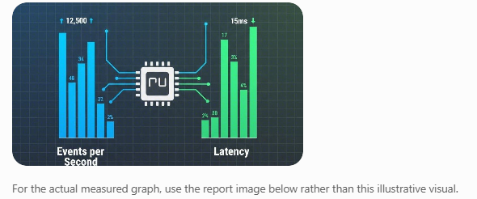
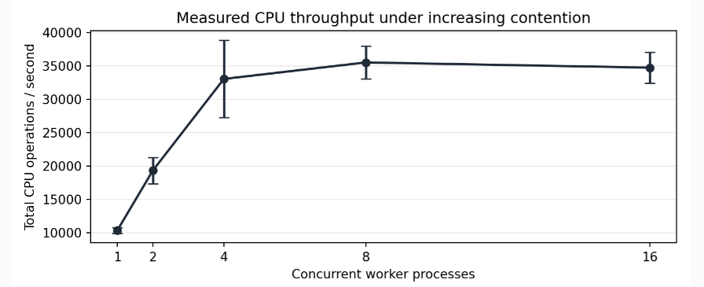
Observations:
- A single process achieved approximately 10,355 operations per second.
- Four concurrent processes achieved approximately 33,053 operations per second.
- Throughput reached approximately 35,527 operations per second at eight processes.
- At sixteen processes, throughput decreased slightly to 34,749 operations per second.
- This indicates that increasing concurrency beyond the available CPU capacity does not necessarily improve performance.
The throughput improvement from one to four processes was approximately 3.19 times.
Latency Analysis
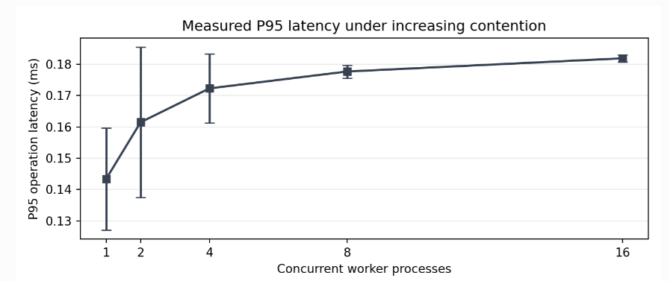
Observations:

- Mean operation latency increased from 0.096 ms to 0.456 ms as concurrency increased from one to sixteen processes.
- P95 latency increased from approximately 0.143 ms to 0.182 ms.
- The higher mean latency at sixteen processes indicates greater scheduling delays.
- At high concurrency, occasional long delays can increase the mean even when P95 remains relatively stable.
This demonstrates that CPU contention can reduce application responsiveness even when aggregate throughput remains high.
Memory Utilization and Context Switching
Processes | Total Memory Usage (MB) | Host Context Switches/sec
1 | 80.29 | 142
2 | 162.23 | 156
4 | 328.32 | 177
8 | 665.71 | 850
16 | 1,333.10 | 1,340
Memory consumption increased with the number of active processes. Host context switching also increased significantly at eight and sixteen processes.
These measurements indicate increasing resource pressure as workload density grows.
Statistical Performance Analysis
Each experiment was repeated three times, and the mean and sample standard deviation were calculated.
Processes | Mean Throughput ± Standard Deviation (ops/sec)
1 | 10,355 ± 444
2 | 19,326 ± 1,984
4 | 33,053 ± 5,794
8 | 35,527 ± 2,452
16 | 34,749 ± 2,298
Formula:
Mean = Sum of measured values / Number of trials
Standard Deviation = √[Σ(x − Mean)² / (n − 1)]
The variation between trials shows why repeated measurements are necessary when evaluating virtualization performance.
Performance Compared With the Baseline
Using the single-process throughput as the reference:
Performance Scaling = Measured Throughput / Single-Process Throughput
For four processes:
Performance Scaling = 33,053 / 10,355 = 3.19×
For sixteen processes:
Performance Scaling = 34,749 / 10,355 = 3.36×
Although the number of processes increased sixteenfold, total throughput improved by only approximately 3.36 times. This indicates that resource contention limits performance scaling.
These scaling values should not be interpreted as virtualization overhead or performance relative to a bare-metal hypervisor benchmark.
Virtualization and Security Mitigation Comparison
The assignment also requires measurements for KVM/QEMU, Docker and Kata Containers, including performance with and without security mitigation.
Those environments were not available for this benchmark. Therefore, CPU steal time, VM exits, actual VM/container startup times and mitigation overhead were not measured.
The host-process measurements provide useful baseline evidence, but additional platform-specific experiments are required to complete that comparison.

Conclusion
The experimental results demonstrate that increasing concurrent workloads improves CPU throughput only up to a certain point. Beyond this limit, resource contention and scheduling delays reduce performance efficiency.
The highest recorded mean throughput was approximately 35,527 operations per second with eight processes, while sixteen processes produced higher mean latency and greater context switching.
These findings highlight the importance of workload distribution, resource allocation and performance monitoring in EduCloud.
For the university's virtualization infrastructure, controlling workload density and preventing noisy-neighbour interference can help maintain application responsiveness during registration and examination periods.
The experiment establishes a measured Linux performance baseline. Further KVM/QEMU, Docker and Kata testing is needed to determine architecture-specific overhead and validate the 10% performance SLA.

TASK 10 – Compare Theory with Experiment

Introduction
The purpose of this task is to compare the theoretical performance predictions developed in Tasks 3 and 4 with the experimental results recorded in Task 9.
The theoretical model predicts that performance depends on CPU allocation, virtualization overhead, memory availability and resource contention. The experiment measures how CPU throughput and latency change when the number of concurrent processes increases.
This comparison helps identify differences between expected and observed performance and determine whether the model is suitable for EduCloud.

Theoretical Performance Predictions
Based on Task 3, the main performance assumptions are:
- Virtualization overhead is assumed to be 5% in the illustrative CPU model.
- CPU performance decreases when multiple workloads compete for physical cores.
- Increasing CPU overcommitment can increase scheduling delays.
- Memory and I/O contention can further reduce application performance.
- EduCloud requires performance degradation to remain within 10%.
Task 4 predicts that best-case conditions produce minimal performance degradation, while typical and worst-case conditions experience increased contention and latency.
For the Linux benchmark, a simple ideal linear-scaling model is used as the comparison baseline.
Predicted Throughput = Single-Process Throughput × Number of Processes
The measured single-process throughput was 10,355 operations per second.
This model assumes sufficient CPU resources and no additional contention. It is not a prediction of EduCloud's actual 64-core host performance.

Experimental Performance Results
The following measurements were obtained from the CPU benchmark in Task 9.
Concurrent Processes | Measured Throughput (ops/sec) | Mean Latency (ms)
1 | 10,355 | 0.096
2 | 19,326 | 0.104
4 | 33,053 | 0.123
8 | 35,527 | 0.224
16 | 34,749 | 0.456
The results show that throughput initially increases with concurrency but reaches a plateau at higher process counts.
Comparison of Theoretical and Experimental Throughput
Processes | Ideal Predicted Throughput | Actual Throughput | Prediction Error
1 | 10,355 | 10,355 | 0%
2 | 20,710 | 19,326 | 6.68%
4 | 41,420 | 33,053 | 20.20%
8 | 82,840 | 35,527 | 57.11%
16 | 165,680 | 34,749 | 79.03%
Percentage Error Formula:
Percentage Error = |Predicted Value − Measured Value| / Predicted Value × 100
Example Calculation for Four Processes:
Percentage Error = (41,420 − 33,053) / 41,420 × 100
Percentage Error = 20.20%
The increasing prediction error shows that ideal linear scaling becomes inaccurate as resource contention increases.

Graphical Comparison
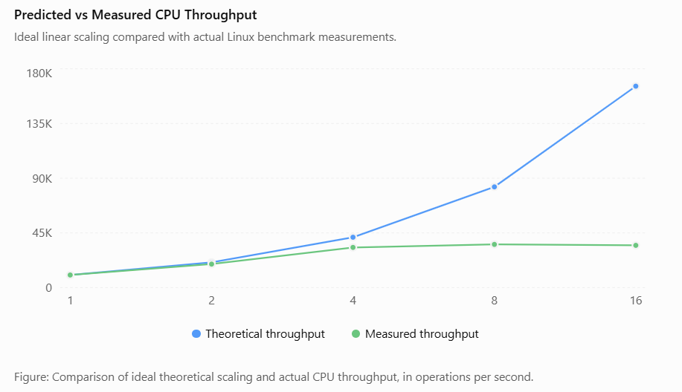

Analysis of Performance Differences
CPU Scheduling and Contention
The theoretical model assumes that sufficient CPU resources are available for each process. In practice, multiple processes compete for available CPU time.
At eight processes, throughput reached approximately 35,527 operations per second. Increasing concurrency to sixteen processes reduced throughput to approximately 34,749 operations per second.
This indicates that additional processes did not improve overall processing capacity.
Context Switching Overhead
As the number of concurrent processes increases, the operating system must switch between tasks more frequently.
In Task 9, the observed host context-switch rate increased from approximately 142 to 1,340 switches per second between the one-process and sixteen-process tests.
This increased scheduling activity can contribute to performance overhead.
Memory and Cache Effects
Multiple processes require additional memory and compete for processor caches and memory bandwidth.
The benchmark's total process memory footprint increased from approximately 80 MB to 1,333 MB as concurrency increased.
Cache contention and memory-access delays are possible explanations for reduced scaling, although cache misses were not measured directly.
Virtualization and Experimental Limitations
Task 3 included VM exit costs, CPU steal time and virtualization overhead. However, Task 9 measured ordinary Linux processes rather than actual KVM, Docker and Kata instances.
Therefore, the experiment cannot directly quantify VM exit overhead, compare hypervisor efficiency or determine the effect of nested virtualization.

Comparison Under Different Operating Conditions
Operating Condition | Theoretical Prediction | Experimental Evidence
Best Case | Minimal contention and efficient processing | One-process test provided the baseline
Typical Case | Increased resource sharing and scheduling overhead | Two- and four-process tests showed increasing throughput with sublinear scaling
Worst Case | Heavy contention and increased latency | Eight- and sixteen-process tests showed throughput saturation and higher mean latency
The observed trends generally support the contention-related predictions in Task 4. However, the experiment did not include memory swapping, live migration or an I/O storm, so those specific worst-case predictions remain unverified.

Effect on Security Conclusions
The results demonstrate that increasing workload density can reduce performance efficiency.
This supports the recommendation to reserve sufficient CPU capacity for critical SIS applications and limit resource-intensive research workloads.
However, the experiment did not measure the overhead of security controls such as micro-VM isolation, image verification or network microsegmentation.
Therefore, the performance cost of stronger isolation must be evaluated separately before selecting the final EduCloud architecture.

Model Accuracy and Limitations
The ideal scaling model provides a useful starting point, but its prediction error increases significantly at higher concurrency.
The experiment also has several limitations:
- It was performed on a Linux test environment rather than EduCloud's actual 16-host infrastructure.
- The test used CPU-intensive processes rather than separate virtual machines.
- Only three trials were performed per configuration.
- Hypervisor-specific metrics and security mitigation overhead were not measured.
The 10% EduCloud SLA cannot be confirmed or rejected using these process-level scaling errors alone. SLA validation requires equivalent workloads measured against appropriate native and virtualized baselines.

Conclusion
The comparison between theoretical predictions and experimental results shows that ideal linear scaling does not continue indefinitely as concurrent workloads increase.
The measured throughput increased from 10,355 operations per second with one process to 35,527 operations per second with eight processes, but decreased slightly at sixteen processes.
The prediction error increased from 6.68% at two processes to 79.03% at sixteen processes, demonstrating the importance of accounting for CPU contention, scheduling overhead and hardware capacity.
These findings support the need for controlled workload density, performance monitoring and resource isolation in EduCloud. Further KVM/QEMU, Docker and Kata experiments are required to validate architecture-specific performance and security trade-offs.

TASK 11 – Recommend and Defend the Final Architecture

Introduction
EduCloud requires a secure, scalable and high-performance virtualization architecture to support the Student Information System (SIS), Learning Management System (LMS), Examination Portal and departmental research applications.
The university currently operates 16 physical servers and approximately 400 virtual machines. During peak registration periods, increased resource contention can cause slow responses and failed logins.
Based on the theoretical performance model, security analysis and available experimental results, a hybrid virtualization architecture is recommended for EduCloud.
Proposed Virtualization Architecture
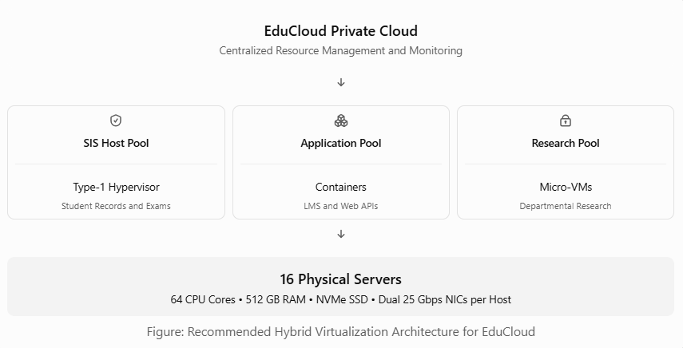
Recommended Workload Allocation
Workload | Recommended Architecture | Justification
Student Information System | Type-1 Hypervisor on dedicated hosts | Strong isolation for confidential student records
Examination Portal | Type-1 Hypervisor | Security and predictable resource allocation
Learning Management System | Containers | Efficient deployment and application scaling
University Web APIs | Containers | Lightweight execution and lower resource overhead
Departmental Research | Micro-VMs | Improved isolation between research workloads
This approach separates critical academic applications from less-sensitive workloads while improving resource utilization.
Performance-Based Justification
The theoretical model developed in Task 3 provides the following estimates:
- Each physical server contains 64 CPU cores and 512 GB RAM.
- Average VM memory allocation is 8 GB.
- Reserving 32 GB RAM for host operations provides 480 GB for VMs.
- Estimated memory-based capacity is 60 VMs per host.
- Existing average density is 25 VMs per host.
- Performance degradation must remain within 10%.
The current average VM density is below the estimated memory capacity. However, CPU, storage and network contention may still affect application performance.
The Linux benchmark performed in Task 9 showed:
Concurrent Processes | Measured CPU Throughput
1 | 10,355 ops/sec
2 | 19,326 ops/sec
4 | 33,053 ops/sec
8 | 35,527 ops/sec
16 | 34,749 ops/sec
The measured throughput increased initially but stopped improving at higher concurrency.
This supports the recommendation to avoid excessive workload consolidation and maintain sufficient CPU capacity for critical university services.
The benchmark was conducted using Linux processes, not separate KVM, Docker or Kata instances. Therefore, it supports the general contention analysis but does not establish which virtualization architecture performs best experimentally.
Security and Residual Risk Analysis
Type-1 Hypervisors
Provide strong separation between guest operating systems and are suitable for sensitive SIS workloads.
Residual risks include hypervisor vulnerabilities, compromised administrator credentials and hardware side-channel attacks.
Containers
Provide efficient application deployment using a shared operating system kernel.
Residual risks include container escape, kernel vulnerabilities and insecure container images.
Micro-VMs
Provide separate guest kernels and hardware-assisted isolation for research workloads.
Residual risks include virtual machine monitor vulnerabilities, side-channel attacks and insecure image configurations.
To reduce these risks, EduCloud should implement network microsegmentation, role-based access control, regular patching and digital image verification.
Operational Management
The following practices are recommended to maintain performance and security:
- Patch Management: Regularly update hypervisors, guest operating systems, container runtimes and applications.
- Image Management: Maintain approved and digitally signed VM and container images.
- Live Migration: Schedule migrations outside peak registration and examination periods whenever possible.
- Performance Monitoring: Track CPU steal time, memory utilization, disk latency and network throughput.
- Access Control: Restrict administrative permissions and isolate sensitive SIS infrastructure.
- Backup and Recovery: Maintain secure backups and regularly test recovery procedures.
Scalability and Future Expansion
EduCloud currently supports approximately 400 virtual machines, but future demand may increase to several thousand instances.
The proposed architecture supports expansion through workload distribution, container orchestration and micro-VM deployment.
Using the Task 3 memory model:
Estimated maximum memory-based capacity = 16 × 60 = 960 VMs
This is only a theoretical memory limit and does not guarantee that 960 active VMs will satisfy CPU, storage, network or security requirements.
To support several thousand workloads, EduCloud may need additional physical servers, more efficient resource allocation and application-level scaling.
Containers can improve application density, while additional dedicated hosts can protect critical workloads as demand increases.
Limitations of the Recommended Architecture
- The theoretical performance model uses simplified assumptions.
- Actual KVM, Docker and Kata performance measurements are not yet available.
- The existing Linux benchmark does not measure VM exits or hypervisor overhead.
- Dedicated SIS hosts may reduce infrastructure utilization.
- Stronger isolation may introduce additional memory and processing overhead.
These limitations should be addressed through platform-specific benchmarking and continuous performance monitoring.
Conclusion
A hybrid virtualization architecture is recommended for EduCloud because it balances security, performance and scalability.
Type-1 hypervisors should protect sensitive SIS and examination workloads, containers should support lightweight LMS and web applications, and micro-VMs should isolate departmental research workloads.
The theoretical model indicates that EduCloud's existing average density of 25 VMs per host is below its estimated memory capacity. Experimental Linux benchmark results also demonstrate that increasing workload concurrency eventually leads to performance saturation.
By combining appropriate workload isolation, resource allocation, security controls and continuous monitoring, EduCloud can improve reliability while preparing for future growth.

TASK 12 – Re-evaluate and Adapt the Design: Day-4 Design Challenge

Introduction
EduCloud initially designed its private cloud to support trusted university applications such as the Student Information System (SIS), Learning Management System (LMS), Examination Portal and departmental research workloads.
However, the university now plans to allow external research collaborators to execute Spark and Hadoop big-data workloads on the same infrastructure.
This introduces new performance and security challenges because external users are less trusted, big-data applications consume significant computing resources, and registration traffic may increase to three times its normal level.
Therefore, the original virtualization architecture must be re-evaluated to ensure strong data isolation, acceptable performance and scalability.

Impact Analysis of the New Requirements
The Day-4 scenario introduces several changes to EduCloud's original operating environment.

Increased Security Risks
External research collaborators introduce a less-trusted tenant category.
- External users may execute unfamiliar or potentially vulnerable applications.
- Spark and Hadoop workloads may access shared computing and network resources.
- Hypervisor vulnerabilities and side-channel attacks could threaten other tenants.
- Insecure VM images or configurations could introduce malicious software.
- New regulations require demonstrable isolation of student data from external tenants.
Security Impact: If external research workloads are not properly isolated, student records and examination data may face confidentiality, integrity and availability risks.
Increased Performance Demands
Spark and Hadoop workloads frequently perform intensive CPU, memory, disk and network operations.
- Big-data jobs may run continuously for several hours.
- Registration traffic may increase to three times its normal level.
- Heavy disk I/O may delay SIS database transactions.
- Network-intensive jobs may compete with university applications.
- Live migration during patching may increase resource contention.
Performance Impact: These conditions can increase CPU steal time, network latency, storage delays and application response times.
Evaluation of the Original Architecture
The original hybrid architecture recommended in Task 11 uses Type-1 hypervisors for SIS, containers for LMS and micro-VMs for research workloads.
Although this design provides different levels of isolation, it requires additional controls before external collaborators can safely share EduCloud's infrastructure.
Performance Evaluation
From Task 3:
Parameter | Value
Physical Servers | 16
CPU Cores per Server | 64
RAM per Server | 512 GB
Average VM Memory | 8 GB
Estimated Memory-Based VM Capacity | 60 per host
Existing Average VM Density | 25 per host
Maximum Allowed Performance Degradation | 10%
The existing average density is below the estimated memory limit. However, this does not guarantee sufficient CPU, storage or network capacity for external big-data workloads.
For example, assume registration traffic causes CPU steal time to rise to 12%, while virtualization overhead remains 5%.
Effective CPU Performance = (1 − 0.05) × (1 − 0.12) × 100
Effective CPU Performance = 83.6%
Performance Degradation = 100 − 83.6 = 16.4%
This exceeds the 10% performance SLA.
The calculation is an illustrative scenario, not a measured result. It demonstrates why additional resource isolation is necessary.
Security Evaluation
The original architecture provides strong logical isolation through hypervisors and micro-VMs.
However, if external research workloads share physical hosts, management systems or network segments with SIS applications, the design may not provide the demonstrable separation required by the new regulation.
Therefore, stronger host-level and network-level isolation is recommended.
Proposed Design Modification
Decision: MODIFY the existing hybrid architecture.
A complete redesign is unnecessary because the existing Type-1 hypervisor, container and micro-VM technologies can still support EduCloud.
However, physical host pools, network controls and resource allocation policies must be modified.
Updated Virtualization Architecture
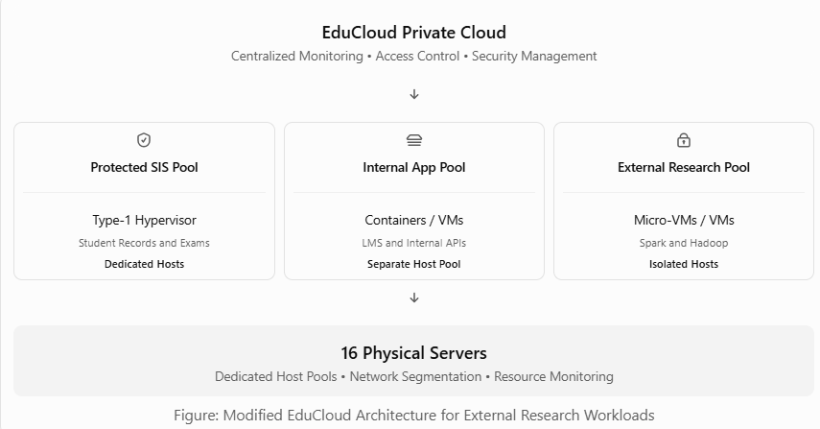

Recommended Architectural Changes
Dedicated Physical Host Pools
Separate the physical infrastructure into three workload categories.
Host Pool | Example Allocation | Workloads
Protected SIS Pool | 6 Hosts | SIS, Examination Portal and Databases
Internal Application Pool | 4 Hosts | LMS, Web Applications and APIs
External Research Pool | 6 Hosts | Spark, Hadoop and External Research
Total | 16 Hosts
This is a proposed allocation, not an existing configuration. The final host distribution must be adjusted according to measured demand.
Dedicated host pools reduce the risk of direct hardware resource sharing between sensitive student systems and external tenants.
Stronger Research Workload Isolation
External Spark and Hadoop workloads should run inside micro-VMs or fully isolated virtual machines.
- Use separate guest kernels for external workloads.
- Restrict access to host operating systems.
- Verify VM images before deployment.
- Apply CPU, memory and storage limits.
- Prevent external tenants from accessing SIS management interfaces.
This reduces the attack surface associated with shared-kernel execution.
Network and Storage Isolation
- Use separate virtual networks for SIS and external research workloads.
- Apply network microsegmentation and firewall policies.
- Use dedicated NICs or SR-IOV where supported and securely configured.
- Restrict storage access through separate permissions and storage pools.
- Encrypt sensitive student data and protect migration traffic.
These controls reduce unauthorized communication and resource interference.
Secure Live Migration
Live migration should be managed carefully during registration and examination periods.
- Avoid nonessential migrations during peak hours.
- Encrypt and authenticate migration connections.
- Monitor network utilization before migration.
- Reserve sufficient CPU and memory capacity on destination hosts.
- Maintain audit logs of migration operations.
These measures reduce the risk of service disruption and data exposure.
Quantitative Performance and Density Trade-off
Using the proposed host allocation and the Task 3 memory model:
Host Pool | Hosts | Estimated Memory-Based Capacity
Protected SIS | 6 | 360 VMs
Internal Applications | 4 | 240 VMs
External Research | 6 | 360 VMs
Total | 16 | 960 VMs
The theoretical memory capacity remains 960 VMs because the number of physical servers has not changed.
However, separating host pools reduces the flexibility to move workloads between categories. Unused capacity in one pool cannot automatically be reassigned to another without affecting the isolation policy.
The actual safe density will be lower when CPU demand, big-data memory requirements, network utilization and storage I/O are considered.
Network Throughput Improvement
Assume external research traffic uses one dedicated 25 Gbps NIC.
If 16 active research workloads share the interface equally:
Theoretical bandwidth per workload = 25 / 16
Theoretical bandwidth per workload = 1.5625 Gbps
This allocation prevents those workloads from consuming the SIS pool's dedicated network bandwidth, provided the underlying network and storage paths are also appropriately separated.
The calculated value represents ideal equal sharing and excludes protocol overhead.
Evidence-Based Defense of the Modified Architecture
The experimental results from Task 9 showed that increasing concurrent CPU workloads does not always produce proportional performance improvement.
Concurrent Processes | Measured Throughput
1 | 10,355 ops/sec
4 | 33,053 ops/sec
8 | 35,527 ops/sec
16 | 34,749 ops/sec
Throughput increased until eight processes and then decreased slightly at sixteen processes.
This supports the general conclusion that high workload density can cause resource contention.
The theoretical model also demonstrates that a combination of 5% virtualization overhead and 12% CPU steal time could produce 16.4% performance degradation, exceeding EduCloud's 10% SLA.
However, the Linux benchmark did not directly test Spark, Hadoop, noisy-neighbour isolation, live migration or security mitigation overhead. Therefore, those effects require additional experiments before the modified architecture can be considered fully validated.
Cost and Security Trade-off
Design Decision | Security Benefit | Performance or Cost Impact
Dedicated SIS Hosts | Physical separation from external tenants | Reduced workload placement flexibility
Micro-VMs for External Users | Stronger isolation than shared-kernel containers | Additional guest OS and virtualization overhead
Dedicated Network Resources | Reduced network interference | More reserved network capacity
Network Microsegmentation | Restricts unauthorized communication | Additional packet filtering overhead
Encrypted Live Migration | Protects data during transfer | Additional CPU and network processing
Resource Limits | Reduces noisy-neighbour interference | May restrict peak research throughput
The modified architecture prioritizes student data protection and predictable SIS performance over maximum infrastructure utilization.
Conclusion
The Day-4 scenario significantly changes EduCloud's security and performance requirements by introducing external Spark and Hadoop workloads, increased registration traffic and stricter student data isolation requirements.
The original hybrid architecture remains suitable as a foundation, but it must be modified to provide stronger separation between trusted university systems and external collaborators.
The recommended solution uses dedicated SIS hosts, separate internal application and external research pools, hardware-isolated VMs or micro-VMs, network microsegmentation and secure live migration.
Theoretical calculations and available experimental evidence support controlling workload density and resource contention. However, final compliance with the 10% performance SLA and new isolation regulation must be demonstrated through virtualization-specific benchmarks, security testing and audit evidence.

