Experiment 2: Basic Image Handling and Processing Operations

Aim
To read an image using Python and apply Gaussian Blur to the image.

Algorithm
- Import the OpenCV (cv2) library.
- Read the input image using cv2.imread().
- Apply Gaussian Blur using cv2.GaussianBlur() with a kernel size of (5,5).
- Display the original image.
- Display the blurred image.
- Wait for a key press and close all display windows.

Python Code
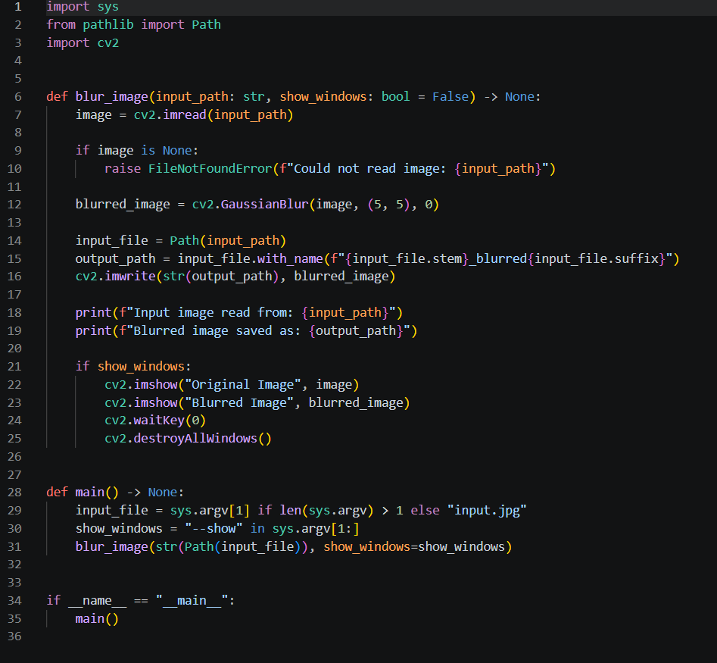
INPUT

OUTPUT


Result
The input image was successfully read using Python, and Gaussian Blur was applied to the image successfully.

