**Task 6:**

1. **Syntax for all loops in shell**

* **Output for for Loop**

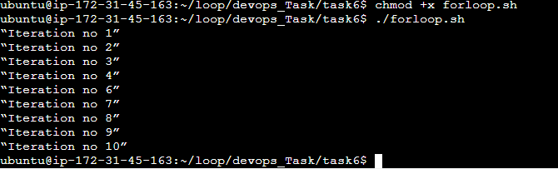

* **Output for while Loop**

