Coding Puzzle

This document covers the following topics detailly.

1. Requirements.
2. Design
3. Features
4. Improvements

**1. Requirements:**

This is a fascinating game and can be played in command line interface (CLI).

***Given requirements****:*

* As a player I want to create a character.
* As a player I want to explore.
* As a player I want to gain experience through fighting.
* As a player I want to save and resume a game.

**As a player I want to create a character:**

To fulfill this story, game will ask you about character and its characteristics. Player can split the points and give it to character.

**As a player I want to explore:**

Player can explore by selecting explore menu. In which, it has key to navigate the character in the battle field.

**As a player I want to gain experience through fighting:**

In the game, player could do two actions other than navigation.

1. Treasure – Player could try to get the treasure by reaching into specific treasure coordinates.
2. Fight – Fight and kill the enemy.

**As a player I want to save and resume a game:**

The player can save the game when he wants to continue later. The state of the game will be saved into a file.

Below are entities for this game.

**Battle field:**

* Build a grid which is of 10x10 size or more than that.
* Create characters and arrange them in player order.
* The treasures will be placed randomly in the middle of the battle field.
* Build the enemy with equivalent powers and automatically order them outside the battle field.

**Character**

* Each character will have a unique move and its quality (Say example, bishop is a character where he moves diagonally to maximum distance).
* Each character will have specific properties such as name, hair, color, experience level, health and points.
* The character who has more points or health will have more ability to kill the enemy and take big treasures.
* The character who has less points will have ability to move faster than other characters.

**Enemy**

* Initially, enemy characters will be built and placed outside the battle field.
* Each time, game will read and analyze the players move. Based on it, enemy will move accordingly to take the treasure or kill the player.

**Game level**

* No points or health added to the characters, he must play with same when he moves into the next level.
* No of treasures will be reduced and placed when the game level increases.
* When treasure reduces, there is more possibility for the fight. Hence, either player or enemies will be killed to conclude the game.

**Winner:**

* Whoever kills all the enemies or take all the treasures.

**2. Design:**

* Main menu
  + New game
    - Create Character menu.
      * Initial points will be given to the player.
      * Player will split the points and create characters with some points.
      * Arrange the characters in the order for the battle.
      * Once done, player will be ready for the game.
    - Explore menu.
      * Player would see all the navigation keys for the characters to move such as which character to go into battle, move forward, backward, left and right.
    - Save Game menu.
      * Player can save the game where he needs to continue later.
  + Load a saved game.
* Get the username and checks the saved state of game for the exists.
* If exists, then load the game for the player.
* If does not, ask the player to create a new game.
* Leave the game
* Exit the game.

**Battle field:**

|  |  |  |  |  |  |  |  |  |  |
| --- | --- | --- | --- | --- | --- | --- | --- | --- | --- |
| Ec1 | Ec2 | Ec3 | Ec4 | Ec5 | Ec6 | Ec7 | Ec8 | Ec9 | Ec10 |
|  |  |  |  |  |  |  |  |  |  |
|  |  |  |  |  |  |  |  |  |  |
|  |  |  |  |  |  |  |  |  |  |
|  |  |  |  |  |  |  |  |  |  |
|  | $1000 | $10 | $20 | $30 | $16 | $500 | $200 | $900 |  |
|  |  |  |  |  |  |  |  |  |  |
|  |  |  |  |  |  |  |  |  |  |
|  |  |  |  |  |  |  |  |  |  |
|  |  |  |  |  |  |  |  |  |  |
|  |  |  |  |  |  |  |  |  |  |
| Pc1 | Pc2 | Pc3 | Pc4 | Pc5 | Pc6 | Pc7 | Pc8 | Pc9 | Pc10 |

**Class diagrams:**

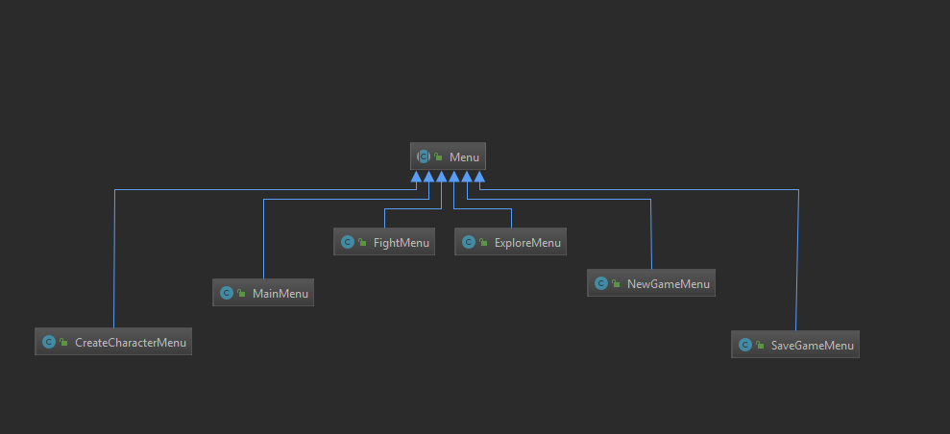

**When player is trying to play without creating a character.**

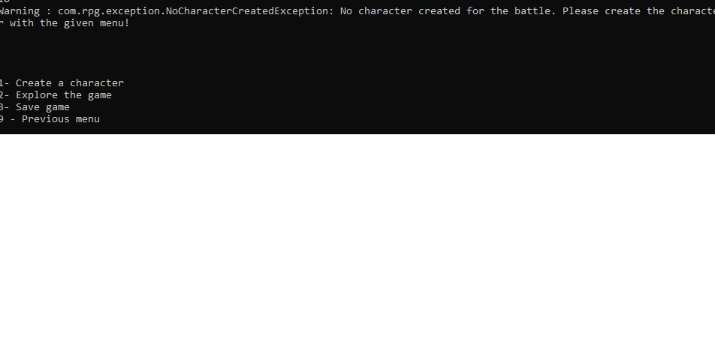

**Battle field:**

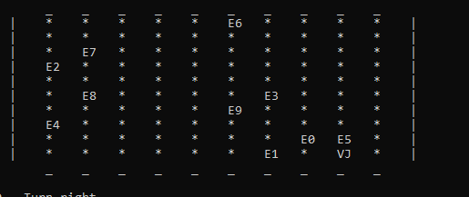

**When player reaches at an enemy point:**

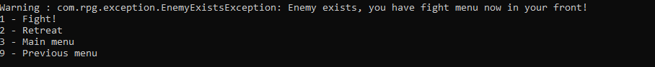

**When he attacks:**

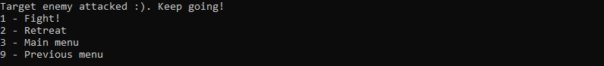

**When the game saves into a file:**

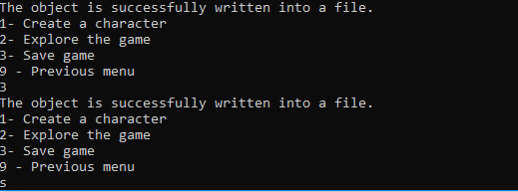

**3. Features:**

* Character can move diagonally to attack the enemies.
* There are few characters created with unique powers like batman, hitman, spiderman and black panther.
* Say example, hitman has unique power who can diagonally up to 3 steps in all directions.
* */**  
   * 3 step for diagonal, 1 step for each move.  
   */  
  HITMAN*(new Navigation(1, 1, 1, 1, 3, 3, 3, 3));
* Can able to save the battle field into a field with the player name as filename.
* Can able to go back to “previous” menu from each menu.
* Once player is trying to reach enemy location, then fight menu will be popped up for the battle.
* Player doesn’t know which enemy has more health and points. So, it’s hard to attack the enemy and it’s also a luck if he attacks all enemies.
* Can able to change the grid size through the properties.
* noOfRows=10  
  noOfColumns=10  
    
  origin.point=0  
  maximum.point=10

**4. Improvements:**

* As an enhancement, enemies could move subsequently after the player moves.
* Currently, the enemy will not move, and it is being placed at random coordinates. But, as an enhancement, we can change the enemies move based on player’s move(In this case, we can use decision-tree algorithm).
* Currently, player can create with single character. In an enhancement, player can create multiple characters with equivalent powers.
* Currently, game character and enemies are placed randomly inside the battle field. But, we could arrange the characters based on position as player choice and enemies outside the battle. Player will command which game character to enter into the battle.
* Timely save is effective way of saving the game. Because, if something goes wrong, then it could help player to continue at least from the latest.
* We can bring the ascii characters to be displayed in the battle field.