Coding Puzzle

This document covers the following topics detailly.

1. Requirements.
2. Design
3. Features
4. Improvements

**1. Requirements:**

This is a fascinating game and can be played in command line interface (CLI).

***Given requirements****:*

* As a player I want to create a character.
* As a player I want to explore.
* As a player I want to gain experience through fighting.
* As a player I want to save and resume a game.

**As a player I want to create a character:**

To fulfill this story, game will ask you about character and its characteristics. Player can split the points and give it to character.

**As a player I want to explore:**

Player can explore by selecting explore menu. In which, it has key to navigate the character in the battle field.

**As a player I want to gain experience through fighting:**

In the game, player could do two actions other than navigation.

1. Treasure – Player could try to get the treasure by reaching into specific treasure coordinates.
2. Fight – Fight and kill the enemy.

**As a player I want to save and resume a game:**

The player can save the game when he wants to continue later. The state of the game will be saved into a file.

Below are entities for this game.

**Battle field:**

* Build a grid which is of 10x10 size or more than that.
* Create characters and arrange them in player order.
* The treasures will be placed randomly in the middle of the battle field.
* Build the enemy with equivalent powers and automatically order them outside the battle field.

**Character**

* Each character will have a unique move and its quality (Say example, bishop is a character where he moves diagonally to maximum distance).
* Each character will have specific properties such as name, hair, color, experience level, health and points.
* The character who has more points or health will have more ability to kill the enemy and take big treasures.
* The character who has less points will have ability to move faster than other characters.

**Enemy**

* Initially, enemy characters will be built and placed outside the battle field.
* Each time, game will read and analyze the players move. Based on it, enemy will move accordingly to take the treasure or kill the player.

**Game level**

* No points or health added to the characters, he must play with same when he moves into the next level.
* No of treasures will be reduced and placed when the game level increases.
* When treasure reduces, there is more possibility for the fight. Hence, either player or enemies will be killed to conclude the game.

**Winner:**

* Whoever kills all the enemies or take all the treasures.

**2. Design:**

* Main menu
  + New game
    - Create Character menu.
      * Initial points will be given to the player.
      * Player will split the points and create characters with some points.
      * Arrange the characters in the order for the battle.
      * Once done, player will be ready for the game.
    - Explore menu.
      * Player would see all the navigation keys for the characters to move such as which character to go into battle, move forward, backward, left and right.
    - Save Game menu.
      * Player can save the game where he needs to continue later.
  + Load a saved game.
* Get the username and checks the saved state of game for the exists.
* If exists, then load the game for the player.
* If does not, ask the player to create a new game.
* Leave the game
* Exit the game.

**Battle field:**

|  |  |  |  |  |  |  |  |  |  |
| --- | --- | --- | --- | --- | --- | --- | --- | --- | --- |
| Ec1 | Ec2 | Ec3 | Ec4 | Ec5 | Ec6 | Ec7 | Ec8 | Ec9 | Ec10 |
|  |  |  |  |  |  |  |  |  |  |
|  |  |  |  |  |  |  |  |  |  |
|  |  |  |  |  |  |  |  |  |  |
|  |  |  |  |  |  |  |  |  |  |
|  | $1000 | $10 | $20 | $30 | $16 | $500 | $200 | $900 |  |
|  |  |  |  |  |  |  |  |  |  |
|  |  |  |  |  |  |  |  |  |  |
|  |  |  |  |  |  |  |  |  |  |
|  |  |  |  |  |  |  |  |  |  |
|  |  |  |  |  |  |  |  |  |  |
| Pc1 | Pc2 | Pc3 | Pc4 | Pc5 | Pc6 | Pc7 | Pc8 | Pc9 | Pc10 |

**Class diagrams:**

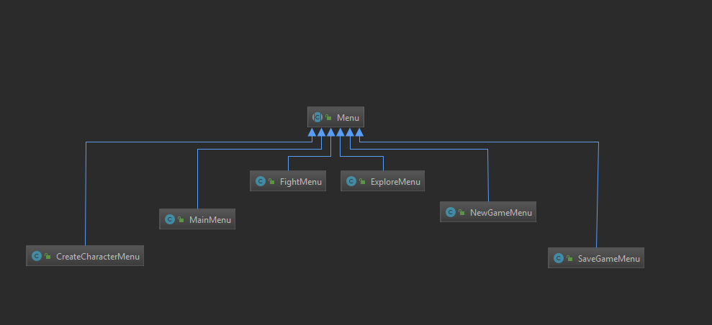

**When player is trying to play without creating a character.**

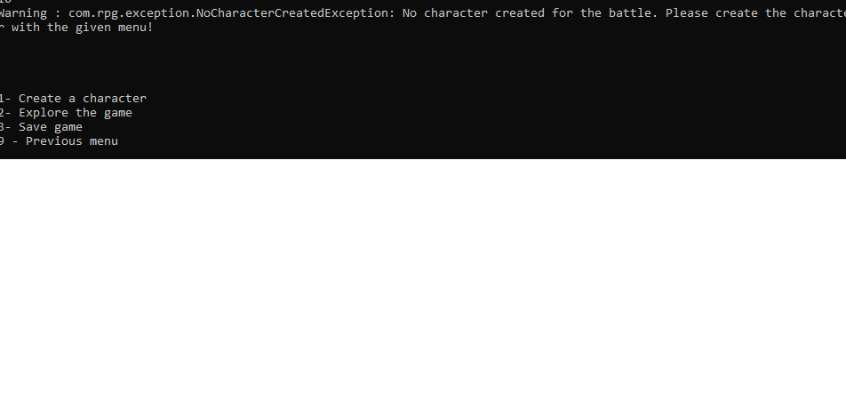

**Battle field:**

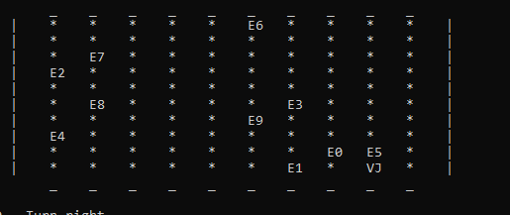

**When player reaches at an enemy point:**

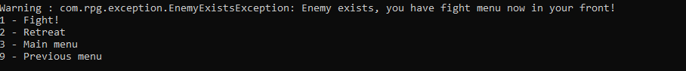

**When he attacks:**

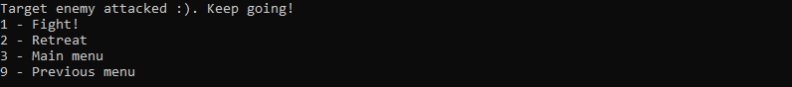

**When the game saves into a file:**

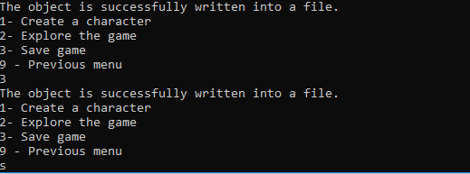

**3. Features.**

* Character can move diagonally to attack the enemies.
* There are few characters created with unique powers like batman, hitman, spiderman and black panther.
* Say example, hitman has unique power who can diagonally up to 3 steps in all directions.
* */**  
   * 3 step for diagonal, 1 step for each move.  
   */  
  HITMAN*(new Navigation(1, 1, 1, 1, 3, 3, 3, 3));
* Can able to save the battle field into a field with the player name as filename.
* Can able to go back to “previous” menu from each menu.
* Once player is trying to reach enemy location, then fight menu will be popped up for the battle.
* Player doesn’t know which enemy has more health and points. So, it’s hard to attack the enemy and it’s also a luck if he attacks all enemies.
* Can able to change the grid size through the properties.
* noOfRows=10  
  noOfColumns=10  
    
  origin.point=0  
  maximum.point=10