Assignment

Java Programming Zero to Hero | AUG 2021 👨🏽‍💻 Day 1

Question 1 : Mention the difference between interpreter and compiler.

Anaswer : Compiler
A compiler is a software program that follows the syntax rule of programming language to convert a source code to machine code. It cannot fix any error if present in a program; it generates an error message, and you have to correct it yourself in the program's syntax. If your written program is correct (contains no error), then the compiler will convert your entire source code into machine code. A compiler converts complete source code into machine code at once. And finally, your program get executes.

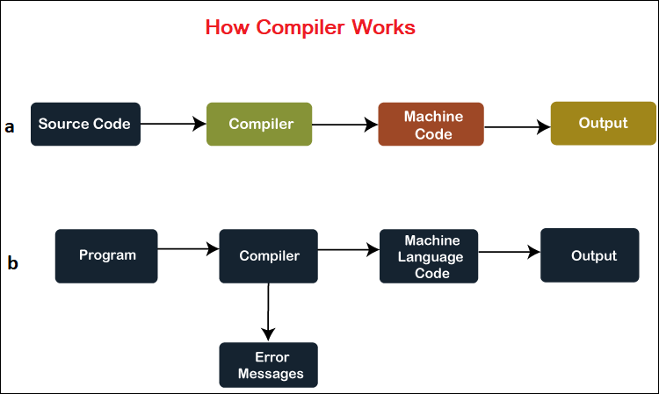

Interpreter
An interpreter is also a software program that translates a source code into a machine language. However, an interpreter converts high-level programming language into machine language line-by-line while interpreting and running the program.
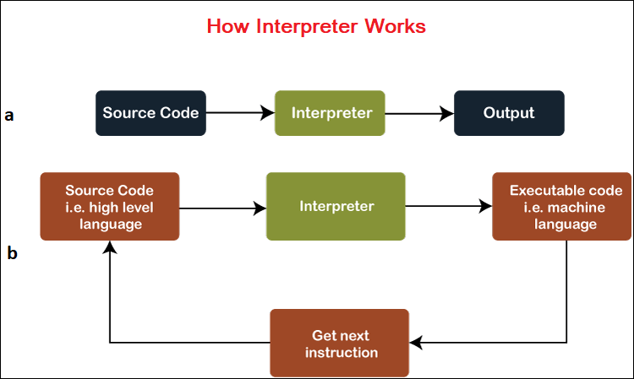

Interpreter Vs Compiler
Interpreter | Compiler
Translates program one statement at a time. | Scans the entire program and translates it as a whole into machine code.
Interpreters usually take less amount of time to analyze the source code. However, the overall execution time is comparatively slower than compilers. | Compilers usually take a large amount of time to analyze the source code. However, the overall execution time is comparatively faster than interpreters.
No Object Code is generated, hence are memory efficient. | Generates Object Code which further requires linking, hence requires more memory.
Programming languages like JavaScript, Python, Ruby use interpreters. | Programming languages like C, C++, Java use compilers.

