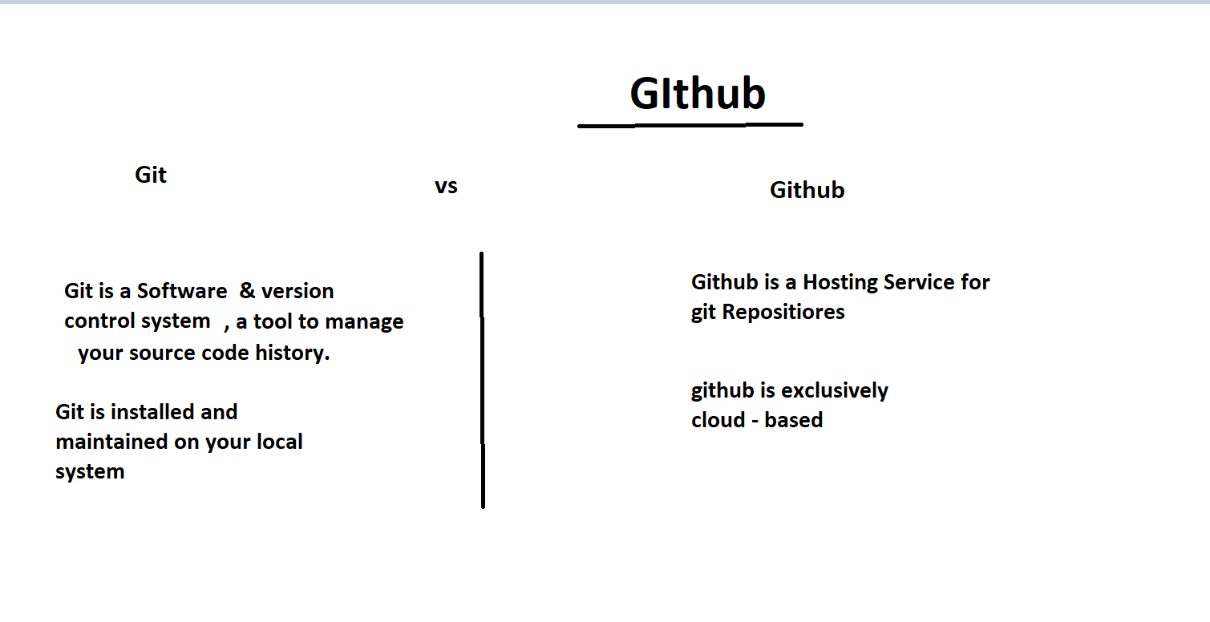 There are some Major Command :-

Git – To Check your folder is working/repositiory area or not

Pwd – ( present Working Directory)

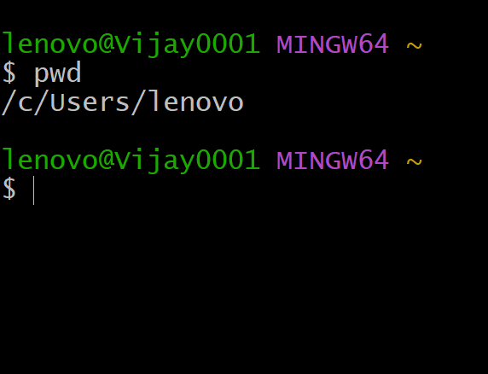

Cd [ file name ]– change directory command

Git Status – To Show your current operation directory status.

Git config --global user.name “ xyz” – here you write your name

Git config –global user.email “xyz@gmail.om” – here you write your email.

Git config user.name – To display your name on the screen.

Git config user.name – To dispay your email id on the screen

>>>> IN GIT THREE STAGE ARCHITRCTURE :-

1. WORKING DIRECTORY
2. STAGING AREA
3. GET DIRECTORY ( REPOSITIORY)

Git init – first intilaize the folder.

Git add --a – to move all file into staging area.

Git commit -m “commit name xyz..” – to commit all files in one time

Git log – to define all commit list which you did previously in a sequence manner.

Git log –p -2 = it is used to display commit list according to your given number

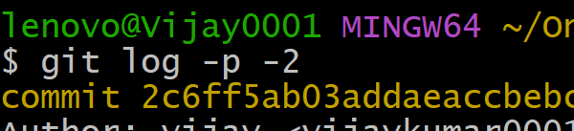

Git add [file name ] – to move specific file in staging area.

Git commit [file name ] – to commit specific file.

ls -lart – to show all hiden folder in your working directory.

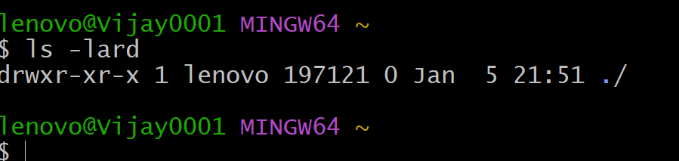

Touch [file name ] – this command create a blank folder in your working directory

Clear – this command is used for clear all screen.

Git checkout -f = to recovery all file.

Git checkout [file name] – to recovery a specific file.

Git diff – comparing working directory to staging area

Git diff--staged - compare staged area to last commit

\*\* git commit –a –m = to skipped staging area and commit.

Ls – to show all files name in your directory

Git rm --cached [file name] – move track file into untrack area

Git rm [file name] – remove specific file

Git status -s – to display short status

Touch