**Database Setup:** Create an IBM Cloud account, choose the appropriate database service like db2, and set up a database instance.

**Steps followed to create IBM Cloud Account.**

**Step 1 -** Go to [myclass.skillup.online](http://myclass.skillup.online) platform and search Introduction to cloud.

**Step 2 -** Then Go to Module 1 and click the obtain feature code to obtain the feature code. Then click to activate the account.

**Step 3 -** Then you will be redirected to the [cloud.ibm.com](http://cloud.ibm.com) and then type our registered email id and password.

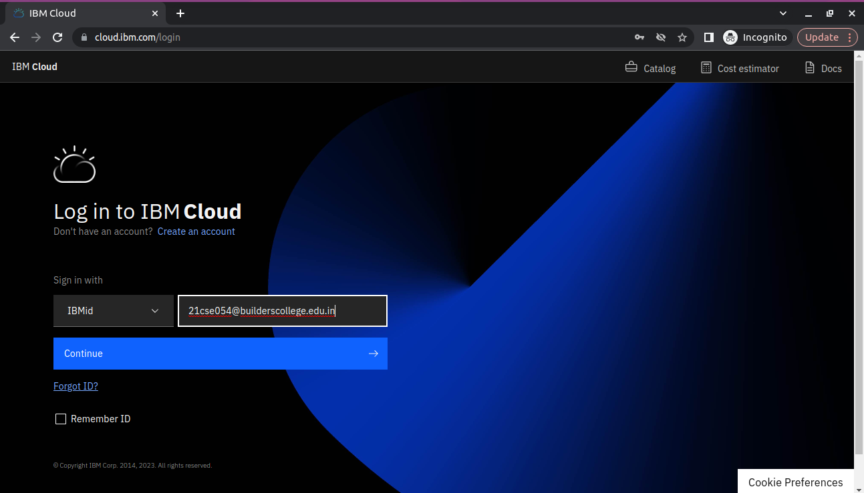

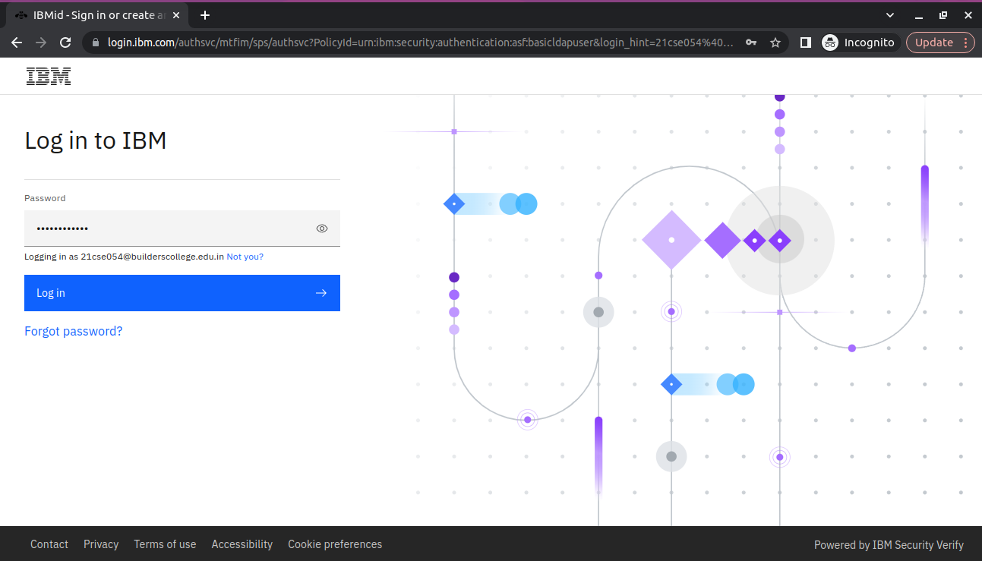

**Step 4 -** Then you will be redirected to the dashboard.

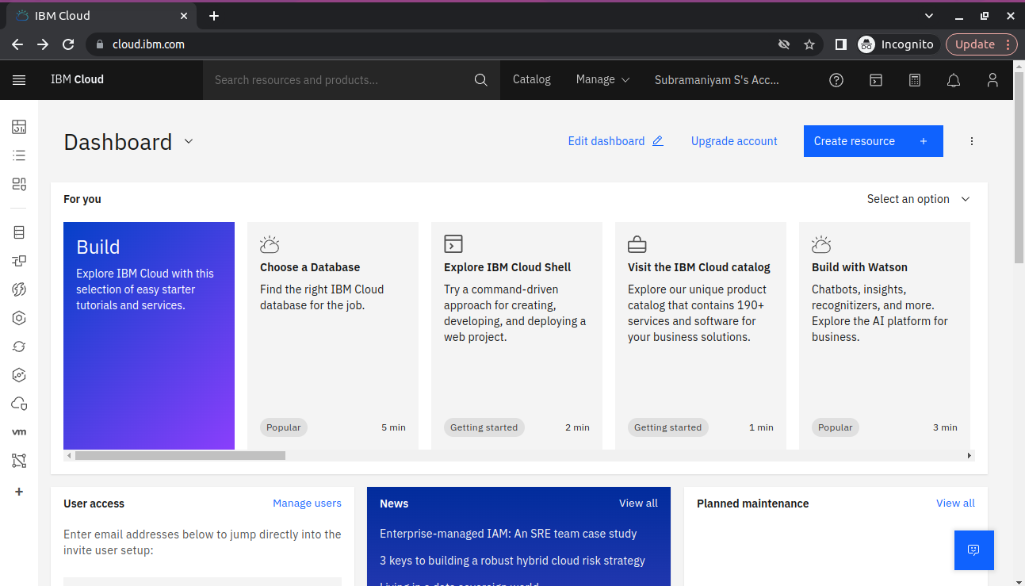

**Step 5 -** Then you go to catalog and add db2 to our resources. After successful creation go to resource list and see that.

**Data exploration and Analysis:** Develop queries to explore the dataset and analyze them and perform basic cleaning and transformation as needed.

**Step 6 –** Then click the database you created in the resource poll and click the service credentials and create new services.

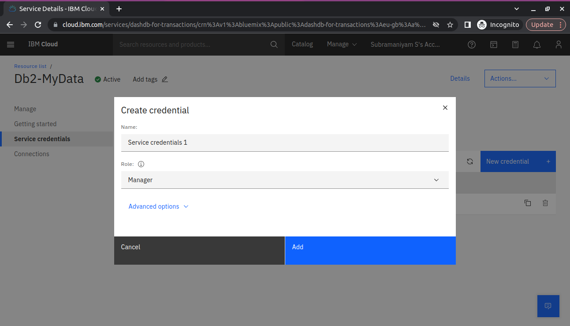

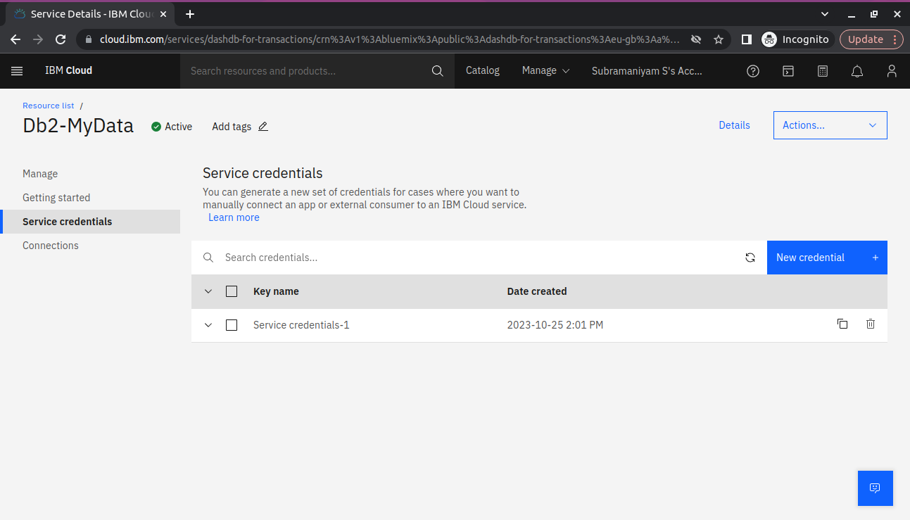

**Step 7 –** Then go to manage section and click go to UI.

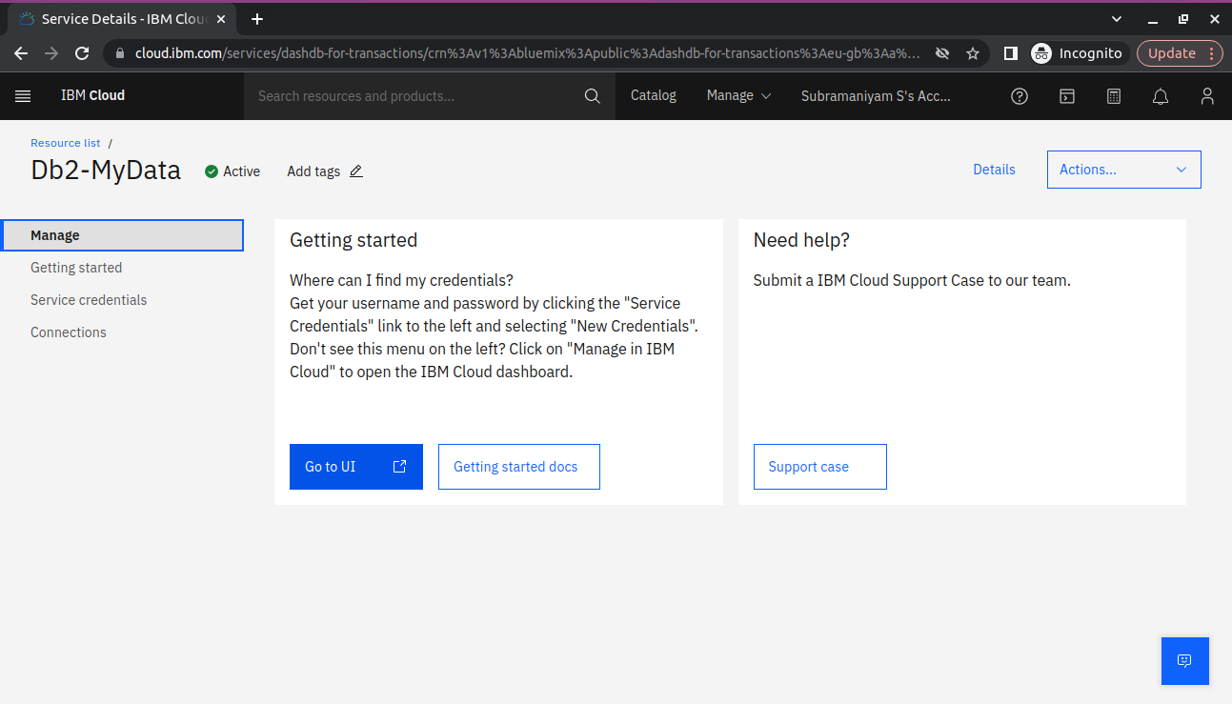

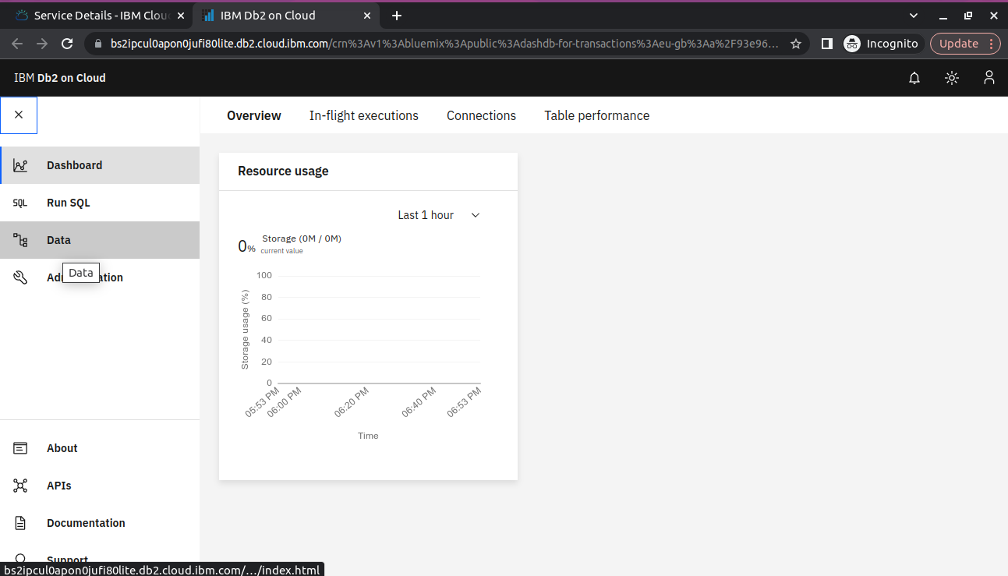

**Step 8 –** Go to data section and upload the dataset that is csv file.

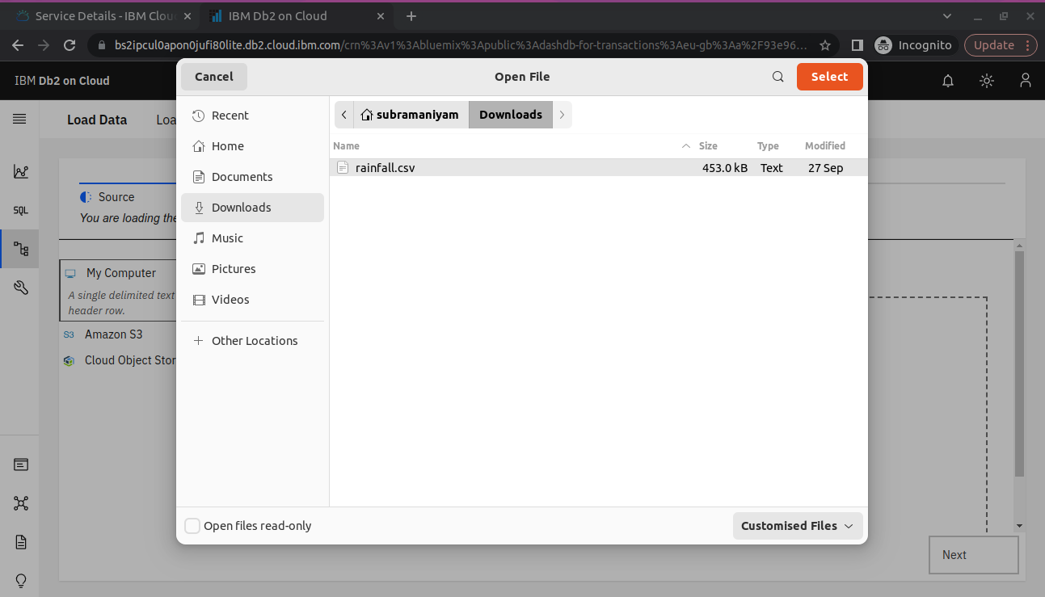

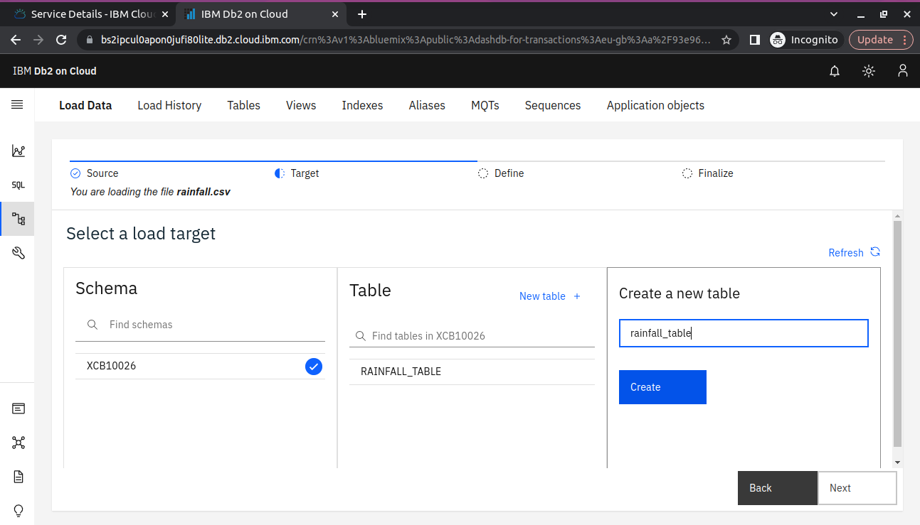

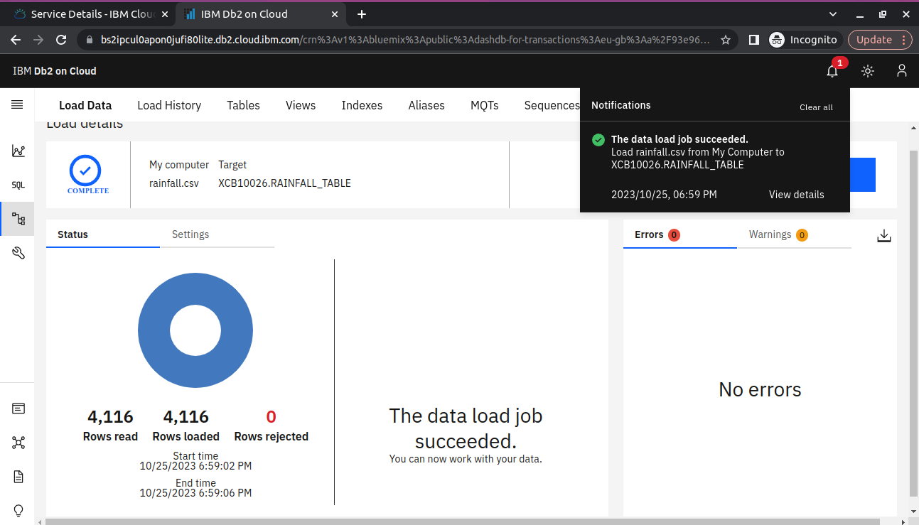

Finally, dataset can be uploaded successfully in db2.

**Step 9-** Using SQL queries to analyze the data.

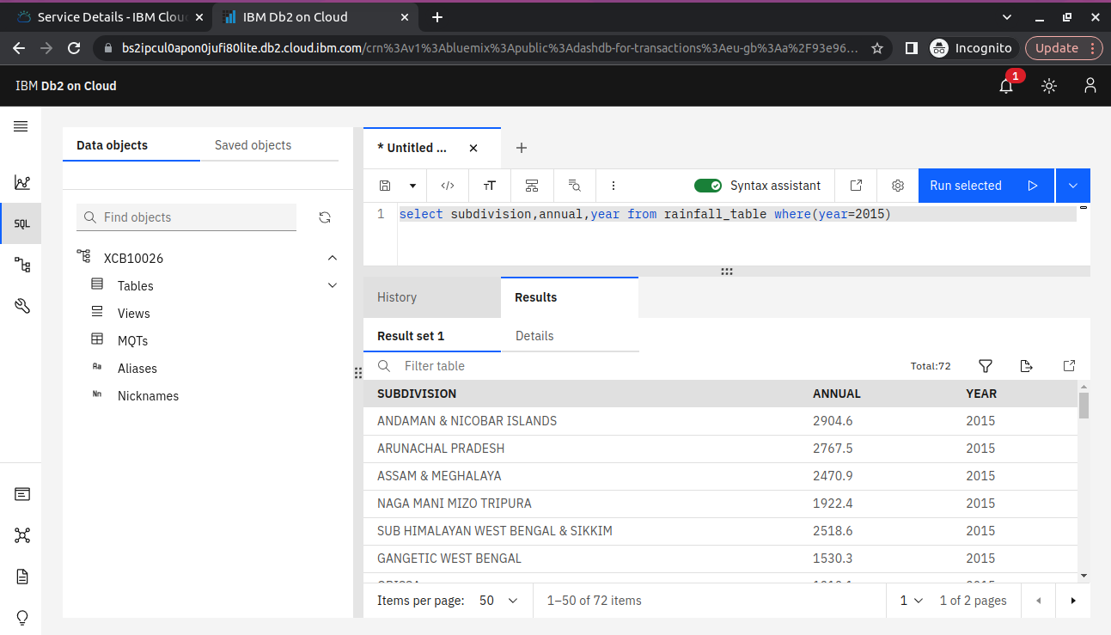

Again, using the SQL queries to analyze the dataset to find the hidden trends and patterns.

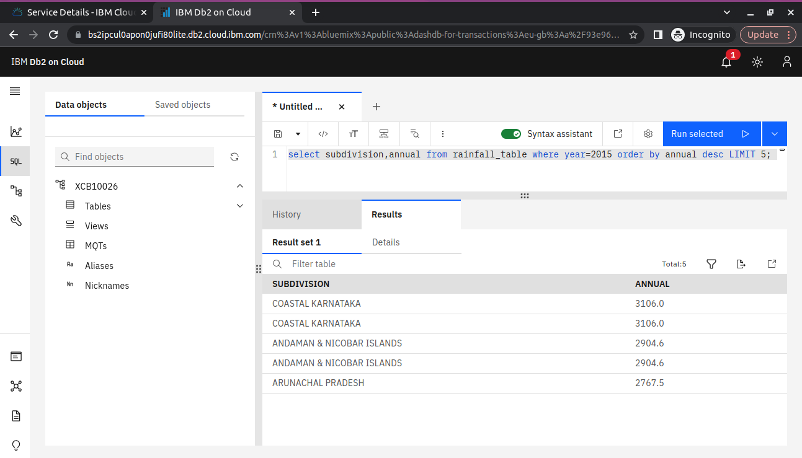

Finally, we analyze the dataset using the IBM db2.