Logging Module Python

—------------------------------------------------------------------------------------------------------------------------

Python has a built-in module **logging** which allows writing status messages to a file or any other output streams. The file can contain the information on which part of the code is executed and what problems have been.

Logging is a means of tracking events that happen when some software runs.

Logging is important for software developing, debugging, and running. If you don’t have any logging record and your program crashes, there are very few chances that you detect the cause of the problem. And if you detect the cause, it will consume a lot of time. With logging, you can leave a trail of breadcrumbs so that if something goes wrong, we can determine the cause of the problem.

## **Log message Levels** :

There are five built-in levels of the log message

* **Debug :** These are used to give Detailed information, typically of interest only when diagnosing problems.
* **Info :** These are used to confirm that things are working as expected
* **Warning :** These are used an indication that something unexpected happened, or is indicative of some problem in the near future
* **Error :** This tells that due to a more serious problem, the software has not been able to perform some function
* **Critical :** This tells serious error, indicating that the program itself may be unable to continue running

Each built-in level has been assigned its numeric value.

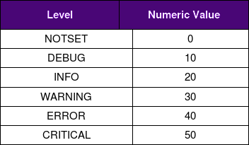

**There are several logger objects offered by the module itself.**

* **Logger.info(msg) :** This will log a message with level INFO on this logger.
* **Logger.warning(msg) :** This will log a message with a level WARNING on this logger.
* **Logger.error(msg) :** This will log a message with level ERROR on this logger.
* **Logger.critical(msg) :** This will log a message with level CRITICAL on this logger.
* **Logger.log(lvl,msg) :** This will Logs a message with integer level lvl on this logger.
* **Logger.setLevel(lvl) :** This function sets the threshold of this logger to lvl. This means that all the messages below this level will be ignored.