**Types of Data Structures**

**What are the main types of data structures, and can you provide an example of each?**

**1. Linear Data Structures**

These structures store data sequentially, and elements are accessed one after another.

**Examples:**

• **Array**: A fixed-size collection of elements of the same type.

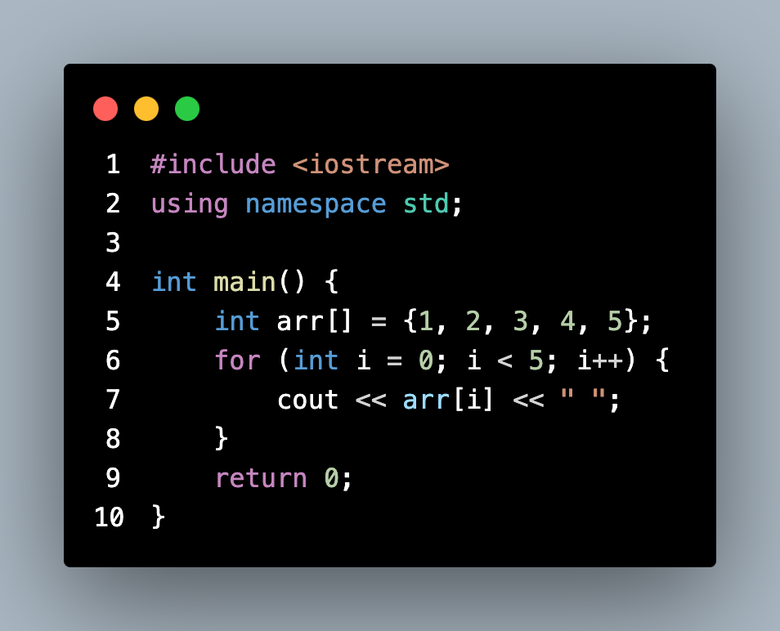

• **Linked List**: A collection of nodes where each node contains data and a pointer to the next node.

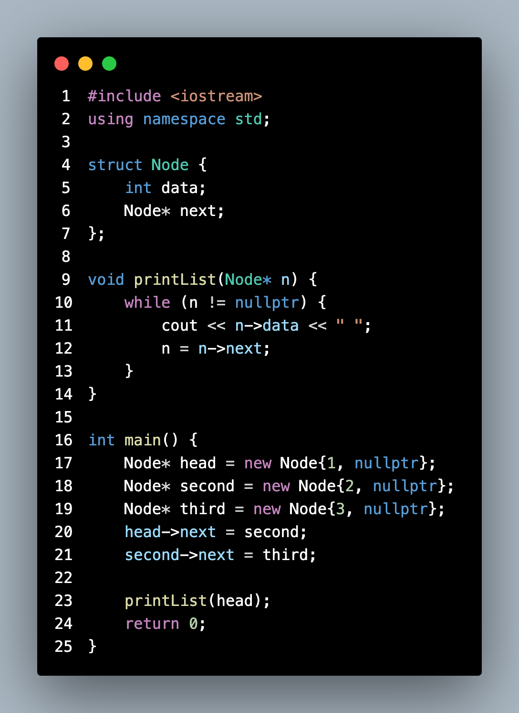

• **Stack**: A LIFO (Last In, First Out) data structure.

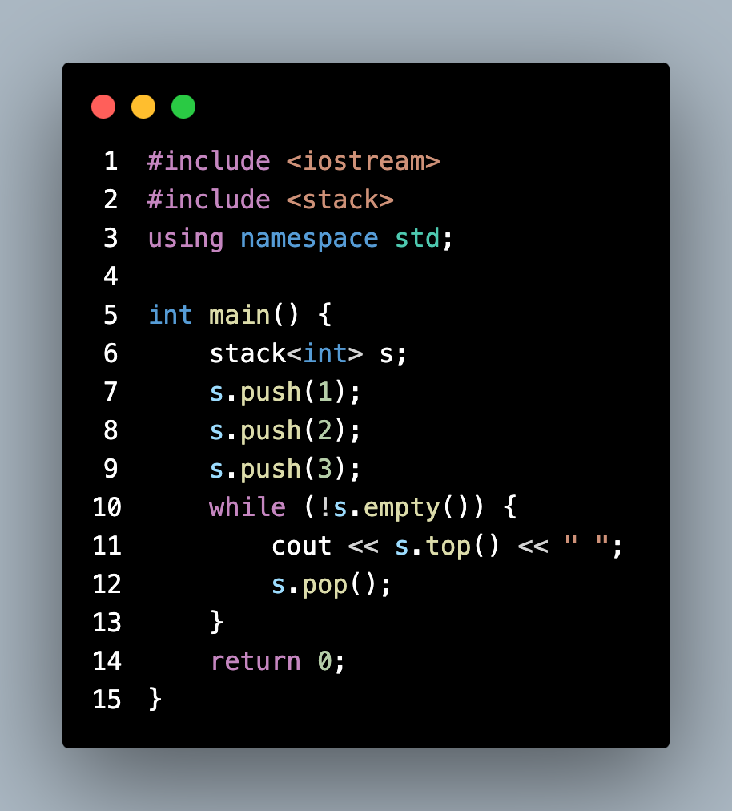

• **Queue**: A FIFO (First In, First Out) data structure.

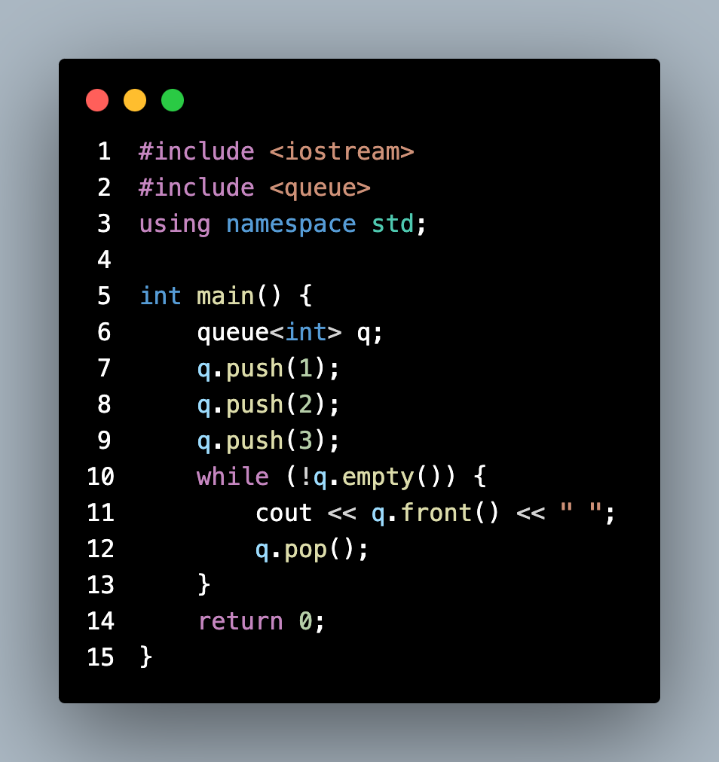

**2. Non-Linear Data Structures**

These structures store data hierarchically or with complex relationships.

**Examples:**

• **Tree**: A hierarchical structure where each node has a value and children.

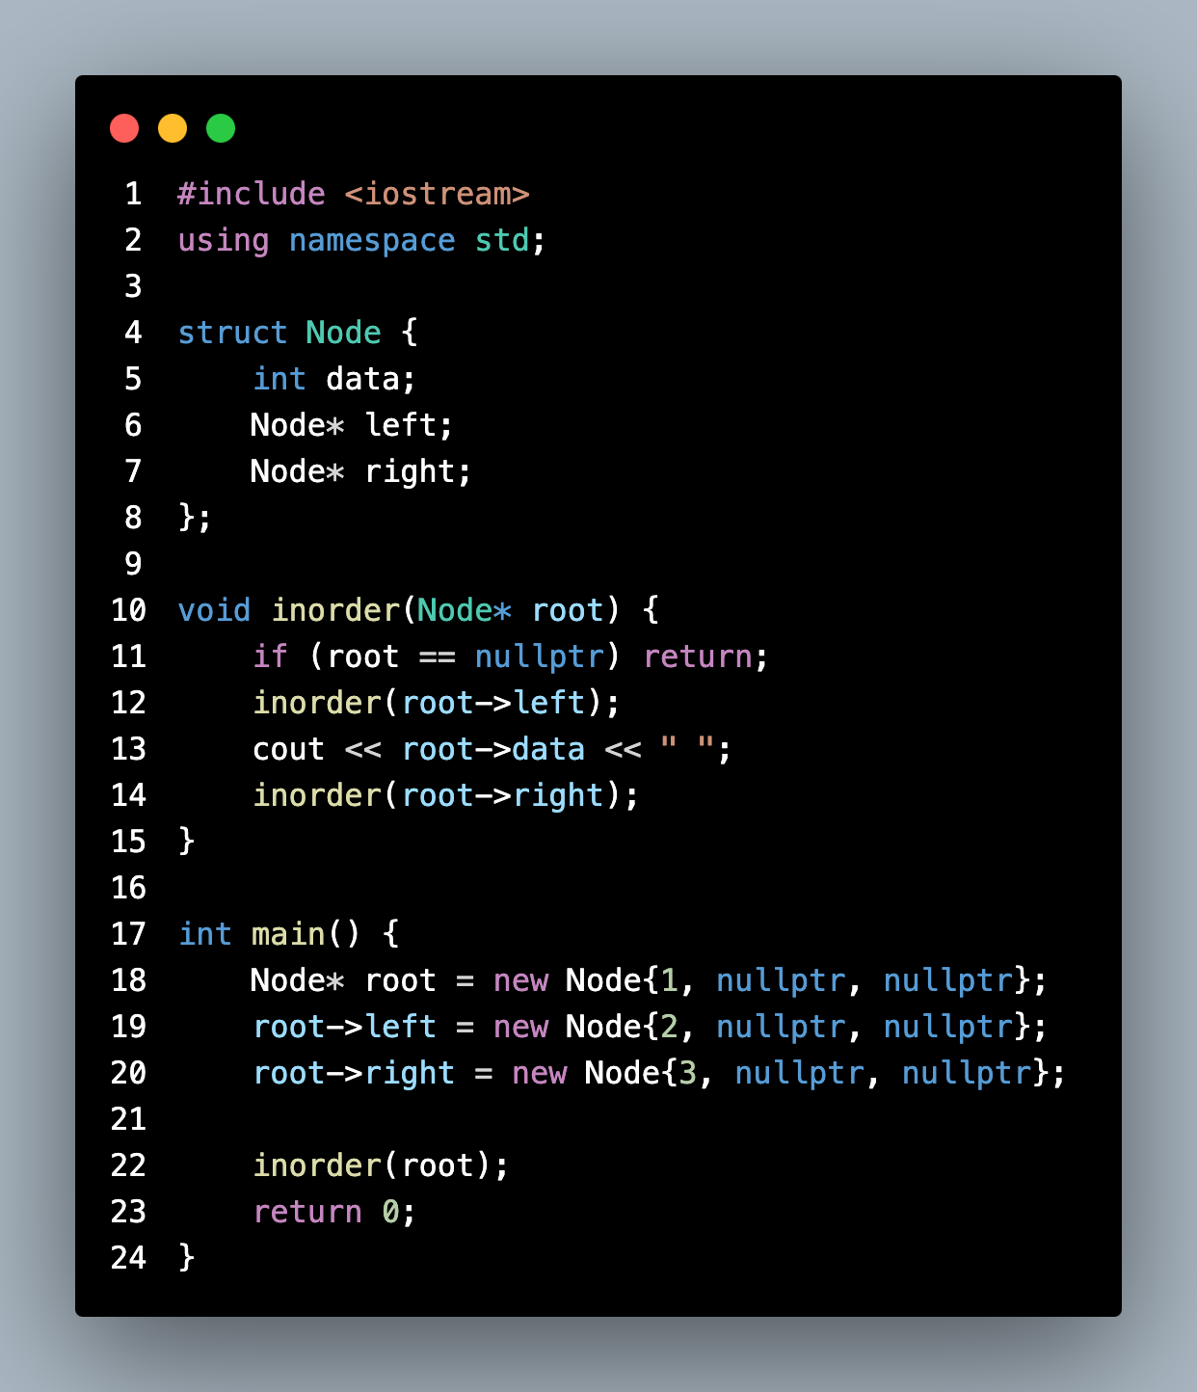

• **Graph**: A set of nodes (vertices) connected by edges.

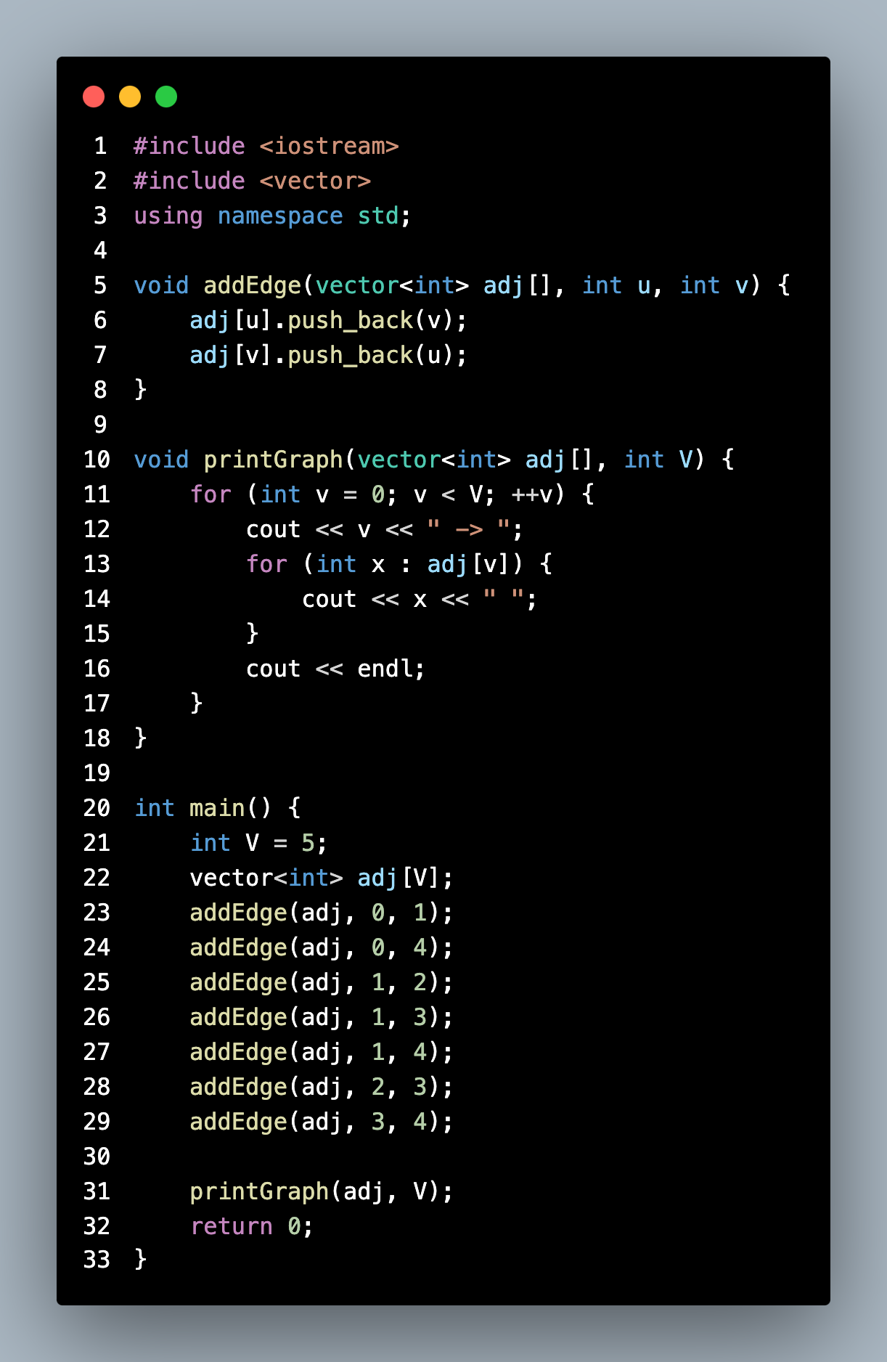

• **Hash Table**: A data structure that maps keys to values using a hash function.

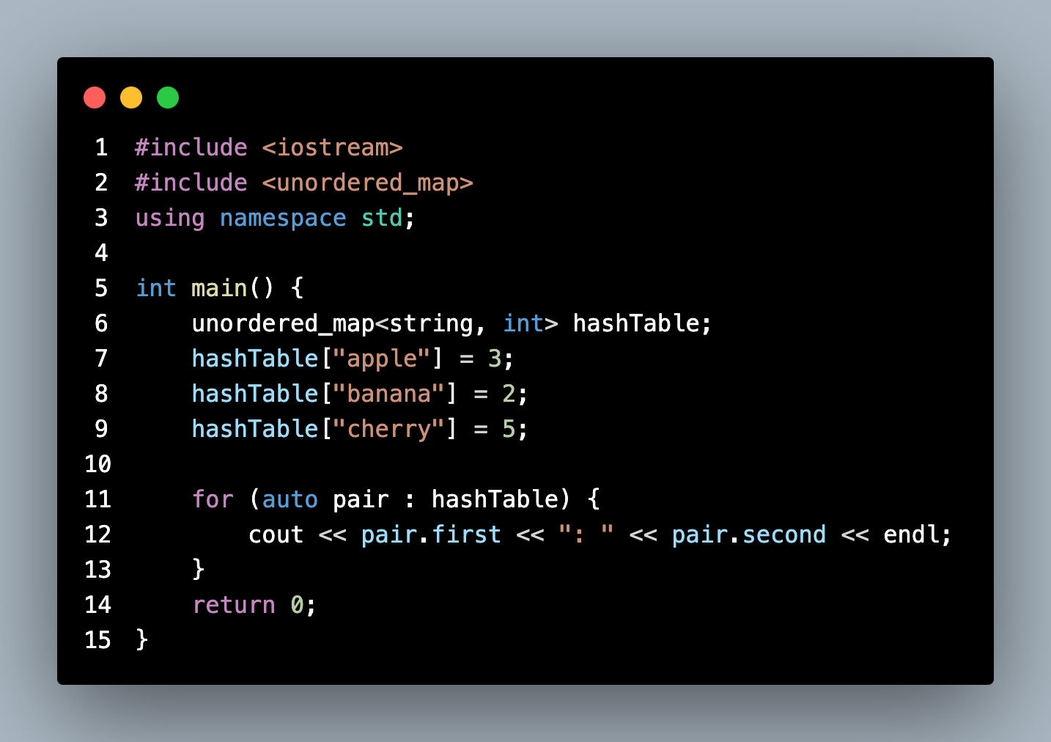

Importance of Data Structures

Why are data structures important in programming? Discuss how they affect algorithm efficiency.

**Why Data Structures Are Important**

1. **Efficient Data Organization**:

• Data structures provide systematic ways to organize data, making it easier to store, access, and modify.

• Example: Arrays and linked lists help store sequences of data, while hash tables allow fast key-value lookups.

2. **Optimized Algorithm Efficiency**:

• Algorithms operate on data, and the choice of the data structure affects their complexity.

• Example: Searching for an element in an unsorted array takes , while in a balanced binary search tree or a hash table, it can be reduced to or , respectively.

3. **Memory Utilization**:

• Some data structures are more memory-efficient than others, depending on the application.

• Example: Linked lists dynamically allocate memory for elements, avoiding waste seen in arrays with fixed sizes.

4. **Scalability**:

• Efficient data structures ensure that applications can handle large datasets without significant performance degradation.

• Example: Databases use B-trees for indexing to support millions of records efficiently.

5. **Facilitates Reusability**:

• Abstract data types (ADTs) like stacks, queues, and graphs encapsulate functionality, enabling reuse across different projects.

6. **Solves Complex Problems**:

• Certain problems can only be solved efficiently using specific data structures.

• Example: Graphs are essential for network routing algorithms like Dijkstra’s or BFS/DFS.

**Impact of Data Structures and Algorithm Efficiency**

Data structures directly affect the **time complexity** and **space complexity** of algorithms. Here are some examples:

1. **Searching**:

• **Array** (unsorted):

• **Binary Search Tree** (balanced):

• **Hash Table**:

2. **Sorting**:

• Data structures like **heaps** are used in algorithms like Heap Sort () to efficiently sort large datasets.

3. **Graph Traversal**:

• Using adjacency lists over adjacency matrices in sparse graphs reduces space complexity from to .

4. **Dynamic Programming**:

• Data structures like **hash maps** or **arrays** help store intermediate results to avoid redundant computations (e.g., memoization).

5. **Priority Queue Operations**:

• Using a **binary heap** instead of an array allows insertion and extraction, crucial for algorithms like Dijkstra’s.

**Examples**

1. **Real-Time Applications**:

• Social media platforms use **graphs** to represent connections between users, enabling efficient friend recommendations or newsfeed ranking.

2. **Big Data**:

• **Trie structures** allow fast search and prefix matching, commonly used in search engines and dictionaries.

3. **Gaming**:

• **2D arrays** and **trees** are used to represent game maps and decision trees for AI players.

Characteristics of Arrays

What are the key characteristics of an array in c++? How does it differ from other data structures like linked lists?

**Key Characteristics of Arrays in C++**

An array is a linear data structure that stores a fixed-size sequence of elements of the same type. Below are its defining characteristics:

**1. Fixed Size**

• The size of an array is defined when it is declared and cannot be changed during runtime.

• Example:

int arr[5]; // Array of size 5

**2. Contiguous Memory Allocation**

• Array elements are stored in contiguous memory locations. This enables constant-time access () to elements using their index.

• Example:

int arr[3] = {10, 20, 30};

cout << arr[1]; // Output: 20

**3. Random Access**

• Direct access to any element using its index is possible, making arrays efficient for indexing operations.

• Example:

arr[2] = 15; // Directly updates the 3rd element.

**4. Homogeneous Data**

• All elements in an array must be of the same type (e.g., integers, floats, etc.).

**5. No Dynamic Expansion**

• Arrays have a fixed size and cannot grow or shrink dynamically during execution. For resizing, you must create a new array and copy elements manually or use dynamic structures like std::vector.

**6. Traversal**

• Arrays support traversal using loops to access all elements sequentially.

• Example:

for (int i = 0; i < 5; i++) {

cout << arr[i] << " ";

}

**7. Static or Dynamic Allocation**

• Arrays can be allocated either on the stack or the heap.

• **Static Array**: Defined at compile-time.

int arr[10];

• **Dynamic Array**: Allocated at runtime using new.

int* arr = new int[10];

delete[] arr; // Free memory

**Use Cases**

• **Arrays**:

• Suitable for scenarios requiring random access, like accessing elements by index or performing mathematical operations on elements.

• Example: Lookup tables, matrices in computational tasks.

• **Linked Lists**:

• Better for dynamic scenarios where frequent insertions and deletions occur, such as in queues or stacks.

Fundamental Concepts of Algorithms

Define an algorithm and explain its fundamental concepts. How do data structures play a role in algorithm design?

**Definition of an Algorithm**

An algorithm is a **step-by-step procedure** or a finite set of well-defined instructions to solve a specific problem or perform a task. It starts with an input, processes the data using the instructions, and produces an output.

In programming, algorithms are the building blocks of computational problem-solving, and they must satisfy the following properties:

• **Input**: Accepts zero or more inputs.

• **Output**: Produces at least one output.

• **Finiteness**: Must terminate after a finite number of steps.

• **Definiteness**: Each step must be clear and unambiguous.

• **Effectiveness**: Steps must be basic enough to be executed mechanically.

**Fundamental Concepts of Algorithms**

1. **Correctness**:

• An algorithm must solve the problem it is intended to solve and produce the correct output for all valid inputs.

2. **Efficiency**:

• Measured by the time complexity () and space complexity () of the algorithm.

• **Time Complexity**: The amount of time an algorithm takes to execute.

• **Space Complexity**: The amount of memory an algorithm uses during execution.

3. **Steps of Execution**:

• **Input**: Collecting raw data.

• **Processing**: Applying transformations or logical operations to solve the problem.

• **Output**: Producing results or outcomes.

4. **Iterative and Recursive Approaches**:

• Algorithms can solve problems using either loops (iterative) or function calls to themselves (recursive).

• Example:

• Iterative: Traversing an array using a for loop.

• Recursive: Finding the factorial of a number.

5. **Abstraction**:

• Focuses on high-level steps rather than the details of how tasks are performed, allowing generalization of solutions.

6. **Scalability**:

• Algorithms must handle increasing input sizes without exponential growth in resource consumption.

7. **Optimization**:

• Algorithms can often be improved to reduce complexity or increase efficiency using techniques like divide-and-conquer, dynamic programming, or greedy approaches.

**Role of Data Structures in Algorithm Design**

Data structures and algorithms are interconnected; the choice of data structure directly impacts the performance and feasibility of an algorithm. Here’s how data structures influence algorithms:

1. **Data Storage and Organization**:

• Data structures define how data is stored and accessed, shaping the algorithm’s operations.

• Example: A binary search algorithm requires data to be stored in a sorted array or tree.

2. **Efficient Operations**:

• Algorithms rely on efficient data access, insertion, deletion, and traversal.

• Example:

• Searching: Hash tables () vs. linked lists ().

• Sorting: Arrays () using Merge Sort.

3. **Reduce Complexity**:

• Algorithms use data structures to minimize time or space complexity.

• Example: Dynamic programming algorithms use arrays or hash tables for memoization to avoid redundant calculations.

4. **Problem-Specific Requirements**:

• Certain algorithms require specialized data structures.

• Example: Graph algorithms (e.g., BFS, DFS) depend on adjacency lists or matrices.

5. **Scalability**:

• The scalability of an algorithm is often determined by the underlying data structure’s ability to handle large inputs.

• Example: Priority queues implemented with heaps optimize algorithms like Dijkstra’s shortest path.

6. **Examples of Data Structure Usage**:

• Arrays: Used for binary search.

• Linked Lists: Used in dynamic stacks and queues.

• Stacks: Used for recursion removal or expression evaluation.

• Trees: Used in search and sort algorithms (e.g., BST, AVL trees).

• Graphs: Used in algorithms like Dijkstra’s and Prim’s.

• Hash Tables: Used for fast lookup and indexing.

Array Implementation

How do you declare and initialize an array in c++? Provide an example of creating an array of integers.

**Declaring and Initializing an Array in C++**

An **array** in C++ is a collection of elements of the same data type stored in contiguous memory locations. To declare and initialize an array,

syntax:

data_type array_name[array_size];

• **data_type**: Type of elements in the array (e.g., int, float, char).

• **array_name**: The name of the array.

• **array_size**: The number of elements the array can store (must be a constant or an integer value).

**Ways to Declare and Initialize an Array**

1. **Declaration Without Initialization**:

• This only declares an array without assigning any values. The values remain uninitialized (garbage values).

int arr[5]; // Declares an array of size 5

2. **Declaration With Initialization**:

• You can initialize an array at the time of declaration.

int arr[5] = {10, 20, 30, 40, 50};

3. **Automatic Size Determination**:

• If you initialize an array at declaration, the size can be omitted. The compiler determines the size automatically based on the number of elements.

int arr[] = {1, 2, 3, 4}; // Array of size 4

4. **Partially Initialized Array**:

• If you provide fewer initial values, the remaining elements are initialized to 0.

int arr[5] = {1, 2}; // Array becomes {1, 2, 0, 0, 0}

5. **Dynamic Array Allocation**:

• Arrays can be dynamically allocated at runtime using pointers and new.

int* arr = new int[5]; // Creates an array of size 5 dynamically

arr[0] = 10;

arr[1] = 20;

delete[] arr; // Free memory

**Example: Creating and Using an Array of Integers**

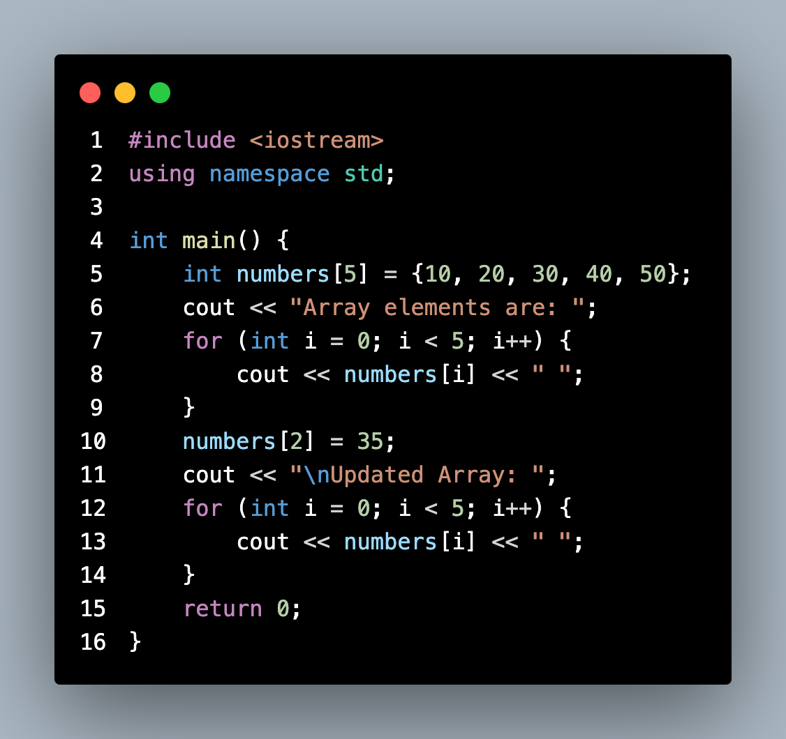

**Output**

Array elements are: 10 20 30 40 50

Updated Array: 10 20 35 40 50

**Explanation**

1. **Declaration and Initialization**:

• int numbers[5] = {10, 20, 30, 40, 50}; creates an integer array of size 5 and initializes it with values.

2. **Accessing Elements**:

• numbers[i] accesses the -th element of the array.

3. **Modifying Elements**:

• Arrays are mutable; elements can be modified using their index.

4. **Traversing Arrays**:

• Loops like for or while are commonly used to iterate through all elements of the array.