1. What is a link in networking, and what does it include?

A network is two or more devices connected through a link. A link is a communication pathway that transfers data from one device to another. Devices can be a computer, printer, or any other device that is capable to send and receive data. For visualization purposes, imagine any link as a line drawn between two points. For communication to occur, two devices must be connected in some way to the same link at the same time. There are two possible types of connections:

1. Point-to-Point Connection

2. Multipoint Connection

Point-to-Point Connection:

1. A point-to-point connection provides a dedicated link between two devices.
2. The entire capacity of the link is reserved for transmission between those two devices.
3. Most point-to-point connections use an actual length of wire or cable to connect the two ends, but other options such as microwave or satellite links are also possible.
4. Point to point network topology is considered to be one of the easiest and most conventional networks topologies.
5. It is also the simplest to establish and understand.

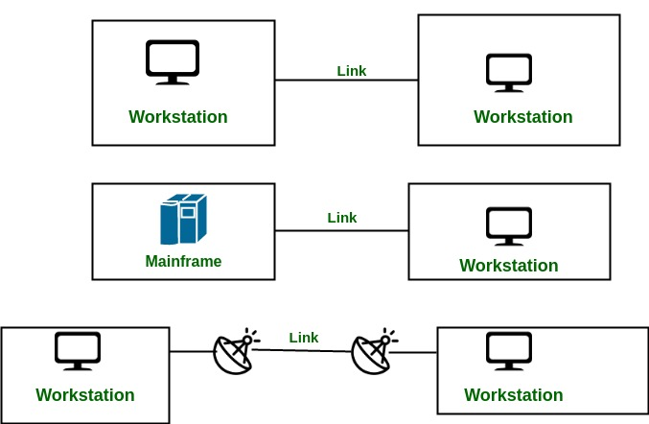

Multipoint Connection :

1. It is also called Multidrop configuration. In this connection, two or more devices share a single link.
2. If more than two devices share the link then the channel is considered a ‘shared channel’. With shared capacity, there can be two possibilities in a Multipoint Line configuration:

**Spatial Sharing:** If several devices can share the link simultaneously, it’s called Spatially shared line configuration. **Temporal (Time) Sharing**: If users must take turns using the link, then it’s called Temporally shared or Time Shared Line configuration.

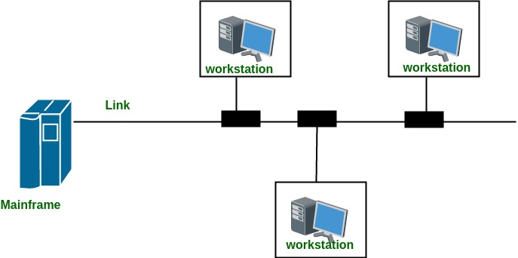

2. How many layers are there in the OSI model, and can you name them?

The **OSI (Open Systems Interconnection) Model** is a set of rules that explains how different computer systems communicate over a network. OSI Model was developed by the International Organization for Standardization (ISO). The OSI Model consists of 7 layers and each layer has specific functions and responsibilities. This layered approach makes it easier for different devices and technologies to work together. OSI Model provides a clear structure for data transmission and managing network issues. The OSI Model is widely used as a reference to understand how network systems function.

Layers of the OSI Model There are 7 layers in the OSI Model. Physical Layer

Data Link Layer

Network Layer

Transport Layer

Session Layer

Presentation Layer

Application Layer

3. What is the purpose of a backbone network?

**Backbone** is most important part of a system which provides the central support to the rest system, for example backbone of a human body that balance and hold all the body parts. Similarly in Computer Networks a Backbone Network is as a Network containing a high capacity connectivity infrastructure that backbone to the different part of the network. Actually a backbone network allows multiple LANs to get connected in a backbone network, not a single station is directly connected to the backbone but the stations are part of LAN, and backbone connect those LANs.

4. How does a LAN differ from a WAN?

Networks can be classified broadly into two categories; Local Area Networks LAN and Wide Area Networks WAN. As compared to LAN, which could be as restricted as a home, office, or school, WAN covers very large areas and is used to connect more than one LAN in different towns, states, countries, or continents. It will therefore be important to understand the comparison between these two networks by comparing the functions of each depending on which one of them will suit the user’s needs best.

**Local Area Network (LAN)**

LAN is a group of network devices that allow communication between connected devices. The private ownership has control over the local area network rather than the public. LAN has a shorter propagation delay than MAN as well as WAN. It covers the smallest area such as College, School Hospital and so on.

**WAN**

An equipment or office is located in more than one geographical area. It is necessary to link several LANs for the organization of your data storage or use of common applications. In multinational organizations, there is always need of communication between different regional offices in the business. Levelling of reliance on external infrastructure like Internet or leased lines is still acceptable as a means of telecommunication for the long distances telecommunication.

5. What is a node in a computer network?

In Computer Networks, a Node is any device that is capable of sending or receiving data, to and from other nodes at definite and desired flow rates securely and reliably. In simple words, you can say that Nodes are the connection point among network devices that results in the transfer of data from one point to another. In a Network, more than one node can be used at one time. On the basis of functionality and usage, the node devices can be broadly classified into the following types:

1. End Devices
2. Intermediary Devices

1. **End Devices** are node devices that serve as a source point or a destination point in the communication that occurs on a computer network. With the coming advancements in computer networking systems, we have nodes that can act as a client, a server, or both. The rest of the network is built around these end devices to establish communication links between them. Software installed on the node devices determines the role they offer to play in a computer network.

2. **Intermediary Devices** are node devices that are designed to forward data from one side to another side in a computer network. These intermediary devices work as a connecting medium (along with other services being offered) for other nodes and handle the tasks in the background ensuring that the data flows effectively at desired flow rates across the entire computer network. The intermediary devices for the management of the data flowing through them use various addressing systems such as IP Addresses, MAC Addresses, and Port Numbers (or Port addresses) along with information about the network interconnections. Further various types of switching in computer networks determine the path that messages take through the network during communication.

6. How do routers help in data transfer, and at which OSI layer do they operate?

Routers are networking devices that facilitate data transfer between different networks by determining the best path for data packets to travel. Here’s a breakdown of how they help and at which OSI layer they operate:

**How Routers Help in Data Transfer:**

1. **Routing Packets**:

Routers use routing tables and protocols (like OSPF, BGP, and RIP) to determine the most efficient path for data packets to reach their destination.

2. **Network Segmentation**:

Routers segment networks into smaller sub-networks, improving performance and reducing congestion by limiting the size of broadcast domains.

3. **Interconnectivity**:

Routers connect different types of networks (e.g., LANs, WANs) and enable communication between devices in separate networks.

4. **Packet Filtering and Security**:

Routers can filter data packets based on IP addresses, protocols, or other criteria using access control lists (ACLs), enhancing network security.

5. **Protocol Conversion**:

Some advanced routers can convert protocols to ensure devices using different communication standards can interact.

6. **Quality of Service (QoS)**:

Routers prioritize certain types of data (e.g., video streaming or VoIP) to ensure optimal performance for critical applications.

**OSI Layer of Routers:**

• **Routers primarily operate at Layer 3 (Network Layer)** of the OSI model.

• **Key functions at this layer** include:

• Logical addressing (using IP addresses).

• Path selection and forwarding.

• Packet fragmentation and reassembly if required.

• Additionally, routers interact with Layer 2 (Data Link Layer) for accessing the physical network (e.g., MAC addresses), but their core functionality resides in Layer 3

7. What is a point-to-point link, and how does it work?

Point to point link : This is the kind of topology that relies upon two functions i.e. Transmit and Receive. It is a type of communication network between two communication nodes where there is one transmitter and on the other end, there is the receiver. It is a kind of communication medium which have two endpoints or end nodes. They provide high bandwidth

Strengths:

Efficiency: P2P networks are highly efficient as they allow for direct communication between two devices without any intermediate devices or network components. Security: P2P networks are relatively more secure than other topologies as they do not rely on intermediate devices that can be compromised or attacked. Simple Configuration: P2P networks are easy to configure and require minimal management or administration.

Weaknesses:

Limited Scalability: P2P networks are not scalable as adding new devices requires establishing a separate link between each new device and the existing network, which can be time-consuming and expensive.

Maintenance: P2P networks can be difficult to maintain as each device has to be managed separately. Lack of Redundancy: P2P networks do not provide redundancy, which can be a problem if a link fails or a device goes offline. with a dedicated communication connection between two systems.

Star topology : It is that type of topology which contains a central node to which all of the other or different nodes are connected through a single path. In this topology, each and every host is connected to a central hub.

Strengths:

Scalability: Star networks are highly scalable as new devices can be added easily by connecting them to the central hub or switch. Easy Management: Star networks are easy to manage as all devices are connected to a central hub or switch, making it easy to troubleshoot and maintain. Redundancy: Star networks provide redundancy as multiple paths exist between devices, reducing the risk of network failure.

Weaknesses:

Cost: Star networks can be expensive as they require a central hub or switch, which can be costly. Single Point of Failure: Star networks have a single point of failure, which is the central hub or switch. If the hub or switch fails, the entire network becomes non-functional. Network Performance: The performance of a star network depends on the capacity of the central hub or switch. If the hub or switch is not able to handle the traffic, the network performance can be impacted.

**8. What is anonymous FTP, and how does it grant access to files?**

Anonymous FTP (File Transfer Protocol) is a service that allows users to access and download files from an FTP server without needing a specific user account or password. Instead, users log in using a generic username like “anonymous” and typically provide their email address as a password.

• **Use case**: This is commonly used for publicly available files, such as software updates, documentation, or other resources that don’t require restricted access.

• **Benefits**: It simplifies access for users while allowing administrators to share files securely and efficiently without creating individual accounts.

**9. What is the function of a subnet mask in networking?**

A subnet mask is a 32-bit number that divides an IP address into a network portion and a host portion. It helps in segmenting a larger network into smaller sub-networks (subnets).

• **Functionality**:

• Defines the range of IP addresses in a subnet.

• Ensures efficient use of IP addresses by minimizing wastage.

• Improves network performance by limiting the size of broadcast domains.

• **Example**:

• IP address: 192.168.1.10

• Subnet mask: 255.255.255.0

Here, the first three octets (192.168.1) represent the network, while the last octet (.10) identifies the host.

**10. What is the maximum length of a UTP cable, and how can this limitation be overcome?**

The maximum length of a UTP (Unshielded Twisted Pair) cable for reliable data transmission is **100 meters (328 feet)**. Beyond this limit, the signal degrades due to attenuation, leading to data loss or communication issues.

• **How to overcome this limitation**:

• Use **switches** or **hubs** to segment the network and amplify the signal.

• Install **repeaters** to regenerate and forward the signal over longer distances.

• Consider upgrading to fiber optic cables for long-distance communication, as they have much higher transmission limits.

**11. What is data encapsulation, and why is it important in networking?**

Data encapsulation is the process of wrapping application data with protocol-specific headers and trailers as it moves through the layers of the OSI or TCP/IP model.

• **How it works**:

1. Application data is created and passed down the layers.

2. Each layer (Transport, Network, Data Link) adds its own header, providing information needed for routing, addressing, error-checking, etc.

3. At the receiving end, the headers are removed layer by layer to retrieve the original data.

• **Importance**:

• Ensures proper data formatting for transmission.

• Enables error detection, retransmission, and reliable communication.

• Allows different networks and devices to communicate seamlessly.

**12. Define network topology and explain its significance.**

Network topology refers to the arrangement of devices (nodes) and connections in a network. It can be **physical** (actual layout of cables/devices) or **logical** (how data flows between devices).

• **Common types**:

• **Star**: Devices connect to a central hub or switch.

• **Bus**: All devices share a single communication line.

• **Ring**: Devices form a closed loop.

• **Mesh**: Each device connects directly to others.

• **Hybrid**: A combination of two or more topologies.

• **Significance**:

• Affects network performance, scalability, and fault tolerance.

• Simplifies troubleshooting and maintenance.

• Impacts the cost of setup and operation.

**13. What is a VPN, and how does it enhance network security?**

A VPN (Virtual Private Network) is a secure tunnel that encrypts data transmitted between a user’s device and a remote server. It allows users to access private networks securely over public networks like the internet.

• **How it enhances security**:

• **Encryption**: Protects data from being intercepted or read by unauthorized parties.

• **Anonymity**: Hides the user’s IP address, providing privacy.

• **Remote Access**: Allows employees to securely access company resources while working from remote locations.

• **Protection on Public Wi-Fi**: Safeguards sensitive data when connected to public or unsecured networks.

**14. How does NAT (Network Address Translation) work?**

NAT is a process used by routers to modify IP addresses in data packets as they pass between private and public networks. It allows multiple devices on a private network to share a single public IP address.

• **How it works**:

1. When a device in a private network sends data to the internet, the router replaces the private IP with its public IP.

2. The router maintains a mapping table to track which private IP corresponds to each outgoing connection.

3. When a response is received, the router translates the public IP back to the corresponding private IP.

• **Benefits**:

• Conserves public IP addresses.

• Adds a layer of security by hiding private IPs.

**15. What are the main functions of the Network Layer in the OSI model?**

The Network Layer (Layer 3) is responsible for data routing, addressing, and delivery across networks.

• **Key functions**:

• Logical addressing (IP addresses).

• Routing data packets between devices across different networks.

• Fragmentation and reassembly of packets for transmission.

• Error handling and diagnostics (e.g., ICMP).

**16. How does network topology affect network setup and performance?**

The choice of network topology directly impacts the efficiency, cost, and reliability of a network.

• **Impact on setup**:

• **Star**: Easier to set up and maintain but depends on the central hub.

• **Mesh**: Complex and costly to set up but offers high redundancy.

• **Impact on performance**:

• **Bus**: Performance decreases as more devices connect.

• **Ring**: Data collisions are rare, but failure of one device affects the whole network.

**17. What is RIP (Routing Information Protocol), and how does it determine the best route?**

* + Routing Information Protocol (RIP) is a distance-vector routing protocol used to determine the best path for data packets based on hop count (the number of routers).   
    For example:  
    If Router A needs to send data to Router C through Router B and Router D:  
    Route A-B-C has 2 hops.Route A-D-C has 2 hops.  
    RIP will choose either route based on current routing tables updated periodically.

**18. What are some effective ways to secure a computer network?**

* + Effective ways include:Using firewalls to block unauthorized access.Implementing strong passwords and two-factor authentication.Regularly updating software and firmware to patch vulnerabilities.Conducting regular security audits and training users about phishing attacks.

**19.What is a NIC (Network Interface Card), and what role does it play in networking?**

* + A Network Interface Card (NIC) connects computers or devices to a network by converting digital data into signals suitable for transmission over various types of networks (wired or wireless).   
    For example:A NIC allows your desktop computer to connect via Ethernet cable or Wi-Fi by providing necessary hardware interfaces.

**20. What is a private IP address, and why is it used in networking?**

* + A private IP address is an address assigned to devices within a private network that cannot be accessed directly from outside that network (e.g., 192.168.x.x).   
    It’s used because:It conserves public IP addresses by allowing multiple devices on local networks to communicate internally while only using one public IP address for external communication via NAT.