**Project Title: Finance Analysis of a Company Using Power BI**

**About the Project:**

This Amazon Sales Analytics Dashboard is designed to provide in-depth insights into sales trends, inventory levels, and performance across various product categories on Amazon. By leveraging Power BI for data visualization, it empowers business stakeholders to identify key sales drivers, monitor inventory, and optimize decision-making strategies. The dataset includes metrics such as total sales, gross value, pieces sold, stock levels, and sales performance by product category.

The primary objective is to present actionable insights to enhance sales strategies, manage inventory effectively, and improve overall business performance.

**Technologies Used:**

* Excel: Used for initial data cleaning and preparation.
* Power BI: Used to create interactive visualizations and dashboards.

**Steps Overview:**

1. **Data Collection**: The dataset includes product-level metrics such as sales value, quantity sold, gross revenue, and stock.
2. **Data Understanding:** Initial analysis was conducted to understand key metrics and relationships between them.
3. **Data Transformation:** Data was cleaned and transformed to derive aggregated values for visual representation.
4. **Data Visualization:** Power BI was used to design interactive dashboards with comprehensive visualizations.

**Dashboard Overview:** The dashboard is divided into three sections, focusing on overall sales performance ,category-wise insights and Products Prices based on the different e-commerce sites .

**Page-1:**

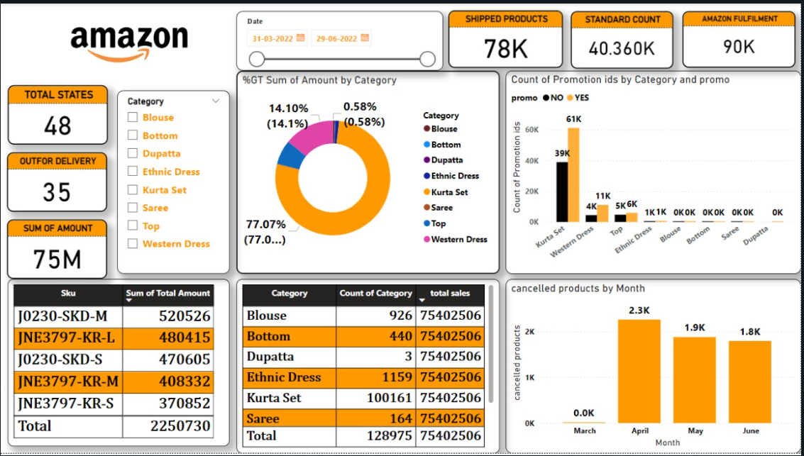

**Page-2:**

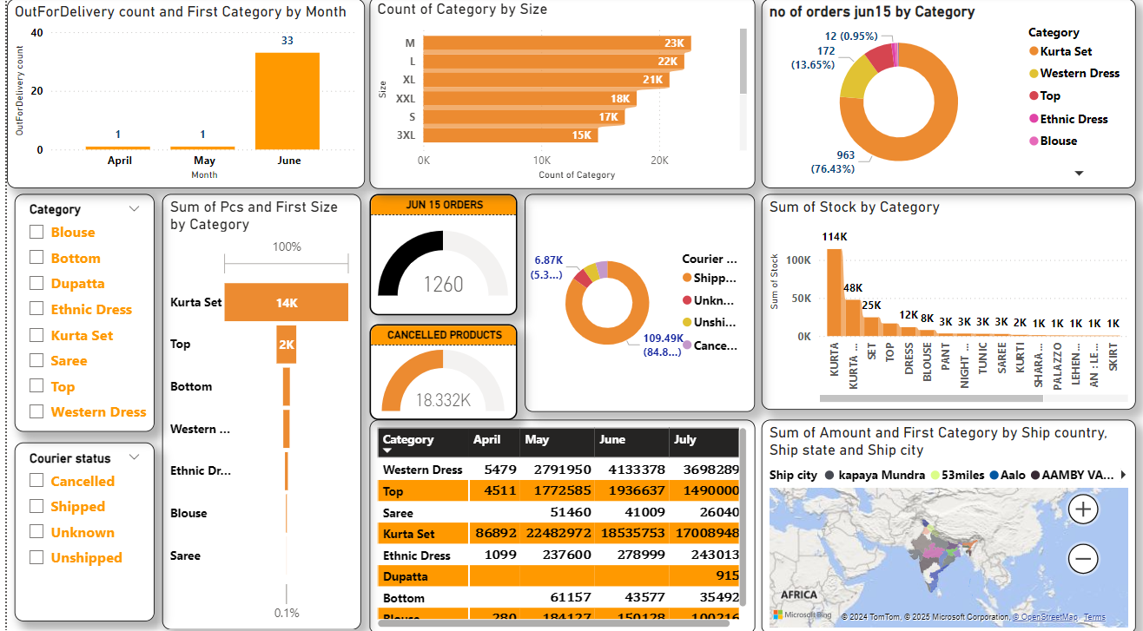

**Page-3:**

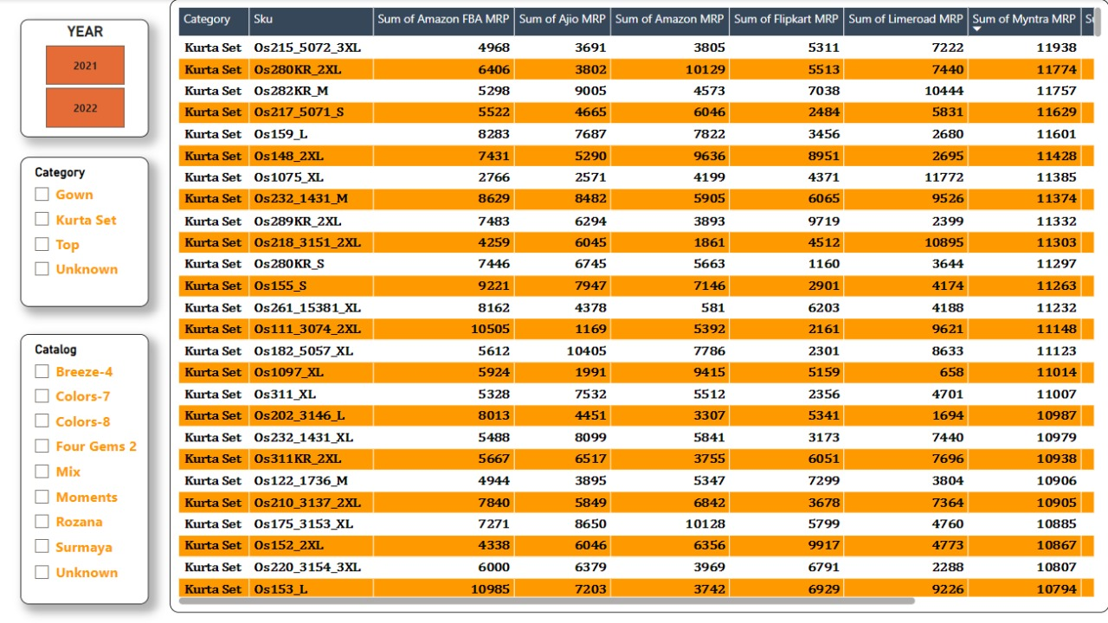

**Page-1 :** Overall Sales Performance:

**Key Performance Indicators (KPIs):**

1. **Shipped Products:**

This Represents the total number of products successfully shipped during the reporting period or selected time frame.

**2. Out of Delivery :**

This shows the number of products that were marked as "Out for Delivery" but may not yet be delivered.

**3.Sum of Amount :**

This represents the total sum of amount generated by the sales of products according to the reporting period .

**4. Total States :**

This shows the number of states where orders were placed or delivered.

**5.Standard Count:**

This represents the count of orders where the shipping service level is in standard mode.

**6.Amazon fullfillment:**

It represents the number of products that were processed, stored, picked, packed, and shipped through **Amazon's Fulfillment Centers (FBA - Fulfillment by Amazon)** during the analyzed period.

**Visualizations (Charts and Tables):**

**1. %GT Sum of Amount by Category:**

* A Donut chart representing the percentage distribution of sales revenue across product categories.

**Key Insights :**

* **Kurta Set -** dominates with 77.07% of the sales amount.
* Other categories like Blouse , Saree, Top,Western dresses,Bottom contribute smaller percentages.

**2. Category-wise Count and Total Sales:**

* Tabel Providing the breakdown of the product categories, their counts, and total sales amounts.

**Key Insights:**

* **Kurta Set -** has the highest count (100,161 units).
* **Western Dress** is the second-largest category with 15,500 units.

**3. Count of Promotion ids by Category and promo:**

* Clustered Column chart Represening the number of promotions used for each category, categorized as "NO" (no promotions) and "YES" (promotions used).

**Key Insights:**

* **Kurtaset** has the **highest** number of promotions, with 61K promotions used.
* **Western dress** has the **second-highest** number of promotions, with 11K promotions used.
* Top has the third - highest number of Promotions , with 6k Promotions used, Other categories have a lower number of promotions.

**4. Cancelled products by Month:**

* Clustered colmun chart showing the number of cancelled products for each month from March to June.

**Key Insights:**

* **April** has the **highest** number of cancelled products, with 2.3K cancellations.
* The number of cancellations decreases from March to June.

**5. Top 5 SKU’S and their Amount:**

* Table providing the detailed information on the top 5 SKU’s about their ID’s and sum of amount generated according to the id and also the total sum of amount generated by the top 5 SKU’s collectively at the bottom of the table.

**Key Insights:**

* **J0230-SKD-M**  has the highest total sales amount (520526).
* **JNE3797-KR-L** has the second highest total sales amount(480415).

**Overall Observations :**

* **Kurta Set** dominates both the **sales revenue** and the **number of orders** (100,161 orders, highest among all categories).
* Promotions are heavily used for Kurta Set and Western dress categories.
* The number of cancelled products has decreased over the reporting period.
* **April**  had the highest number of cancelled products.

**Page -2 : Category Wise Insights:**

**Key Performance Indicators(KPIs):**

1. **Cancelled Products:**

This indicates the total number of cancelled products during the reporting period.

1. **JUN 15 ORDERS:**

This represents the number of orders placed on June 15th.

**Visualizations (Charts and Tables):**

**1**.**Count of Category by Size:**

This chart shows the distribution of sizes for each category, Stacked bar chart chart shows the count of products sold by size (M, L, XL, XXL, etc.).

**Key Insights:**

* The sizes M and L are the most common across all categories.
* There is a significant drop in the number of orders for larger sizes (XXL, 3XL).
* Sizes like 3XL and S have lower sales, suggesting less demand for these sizes.
* This information can guide inventory planning and marketing efforts for different sizes.

**2.**  **OutForDelivery count and First Category by Month:**

This chart displays the number of orders "Out For Delivery" for each month (April, May, June).

**Key Insights:**

* The number of orders "Out For Delivery" increased from April to June.
* There’s a significant increase in June (33 items), while April and May show negligible activity (1 each).

**3.**  N**o of orders jun15 by Category:**

**A donut chart shows the percentage breakdown of orders placed on June 15 by product category.**

**Key Insights:**

* Kurta Set dominates with 76.43% of the orders, followed by Western Dress (13.65%).
* Categories like Blouse and Ethnic Dress contribute minimally, indicating lower demand.

**4.Sum of Pcs and First Size by Category:**

This Funnel chart provides information on the total number of pieces sold and the most common size for each category.

**Key Insights:**

* Kurta Sets lead with 14K pieces sold, significantly outperforming other categories.
* Tops come second with just 2K, showing a steep drop in demand for other categories.

**5. Courier status:**

A donut chart categorizing orders by their shipping status (Shipped, Unshipped, Cancelled, Unknown).

**Key Insights:**

* A large portion of orders are under "Shipped" status(84.89%)
* Cancelled , Unshipped ,Unkown orders represent a significant portion.

**6. June 15 Orders :**

**A gauge chart indicating the total number of orders on June 15 (1,260).**

**Key Insights:**

* **This chart highlights sales performance for a single day, showing moderate activity.**

**7. Sales by Category Over Time :**

A table showing the sales of each category across four months (April to July).

**Key Insights:**

* Kurta Sets consistently dominate sales, with their peak in May (22M).
* Western Dress and Top categories have steady but lower performance.
* Minimal sales for Bottom, Dupatta, and Ethnic Dress suggest they aren’t major contributors to overall revenue.

**8.** **Sum of Amount and First Category by Ship country, Ship state and Ship city:**

This map visualizes the sales distribution by country, state, and city, it shows sales data geographically, highlighting key shipping regions.

**Key Insights:**

* Specific cities like Kapaya Mundra and Aalo contribute heavily to sales.
* Regional analysis can help focus marketing and logistics efforts in high-performing areas.

**9. Sum of Stock by Category :**

A bar chart showing the current stock for each category.

**KeyInsights:**

* Kurta Sets have the highest stock levels (114K), aligning with their high sales performance.
* Sarees, Blouses, and Pants have minimal stock, indicating either low demand or insufficient inventory.

1. **Cancelled Products Gauge :**

A gauge showing the total number of cancelled products .

**Key Insights:**

* High cancellations could indicate operational inefficiencies, product quality issues, or customer dissatisfaction.
* It suggests the need for closer monitoring and action to reduce cancellations.

**Overall Observations:**

* Kurta Sets are the most popular and best-performing category across all visualizations.
* **June** stands out as a peak month for deliveries and orders.
* High cancellation rates and unshipped orders highlight potential operational inefficiencies.
* Demand varies significantly by size and category, emphasizing the need for targeted inventory and marketing strategies.

**Page-3: Product Prices Based on the E-Commerce website:**

This Page consists of a table which displays the category name and along with their SKU and their sum of their MRP according to the different e-commerce webistes like Amazon ,Ajio, Myntra,Snapdeal,Paytm , etc….

**Key Insights:**

Detailed pricing data helps in comparing platform-wise pricing for each SKU. It aids in decision-making for pricing strategies, identifying platforms for discounts or promotions, and understanding customer behavior across e-commerce platforms.

### Conclusion:

The three Pages combined provide a comprehensive overview of Amazon's sales performance. The dashboards covers high-level KPIs, sales and stock trends, promotional impacts, and detailed pricing strategies. It serves the following purposes:

1. **Performance Tracking**: Provides insights into sales performance, cancellations, and stock levels.
2. **Category Insights**: Highlights top-performing categories and size preferences.
3. **Pricing Strategy**: Enables competitive analysis of product prices across various e-commerce platforms.
4. **Optimization Opportunities**:
   1. Address high cancellation rates by analyzing causes.
   2. Adjust stock levels for popular categories and sizes.
   3. Fine-tune pricing strategies to remain competitive.

The dashboard's insights are invaluable for decision-making in inventory management, pricing strategies, and sales optimizations.