Recruitment Management App – Salesforce Implementation

# Phase 10: Final Presentation & Demo Day

## Executive Summary

Phase 10 marks the conclusion of the Recruitment Management App implementation. This phase focuses on showcasing the project’s value through a structured pitch, a functional demo walkthrough, thorough documentation, and final steps to highlight the work professionally on LinkedIn and portfolios.

## 1. Pitch Presentation

Structure:

• Problem: Recruitment inefficiencies – manual job tracking, duplicate applications, poor communication.

• Solution: Salesforce-based Recruitment Management App with automation, streamlined workflows, and dashboards.

• Benefits:

- Faster hiring process.  
 - Reduced duplicate applications.  
 - Real-time visibility for recruiters and managers.  
 - Improved candidate experience.

## 2. Demo Walkthrough

Demo Steps:

1. Create a Job Opening.

2. Submit an Application.

3. Trigger Approval Process for offer.

4. Show Notifications via Email/SMS.

5. Run a Recruitment Report (e.g., Applications per Job).

6. Display Recruitment Dashboard (e.g., Hiring pipeline).

## 3. Handoff Documentation

Deliverables include:

• System Design Document → Data model, flows, security.

• User Guide → Step-by-step usage instructions.

• Admin Guide → Configurations, deployment notes, backup strategy.

## 4. LinkedIn/Portfolio Showcase

LinkedIn Post Structure:

• Title: 🚀 Successfully built a Recruitment Management App on Salesforce!

• Content: Share the journey (problem, solution, tools used).

• Screenshots: UI, dashboards, data model.

• Hashtags: #Salesforce #CRM #Recruitment #AppDevelopment #PortfolioProject

Portfolio:

• Upload documentation, demo video, and screenshots.

• Provide GitHub (if metadata/code export is available).

• Highlight key features: Job openings, applications, approvals, dashboards.

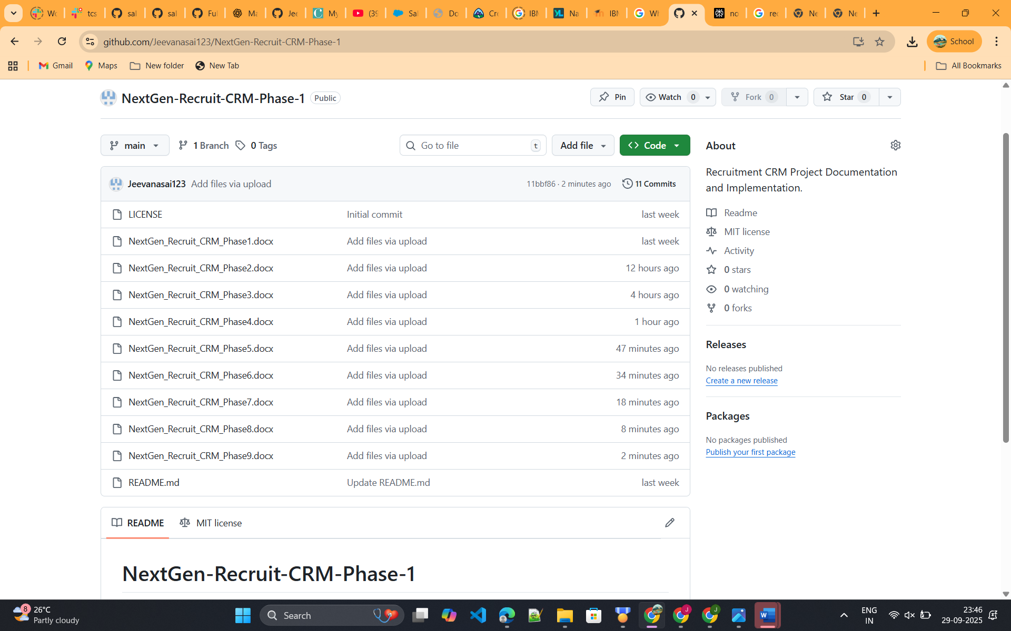

## Conclusion

Phase 10 delivers a complete project handoff with a professional pitch, a working demo, comprehensive documentation, and portfolio showcase material. This ensures the Recruitment Management App is ready for stakeholders, end-users, and future opportunities.