# Phase 6 Report: User Interface Development

**Recruitment Management App – Salesforce Implementation**

## Executive Summary

This report documents the completion of Phase 6 activities for the **Recruitment Management App**, focusing on **user interface development** using **Lightning App Builder**. The phase involved creating a custom Lightning application with optimized navigation, custom tabs, and a branded home page layout that provides recruiters, HR managers, and candidates with an intuitive interface for managing recruitment operations.

## 1. Lightning App Builder Implementation

### 1.1 Custom Lightning Application Creation

✅ **Implementation Status:** Complete

**Application Configuration:** - **App Name:** TalentTrack Recruit - **App Type:** Lightning App - **Branding:** Custom branded interface with recruitment theme - **Navigation Style:** Standard Lightning navigation with custom tabs

**Application Purpose:**  
The Lightning app serves as the central hub for all recruitment management activities, providing role-based access to job openings, candidate management, interview schedules, and analytics.

### 1.2 Application Navigation Structure

✅ **Implementation Status:** Complete

**Navigation Bar Configuration:** - Organized tab structure for efficient workflow - Logical grouping of related functionality (Recruiter, HR, Candidate) - Role-based visibility for different user types - Responsive design for desktop and mobile access

## 2. Custom Tabs Implementation

### 2.1 Tab Architecture

✅ **Implementation Status:** Complete

**Custom Tabs Created:**

**Core Business Object Tabs:** - **Job Openings** – Central hub for job posting and management - **Candidates (Contacts)** – Candidate relationship and profile management - **Applications (Custom Object)** – Application tracking and status updates - **Interviews (Custom Object)** – Interview scheduling and feedback - **Offers (Custom Object)** – Offer letters and approvals - **Employee Records (Accounts/Contacts)** – HR records after hiring

**Standard Object Integration:** - **Leads** – Prospective candidates or referrals - **Opportunities** – Talent pipeline tracking - **Reports** – Recruitment analytics and metrics - **Dashboards** – Real-time hiring performance monitoring

### 2.2 Tab Customization Features

✅ **Implementation Status:** Complete

**Tab Configuration:** - Custom icons for quick visual recognition - Consistent color scheme aligned with brand identity - Optimized tab order based on workflow frequency - Mobile-responsive tab behavior

**Business Benefits:** - Streamlined navigation reduces clicks and improves efficiency - Role-based tab visibility enhances security - Consistent interface reduces training time - Quick access to frequently used objects

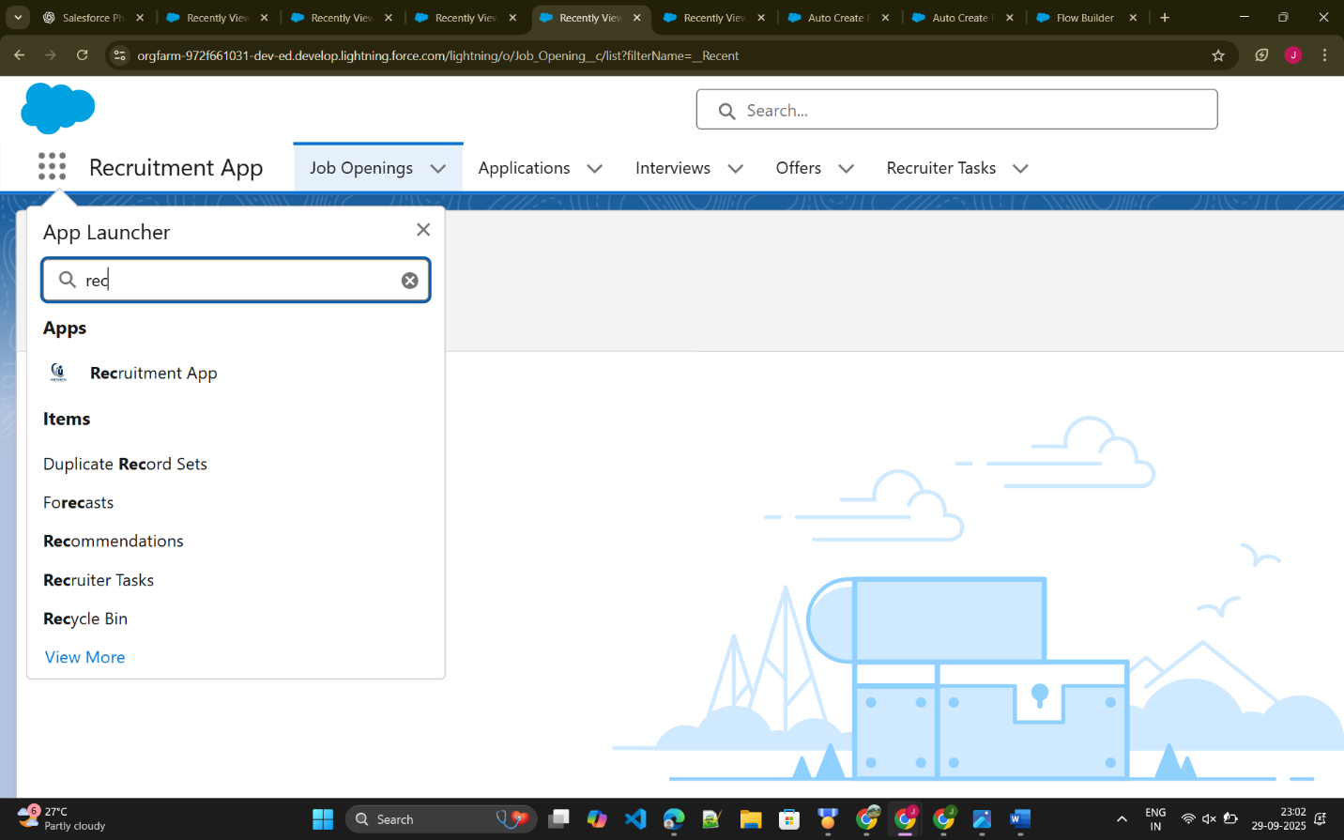

## 3. Home Page Layout Design

### 3.1 Welcome Interface

✅ **Implementation Status:** Complete

**Home Page Header:** 👋 Welcome to TalentTrack Recruit – Your Recruitment Management Hub

**Design Philosophy:** - Clean, professional welcome message - Recruitment-themed branding with emoji for visual appeal - Clear system identification for user orientation - Immediate context setting for recruitment focus

### 3.2 Home Page Layout Structure

✅ **Implementation Status:** Complete

**Layout Components:**

**Header Section:** - Branded welcome message - System identification subtitle - Professional typography for readability

**Navigation Access:** - Quick access to primary business objects (Job Openings, Candidates, Applications) - Recent items display for workflow continuity - Search functionality integration - User-specific customization options

**Layout Benefits:** - Immediate user orientation upon login - Clear brand identity reinforcement - Simplified navigation structure - Professional appearance for recruiter and candidate interactions

**Recruitment App Logo:**



