Phase 7 Report: Integration & External Access

# Executive Summary

This report documents the completion of Phase 7 activities for the Recruitment Management App, focusing on integration and external access. The phase ensures seamless connectivity with external systems, enabling secure data exchange, real-time updates, and improved recruitment workflow automation.

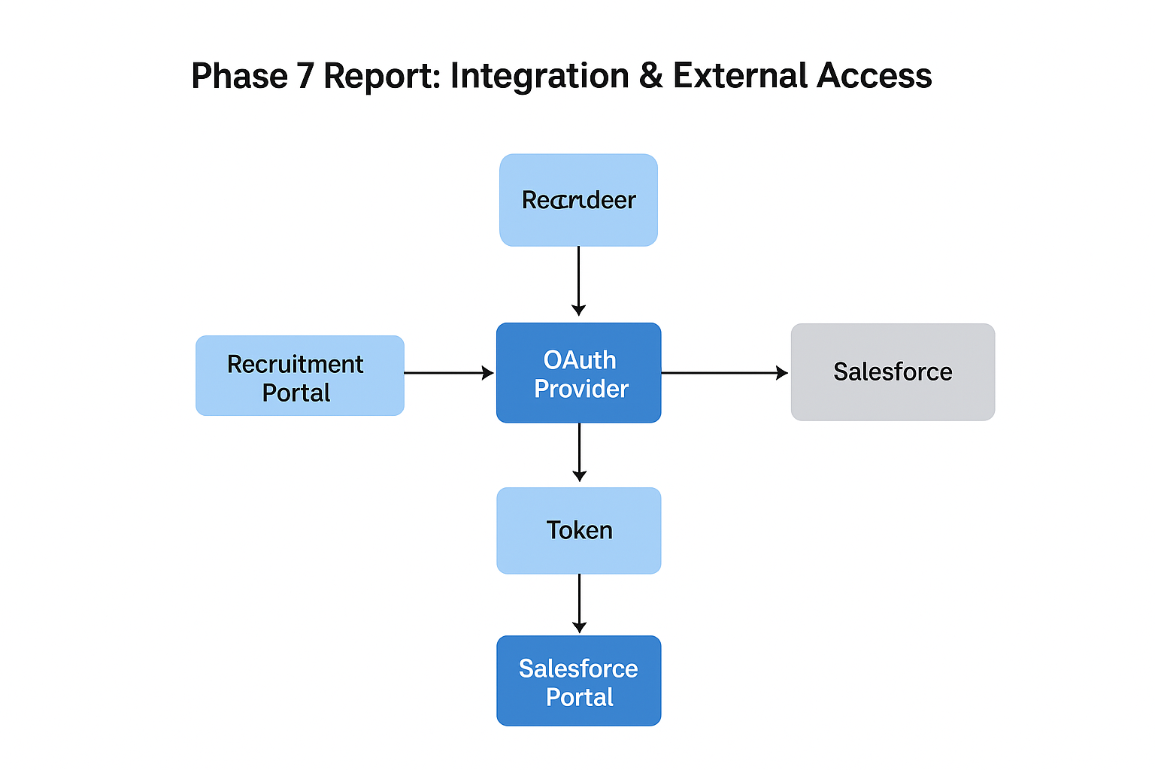

## 1. Named Credentials

Store recruitment-related API credentials (e.g., background verification, insurance) securely.

## 2. External Services

Connect Salesforce with external verification services (e.g., candidate background checks, insurance verification).

## 3. Web Services (REST/SOAP)

Use REST callouts to fetch candidate verification status or job posting updates from external systems.

## 4. Callouts

Triggered when a job application or booking is created, initiating background verification or insurance checks.

## 5. Platform Events

Publish platform events when a candidate reports issues (e.g., missing documents or job status updates).

## 6. Change Data Capture

If candidate/application data is updated in Salesforce, external systems are notified automatically.

## 7. Salesforce Connect

Connect with external HR/Recruitment databases if candidates or job postings are managed outside Salesforce.

## 8. API Limits

Monitor daily API calls to ensure recruitment integrations do not exceed limits.

## 9. OAuth & Authentication

Enable candidates or recruiters to log in via secure OAuth providers (e.g., LinkedIn, Google).

## 10. Remote Site Settings

Allow secure callouts to external recruitment or HR systems.