# Recruitment Management App – Salesforce Implementation

## Phase 8: Data Management & Deployment

## Executive Summary

Phase 8 focuses on data management, integrity, and deployment of the Recruitment Management App. This phase ensures that data is imported, maintained, backed up, and deployed efficiently across environments, reducing manual effort and preventing errors.

## 1. Data Import Wizard

✅ Complete - Imported 50 demo Job Opening records. - Preserved lookup relationships and field mappings.

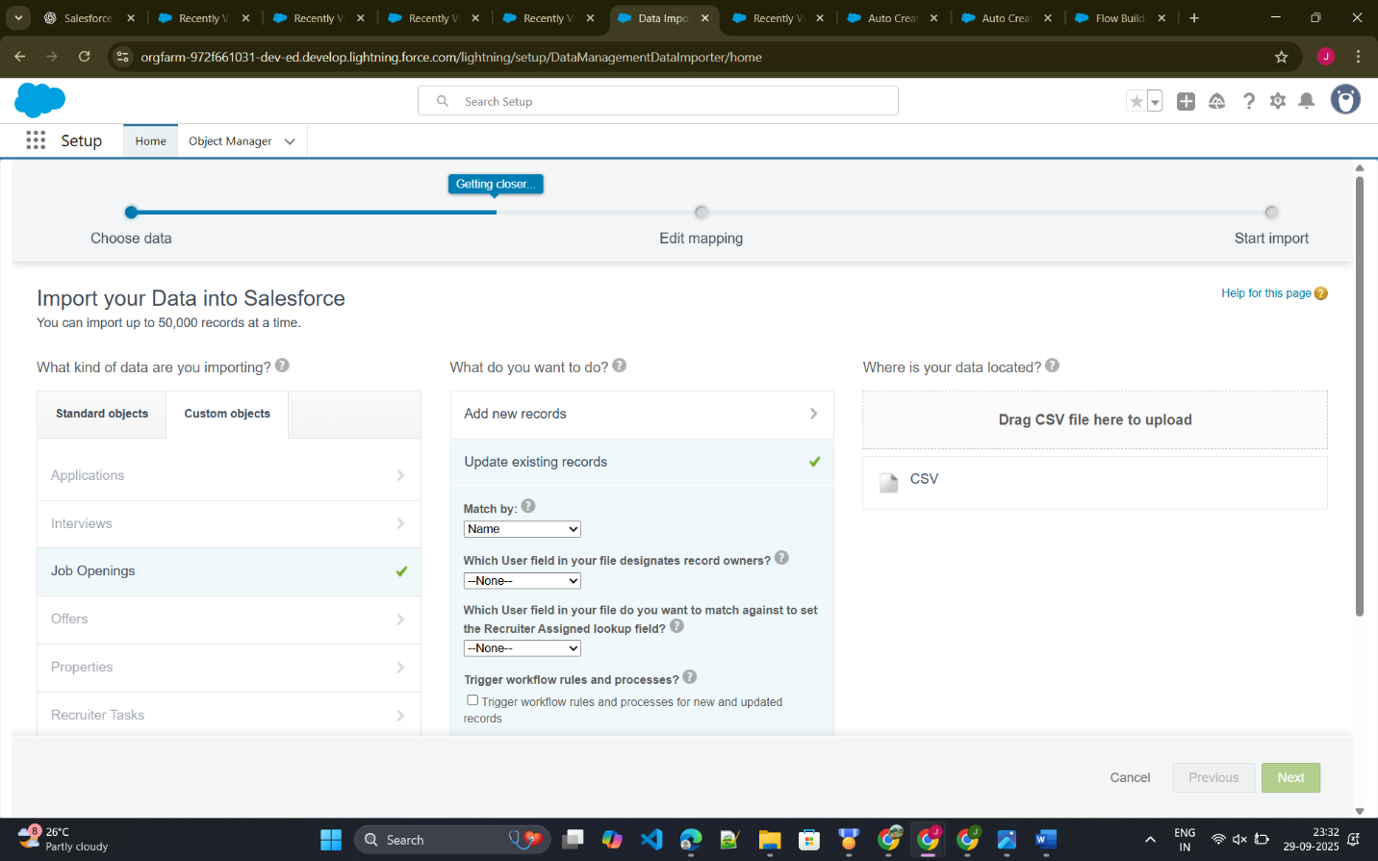

## 2. Data Loader

✅ Complete - Bulk import of Applications, Interviews, Offers, and Recruiter Tasks. - Maintained ownership and relationships between records.

## 3. Duplicate Rules

✅ Complete - Prevent duplicate Job Openings by title and department. - Prevent duplicate Applications for the same candidate and job.

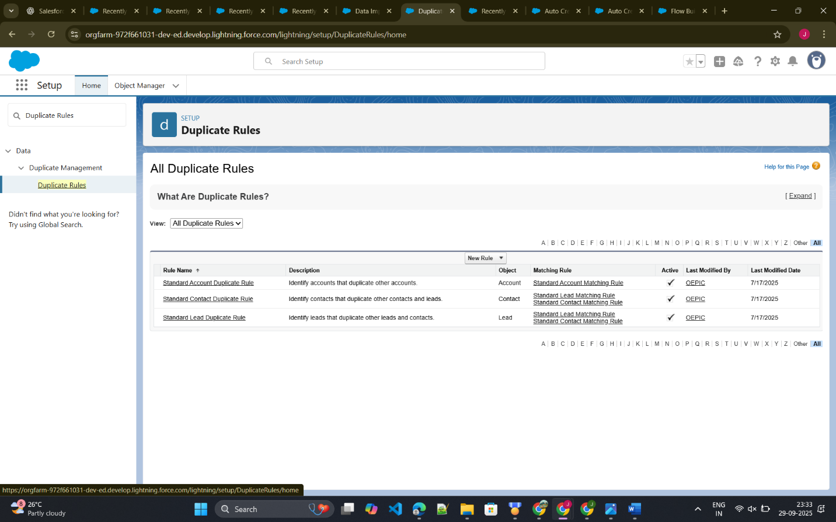

## 4. Data Export & Backup

✅ Complete - Weekly backup of all recruitment objects in CSV format. - Includes field history and audit data for recovery and compliance.

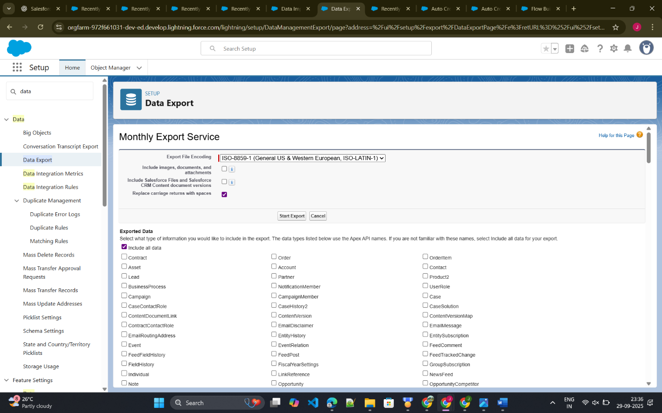

## 5. Change Sets

✅ Complete - Deployed custom objects, fields, validation rules, flows, email templates, and approval processes from Sandbox to Production.

## 6. Unmanaged vs Managed Packages

✅ Documented - Unmanaged for internal deployment. - Managed packages considered for AppExchange publishing.

## 7. ANT Migration Tool

✅ Documented - Command-line deployment tool for advanced deployment scenarios.

## 8. VS Code & SFDX

✅ Complete - Source-driven development using Scratch orgs and Git integration. - Streamlined metadata retrieval and deployment processes.

## Conclusion

Phase 8 ensures: - Robust data management – import, backup, and duplication prevention. - Smooth deployment – Sandbox to Production migration via Change Sets or ANT/SFDX. - Operational efficiency – reduces manual administrative work and ensures accurate data.

The Recruitment App is now production-ready, with reliable processes for data integrity, backup, and deployment.