Recruitment Management App – Salesforce Implementation

# Phase 9: Reporting, Dashboards & Security Review

## Executive Summary

Phase 9 ensures effective business monitoring through reports and dashboards while strengthening system security. This phase enables data-driven decision-making for managers while protecting sensitive customer data with Salesforce’s security features.

## 1. Reports ✅

• Cars Utilization – Track number of days cars are rented.

• Revenue by Car Model – Analyze profitability by vehicle type.

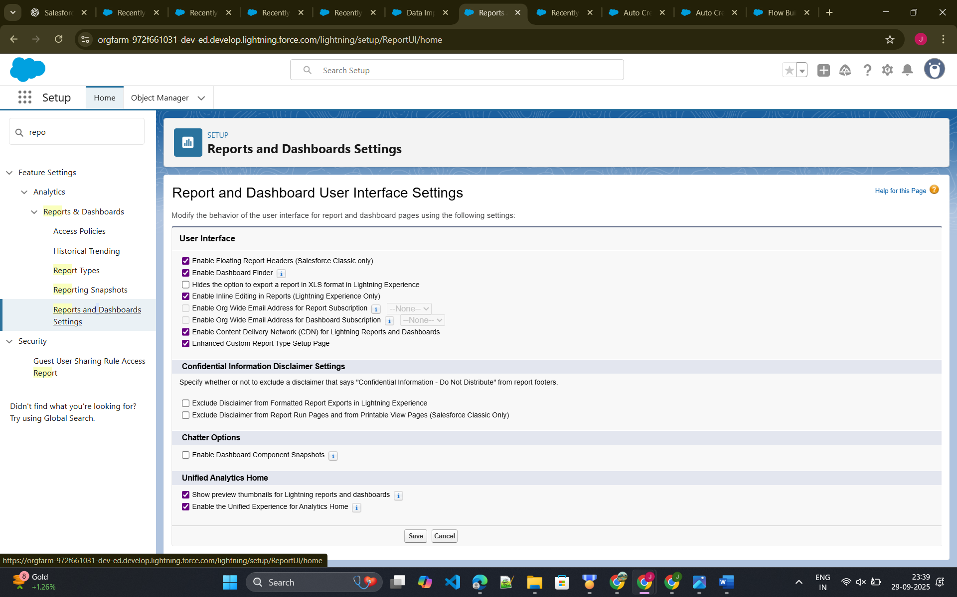

## 2. Report Types ✅

• Custom Report Type: Car + Rental Booking for combined insights.

## 3. Dashboards ✅

• Fleet Utilization Dashboard – Overview of vehicle usage.

• Manager’s Revenue Dashboard – Highlights revenue trends.

## 4. Dynamic Dashboards ✅

• Personalized dashboards: Each agent only sees their own bookings.

## 5. Sharing Settings ✅

• Bookings – Private

• Cars – Public

## 6. Field-Level Security ✅

• Hide Customer ID Proof from Agents.

## 7. Session Settings ✅

• Auto logout after 30 minutes of inactivity.

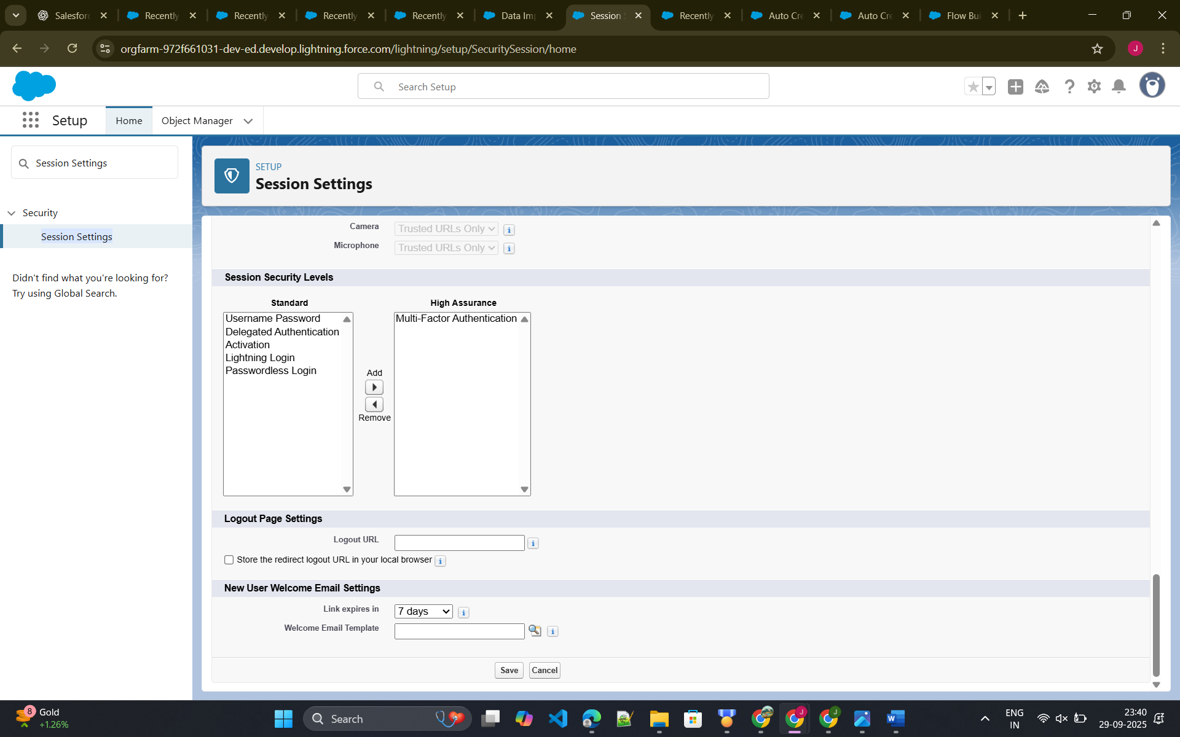

## 8. Login IP Ranges ✅

• Restrict agent access to office IPs only.

## 9. Audit Trail ✅

• Monitor who made changes and when.

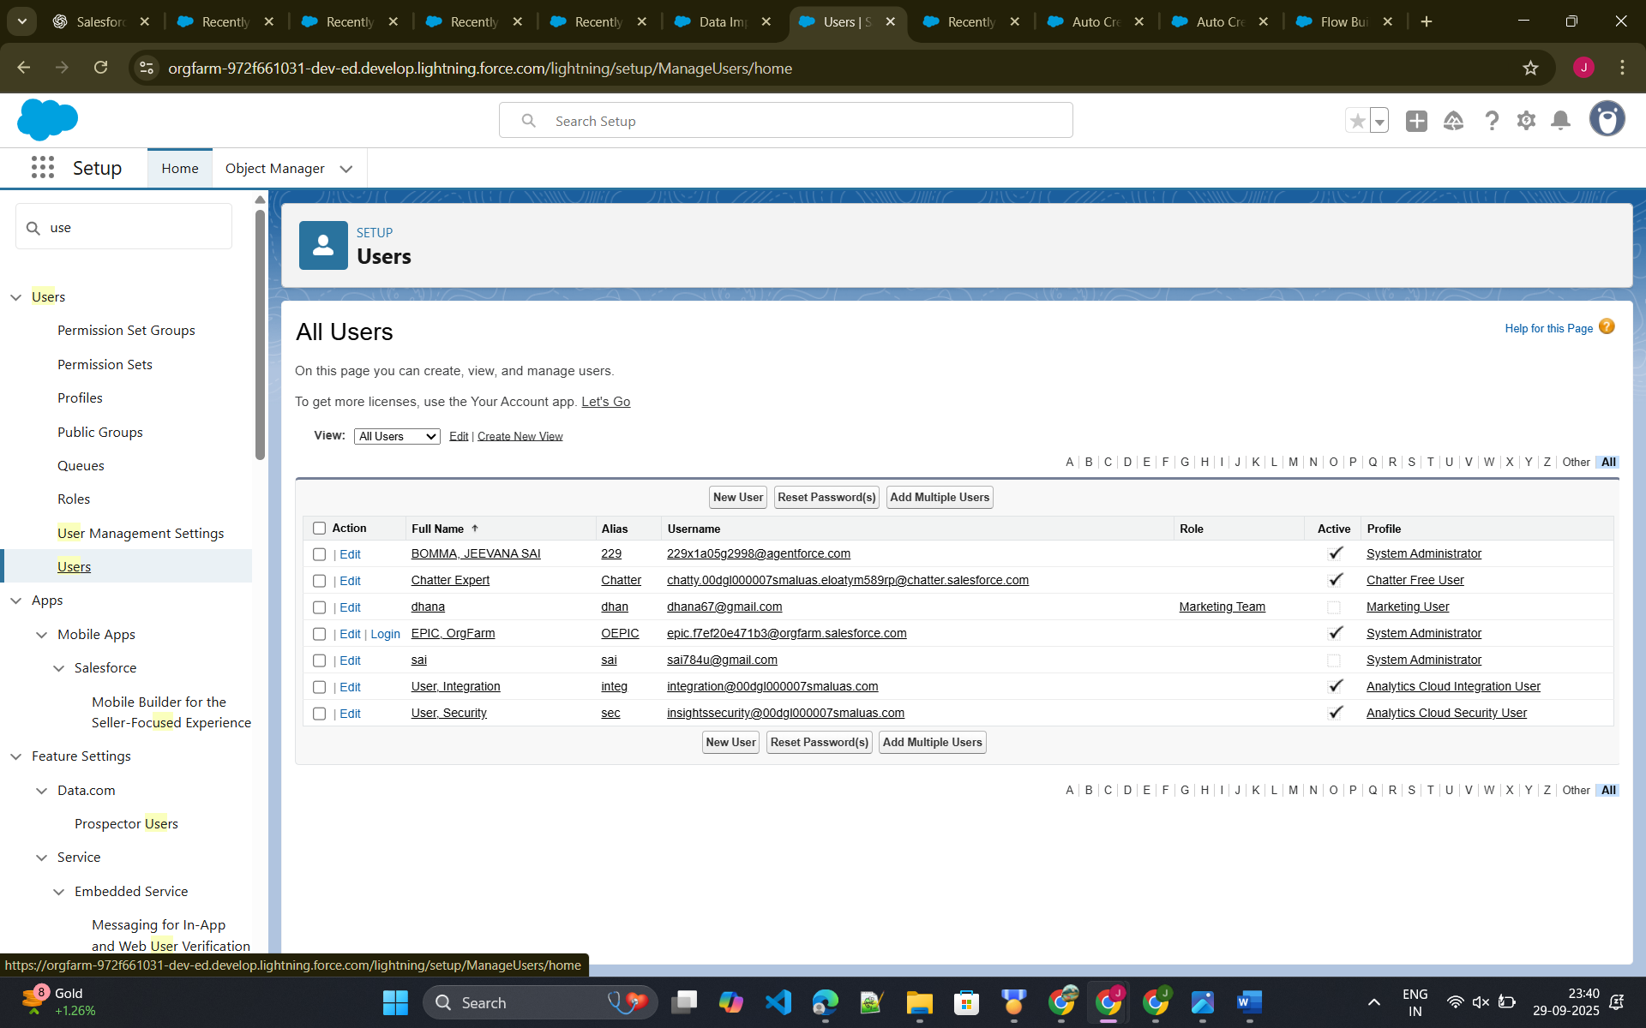

## Conclusion

Phase 9 delivers:  
• Business insights via reports & dashboards.  
• Enhanced security with sharing rules, IP restrictions, and audit trails.  
• Operational trust by ensuring only authorized people access sensitive data.