Enterprise Network Security Assessment and Defense Planning
Simulated Enterprise Network Security Assessment

Prepared by: Tekumalla M. Vijayalaxmi
Role: Junior Cyber Security Analyst
Organization: TechNova Solutions Pvt. Ltd. (Fictional Organization)
Program: Cyber Security Trainee Internship – Final Project
Assessment Type: Authorized / Simulated Training Environment
Date: 25 August 2026

Executive Summary
This project presents a simulated network security assessment for TechNova Solutions Pvt. Ltd., a fictional 75-employee organization. The assessment is performed from the perspective of a Junior Cyber Security Analyst after suspicious network behavior was reported.
The assessment focuses on enterprise architecture, attack surfaces, network-level threats, risk analysis, and defensive planning. No real production system is tested. Ten representative findings are identified, with the highest priorities being privileged authentication, unnecessary exposed services, network segmentation, outdated systems, wireless security, and monitoring.
The proposed defense strategy uses layered security: perimeter firewall controls, IDS/IPS, VLAN segmentation, secure Wi-Fi, MFA, least privilege, patch management, centralized logging/SIEM, endpoint protection, and protected backups.

1. Project Overview
TechNova Solutions Pvt. Ltd. is a fictional company with approximately 75 employees, one primary office, an internal LAN, Internet-facing services, corporate Wi-Fi, guest Wi-Fi, servers, endpoints, and network management infrastructure. The project demonstrates how a Junior Cyber Security Analyst can assess security posture and translate technical risks into practical defensive recommendations.

2. Project Objectives
- Understand enterprise network architecture and data flows.
- Identify critical assets, trust boundaries, threats, vulnerabilities, and attack surfaces.
- Analyze risks related to open ports, weak access control, wireless security, patching, and monitoring.
- Design defensive controls using firewalls, IDS/IPS, segmentation, secure Wi-Fi, MFA, and least privilege.
- Prioritize findings according to likelihood and business impact.
- Produce professional security documentation suitable for an entry-level analyst portfolio.

3. Scope and Rules of Engagement

3.1 In Scope
- Perimeter firewall/router and VPN
- Core switching and VLAN architecture
- Employee endpoints and corporate Wi-Fi
- Server and management networks
- Guest Wi-Fi isolation
- Authentication, privileged access, patching, logging, and backups
- Conceptual review of exposed services and attack surface

3.2 Out of Scope
- Testing real production systems
- Exploitation of vulnerabilities
- Password cracking against real accounts
- Denial-of-service testing
- Phishing/social engineering of real personnel
- Access to confidential production data
All findings are simulated training findings. The report must not be interpreted as evidence of compromise of any real organization.

4. Network Architecture and Mapping
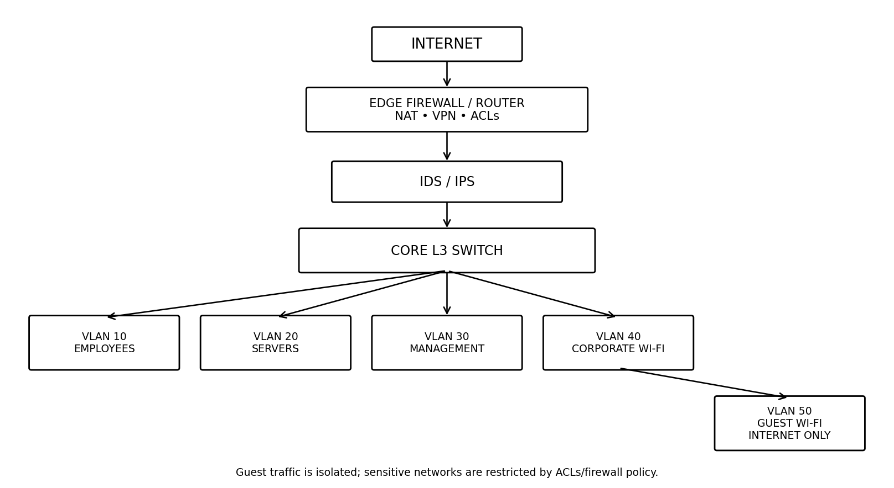
The proposed architecture places the firewall at the Internet boundary, IDS/IPS monitoring behind the perimeter, and a core Layer-3 switch controlling separate security zones. Guest traffic is isolated from corporate resources.

5. Network Components and Critical Assets
Asset | Example | Purpose | Criticality
Perimeter Firewall | FW-01 | Internet filtering, NAT, VPN | Critical
Core L3 Switch | SW-CORE-01 | Inter-VLAN routing and ACLs | Critical
Directory/DNS Server | SRV-AD01 | Identity and name resolution | Critical
File/Application Server | SRV-APP01 | Business applications and files | Critical
Employee Endpoints | PC-001–PC-075 | Business productivity | High
Wireless APs | AP-01–AP-06 | Corporate/guest Wi-Fi | High
Management Network | VLAN 30 | Network administration | Critical
Backup Storage | BKP-01 | Recovery and resilience | Critical
Printers/IoT | PRN-01–PRN-08 | Peripheral services | Medium

6. Data Flow and Trust Boundaries
Internet traffic is filtered by the perimeter firewall. Approved remote users enter through VPN with MFA. Employee devices access only required business services. Management traffic is restricted to the management VLAN. Guest Wi-Fi is routed to the Internet and explicitly denied access to internal networks. Server access is limited to required protocols and authorized groups.

7. Threat Identification
Threat | Attack Surface | Impact | Defense
Unauthorized access | VPN, services, credentials | Account/system compromise | MFA, firewall, least privilege
Malware/ransomware | Endpoints, downloads | Data loss/downtime | EDR, patching, backups
Lateral movement | Flat/weak LAN | Broader compromise | VLANs, ACLs
Wireless attack | Corporate/guest Wi-Fi | Unauthorized access | WPA3/Enterprise, isolation
Insider threat | Privileged accounts | Data theft/disruption | RBAC, logging
Service exploitation | Internet-facing services | Remote compromise | Minimize exposure, patching
Credential theft | VPN, portals, endpoints | Identity compromise | MFA, monitoring
Denial of service | Internet services | Availability loss | Rate limiting, redundancy

8. Attack Surface Analysis
Primary attack surfaces include Internet-facing services, VPN, employee endpoints, corporate wireless, guest wireless, privileged management interfaces, and exposed network services. Attack-surface reduction requires accurate asset inventory, disabling unused services, restricting administration, strong authentication, and timely patching.

9. Vulnerability and Risk Analysis
Risk is rated using qualitative likelihood and business impact.
Likelihood / Impact | Low | Medium | High
Low | Low | Low | Medium
Medium | Low | Medium | High
High | Medium | High | Critical

10. Detailed Findings
ID | Finding | Likelihood | Impact | Risk | Mitigation
NET-01 | Weak/reused privileged credentials | High | High | Critical | Strong unique credentials, MFA, separate admin accounts, access reviews.
NET-02 | Unnecessary/broadly exposed services | Medium | High | High | Inventory services, disable unused services, restrict required ports.
NET-03 | Insufficient network segmentation | Medium | High | High | Use VLANs and ACLs; isolate servers, management, guests, users.
NET-04 | Weak/poorly isolated Wi-Fi | Medium | High | High | Use WPA3/Enterprise, strong authentication, separate guest VLAN.
NET-05 | Outdated systems/firmware | High | High | Critical | Patch management and priority remediation of critical vulnerabilities.
NET-06 | Excessive administrative privileges | Medium | High | High | Least privilege, RBAC, separate admin accounts.
NET-07 | Limited centralized monitoring | Medium | Medium | Medium | Centralize firewall, endpoint, server, and authentication logs.
NET-08 | Remote access needs strengthening | Medium | High | High | Managed VPN, MFA, device controls, restricted admin access.
NET-09 | Guest isolation not guaranteed | Medium | High | High | Guest VLAN with explicit deny rules to internal networks.
NET-10 | Backup protection/testing gaps | Medium | High | High | Protected/isolated backups and periodic restoration tests.

11. Defense Strategy Design

Firewall Strategy
Use least-access rules, restrict inbound traffic, protect administrative interfaces, log relevant events, and remove stale rules.

IDS/IPS Placement
Monitor traffic at the Internet perimeter and key internal trust boundaries; correlate alerts with firewall, endpoint, authentication, and server logs.

Network Segmentation
Separate employees, servers, management, corporate Wi-Fi, guests, and printers/IoT using VLANs and ACLs.

Secure Wi-Fi
Use WPA3 or WPA2-Enterprise where supported, strong authentication, separate guest SSID/VLAN, and restricted management access.

Identity Security
Use MFA for VPN and privileged access, unique passwords, least privilege, account lifecycle controls, and separate administrator accounts.

Patch Management
Maintain an asset/software inventory, define patch SLAs, prioritize critical vulnerabilities, and verify remediation.

Monitoring and SIEM
Centralize security-relevant logs and alert on repeated failures, privilege changes, unusual administration, and suspicious network behavior.

Endpoint Security
Use centrally managed endpoint protection/EDR, host firewalls, application controls, and restricted local administrator rights.

Backup and Recovery
Maintain protected backups, an isolated copy, restricted backup administration, and periodic restoration testing.

Incident Response
Maintain procedures for detection, containment, eradication, recovery, evidence preservation, and lessons learned.

12. Recommended Firewall Policy
Rule | Source | Destination | Action | Purpose
1 | Internet | Internal network | DENY | Block unsolicited inbound traffic
2 | Internet | Approved public service | ALLOW | Permit only documented public services
3 | VPN users | Required services | ALLOW | Controlled remote access
4 | Guest VLAN | Internal VLANs | DENY | Prevent guest-to-corporate access
5 | Guest VLAN | Internet | ALLOW | Guest Internet access
6 | Management VLAN | Network devices | ALLOW | Authorized administration
7 | Employee VLAN | Server VLAN | ALLOW | Required business services only
8 | Any | Firewall management | DENY | Protect management interface

13. IDS/IPS Placement
A network IDS/IPS should monitor traffic at the Internet perimeter and selected internal boundaries. Perimeter visibility helps identify suspicious external activity, while internal monitoring helps identify lateral movement and unusual activity. Alerts should be correlated with endpoint, authentication, server, and firewall logs.

14. Network Segmentation Plan
VLAN | Purpose | Subnet | Access Principle
10 | Employees | 192.168.10.0/24 | Business services only
20 | Servers | 192.168.20.0/24 | Required clients only
30 | Management | 192.168.30.0/24 | IT/security administration
40 | Corporate Wi-Fi | 192.168.40.0/24 | Authenticated employees
50 | Guest Wi-Fi | 192.168.50.0/24 | Internet only
60 | Printers/IoT | 192.168.60.0/24 | Restricted device access

15. Remediation Roadmap
Priority | Timeframe | Action | Owner
1 | 0–30 days | MFA; privileged credential reset; close unnecessary exposure; patch critical systems | IT/Security
2 | 0–30 days | Secure Wi-Fi and enforce guest isolation | Network Team
3 | 31–60 days | Implement VLAN segmentation and inter-zone ACLs | Network Team
4 | 31–60 days | Centralize logs and create priority alerts | Security/SOC
5 | 31–60 days | Review privileged and remote access | IT/Security
6 | 61–90 days | Test backups and incident-response procedures | IT/Security
7 | 61–90 days | Follow-up assessment and verify remediation | Security

16. Security Monitoring Recommendations
- Monitor firewall denies, VPN authentication, privileged account changes, repeated login failures, and unusual outbound traffic.
- Centralize server, endpoint, firewall, and authentication logs where practical.
- Define alert severity, escalation, and investigation procedures.
- Retain logs according to organizational and regulatory requirements.
- Review alerts regularly and document investigations.

17. Security Assessment Checklist
- Asset inventory is current.
- Unnecessary services are disabled.
- Firewall rules are documented and reviewed.
- VPN uses MFA.
- Corporate and guest Wi-Fi are separated.
- Servers, users, management, and IoT are segmented.
- Critical patches are current.
- Privileged access follows least privilege.
- Security logs are monitored.
- Backups are protected and restoration is tested.
- Incident-response procedures are documented.

18. Conclusion
The simulated assessment demonstrates that enterprise security requires multiple coordinated controls. The highest priorities are strengthening identity security, reducing unnecessary exposure, patching critical systems, implementing segmentation, isolating guest wireless, securing remote access, and improving centralized monitoring. These controls reduce the likelihood and impact of unauthorized access, malware propagation, lateral movement, and prolonged outages.

19. Learning and Professional Reflection
This project strengthened my understanding of enterprise network architecture, security risks, access control, wireless security, segmentation, firewall policy, IDS/IPS placement, monitoring, and risk-based remediation. I learned that a security analyst must combine technical knowledge with clear documentation and business-focused risk prioritization. My next learning goals are SIEM/log analysis, vulnerability management, Linux security, cloud security, incident response, and security frameworks.

Appendix A – Project Disclaimer
This is an educational simulation. TechNova Solutions Pvt. Ltd. is fictional. IP addresses, assets, findings, and recommendations are sample data. No real organization or system was tested. Security testing should only be performed with explicit authorization.

