**RESUME**

**L. Vijaya**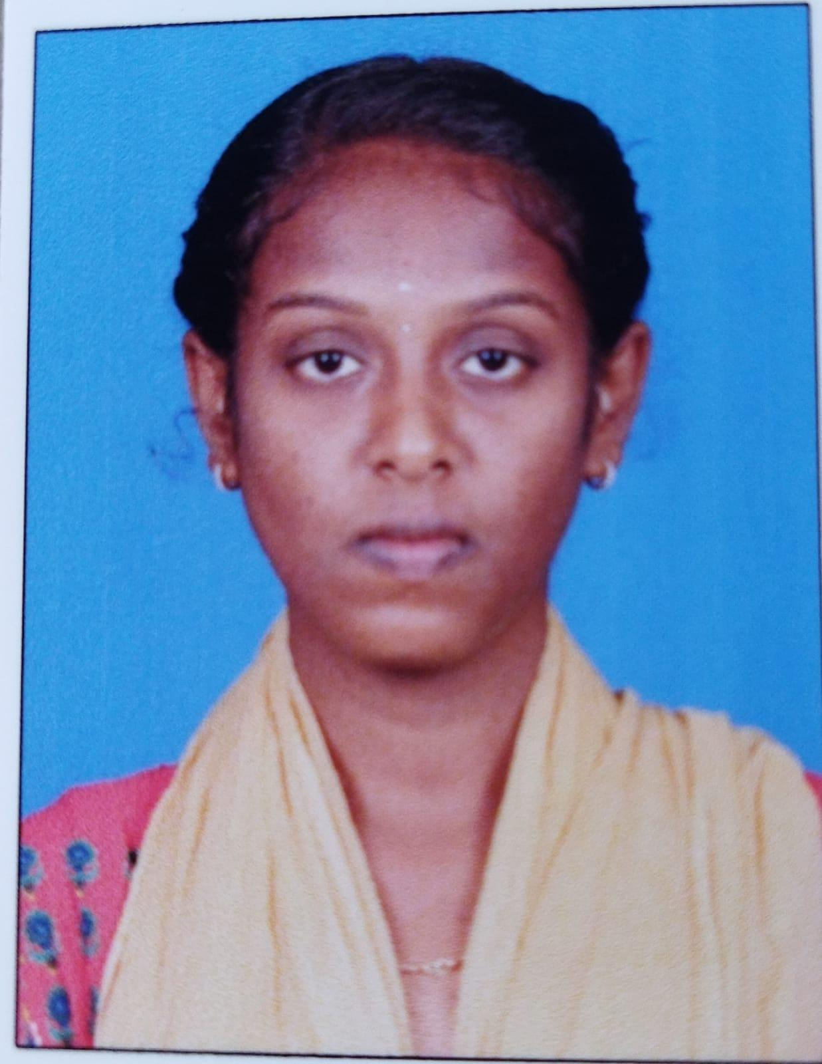

**D\o V. Lakshmanan,**

14-1-85(5),

Surandai,

TENKASI(TK)-627859,

TENKASI(DIST).

EMAIL ID : lvijaya170903@gmail.com

MOBILE NUMBER : 9566576608/8870358651

**OBJECTIVE:**

Seeking a challenging position in a reputed organization where I can learn new skills,expand my knowledge, and leverage my Learnings.

**EDUCATIONAL CREDENTIALS**:

* SSLC 73.8%(2019)
* HSC 84.83%(2021)
* Bachelor of Computer science(2nd year)

(Government Arts and Science College for Women,

Alangulam

* Type : English Higher &Lower

**KEY STRENGTH:**

* Improving own learning and performance.
* Good Communication Skill.
* Flexibility in Adapting New Things.
* Good Creative Skill.

**ERSONAL DETAILS:**

Father’s Name : V. Lakshmanan

Date of birth : 17th September 2003

Gender : Female

Marital Status : Unmarried

Nationality : Indian

Religion : Hindu

Language known : Tamil & English

**DECLARATION:**

I hereby declare that all the details given below are true to the best of my Knowledge and belief.

Place : surandai Signature

Date : 17Mar 2023 (L.vijaya)