Case Study-Statistical Quality Control

Statistical Quality Control
By SQC we mean controlling variation in quality statistically. The term statistical control refers to the stability and predictability of a process over time and the type of variability that exists. A process that is completely stable over time exhibits only natural variability ,with its regular random behaviour remaining unchanged and is referred to as being in a state of statistical control. Conversely a process that changes from its norm will exhibit unnatural variability and is referred to as being out of statistical control. There can be two types of variations viz. assignable/ controllable/ preventable causes. For instance, defective raw material, negligence of operator, faulty equipment etc., and un-assignable/ uncontrollable/ unpreventable/ chance causes for instance, vibrations in a machine, voltage fluctuations & temperature differences etc. Statistical quality control can be classified into two parts viz. process control and product control.

3.1 Process Control
Process control involves controlling and maintaining the quality of manufactured product so that it conforms to standard quality standards, which is achieved through the technique called control charts pioneered by W.A. Shewhart. A control chart is a pictorial way of understanding the variations in quality with respect to a certain attribute. A standard control chart has three horizontal lines viz. upper control limit (UCL) – maximum allowed level of quality characteristic, central line (CL) – average or desired level of quality characteristic and lower control limit (LCL) – minimum allowed level of quality characteristic. A process is said to be in state of control if:
- All sample points fall within control limits
- ii. The points are randomly scattered i.e. they do not follow any trend indicating Assignable causes.
Table 1 Difference between chance and assignable causes
Chance Causes | Assignable Causes
(i) Consist of many individual causes. | Consists of one or just a few individual causes.
(ii) Any one chance causes results in only a minute amount of variation. (However, many of the chance causes act simultaneously so that the total amount of chance variation is substantial). | Any one assignable cause can result in a large amount of variation.
(lit) Some typical chance causes of variation are:  (a) Slight variations in raw material (though within  the specifications) (b) Slight vibration of machine (c) Lack of human perfection in reading instruments  and setting controls. | Some typical assignable causes of variation are : Batch of defective raw material  Faulty set up Untrained operator
(jy) As a practical matter, chance variation cannot economically be eliminated from a process. | The presence of assignable variation can be detected and action to eliminate the causes is usually justified.

Association between Testing of Hypothesis and Control Charts:
Ho: The process is under statistical control,
H1: The process is not under statistical control,

Test Statistic: control chart,

Type I Error: Regarding process to be out of statistical control when it is actually under statistical control, and

Type II Error: Regarding process to be in statistical control when it is actually out of statistical control.
Thus, widening the control band leads to Type II Error while narrowing the control band leads to Type I Error.

Process of Drawing Statistical Control Charts:
Firstly one identifies a quality characteristic and then consider a statistic t that specifies it. The control limits can then be drawn as follows:
Central Line (t), Lower Control Limit: E(t) − 3 × SE(t), and Upper Control Limit: E(t) + 3 × SE(t).
Which is due to the area property of normal distribution that chances of the value lying beyond 3 standard deviation steps is very negligible. Of course, when the underlying process isn’t normal the argument may not hold.

3.1.1 Control Charts for Variables
These are the control charts for quality characteristics which can be measured quantitatively. For example length, thickness etc.We have 4 types of control charts for variables p,np,c,u.These four are used when we have count data and yes/no type data.

3.1.1.1 Control Charts for Mean (X̅ −Chart) and Range (R −Chart)

3.1.1 Control Charts for Variables

These are the control charts for quality characteristics which can be measured quantitatively. For example length, thickness etc.
3.1.1.1 Control Charts for Mean (X̅ −Chart) and Range (R −Chart)
Let 𝑋ij j = 1, … , n be measurements on the i th sample or subgroup i = 1, … , k. Suppose 𝑋ij ~ N(µ, 𝜎2).
The 𝑋̅ chart tries to see if average measurement is under control or not, i.e. the statistic is sample mean. We calculate:

𝑋̅ i = 1/ni ∑Xij j=1,…ni

Then as discussed the control limits

Lower Control Limit: µ − 3 × S𝐸(𝑋̅ i ) = µ- 3σ
√ni

3𝜎 Upper Control Limit: µ + 3 × S𝐸(𝑋̅ i ) = µ + .
√ni
Central Line: 𝐸(𝑋̅ 𝑖) = µ,
‾Clearly when standards are given, i.e. µ and 𝜎2 are known, we can execute the limits directly, otherwise we replace the standards with their estimates based on the data.
Consider another statistic which specifies the dispersion in the quality characteristic called Range and defined as:
Ri = max 𝑋ij − min 𝑋ij.
It can be shown that 𝐸(Ri) = d2𝜎 where d2 is a constant depending upon n. Hence we can write:

3𝐸(Ri) 3R
S𝐸(𝑋̅ i ) = ⇒ S𝐸(𝑋̅ i ) = … (1)
d2√nii d2√ni

Where R is the population range.

We can estimate µ and R as follows:
µ^ = 𝑋̅̅ =(1/k)∑ 𝑋̅ 𝑖
=overall sample mean and R^= R⎺ =(1/k) ∑Ri⎺ = overall sample range

Hence we can write the control limits as follows:
Central Line: 𝐸(𝑋̅ 𝑖) = µ̂ = 𝑋̅̅

Upper Control Limit 𝑋̅̅ + 3R * 1 .
d2 √ni

Lower Control Limit: 𝑋̅̅ - 3R * 1 .
d2 √ni
It is also important to see that variability within the sample is within the permissible limits. For this purpose we use the R chart, where the statistic is sample range which is defined as follows:
Ri = max 𝑋ij − min 𝑋ij.
We need the expectation and standard error of the statistic for calculating the control limits, which are obtained as 𝐸(Ri) = R, i.e. population range and S𝐸(Ri) = cR where c is a constant depending upon sample size. Clearly if the standard, i.e. the population range (R) is given then we can execute the limits, otherwise we replace R by overall sample range, i.e. R̅.

Control Charts for Mean (𝑿̅ −Chart) and Standard Deviation (𝒔 −Chart)
R Chart is used to see if the variability in the measurement is within the permissible limits or not? We can use standard deviation as well to quantify this. S -Chart actually does this, we try to obtain the control limits using sample standard deviation as the statistic which is defined as:

Table 2 Interpretation of Control Charts for Variables:
SNo. | 𝑹 −Chart/ 𝒔 –Chart | 𝑿̅−Chart | Interpretation
1. | In control. | Points beyond limits only on one side. | Level of process has shifted.
2. | In control. | Points beyond limits on both the sides. | Level of process is changing in erratic manner – frequent adjustments.
3. | Out of control | Points beyond limit on both sides. | Variability has increased.
4. | Out of control. | Out of control on one side. | Both level and variability have changed.
5. | In control. | Trend of 7 or more points. No point is outside control limits. | Process is gradually changing.
6. | Run of 7 or more points above central line | - | Variability has increased.
7. | Points to close to central line | - | Systematic differences within subgroups.
9. | - | Points too close to the central line. | Systematic differences within subgroups.

While interpreting control charts for variables we have the following rules:

- First of all interpret the chart of within sample variation (R −Chart or s−Chart) and if it is not in control then first bring it in control using iterative removal of samples which are out of control.

- After bringing the chart of within sample variation under control we can go ahead with interpreting the 𝑋̅ −Chart and then comment about the state of process control. If all the points are within limits then the process is in control and the obtained control limits can be used for future reference. But, if some points are outside the limits we say that the process is out of control and hence the obtained control limits should not be used for future reference, instead one redraws the chart using iterative removal of samples which are out of control. Note that redrawing doesn’t bring the original process in control, we do it to get good control limits for future reference. In the process of iterative removal it may so happen that the no. of samples become very small say ≤ 10, then we conclude that the data is insufficient to arrive at good control limits.

- In SPSS you can check on control rules related to 3𝜎 limits, trend (upward and downward), run near central line (above and below) and cyclic patterns (alternating above and below central line).

2. Choosing between 𝒔 −Chart and 𝑹 −Chart:

For analyzing small samples (≤ 10), range is preferred while for large samples standard deviation is preferred.
X-R chart
- This control chart uses the range to measure the variation within a subgroup. For the measurements within a subgroup, the range is the maximum - minimum value. The range is an easy concept to understand - and to calculate.
- One problem with the X-R chart is that the range becomes a poorer and poorer measure of within-subgroup variation as the subgroup size increases. A different method is needed for the larger subgroup sizes. This is where the X-s chart provides the solution. Yet, the X-s chart is very similar to the X-R chart.
- The major difference is that the subgroup standard deviation is plotted when using the X-s chart, while the subgroup range is plotted when using the X-R chart.
- One advantage of using the standard deviation instead of the range is that the standard deviation takes into account all the data, not just the maximum and the minimum.
- The constants used to calculate the control limits and to estimate the process standard deviation are different for the X-s chart than for the X-R chart.

Control Charts for Attributes

Attribute data is known as discrete and count data. Attributes are the quality characteristics which can’t be measured quantitatively. We study the following control charts for attributes:

Control Chart for Fraction Defectives (𝒑 −Chart) and No. of Defectives (𝒏𝒑 or d−Chart)

Let di be the no. of defectives in a sample of size ni then proportion of defectives is:
di
pi = , i = 1, . . , k.
ni
i
We want to construct control chart to see if proportion of defectives is within permissible limits of not. We need the following:

𝐸(pi) = P and S𝐸(pi) = ⇃P(1-P)/ni

Where P is the population proportion of defectives. If P is known then use that, otherwise estimate P as overall proportion of defectives, i.e.

P̂ =p = ∑ pi/k

i=1,2….k
Hence the control limits are given by 𝐸(pi )± 3S𝐸(pi )i.e.p ±3 sqrt(^{pq} /ni) .We can instead use directly the number
Of defects as well, the control limits will be by 𝐸(di) ± 3S𝐸(di), i.e. nip̅ ± 3√ni pq . In fact p−Chart and d − Chart give exactly same information but when same size varies p −Chart is preferred as the central line remains constant unlike in d−Chart.

Control Chart for No. of Defects per sample (c −Chart ) and No. of Defects per unit (𝒖−Chart)

An article which doesn’t conform to one or more of the specifications is termed as defective while any instance of article’s lack of conformity to specifications is a defect. In many manufacturing and inspection situations the sample size n is large (since the opportunities for the defects to occur are numerous) and the probability p of occurrence of a defect in any one spot is very small such that np is finite. In such situations from the statistical theory we know that the pattern of variations in data can be represented by Poisson distribution, i.e. the variable no. of defects per unit follows a Poisson distribution.
Let ci be the no. of defects in the ith sample of size n_{i} , i = 1, … , k, which follows a Poisson distribution with parameter λ. We use c_{i} as the statistic and obtain the control limits using:
𝐸(ci) = λ and S𝐸(ci) = √λ

When λ is unknown we estimate it as overall average no. defects, i.e.

λ̂ = c̅ =(1/k)*∑ c_{i} where i=1,…..k

When the sample size is varying we generally use u_{i} = 𝑐𝑖 , i.e. average no. defects per unit for the i th sample. 𝑛𝑖
�

λ
𝐸(ui) =
ni
√λ
, S𝐸(ui) =
ni

Note: Interpretation of Control Chart for Attributes:

- If all the points are within upper control limit then the process is in control and the obtained control limits can be used for future reference. But, if some points are outside the upper control limit then we say that the process is out of control and hence the obtained control limits should not be used for future reference, instead one redraws the chart using iterative removal of samples which are above UCL. Note that redrawing doesn’t bring the original process in control, we do it to get good control limits for future reference. In the process of iterative removal it may so happen that the no. of samples become very small say ≤ 10, then we conclude that the data is insufficient to arrive at good control limits.

- Points outside the UCL are termed as high spots. These suggest deterioration in the quality and should be regularly reported to the production engineers.

- Points below LCL are called low spots. Such points represent a situation showing improvement in the quality.

Control charts have two general uses. The most common application is as a tool to monitor process stability and control. A less common, use of control charts is as an analysis tool.

Identifying Variation
When a process is stable and in control, it displays common cause variation, variation that is inherent to the process. A process is in control when based on past experience it can be predicted how the process will vary (within limits) in the future. If the process is unstable, the process displays special cause variation, non-random variation from external factors. Control charts are simple, robust tools for understanding process variability
A control chart represents a picture of a process over time.The 3 characteristics of a process that is in control are:
1)Most points are near the average.
2) A few points are near the control limits
3) No points are beyond the control limits.

R chart plots the ranges of each subgroup. The R chart is used to evaluate the consistency of process variation. Look at the R chart first; if the R chart is out of control, then the control limits on the Xbar chart are meaningless. In R chart control limits are a function of average range. The control limits on the X bar chart are derived from the average range This is the technical reason why the R chart needs to be in control before further analysis. If the range is unstable, the control limits will be inflated, which could cause an errant analysis and subsequent work in wrong area of process In order to judge if a process is in control, X bar and s charts should be examined together and the process should be deemed in statistical control if both the charts show state of control.

Case 1: Consider the file diameter.xlsx which has data on diameter of a fiber for 15 different samples with each sample of size 14. Comment on the state of process control using 𝑋̅ − R chart or 𝑋̅ − s chart.

As the sample size (>10),it is a large sample ,so standard deviation is preferred. These charts are a very powerful tool for monitoring variation in a process and detecting changes in either the average or the amount of variation in the process. We have the s chart as follows-

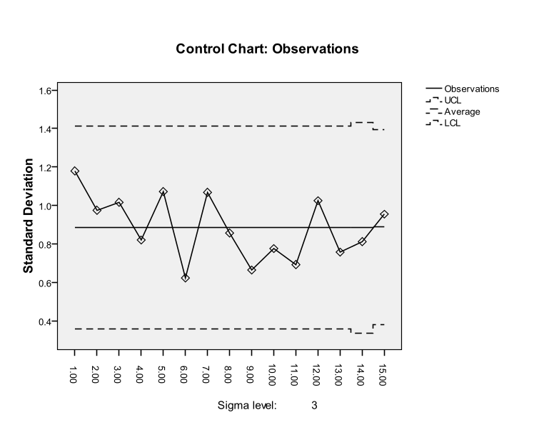
Figure 1 s chart Interpretation
- First we interpret the chart of within sample variation i.e. s chart .We should use this chart first to determine if the distribution of the process characteristic is stable.
- All the sample points vary randomly and fall within control limits. No trends or patterns are present. This chart shows that sample variability is in statistical control.
- The chart above is an example of a stable (in statistical control) process. This pattern is typical of processes that are stable.
- When we say s chart is in statistical control variation within the subgroup is consistent from subgroup to subgroup. There is no statistical difference between these standard deviations. The average standard deviation will be 0.9 units but it can vary anywhere from around 4.4 to 1.4 approximately.
As the s chart is under control we can go ahead with interpreting the X bar chart.
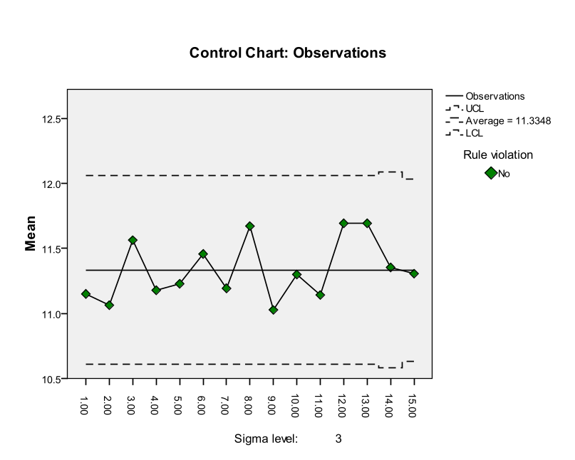
- X bar chart is used to evaluate consistency of process averages by plotting the averages of each subgroup. It is efficient at detecting relatively large shifts in process average.

Figure 2 X bar chart Interpretation
- In X bar chart all the sample points fall within control limits, this chart shows that process mean is in control. The chart above is an example of a stable (in statistical control) process.
- X bar chart is in statistical control means that the variation between subgroup averages is the same from subgroup to subgroup. it means that there is no statistical difference between the subgroup averages. The long-term average will be 11.33. The average will vary between UCL and LCL.
- The X and s charts above are in statistical control. This means that the process is consistent and predictable. There are only common causes of variation present .
- As all the points are within limits then the process is in control and the obtained control limits can be used for future reference.

Case 2: Consider the file weight.xlsx which has data on weight of a container for 27 different samples with each sample of size 3. Comment on the state of process control using 𝑋̅ − R chart or 𝑋̅ − s chart.

As the sample size (<10),it is a small sample ,so range is preferred We want to use an X bar -R chart to find out if this process is consistent and predictable(in control).
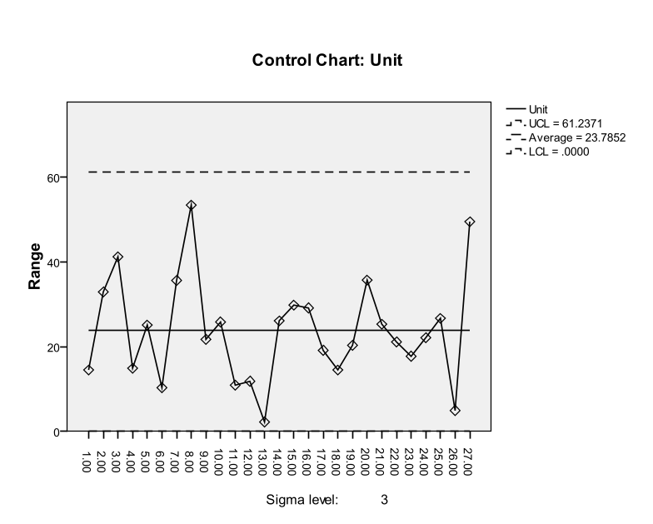
- In R chart all the sample points fall within control limits. This chart shows that process variability is in control. The chart above is an example of a stable (in statistical control) process.
- This pattern is typical of processes that are stable. Run of 7 or more points above central line indicates the variability has increased.

Figure 3 R chart Interpretation
- A run of points above the central line is indicative of increase in process spread and therefore represents an undesirable situation.
- While a run below the central line indicates an improvement in the sense that the variability has been reduced.
- When the range chart is in statistical control variation within the subgroup is consistent. There is no statistical difference between these ranges. The average range will be 23.7852. but it can vary anywhere from 0.0 to 61.23.
- Since the range chart is in control we go for X bar chart.
- As all the points are within limits the process is in control and the obtained limits can be used for future reference.
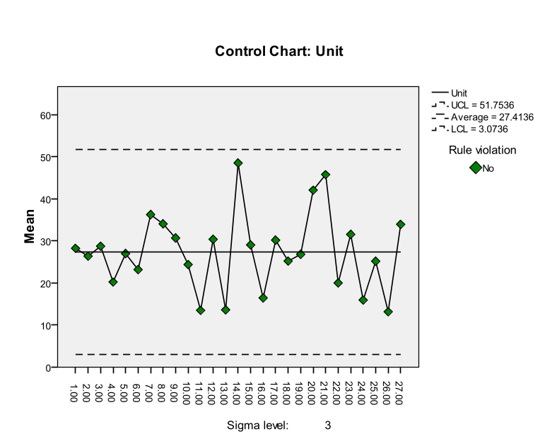
In the chart all the sample points fall within control limits, which implies that process average is in control. The chart above is an example of a stable (in statistical control) process. We can see there are no rule violations.

Figure 4 X bar chart Interpretation
- X bar chart is in statistical control means that the variation between subgroup averages is the same from subgroup to subgroup. it means that there is no statistical difference between the subgroup averages. The long-term average will be 27.41. The average will vary between UCL (51.75)and LCL.(3.07)
- As R is in control and we have a run of 7 or more points above or below the central line indicating a shift in the process level.
- As all the points are within control limits the process is in statistical control and the obtained control limits can be used for future reference.

X bar and R chart have the following limitations:
- They are charts for variables only.
- In certain situations they are impracticable and uneconomical.

- So as an alternative to X bar and R charts we have control limits for attributes. Notice that no discrete control charts have corresponding range charts as with the variable charts. The standard deviation is estimated from the parameter itself (p, u or c); therefore, a range is not required.
- It is used to look at variation in yes/no type data. This type of chart involves counts. There are only 2 possible outcomes either the item is defective or it is not. The p control chart is used to determine if the fraction of defective items in a group of items is consistent over time.

SPchart

Use an np-chart when identifying the total count of defective units (the unit may have one or more defects) with a constant sampling size.

P-Chart
Used when each unit can be considered pass or fail – no matter the number of defects – a p-chart shows the number of tracked failures (np) divided by the number of total units (n).

Interpretation of p chart (d chart)

- From the p chart process is judged to be in statistical control if all the sample points’ fall within the control limits without exhibiting any specific pattern. In such a case, the observed variation in fraction defectives are attributed to the stable pattern of chance causes. And the average fraction defective p bar is taken as the standard fraction defective P.
- A point outside the Upper control limit is called high spots, it suggests deterioration in the quality and should be regularly reported to the production engineers.
- Points below LCL are called low spots. Such points represent a situation showing improvement in the product quality.
- When a number of points fall outside the control limits a revised estimate of P should be obtained by eliminating all the points that fall above UCL ( it is assumed that points that fall below LCL are not due to faulty inspection).The standard fraction defective(p) should be revised periodically in this way.

Case 3: Consider the file leather_belts.xlsx which has data on no. of defectives in 22 lots each containing 2000 leather belts. Draw a control chart for fraction defectives in order to assess the state of process control.

When we want to determine the variation in yes/no type data i.e. either the item is defective or it is not defective. The p control chart is used to determine if the fraction of defective items over a group of items is consistent over time. Hence we use p chart here as i want to draw control chart for fraction defectives.
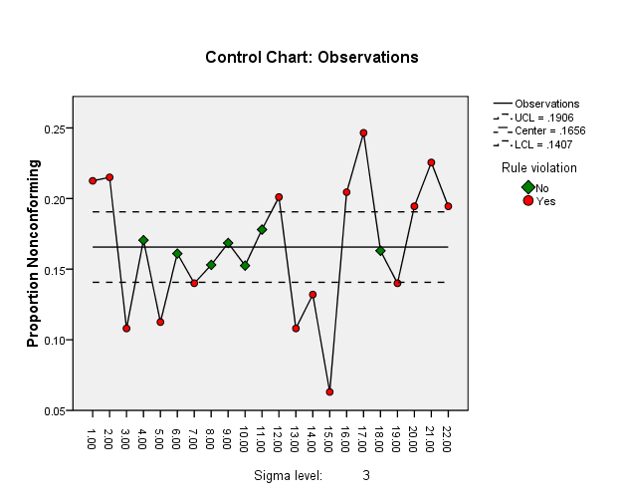
The variation being examined is the variation in the number of defectives in 22 lots each containing 2000 leather belts. As we can see there are some points going outside Control limits which is a clear indication of presence of assignable causes of variation, which must be corrected.
Figure 5 p chart Interpretation

- Points outside the UCL are termed as high spots. These suggest deterioration in the quality and should be regularly reported to the production engineers.
- Points below LCL are called low spots. Such points represent a situation showing improvement in the quality.
- The process is not in statistical control. This means the process is inconsistent and unpredictable.

Table 3 Rule Violations
Sampleno | Violations for Points
1.00 | Greater than +3 sigma
2.00 | Greater than +3 sigma
3.00 | Less than -3 sigma
5.00 | Less than -3 sigma
7.00 | Less than -3 sigma
12.00 | Greater than +3 sigma
13.00 | Less than -3 sigma
14.00 | Less than -3 sigma
15.00 | Less than -3 sigma
16.00 | Greater than +3 sigma
17.00 | Greater than +3 sigma
19.00 | Less than -3 sigma
20.00 | Greater than +3 sigma
21.00 | Greater than +3 sigma
22.00 | Greater than +3 sigma
15 points violate control rules.

Some points are outside the upper control limits and the obtained control limits should not be used for future reference We redraw the chart using iterative removal of samples which are above UCL.Note that redrawing doesn’t bring the original process in control, we do it to get good control limits for future reference .

SPchart
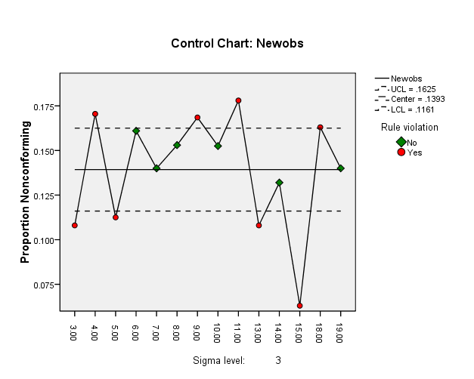
Figure 6 p chart Interpretation
- As points are falling out of control limits which is indicative of assignable causes of variation which must be searched and rectified.
- We will obtain the revised control limits by eliminating the samples falling outside the Upper control limits.

Table 4 Rule Violations
Sampleno | Violations for Points
3.00 | Less than -3 sigma
4.00 | Greater than +3 sigma
5.00 | Less than -3 sigma
9.00 | Greater than +3 sigma
11.00 | Greater than +3 sigma
13.00 | Less than -3 sigma
15.00 | Less than -3 sigma
18.00 | Greater than +3 sigma
8 points violate control rules.

The above sample points fall outside control limits. By iterative method we remove points above UCL.Note that redrawing doesn’t bring the original process in control, we do it to get good control limits for future reference .

SPchart

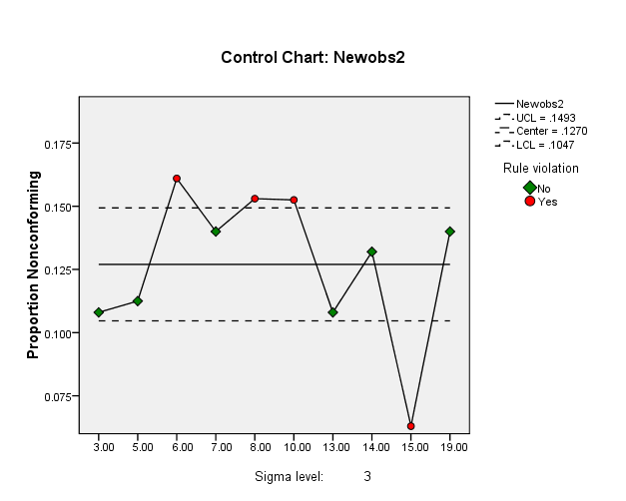
Figure 7
Table 5 Rule Violations
Sampleno | Violations for Points
6.00 | Greater than +3 sigma
8.00 | Greater than +3 sigma
10.00 | Greater than +3 sigma
15.00 | Less than -3 sigma
4 points violate control rules.

The above sample points fall outside control limits. By iterative method we remove points above UCL.Note that redrawing doesn’t bring the original process in control, we do it to get good control limits for future reference .
Even after removing the sample points (which are falling outside control limits) the process is still not in state of statistical control.

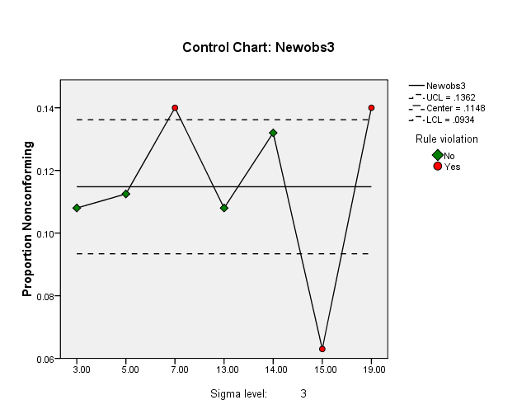
Table 6 Rule Violations
Sampleno | Violations for Points
7.00 | Greater than +3 sigma
15.00 | Less than -3 sigma
19.00 | Greater than +3 sigma
3 points violate control rules.
Figure 8
To establish quality standards for the future we eliminate the 2 points above UCL. Even after removing the sample points (which are falling outside control limits) the process is still not in state of statistical control.

SPchart
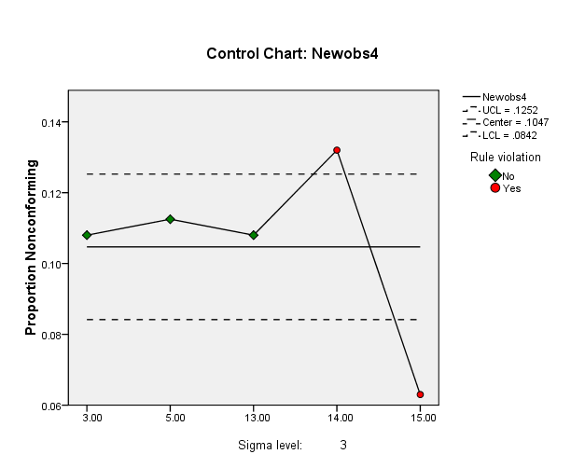
Table 7 Rule Violations
Sampleno | Violations for Points
14.00 | Greater than +3 sigma
15.00 | Less than -3 sigma
2 points violate control rules.
Figure 9

The above sample points fall outside control limits. By iterative method we remove points above UCL. To establish quality standards for the future we eliminate the sample point (14) above UCL. Note that redrawing doesn’t bring the original process in control, we do it to get good control limits for future reference.

SPchart
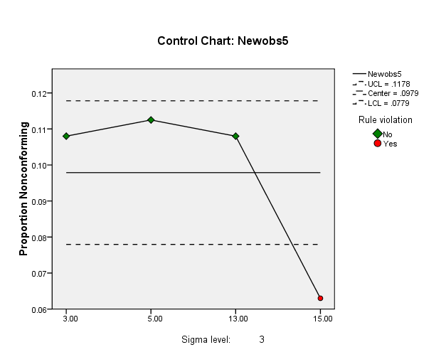
Table 8 Rule Violations
Sampleno | Violations for Points
15.00 | Less than -3 sigma
1 points violate control rules.
Figure 10

Interpretation
- We do not eliminate any further as there are no points above UCL.
- No sample values other than those which have been deleted, fall outside the new limits.
- In the process of iterative removal we notice that the no. of samples become very small say ≤ 10, so we conclude that the data is insufficient to arrive at good control limits.
- Only common causes of variation are present and the process is in statistical control.
- Hence the above p chart monitors the variation in the fraction of defective items in a group of items.

Case 4: Consider the file cricket_gloves.xlsx which has data on no. of defectives in 24 lots each containing different no. of cricket gloves. Draw a control chart for fraction defectives in order to assess the state of process control

When we want to determine the variation in yes/no type data i.e. either the item is defective or it is not defective. The p control chart is used to determine if the fraction of defective items over a group of items is consistent over time. Hence we use p chart here as I want to draw control chart for fraction defectives
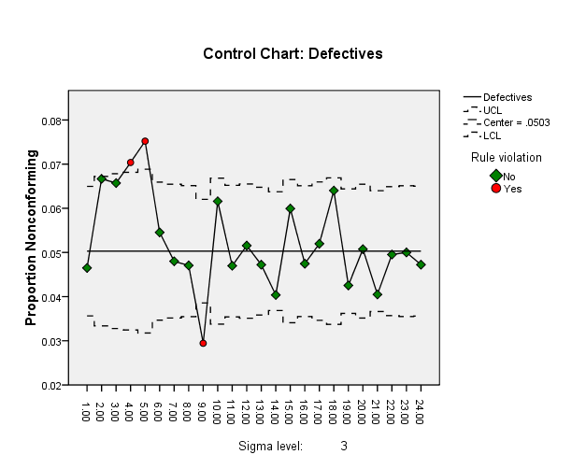
- As we can see there are some points going outside Control limits which is a clear indication of presence of assignable causes of variation, which must be corrected.
- A point outside the Upper control limit is called high spots, it suggests deterioration in the quality and should be regularly reported to the production engineers.
- Points below LCL are called low spots. Such points represent a situation showing improvement in the product quality
Figure 11

.
Table 9 Rule Violations
LotNo | Violations for Points
4.00 | Greater than +3 sigma
5.00 | Greater than +3 sigma
9.00 | Less than -3 sigma
3 points violate control rules.

The above sample points(4,5) fall outside UCL. By iterative method we remove points above UCL. To establish quality standards for the future we eliminate the sample point (14) above UCL. Note that redrawing doesn’t bring the original process in control, we do it to get good control limits for future reference.

SPchart
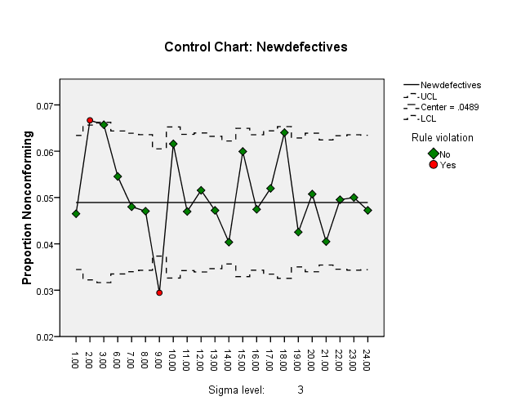
Figure 12
The above sample points fall outside control limits. By iterative method we remove points above UCL.Note that redrawing doesn’t bring the original process in control, we do it to get good control limits for future reference .
After removing points 4 and 5 the process is still outside statistical control.

Table 10 Rule Violations
LotNo | Violations for Points
2.00 | Greater than +3 sigma
9.00 | Less than -3 sigma
2 points violate control rules.

SPchart
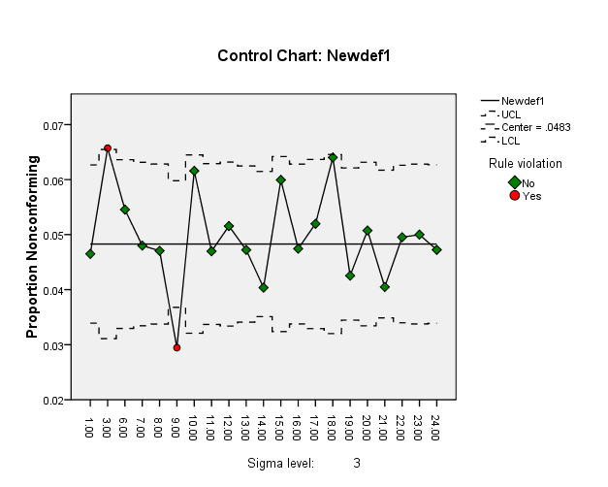
Figure 13
We have to remove this point in order to achieve a consistent and in control process. After removing point 2 the process is still outside statistical control.

Table 11 Rule Violations
LotNo | Violations for Points
3.00 | Greater than +3 sigma
9.00 | Less than -3 sigma
2 points violate control rules.
The above sample points fall outside control limits. By iterative method we remove points above UCL.Note that redrawing doesn’t bring the original process in control, we do it to get good control limits for future reference.

Even after removing the sample points (which are falling outside control limits) the process is still not in state of statistical control

SPchart
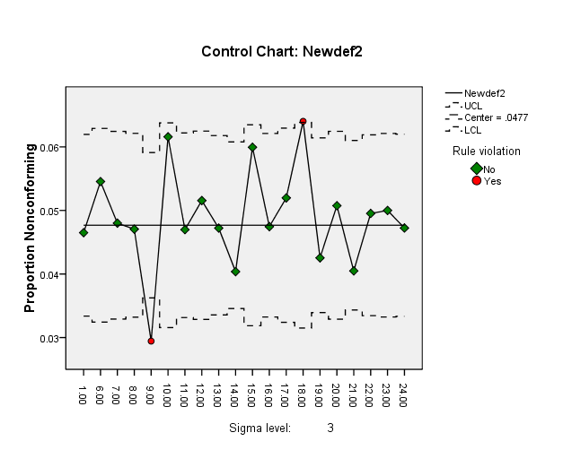
Figure 14
- After removing point 3 the process is still outside statistical control. This suggests the presence of some assignable causes of variation which have to be detected and eliminated.
- As the plotted subgroup values are not between the control limits there is evidence of unusual behaviour.

Table 12 Rule Violations
LotNo | Violations for Points
9.00 | Less than -3 sigma
18.00 | Greater than +3 sigma
2 points violate control rules.

SPchart
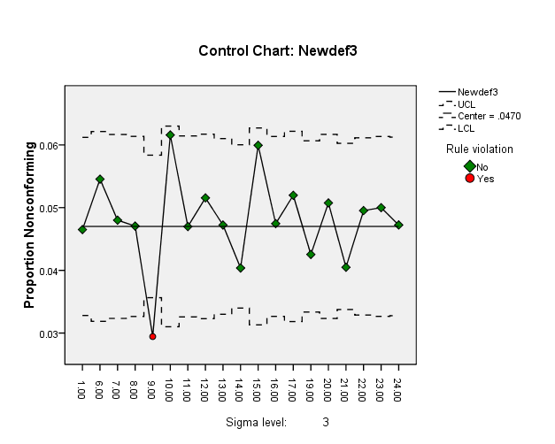
- After removing point 18 the process is now in statistical control. We take these new limits as standards for controlling future production from this process.
- The process is in statistical control.
- This means the process is consistent and predictable. Only common causes of variation are present.
- P control charts are used to monitor the variation in fraction of defective items in a group of items.

Figure 15
- We do not eliminate any further as there are no points above UCL.
- No sample values other than those which have been deleted, fall outside the new limits.
- Only common causes of variation are present and the process is in statistical control.
- Hence the above p chart monitors the variation in the fraction of defective items in a group of items.

Table 13 Rule Violations
LotNo | Violations for Points
9.00 | Less than -3 sigma
1 points violate control rules.

Case 5: Consider the file welding.xlsx which has data on defects in the process of welding, such as pinholes, cracks etc. Draw a control chart for the no. of defects and comment on the state of process control

c-Chart
- Used when identifying the total count of defects per unit (c) that occurred during the sampling period, the c-chart allows the practitioner to assign each sample more than one defect.
- This chart is used when the number of samples of each sampling period is essentially the same. As we are interested in drawing control chart for the number of defects we prefer c chart.
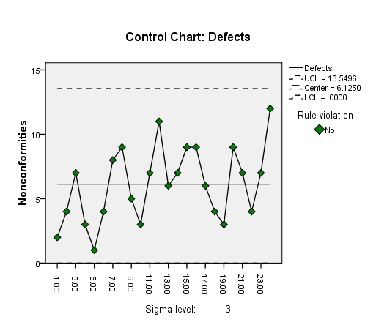
- c charts are used to look at variation in counting type attributes data.
- They are used to determine the variation in the number of defects in a constant subgroup size.
- Subgroup size usually refers to area being examined. For example c chart can be used to monitor the number of recordable injuries in a plant.

Figure 16

- The first control chart given as output is the chart for the number of defects. This chart, which is pretty much self-explanatory, clearly shows the defects along with the control limits. It is clear that the process is always in control.
- As the number of defects can’t be negative so we consider the lower limit to be 0.The average number is 6.12 .That is c bar is allowed to vary between 0 and 13.54.Since none of the 23 points fall outside the control limits the process average is in a state of statistical control.
- As the figure is in statistical control it means that there are only common causes of variation present.
- It also means that the number of defects will remain consistent in the near future.
Case 6: Consider the file circuit_board.xlsx which has data on no. of defects observed in 26 successive samples of 100 printed circuit boards. Setup a control chart for non-conformities. Does the process appear to be in statistical control?

- Used when identifying the total count of defects per unit (c) that occurred during the sampling period, the c-chart allows the practitioner to assign each sample more than one defect.
- This chart is used when the number of samples of each sampling period is essentially the same. As we are interested in drawing control chart for the number of defects we prefer c chart
- to use the c chart, the opportunities for defects to occur in the subgroup must be very large, but the number that actually occurs is small.

SPchart

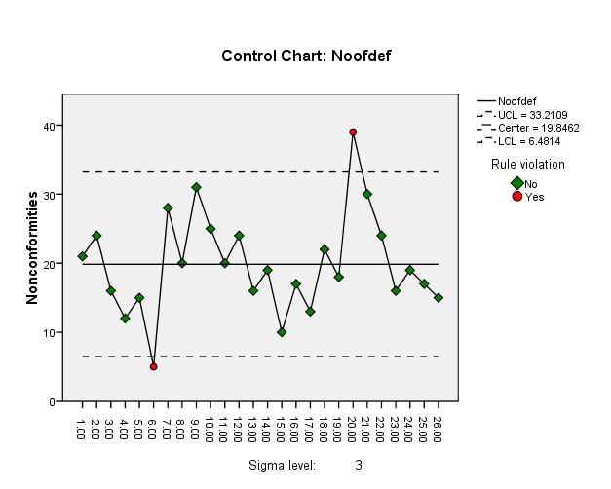
- This suggests the presence of some assignable causes of variation which have to be detected and eliminated. The sample point 20 has to be eliminated.
- A point outside the Upper control limit is called high spots, it suggests deterioration in the quality and should be regularly reported to the production engineers.

The above sample points fall outside control limits. By iterative method we remove points above UCL.Note that redrawing doesn’t bring the original process in control, we do it to get good control limits for future reference.

Even after removing the sample points (which are falling outside control limits) the process is still not in state of statistical control

Figure 17
Table 14 Rule Violations
Sampleno | Violations for Points
6.00 | Less than -3 sigma
20.00 | Greater than +3 sigma
2 points violate control rules.
SPchart
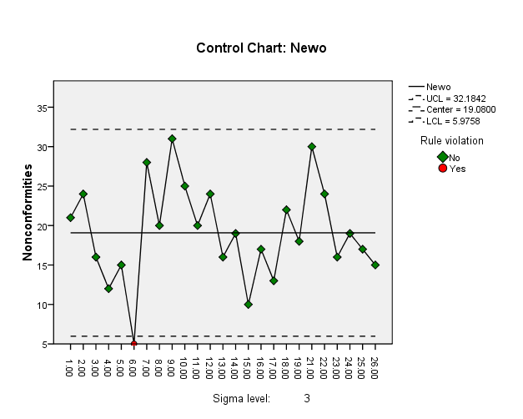
Table 15 Rule Violations
Sampleno | Violations for Points
6.00 | Less than -3 sigma
1 points violate control rules.

Figure 18
- The average number is 19.08 .That is c bar is allowed to vary between 5.97 and 32.18.Since none of the 26 points fall outside the control limits the process average is in a state of statistical control.
- As the figure is in statistical control it means that there are only common causes of variation present.
- It also means that the number of defects will remain consistent in the near future.

It may be noted that now no sample points other than those which have been deleted fall outside control limits. We take these new limits along with the new central line as standards for controlling production in future.

Case 7: Consider the file paper_rolls.xlsx which has data on no of imperfections in finished rolls of paper observed by a paper mill during inspection of production output for 20 days. Setup a control chart for non- conformities per roll of paper. Does the process appear to be in statistical control?

U-Chart
Similar to a c-chart, the u-chart is used to track the total count of defects per unit (u) that occur during the sampling period and can track a sample having more than one defect. However, unlike a c-chart, a u-chart is used when the number of samples of each sampling period may vary significantly. Here we use u control chart as the subgroup size changes from subgroup to subgroup.

SP chart
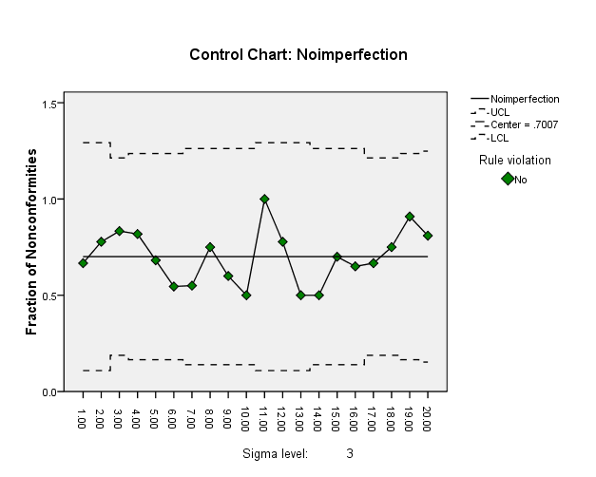
This plot depicts the relationship between the quality of the incoming material and the no. of items that need to be inspected, assuming that rejected lots will be 100% inspected and that a rectifying inspection of defective items will be performed.
Figure 19

- Since the subgroup size varies, the control limits must be calculated for each subgroup size.
- The average number is 19.08 .That is u bar is allowed to vary between LCL and UCL.Since none of the 20 points fall outside the control limits the process average is in a state of statistical control.
- As control limits will vary for each sample (due to varying sample sizes) the central line will be same. As all the sample points’ fall within the control limits without exhibiting any specific pattern, the process is said to be in statistical control.
- In such a case, the observed variation in no. of defects are attributed to the stable pattern of chance causes.

Product Control
Product control involves controlling the quality of product by critical examination at strategic points and this is achieved through Sampling Inspection Plans pioneered by Dodge and Romig. In sampling inspection plans a sample is drawn from a lot and is examined for defectives, if the no. of defectives are less than some specified threshold then one accepts the lot otherwise it is rejected (acceptance sampling) or sends for 100% inspection and all the defectives are replaced with standard ones (rectifying or corrective sampling). Also note that sometimes more than one samples can also be drawn to arrive at a decision. We are going to analyze a single sampling plan under corrective sampling.
    - Single Sampling Plan under Corrective Sampling

As discussed in a single sampling plan under corrective sampling a sample is drawn from a lot and is examined for defectives, if the no. of defectives are less than some specified threshold then one accepts the lot while replacing the defective pieces found in sample by non-defective ones, otherwise it is sent for 100% inspection and all the defectives are replaced with standard ones (rectifying or corrective sampling).
We define and calculate the concepts of acceptance quality level,

Definition. Incoming Quality. The quality of a lot, i.e. the proportion of defectives p say in a lot is termed as its incoming quality.
Definition. Acceptance Quality Level (AQL). A lot with relatively small fraction defective say p1 that the consumer do not wish to reject more often than a small proportion of times is referred to as “Good” quality lot,
i.e. P(Rejecting a lot of quality p1) = α ⇒ P(Accepting a lot of quality p1) = 1 − α, where α a very small positive number then p is termed as acceptance quality.

Definition. Lot Tolerance Proportion Defective (LTPD). The lot tolerance proportion defective usually denoted as p𝑡, is the lot quality which is considered to be bad by the consumer. The consumer is not willing to accept a lot with proportion of defectives p𝑡 or greater.
It is usually of importance to know the probability of accepting a lot of a specific incoming quality p. It can be approximated using Poisson distribution. Suppose c is the threshold on no. of defectives, and p is the incoming quality then:

𝑐
P𝑎 ≔ P(Accepting a lot of quality p) = ∑
𝑥=0

(np)𝑥 exp(−np)
𝑥!

The behavior of P𝑎 with the values of p is termed as Operating Characteristic (OC) of the sampling plan which describes how well a sampling plan discriminates between good and bad lots. Undoubtedly, every manager wants a plan that accepts lots with a quality level better than the AQL 100 percent of the time and accepts lots with a quality level worse than the AQL 0 percent of the time. This ideal OC curve for a single-sampling plan is plotted in black. However, such performance can be achieved only with 100 percent inspection. A typical OC curve for a single-sampling plan, plotted in red, shows the probability α of rejecting a good lot (producer’s risk) and the probability β of accepting a bad lot (consumer’s risk). Consequently, managers are left with choosing a sample size n and an acceptance number to achieve the level of performance
Specified by the AQL, α, LTPD, and β.

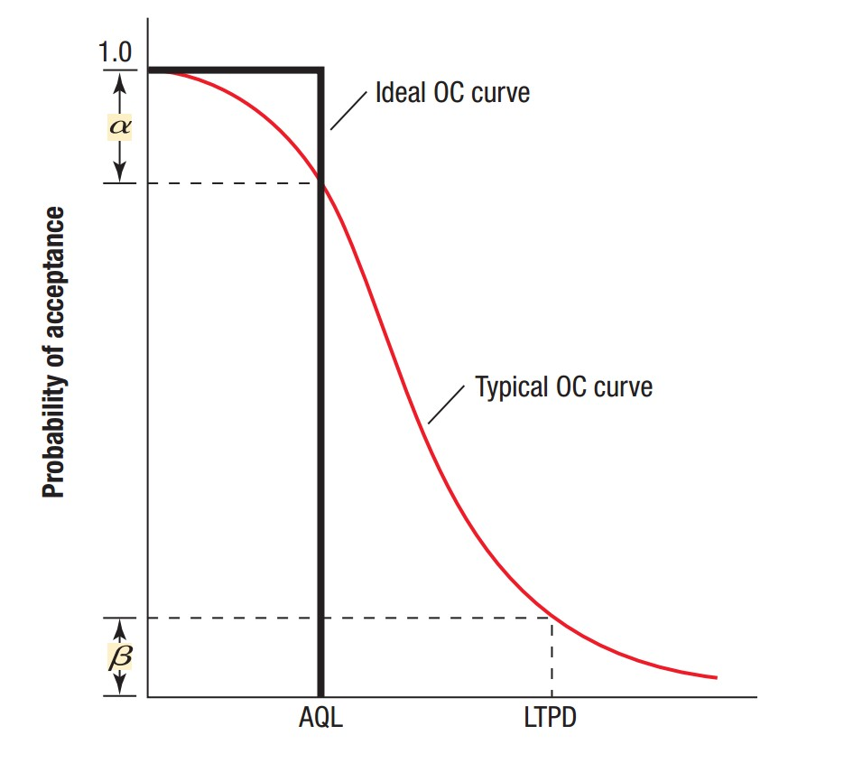Figure20

Definition. Average Outgoing Quality (AOQ)
Sometimes the consumer is guaranteed a certain quality level after inspection regardless of what quality level is being maintained by the producer. Let the producer’s fraction defective, i.e. lot quality before inspection be p. This is termed as incoming quality. The fraction defective after inspection is known as outgoing quality of the lot. The expected fraction defective remaining in the lot after application of sampling plan is termed as Average Outgoing Quality.

For single sampling plan under corrective sampling AOQ is given by the following formula:

p(N − n)P𝑎
AOQ =
N

Where N is the size of lot, n is the size of sample and P𝑎 is the probability of acceptance of lot with incoming quality p. It is derived as follows:

The outgoing quality of the lot when it is accepted is given by the proportion of defectives in the uninspected units (N − n) as the incoming quality is p, the number of defectives in uninspected part of the lot will be p(N − n). Hence the fraction defectives is p(N-n)/N. This can happen with probability P𝑎
.

If the lot is rejected then under corrective sampling we go for 100% inspection and then replace all the defectives with good ones and hence there are no defectives, i.e. outgoing quality is zero. This happens with probability 1 − P𝑎.
Hence we have,

AOQ= p(N-n)Pa/N + 0(1-Pa)

Case 8: From a lot consisting of 2200 items, a random sample of 225 items is drawn. If the criteria for acceptance of the lot is to have 14 or less defectives. Under a single sampling plan with corrective sampling plot AOQ, ASN & OC Curves, also obtain AOQ.

Operating Characteristic Curves
Analysts create a graphic display of the performance of a sampling plan by plotting the probability of accepting the lot for a range of proportions of defective units. This graph, called an operating characteristic (OC) curve, describes how well a sampling plan discriminates between good and bad lots.
- Undoubtedly, every manager wants a plan that accepts lots with a quality level better than the AQL 100 percent of the time and accepts lots with a quality level worse than the AQL 0 percent of the time.
- The discriminatory power of a sampling plan is revealed by its OC Curve .The greater the slope of the OC Curve the greater the discriminatory power.
- By increasing the sample size we can increase the discriminatory power of the sampling plan.The acceptance no. c (should be kept proportional to n).
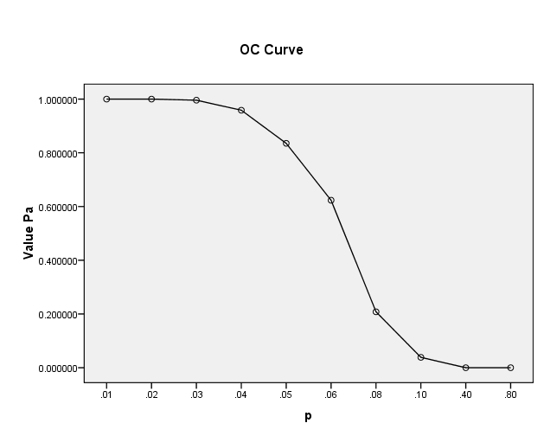
Figure 21 Graph
- By examining this curve we observe that when the incoming quality is very good (very small fraction of defectives coming in) then the outgoing quality is also very good. (Very small fraction of defectives going out. when the incoming quality is very bad, most of the lots are rejected and inspected.

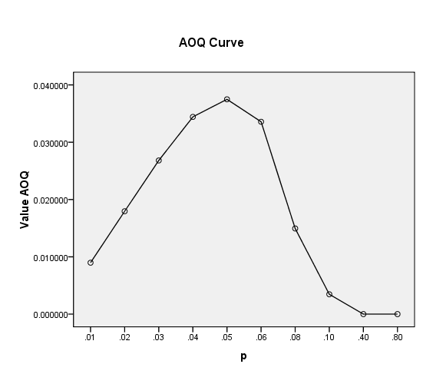
- By examining this curve we observe that when the incoming quality is very good (very small fraction of defectives coming in) then the outgoing quality is also very good. (Very small fraction of defectives going out. when the incoming quality is very bad, most of the lots are rejected and inspected.

Figure 22

- The duds are eliminated or replaced by good ones, so that the quality of the outgoing lots, the AOQ becomes very good. In between these extremes the AOQ rises, reaches a maximum and then drops.
- The maximum ordinate on the AOQ curve represents the worst possible quality that results from the rectifying inspection program. It’s called Average Outgoing Quality Limit (AOQL).From the graph we see that the AOQL is approx. 0.038 and p is 0.05.
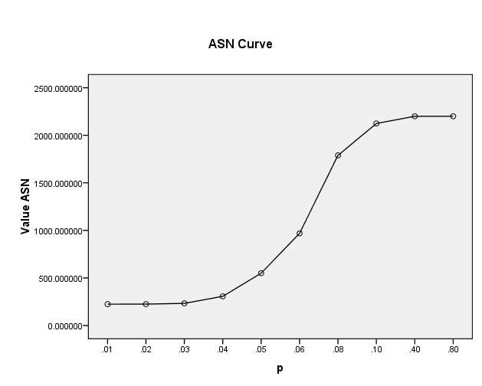
This plot depicts the relationship between the quality of the incoming material and the no. of items that need to be inspected, assuming that rejected lots will be 100% inspected and that a rectifying inspection of defective items will be performed
Figure 23

- This plot allows us to see the average total number of inspected units at various incoming quality levels.
- It is the total amount of inspection when rejected lots are screened. If all lots contain 0 defectives then no lot will be rejected. If all items are defective, all lots will be inspected and the amount to be inspected is finally if the lot quality is 0<p<1 the average amount of inspection will vary between sample size n and the lot size N.

