***Case Study-Exploratory Data Analysis***

***Submitted by: T. Vijaya***

***INTRODUCTION***

In Statistics Exploratory Data Analysis (EDA) is a critical first step in analyzing the data from an experiment. EDA is an approach to analyzing data sets to summarize their main characteristics often with visual methods. A statistical model can be used or not, but primarily EDA is for seeing what the data can tell us beyond the formal modeling or hypothesis testing task. The main reasons for using EDA are: detection of mistakes, checking of assumptions, preliminary selection of appropriate models, determining relationships among the explanatory variables and assessing the direction and rough size of relationships between explanatory and outcome variables. It also helps us in finding missing data.

There are two main types of data qualitative and quantitative. Quantitative data is always assosciated with a scale measure. Additionally quantitative data can be divided into discrete and continuous data. Discrete data can only take specific numeric values. Eg-number of cars in a car park, shoe size etc. Continuous data can take any numerical value. Eg- height,length etc. Qualitative data is a categorical measurement expressed not in terms of numbers but rather by means of a natural language description. In statistics it is often used interchangeably with “categorical” data. For eg-favorite colour=”blue”, height =”tall”. A statistical parameter is a parameter that indexes a family of probability distributions. It can be regarded as a numerical characteristic of a population or a statistical model. Among parametrized families of distributions are the normal distributions, poisson distributions, the binomial distributions and the exponential family of distributions. The family of normal distributions has two parameters mean and variance. The family of chi squared distributions has only one parameter the number of degrees of freedom. Even if a family of distributions is not specified quantities such as mean and variance can still be regarded as parameters of the distribution of the population from which a sample is drawn. Parameters of this type are given names appropriate to their roles including-location parameter, dispersion parameter or scale parameter and shape parameter.

***METHODOLOGY***

***Exploratory Data Analysis for individual variables***

The measures of central tendency which measure the “location” of centre of a data distribution are the mean, median and mode. The mean summarizes a sample or population by a single typical value. The trimmed mean is the mean that results from trimming away (or discarding a fixed percentage of the extreme observations from both ends).They are becoming more common in treating particularly skewed data. The median is the middle value after all the values are put in an ordered list. In unusual situations for discrete random variables there may not be a unique median. The median has a special property called robustness. A sample statistic is said to be “robust” if by moving some data, the statistic remains unchanged. Mode is defined as the most likely or frequently occurring value. We use mode when describing whether a distribution has a single peak (unimodal) or two or more peaks(bimodal or multimodal) .Averages do not give us a complete picture of the distribution .Several statistics are commonly used as a measure of the spread of a distribution including variance, standard deviation and interquartile range. These are known as measures of dispersion. Spread is an indicator of how far away from the center we are still likely to find data values. The variance is a standard measure of spread of observations from their average. Skewness and kurtosis are used to describe the nature of the distribution. Skewness is a measure of asymmetry. A distribution is said to be symmetrical when the values are uniformly distributed around the mean. Kurtosis is a measure of peakedness or convexity of a curve relative to a Gaussian shape. Ideal value for kurtosis is 0.

Bar chart visually compares the data from different groups. Histogram (or frequency histograms) is used to summarize the distribution of numerical data graphically.”Histos” means pole or mast and gram means chart .So histogram is a chart of poles. The range of observed values is subdivided into equal intervals and then the cases in each interval are obtained .Stem and Leaf plots are a method for showing the frequency with which certain classes of values occur. The STEM is the left hand column which contains the tens digits. The LEAVES are the lists in the right hand column, showing all the ones digits for each of the tens, twenties and thirties. The horizontal leaves in the stem and leaf plot correspond to the vertical bars in the histogram and the leaves have lengths that equal the numbers in frequency tables. The advantage of using stem and leaf over a histogram is that we get to see the entire data in a tabular form along with their respective frequencies. A very useful univariate graphical technique is the box plot.It is also called the Box and Whishkers plot. Box plots are very good at presenting information about the central tendency, symmetry, skew and location of quantiles as well as outliers. It represents the five statistics namely; minimum,the lower quartile ,the median ,the upper quartile and the maximum-in a visual display. The box of the plot is a rectangle which encloses the middle half of sample, with an end at each quartile. The length of the box is the interquartile range of the sample. A line is drawn across the box at the sample median. Whiskers sprout from the two ends of the box until they reach the sample maximum and minimum. The length of the box depicts variability of observations which corresponds to the interquartile range i.e. the difference between 1stand 3rd quartiles. It identifies extreme values which are more than 3 box lengths from the upper or lower edge of the box. The values which are more than 1.5 box lengths are known as outliers. We infer that the data are positively skewed if the median is closer to the bottom of the box than the top.

Missing value imputation is a method by which we substitute plausible values for the missing scores. Normal Q-Q (Quantile-Quantile) plot is a univariate graphical EDA technique which is used to see how well a particular sample follows a particular theoretical distribution. It compares the observed quantiles of the data (depicted as dots/circles) with the quantiles that we would expect to see if the data were normally distributed .If the data are normally distributed the data points will be close to the diagonal line .If the data points stray from the line in obvious non linear fashion, the data are not normally distributed.

Besides these visual displays, the statistical tests are Shapiro-Wilk and the Lilliefors. The Lilliefors test is based on the modification of Kolmogrov-Smirnov test for the situation when means and variances are not known but are estimated from the data. Kolmogrov-Smirnov is a non parametric test and Shapiro-Wilk is a parametric test .Kolmogrov Smirnov is typically used for larger data sets. Shapiro-Wilk is used for smaller data sets (i.e. with less than 50 observations).In statistics the p-value is a function of the observed sample results (a statistic) that is used for testing a statistical hypothesis. Before the test is performed, a threshold value is chosen, called the significance level of the test, usually 5% or 1% and denoted as α.

***Decision Rule*** –If p-value<0.05, we may reject the null hypothesis at 5% level of significance (here α=5).

***Exploratory Data Analysis for Multiple variables***

In terms of correlation graphical plots are called scatter plots. They help us to look at the general trend of the data. A scatter plot is simply a graph that plots each subjects score on one variable against their score on another. It tells us whether there is a relationship between the variables, what kind of relationship it is and whether any cases are markedly different from others. A case that differs substantially from the general trend of the data is known as an outlier and such cases can severely bias the correlation coefficient. When we have to check the correlation between several variables and compare them then we can use the matrix of scatterplots. It plots all possible combinations of two or more numeric variables against one another. Correlation is a statistical technique that can show whether and how strongly pairs of variables are related. Correlation coefficients measure the strength of association between two variables. The strength of the relationship is measured from -1 to 1.The farther the value is from 0 the stronger the relationship. Partial correlation allows us to look at the relationship between two variables when the effects of a third variable are held constant.

Consider the mtcars data set available in R. We have exported it to spss using function (write.csv (mtcars,”mtcars.sav”)).The data was extracted from the 1974 Motor Trend US Magazine and comprises gasoline mileage in miles per gallon and ten aspects of automobile design and performance for 32 automobiles(1973-74 models).It's a data frame with 32observations on 11 variables. The source of data is Henderson and Velleman(1981),building multiple regression models interactively.Biometrics,37,391-441.We have the variables and their data types as follows:

***Table 1.1: Description of Variables in Our Dataset***

|  |  |  |
| --- | --- | --- |
| S.No. | Variable Name | Type |
| 1 | Miles /(US) gallon (mpg) | Continuous |
| 2 | Number of cylinders (cyl) | Discrete |
| 3 | Displacement (disp) | Continuous |
| 4 | Gross horsepower (hp) | Continuous |
| 5 | Rear axle ratio (drat) | Continuous |
| 6 | Weight (wt) | Continuous |
| 7 | (1/4)th mile time(qsec) | Continuous |
| 8 | V/S(vs)(0=Vengine1=straightengine) | Discrete |
| 9 | Transmission (0=automatic,1=manual)(am) | Discrete |
| 10 | Number of forward gears(gear) | Discrete |
| 11 | Number of carburetors(carb) | Discrete |

***We start EDA with mpg***.

|  |  |  |  |  |
| --- | --- | --- | --- | --- |
| ***Table 1.2 DESCRIPTIVES(mpg)*** | | | Statistic | Std. Error |
| Miles per gallon | Mean | | 20.09 | 1.065 |
| 95% Confidence Interval for Mean | Lower Bound | 17.92 |  |
| Upper Bound | 22.26 |  |
| 5% Trimmed Mean | | 19.89 |  |
| Median | | 19.20 |  |
| Variance | | 36.324 |  |
| Std. Deviation | | 6.027 |  |
| Minimum | | 10 |  |
| Maximum | | 34 |  |
| Range | | 24 |  |
| Interquartile Range | | 8 |  |
| Skewness | | .672 | .414 |
| Kurtosis | | -.022 | .809 |

1) From the table above we infer that the mean and median are not equal. So they might be skewed (As in a normal distribution mean, median and mode are equal i.e. it is a symmetric distribution).

2) As the mean and trimmed mean are almost equal, we need not investigate for outliers.

3) The measure of kurtosis is -0.022 and indicates that the observations cluster less and the distribution has only slightly shorter tails(less peaked) .The ratio of kurtosis to standard error is -0.0271 .Hence we conclude that data is normal.

4) We have mean > median and coefficient of skewness is greater than zero .It implies that the distribution is positively skewed. Moreover the coefficient is insignificant as its absolute value is not greater than twice its standard error (0.672<0.828).

These measures indicate that treating this distribution as approximately normal is justified.

|  |  |  |  |  |  |  |
| --- | --- | --- | --- | --- | --- | --- |
| ***Table 1.3:Tests of Normality*** | | | | | | |
|  | ***Kolmogorov-Smirnova*** | | | Shapiro-Wilk | | |
| Statistic | Df | Sig. | Statistic | Df | Sig. |
| Miles per gallon | .126 | 32 | .200* | .948 | 32 | .123 |
| *. This is a lower bound of the true significance. a. Lilliefors Significance Correction | | | | | | |

We set the following hypothesis:

Ho-The data fits the normal distribution

H1-The data does not fit the normal distribution.

So from the table above we infer that the p value is 0.200(which is >0.05).Hence we accept the null hypothesis at 5% level of significance and conclude that data fits the normal distribution.

|  |
| --- |
| ***A stem and leaf plot shows all data values .From the table on the left we infer from the fourth row that the observations26, 27 appear in the data. The digit with 2 in the tens place occurs 2 times. Every row can be interpreted similarly.*** |

***Table1.4: Stem-and-Leaf Plot***

|  |  |
| --- | --- |
| ***Frequency*** | ***Stem and Leaf*** |
| 5.00 | 1 . 00344 |
| 13.00 | 1 . 5555567788999 |
| 8.00 | 2 . 11111224 |
| 2.00 | 2 . 67 |
| 4.00 | 3 . 0023 |
| Stemwidth: | 10 |
| Eachleaf: | 1 case(s) |

***Figure 1.1: Histogram***



The largest bar does not lie on the centre of the normal curve. The gap between 27.5 and 30 reveals that either there are no frequencies or there may be outliers. Despite this variation the distribution appears to the eye to be approximately normal.

***Figure 1.2: Normal Q-Q plot***

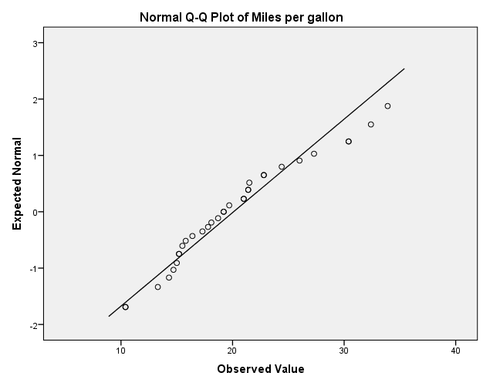

For the variable mpg the curvature of the points in the plot, indicates a possible departure from normality. So from above we infer that the data is fairly normally distributed.

***Figure 1.3******Box plots***

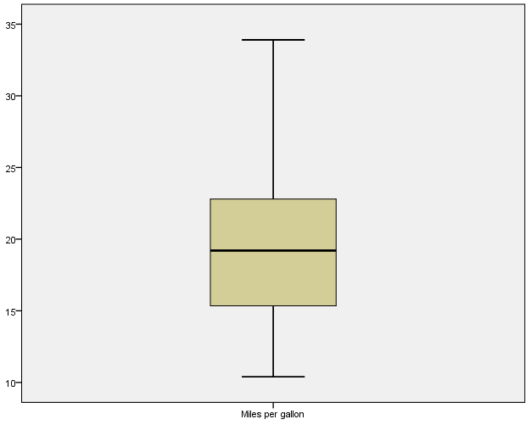

A box plot that is symmetric with the median line in approximately the centre of the box and with symmetric whiskers somewhat longer than the subsections of the center box suggests that the data may have come from a normal distribution. Since there are no points outside the edge of the box we infer that there are no outliers.

***EDA with (no of cylinders)***

| ***Table 1.5 : Descriptive Statistics*** | | | | | | | | |
| --- | --- | --- | --- | --- | --- | --- | --- | --- |
|  | N | Minimum | Maximum | Mean | | Std. Deviation | Skewness | |
|  | Statistic | Statistic | Statistic | Statistic | Std. Error | Statistic | Statistic | Std. Error |
| Cyl | 32 | 4 | 8 | 6.19 | .316 | 1.786 | -.192 | .414 |

1) Standard deviation measures how concentrated the data are around the mean. A small standard deviation means that the values in a statistical data set are close to the mean of the data set.

2) As coefficient of skewness <0, it implies that it is negatively skewed. Moreover the coefficient of skewness is insignificant as its absolute value is not greater than twice its standard error (0.192<0.828).

***Figure 1.4: Bar chart***



The bar chart visually represents the mtcars data set which has been divided into three classes depending on the number of cylinders.

***Figure 1.5: Box plot***



As no points are lying above or below the edges of the box, we infer that there are no outliers.

***EDA with displacement***

|  |  |  |  |  |
| --- | --- | --- | --- | --- |
| ***Table 1.6:Descriptives*** | | | Statistic | Std. Error |
| Displacement | Mean | | 230.72 | 21.909 |
| 95% Confidence Interval for Mean | Lower Bound | 186.04 |  |
| Upper Bound | 275.41 |  |
| 5% Trimmed Mean | | 226.34 |  |
| Median | | 196.30 |  |
| Variance | | 15360.800 |  |
| Std. Deviation | | 123.939 |  |
| Interquartile Range | | 222 |  |
| Skewness | | .420 | .414 |
| Kurtosis | | -1.068 | .809 |

1) From the table above we infer that there is considerable difference between the mean and median .So they might be skewed (As in a normal distribution mean, median and mode are equal i.e. it is a symmetric distribution).

2) As the mean and trimmed mean are almost equal, we need not investigate for outliers.

3) The measure of kurtosis is -1.068 and indicates that the observations cluster less and the distribution has shorter tails. The ratio of kurtosis to standard error is -1.3201 .Hence we conclude that data is normal.

4) We have mean> median and coefficient of skewness is greater than zero .It implies that the distribution is positively skewed. Moreover the coefficient is insignificant as its absolute value is not greater than twice its standard error (0.420<0.828).

These measures indicate that treating this distribution as approximately normal is justified.

|  |  |  |  |  |  |  |
| --- | --- | --- | --- | --- | --- | --- |
| ***Table 1.7:Tests of Normality*** | | | | | | |
|  | Kolmogorov-Smirnova | | | Shapiro-Wilk | | |
| Statistic | Df | Sig. | Statistic | Df | Sig. |
| Displacement | .195 | 32 | .003 | .920 | 32 | .021 |
| -Lilliefors Significance Correction  We set the following hypothesis :  Ho-The data fits the normal distribution.  H1-The data does not fit the normal distribution.  So from the table above we infer that the p value is 0.003(which is <0.05).Hence we reject the null hypothesis at 5% level of significance and conclude that data does not fit the normal distribution. | | | | | | |

***Figure 1.6: Histogram***



The first and second bars are well above the normal curve. A lot of variation exists implying that the above data does not follow the normal distribution.

***Table 1.8: Stem-and-Leaf Plot***

|  |  |
| --- | --- |
| Frequency | Stem & Leaf |
| 5.00 | 0 . 77779 |
| 7.00 | 1 . 0222444 |
| 4.00 | 1 . 6666 |
| 1.00 | 2 . 2 |
| 4.00 | 2 . 5777 |
| 3.00 | 3 . 001 |
| 4.00 | 3. 5566 |
| 2.00  2.00 | 4. 04  4.67 |
| Stmwidth: | 100 |
| Each leaf: 1 case(s) | |

A stem and leaf plot is a method of displaying data that shows the data in a histogram like pattern. From the table on the left we infer from the sixth row that the observations 30, 30, 31 appear in the data. The digit with 3 in the tens place occurs 3 times. Every row can be interpreted similarly.

***Figure 1.7: Normal Q-Q Plot***

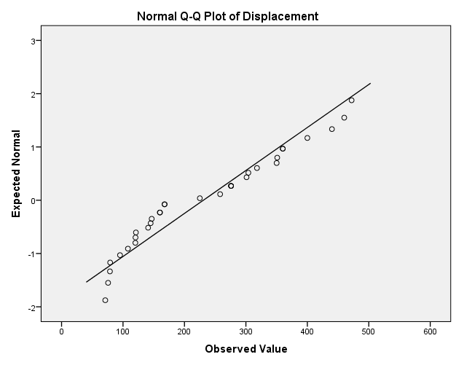  
For the variable disp the curvature of the points in the plot, indicates a departure from normality. So from above we infer that the data is not normally distributed.

***Figure 1.8: Box Plot***

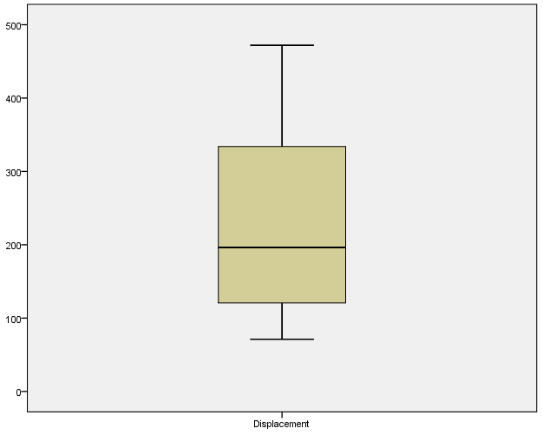

As the median line is not at the centre of the box, it implies that it is not a symmetric distribution.Since there are no points outside the edge of the box, we infer that there are no outliers.

(EDA with hp)

|  |  |  |  |  |
| --- | --- | --- | --- | --- |
| ***Table 1.9:Descriptives*** | | | Statistic | Std. Error |
| Gross horsepower | Mean | | 146.69 | 12.120 |
| 95% Confidence Interval for Mean | Lower Bound | 121.97 |  |
| Upper Bound | 171.41 |  |
| 5% Trimmed Mean | | 142.76 |  |
| Median | | 123.00 |  |
| Variance | | 4700.867 |  |
| Std. Deviation | | 68.563 |  |
| Minimum | | 52 |  |
| Maximum | | 335 |  |
| Range | | 283 |  |
| Interquartile Range | | 85 |  |
| Skewness | | .799 | .414 |
| Kurtosis | | .275 | .809 |

1) Since there is a considerable difference in the mean and the median we infer that the distribution might be skewed (As in a normal distribution mean, median and mode are equal).

2) There is a difference of four units between trimmed mean and the mean .It indicates presence of outliers.

3).Here mean>median and coefficient of skewness is greater than zero .We can infer that the distribution is positively skewed. Moreover the coefficient of skewness is insignificant as its absolute value is not greater than twice its standard error (0.799<0.828).

4) The ratio of kurtosis to standard error is 0.3399.Hence we conclude that data is normal. A positive value for kurtosis indicates that the observations cluster more and have longer tails (than those in normal distribution).

|  |  |  |  |  |  |  |
| --- | --- | --- | --- | --- | --- | --- |
| ***Table 1.10:Tests of Normality*** | | | | | | |
|  | Kolmogorov-Smirnova | | | Shapiro-Wilk | | |
| Statistic | Df | Sig. | Statistic | df | Sig. |
| Gross horsepower | .166 | 32 | .024 | .933 | 32 | .049 |
| a. Lilliefors Significance Correction | | | | | | |

We set the following hypothesis:

Ho-The data fits the normal distribution.

H1-The data does not fit the normal distribution.

So from the table above we infer that the p value is 0.024(which is <0.05).Hence we reject the null hypothesis at 5% level of significance and conclude that data does not fit the normal distribution.

***Figure 1.9: Histogram***



The largest bar lies outside the normal curve .It has a lot of variation when compared with a normal curve. So we conclude that data is not normally distributed.

***Table1.11: Stem-and-Leaf Plot***

|  |  |
| --- | --- |
| Frequency | Stem & Leaf |
| 9.00 | 0 . 566669999 |
| 8.00 | 1 . 00111122 |
| 8.00 | 1 . 55777888 |
| 5.00 | 2 . 01344 |
| 1.00 | 2 . 6 |
| 1.00 | Extremes (>=335) |
| Stemwidth: | 100 |
| Each leaf: | 1 case(s) |

|  |
| --- |
| ***A stem and leaf plot shows all data values .From the table on the left we infer from the fourth row that the observations 20, 21, 23, 24, 24 appear in the data. The digit with2 in the tens place occurs 5 times. Every row can be interpreted similarly.*** |

***Figure 1.10: Normal Q-Q plot***

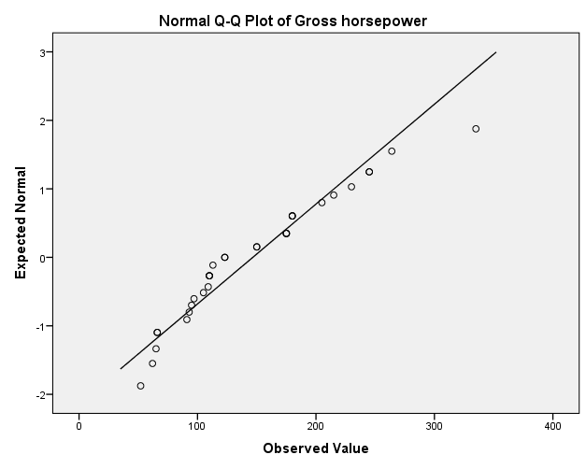

For the variable gross hp the curvature of the points in the plot, indicates departure from normality. So from above we infer that the data is not normally distributed.

***Figure 1.11: Box Plot***

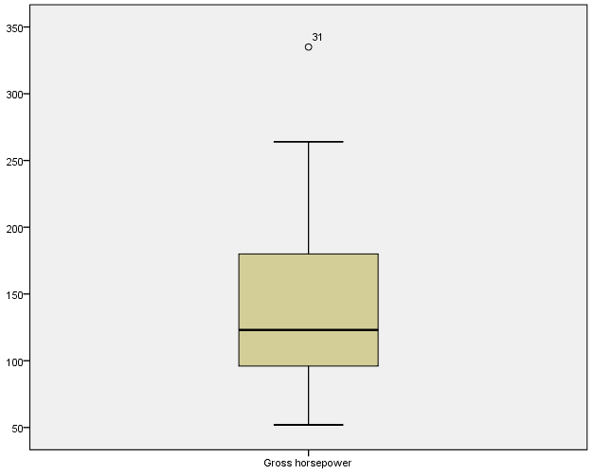

As the box plot is not symmetric with the median line it suggests data has not come from a normal distribution .It also indicates the presence of outliers.

So we will perform EDA again after removing the outlier and using missing value imputation.

The missing value has been calculated by the method of median of nearby points.

|  | | | | |
| --- | --- | --- | --- | --- |
| ***Table1.12*** | ***Descriptives*** | ***Horsepower*** | Statistic | Std. Error |
| MEAN(hp,1) | Mean | | 140.656 | 10.4882 |
| 95% Confidence Interval for Mean | Lower Bound | 119.265 |  |
| Upper Bound | 162.047 |  |
| 5% Trimmed Mean | | 138.917 |  |
| Median | | 123.000 |  |
| Variance | | 3520.104 |  |
| Std. Deviation | | 59.3305 |  |
| Minimum | | 52.0 |  |
| Maximum | | 264.0 |  |
| Range | | 212.0 |  |
| Interquartile Range | | 84.5 |  |
| Skewness | | .460 | .414 |
| Kurtosis | | -.749 | .809 |

After removing the outlier we observe the following:

1)The mean of the variable has considerably reduced while the median remains unchanged.As mean and median are not equal it implies that the distribution may be skewed.Coefficient of skewness is positive implying positive skewness.

2)A negative value of kurtosis indicates that the observations cluster less and have shorter tails.

3)A large value of standard deviation implies that the data is less concentrated around the mean.

| ***Table 1.13: Tests of Normality*** | | | | | | |
| --- | --- | --- | --- | --- | --- | --- |
|  | Kolmogorov-Smirnova | | | Shapiro-Wilk | | |
|  | Statistic | Df | Sig. | Statistic | df | Sig. |
| MEAN(hp,1) | .148 | 32 | .072 | .944 | 32 | .096 |
| a. Lilliefors Significance Correction | | | | | | |

We set the following hypothesis:

Ho-The data fits the normal distribution.

H1-The data does not fit the normal distribution.

So from the table above we infer that the p value is 0.072 (which is >0.05).Hence we accept the null hypothesis at 5% level of significance and conclude that data fits the normal distribution.

***Figure 1.12: Histogram***



As the bars are lying outside the curve, it appears that the distribution could be bimodal.

***Figure 1.13: Normal Q-Q Plot***



We infer that after removing the outliers the data is normally distributed.

***Figure 1.14: Box plot***



From the figure we infer that there are no outliers.

(EDA with drat)

|  |  |  |  |  |
| --- | --- | --- | --- | --- |
| ***Table 1.14:Descriptives*** | | | Statistic | Std. Error |
| Rear axle ratio | Mean | | 3.597 | .0945 |
| 95% Confidence Interval for Mean | Lower Bound | 3.404 |  |
| Upper Bound | 3.789 |  |
| 5% Trimmed Mean | | 3.579 |  |
| Median | | 3.695 |  |
| Variance | | .286 |  |
| Std. Deviation | | .5347 |  |
| Minimum | | 2.8 |  |
| Maximum | | 4.9 |  |
| Range | | 2.2 |  |
| Interquartile Range | | .8 |  |
| Skewness | | .293 | .414 |
| Kurtosis | | -.450 | .809 |

1. Since the value of the mean and trimmed mean are approximately equal so it indicates absence of outliers.
2. A small value of standard deviation implies that the data is more concentrated around the mean.
3. As kurtosis is negative, it implies tails are lighter and we will assume that it is flatter than what the normal distribution will allow.
4. Coefficient of skewness is positive implying positive skewness. Coefficient is insignificant.

|  |  |  |  |  |  |  |
| --- | --- | --- | --- | --- | --- | --- |
| ***Table 1.15:Tests of Normality*** | | | | | | |
|  | Kolmogorov-Smirnova | | | Shapiro-Wilk | | |
| Statistic | Df | Sig. | Statistic | Df | Sig. |
| Rear axle ratio | .160 | 32 | .037 | .946 | 32 | .110 |
| a. Lilliefors Significance Correction | | | | | | |

We set the following hypothesis:

Ho-The data fits the normal distribution.

H1-The data does not fit the normal distribution.

So from the table above we infer that the p value is 0.037(which is <0.05).Hence we may reject the null hypothesis at 5% level of significance and conclude that data does not fit the normal distribution.

***Figure 1.15: Histogram***



As there are some gaps in the histogram it indicates either presence of outliers before 3.5 and after 4.5 or no frequencies in that interval. The largest bar lies outside the normal curve .It has a lot of variation when compared with a normal curve. So we conclude that data is not normally distributed.

|  |  |
| --- | --- |
| ***Table 1.16: Stem-and-Leaf Plot*** | |
| Frequency | Stem & Leaf |
| 3.00 | 2 . 779 |
| 10.00 | 3 . 0000001122 |
| 12.00 | 3 . 566777899999 |
| 6.00 | 4 . 001224 |
| 1.00 | 4 . 9 |
| Stem width: | 1. 0 |
| Each leaf: | 1 case(s) |

***Figure 1.16: Normal Q-Q Plot***

|  |
| --- |
| ***A stem and leaf plot shows all data values .From the table on the left we infer from the first row that the observations 27, 27, 29 appear in the data. The digit with2 in the tens place occurs 3 times. Every row can be interpreted similarly.*** |

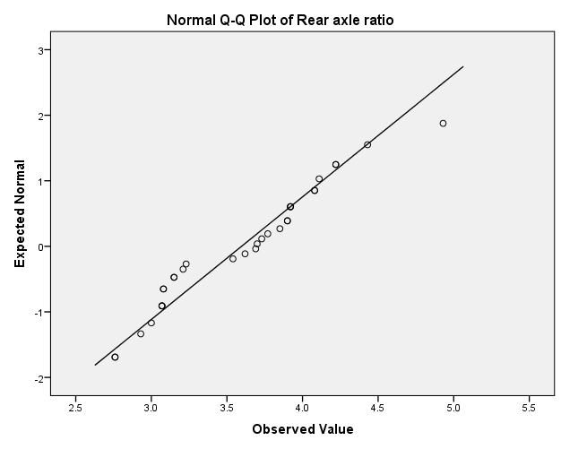

As some points in the data are going astray it implies that data is not normally distributed.

***Figure 1.17: Box Plot***

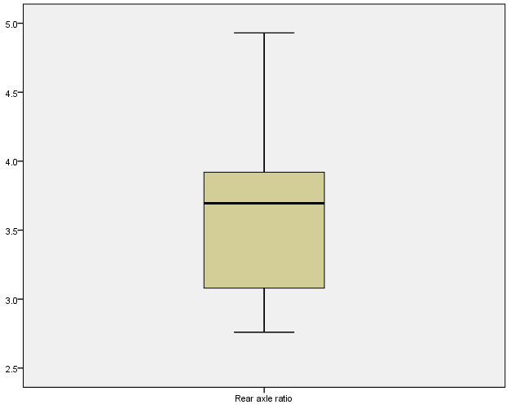

As the median line does not lie on the centre of the box, it implies that the distribution is not symmetric. There are no outliers.

(EDA with wt)

|  |  |  |  |  |
| --- | --- | --- | --- | --- |
| ***Table 1.17:Descriptives(Weight)*** | | | Statistic | Std. Error |
| Weight | Mean | | 3.2173 | .17297 |
| 95% Confidence Interval for Mean | Lower Bound | 2.8645 |  |
| Upper Bound | 3.5700 |  |
| 5% Trimmed Mean | | 3.1889 |  |
| Median | | 3.3250 |  |
| Variance | | .957 |  |
| Std. Deviation | | .97846 |  |
| Minimum | | 1.51 |  |
| Maximum | | 5.42 |  |
| Range | | 3.91 |  |
| Interquartile Range | | 1.19 |  |
| Skewness | | .466 | .414 |
| Kurtosis | | .417 | .809 |

1. A small value of standard deviation implies that the data is more concentrated around the mean.
2. As kurtosis is positive, it implies that the observations cluster more and have longer tails then those in normal distribution.
3. Coefficient of skewness is positive implying positive skewness. Coefficient is insignificant.

|  |  |  |  |  |  |  |
| --- | --- | --- | --- | --- | --- | --- |
| ***Table 1.18:Tests of Normality*** | | | | | | |
|  | Kolmogorov-Smirnova | | | Shapiro-Wilk | | |
| Statistic | Df | Sig. | Statistic | df | Sig. |
| Weight | .136 | 32 | .142 | .943 | 32 | .093 |
| a. Lilliefors Significance Correction | | | | | | |

We set the following hypothesis:

Ho-The data fits the normal distribution.

H1-The data does not fit the normal distribution.

So from the table above we infer that the p value is 0.142(which is >0.05).Hence we may accept the null hypothesis at 5% level of significance and conclude that data fits the normal distribution.

***Figure 1.18: Histogram***



Despite the fact that the largest bar goes outside the normal curve, we conclude that the data is normal.

|  |  |
| --- | --- |
| ***Table 1.19: Stem-and-Leaf Plot*** | |
| Frequency | Stem & Leaf |
| 4.00 | 1 . 5689 |
| 4.00 | 2 . 1234 |
| 4.00 | 2 . 6778 |
| 9.00 | 3 . 111244444 |
| 7.00 | 3 . 5557788 |
| 1.00 | 4 . 0 |
| .00 | 4 . |
| 1.00 | 5 . 2 |
| 2.00 | Extremes (>=5.3) |
| Stemwidth | 1.00 |
| Each leaf | 1 case(s) |

|  |
| --- |
| ***A stem and leaf plot shows all data values .From the table on the left we infer from the first row that the observations 15,16,18,19 appear in the data .The digit with 1 in the tens place occurs 4 times. Every row can be interpreted similarly.*** |

***Figure 1.19: Normal Q-Q Plot***

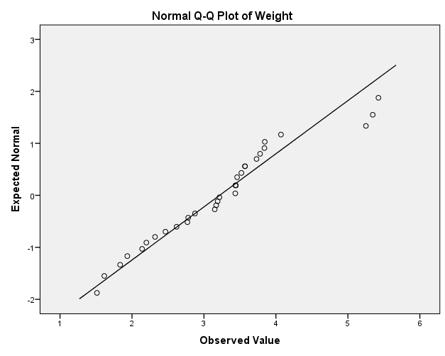

Except the outliers all the points are more or less lying on the straight line which indicates that the distribution of the data is normal.

***Figure 1.20: Box plot***

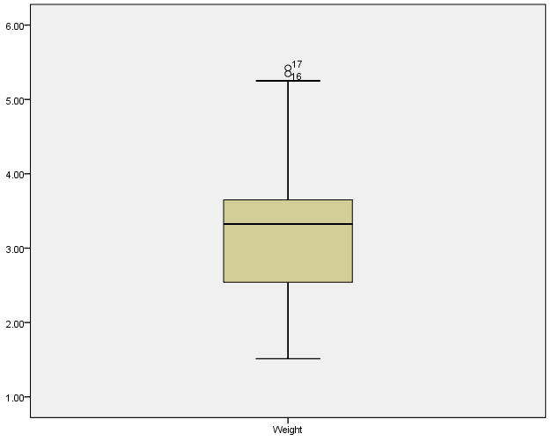

The points above the horizontal line indicate presence of outliers. As the median is closer to the top of the box we conclude that the data is skewed.

After removing outliers we will use missing value imputation and then conduct EDA.

| (EDA with wt) | | | | |
| --- | --- | --- | --- | --- |
| ***Table 1.20:*** | ***Descriptives*** | ***(Weight)*** | Statistic | Std. Error |
| SMEAN(wt) | Mean | | 2.99769 | .121945 |
| 95% Confidence Interval for Mean | Lower Bound | 2.74898 |  |
| Upper Bound | 3.24640 |  |
| 5% Trimmed Mean | | 3.02316 |  |
| Median | | 3.16000 |  |
| Variance | | .476 |  |
| Std. Deviation | | .689825 |  |
| Minimum | | 1.513 |  |
| Maximum | | 4.070 |  |
| Range | | 2.557 |  |
| Interquartile Range | | 1.001 |  |
| Skewness | | -.636 | .414 |
| Kurtosis | | -.483 | .809 |

1) Smaller value of standard deviation implies more concentration of points around the mean.

2) Coefficient of skewness has changed from 0.466 to -0.636 after removing the outlier. It implies negative skewness and the coefficient is insignificant.

3) Negative kurtosis indicates that the observations cluster less and have shorter tails.

| ***Table 1.21:Tests of Normality*** | | | | | | |
| --- | --- | --- | --- | --- | --- | --- |
|  | Kolmogorov-Smirnova | | | Shapiro-Wilk | | |
|  | Statistic | df | Sig. | Statistic | df | Sig. |
| SMEAN(wt) | .143 | 32 | .094 | .942 | 32 | .084 |
| a. Lilliefors Significance Correction | | | | | | |

We set the following hypothesis:

Ho-The data fits the normal distribution.

H1-The data does not fit the normal distribution.

So from the table above we infer that the p value is 0.094(which is >0.05).Hence we may accept the null hypothesis at 5% level of significance and conclude that data fits the normal distribution.

***Figure 1.21: Histogram***



Even though the largest bar lies outside the normal curve,it lies at the centre of the curve.Despite this fact it appears to be normally distributed.

***Figure 1.22: Normal Q-Q Plot***



As the points lie along the straight line, we infer that the data appears to be normally distributed.

***Figure 1.23: Box plot***



Figure indicates absence of outliers.

(EDA with qsec)

|  |  |  |  |  |
| --- | --- | --- | --- | --- |
| ***(1/4)th mile time Table 1.22:Descriptives*** | | | Statistic | Std. Error |
|  | Mean | | 17.8488 | .31589 |
| 95% Confidence Interval for Mean | Lower Bound | 17.2045 |  |
| Upper Bound | 18.4930 |  |
| 5% Trimmed Mean | | 17.8079 |  |
| Median | | 17.7100 |  |
| Variance | | 3.193 |  |
| Std. Deviation | | 1.78694 |  |
| Minimum | | 14.50 |  |
| Maximum | | 22.90 |  |
| Range | | 8.40 |  |
| Interquartile Range | | 2.02 |  |
| Skewness | | .406 | .414 |
| Kurtosis | | .865 | .809 |

1) As the standard deviation is small the observations are more concentrated around the mean.

2) As kurtosis is positive, it implies tails are heavier and we will assume that it is more peaker than what the normal distribution will allow.

3) Coefficient of skewness is positive implying positive skewness. Coefficient is insignificant.

|  |  |  |  |  |  |  |
| --- | --- | --- | --- | --- | --- | --- |
| ***Table 1.23:Tests of Normality*** | | | | | | |
|  | Kolmogorov-Smirnova | | | Shapiro-Wilk | | |
| Statistic | df | Sig. | Statistic | df | Sig. |
| 1/4 th mile time | .073 | 32 | .200* | .973 | 32 | .594 |
| *This is a lower bound of the true significance. a.Lilliefors Significance Correction | | | | | | |

We set the following hypothesis:

Ho-The data fits the normal distribution.

H1-The data does not fit the normal distribution.

So from the table above we infer that the p value is 0.200(which is >0.05).Hence we may accept the null hypothesis at 5% level of significance and conclude that data fits the normal distribution.

***Figure 1.24: Histogram***



The gap after 20 indicates presence of outlier or there is no frequency in that interval. Ignoring that, the shape of the curve is bell shaped. So the distribution of the data is normal.

|  |  |
| --- | --- |
| ***Table 1.24:Stem-and-Leaf Plot*** | |
| Frequency | Stem & Leaf |
| 2.00 | 14 . 56 |
| 3.00 | 15 . 458 |
| 4.00 | 16 . 4789 |
| 9.00 | 17 . 000344689 |
| 7.00 | 18 . 0356699 |
| 3.00 | 19 . 449 |
| 3.00 | 20 . 002 |
| 1.00 | Extremes (>=22.9) |
| Stemwidth | 1.00 |
| Each leaf | 1 case(s) |

|  |
| --- |
| ***A stem and leaf plot shows all data values .From the table on the left we infer from the first row that the observations 145,146 appear in the data. The digit with 14 in the tens place occurs 2 times. Every row can be interpreted similarly.*** |

***Figure 1.25: Normal Q-Q Plot***

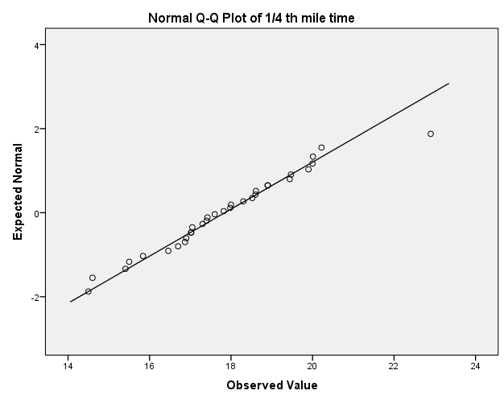

Almost all points are lying on or around the straight line so the distribution of the data is normal.

***Figure 1.26: Box plot***

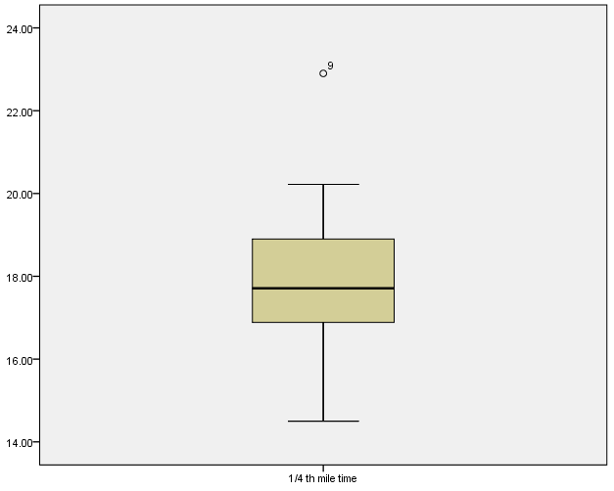

There is an outlier .We delete the outlier and treat it as a missing value. Then we compute the missing value using series mean. Finally now we perform the EDA.

.

| **Table 1.25** | **:Descriptives** | (qsec) | Statistic | Std. Error |
| --- | --- | --- | --- | --- |
| SMEAN(qsec) | Mean | | 17.6858 | .27062 |
| 95% Confidence Interval for Mean | Lower Bound | 17.1339 |  |
| Upper Bound | 18.2377 |  |
| 5% Trimmed Mean | | 17.7243 |  |
| Median | | 17.6429 |  |
| Variance | | 2.344 |  |
| Std. Deviation | | 1.53086 |  |
| Minimum | | 14.50 |  |
| Maximum | | 20.22 |  |
| Range | | 5.72 |  |
| Interquartile Range | | 1.95 |  |
| Skewness | | -.248 | .414 |
| Kurtosis | | -.400 | .809 |

1) As the standard deviation is small the observations are concentrated around the mean .

2) Coefficient of skewness has changed from 0.406 to -0.248 implying negative skewness. Coefficient of skewness is insignificant.

3) As kurtosis is negative, it indicates that the observations cluster less and have shorter tails.

| **Table 1.26: Tests of Normality** | | | | | | |
| --- | --- | --- | --- | --- | --- | --- |
|  | Kolmogorov-Smirnova | | | Shapiro-Wilk | | |
|  | Statistic | df | Sig. | Statistic | df | Sig. |
| SMEAN(qsec) | .078 | 32 | .200* | .971 | 32 | .514 |
| a. Lilliefors Significance Correction | | | | | | |
| *. This is a lower bound of the true significance. | | | | | | |

We set the following hypothesis:

Ho-The data fits the normal distribution.

H1-The data does not fit the normal distribution.

So from the table above we infer that the p value is 0.200(which is >0.05).Hence we may accept the null hypothesis at 5% level of significance and conclude that data fits the normal distribution.

***Figure 1.27: Histogram***



As the figure shows bell shaped curve ,it implies data follows normal distribution.

***Figure 1.28: Normal Q-Q Plot***

  
It indicates that the data is normally distributed.

***Figure 1.29: Box Plot***



It indicates absence of outliers.

(EDA with V/S)

| ***Table 1.27: Statistics (v/s)*** | | | | | |
| --- | --- | --- | --- | --- | --- |
|  |  | Frequency | Percent | Valid Percent | Cumulative Percent |
| Valid | 0 | 18 | 56.3 | 56.3 | 56.3 |
| 1 | 14 | 43.8 | 43.8 | 100.0 |
| Total | 32 | 100.0 | 100.0 |  |

The left hand column shows the valid categories and total number of participants. The frequency column gives the number of cars who have the following values. The percent column is the percentage of each value, including missing values. Cumulative percent is the percentage of subjects in a category plus the categories listed above it.56.3% are v engines and 43.8 are straight engines.

***Figure 1.30: Bar chart***



The bar chart presents a bar for each level (0=v engine, 1=straight engine) of the nominal variable. So we have a frequency of 18 for v engines and 14 for straight engines.

(EDA with am)

| ***Table 1.28:Statistics(am)*** | | | |
| --- | --- | --- | --- |
|  |  | Frequency | Percent | | Valid Percent | Cumulative Percent |
| Valid | 0 | 19 | 59.4 | | 59.4 | 59.4 |
| 1 | 13 | 40.6 | | 40.6 | 100.0 |
| Total | 32 | 100.0 | | 100.0 |  |

59.4% of all cars are having automatic transmission and 40.6% have a manual transmission.

***Figure 1.31: Bar chart***



Automatic transmission has a frequency of 19 and manual transmission has a frequency of 13.

(EDA with gear)

| | ***Table1.29:DescriptiveStatistics(gear)*** | | --- | | | | | | | | |
| --- | --- | --- | --- | --- | --- | --- | --- | --- |
|  | N | Minimum | Maximum | Mean | Std. Deviation | Skewness | |
|  | Statistic | Statistic | Statistic | Statistic | Statistic | Statistic | Std. Error |
| Gear | 32 | 3 | 5 | 3.69 | .738 | .582 | .414 |

1) Smaller value of standard deviation implies that the data is more concentrated around the mean.

2) As coefficient of skewness >0, it implies that it is positively skewed. Moreover the coefficient of skewness is insignificant as its absolute value is not greater than twice its standard error (0.582<0.828).

***Figure 1.32: Bar chart***

The bar chart shows that the mtcars data has been split into three classes depending on the number of gears.

***Figure 1.33: Box plot***

| It indicates absence of outliers. |
| --- |

(EDA with carb)

| ***Table 1.30:Descriptive Statistics(carb)*** | | | | | | | |
| --- | --- | --- | --- | --- | --- | --- | --- |
|  | N | Minimum | *Maximum* | Mean | Std. Deviation | Skewness | |
|  | Statistic | Statistic | Statistic | Statistic | Statistic | Statistic | Std. Error |
| Carb | 32 | 1 | 8 | 2.81 | 1.615 | 1.157 | .414 |

As coefficient of skewness >0, it implies that it is positively skewed. Moreover the coefficient of skewness is significant as its absolute value is greater than twice its standard error (1.157>0.828).

***Figure 1.34: Box plot***



| It indicates presence of outliers.  We perform EDA again after removing the outlier.   | ***Table 1.31:Descriptive Statistics(carb)*** | | | | | | | | | --- | --- | --- | --- | --- | --- | --- | --- | |  | N | Minimum | Maximum | Mean | Std. Deviation | Skewness | | |  | Statistic | Statistic | Statistic | Statistic | Statistic | Statistic | Std. Error | | SMEAN(carb) | 32 | 1.0 | 6.0 | 2.645 | 1.3087 | .444 | .414 |   As coefficient of skewness >0, it implies that it is positively skewed. Moreover the coefficient of skewness is insignificant as its absolute value is not greater than twice its standard error (0.444<0.828).  ***Figure 1.35: Bar chart*** |
| --- | --- | --- | --- | --- | --- | --- | --- | --- | --- | --- | --- | --- | --- | --- | --- | --- | --- | --- | --- | --- | --- | --- | --- | --- | --- | --- | --- | --- | --- | --- | --- | --- |

The bar chart shows that the mtcars data has been split into six classes depending on the number of carburetors.

***Figure 1.36: Box plot***

It indicates absence of outliers.

***Figure1.37: Scatterplot matrix***



Wt and qsec show low negative correlation. Hp and qsec show moderately negative correlation pattern Hp and wt show moderately positive correlation pattern. Disp and drat show high negative correlation pattern. Hp and disp show high positive correlation pattern.Disp and wt show moderately positive correlation pattern. Qsec and disp show low negative correlation pattern. Drat and hp show moderately negative correlation pattern. Drat and wt show moderately negative correlation pattern. Drat and qsec show low positive correlation pattern. Mpg and disp show high negative correlation pattern. Mpg and drat show moderately positive correlation pattern. Mpg and hp show high negative correlation pattern. Mpg and wt show high negative correlation pattern. Mpg and qsec show low positive correlation pattern.

***Correlations-We set the following Hypothesis for the correlation part.***

|  |
| --- |
| ***Ho: r=0 ie. Correlation is not significant***  ***H1: Correlation is significant*** |

| ***Table No.1.32*** | ***Correlations*** | Mpg | disp | drat | MEAN(hp,1) | SMEAN(wt) | SMEAN(qsec) |
| --- | --- | --- | --- | --- | --- | --- | --- |
| Mpg | Pearson Correlation | 1 | -.848** | .681** | -.808** | -.781** | ***.439\**** |
| Sig. (2-tailed) |  | .000 | .000 | .000 | .000 | ***.012*** |
| Disp | Pearson Correlation | -.848** | 1 | -.710** | .855** | .659** | ***-.427\**** |
| Sig. (2-tailed) | .000 |  | .000 | .000 | .000 | ***.015*** |
| Drat | Pearson Correlation | .681** | -.710** | 1 | -.507** | -.677** | .040 |
| Sig. (2-tailed) | .000 | .000 |  | .003 | .000 | .828 |
| MEAN(hp,1) | Pearson Correlation | -.808** | .855** | -.507** | 1 | .604** | -.648** |
| Sig. (2-tailed) | .000 | .000 | .003 |  | .000 | .000 |
| SMEAN(wt) | Pearson Correlation | -.781** | .659** | -.677** | .604** | 1 | -.290 |
| Sig. (2-tailed) | .000 | .000 | .000 | .000 |  | .108 |
| SMEAN(qsec) | Pearson Correlation | .439* | -.427* | .040 | -.648** | -.290 | 1 |
| Sig. (2-tailed) | .012 | .015 | .828 | .000 | .108 |  |
| **. Correlation is significant at the 0.01 level (2-tailed). | | | | | | | |
| *. Correlation is significant at the 0.05 level (2-tailed). | | | | | | | |

From the above table we infer that for the underlined values we reject the null hypothesis at 5% level of significance and conclude that correlation is significant.

***Table No1.33: Correlations***

| Mpg | Cyl | disp | Drat | Vs | am | gear | MEAN(hp,1) | SMEAN(wt) | SMEAN(qsec) | SMEAN(carb) |
| --- | --- | --- | --- | --- | --- | --- | --- | --- | --- | --- |
| 1.000 | -.911** | -.909** | .651** | .707** | .562** | .543** | -.881** | -.698** | ***.439\**** | -.635** |
| . | .000 | .000 | .000 | .000 | .001 | .001 | .000 | .000 | ***.012*** | .000 |
| -.911** | 1.000 | .928** | -.679** | -.814** | -.522** | -.564** | .898** | .762** | -.535** | .559** |
| .000 | . | .000 | .000 | .000 | .002 | .001 | .000 | .000 | .002 | .001 |
| -.909** | .928** | 1.000 | -.684** | -.724** | -.624** | -.594** | .865** | .706** | ***-.444\**** | .537** |
| .000 | .000 | . | .000 | .000 | .000 | .000 | .000 | .000 | ***.011*** | .002 |
| .651** | -.679** | -.684** | 1.000 | ***.447\**** | .687** | .745** | -.539** | -.633** | .058 | -.122 |
| .000 | .000 | .000 | . | ***.010*** | .000 | .000 | .001 | .000 | .754 | .505 |
| .707** | -.814** | -.724** | .447* | 1.000 | .168 | .283 | -.752** | -.464** | .771** | -.620** |
| .000 | .000 | .000 | .010 | . | .357 | .117 | .000 | .007 | .000 | .000 |
| .562** | -.522** | -.624** | .687** | .168 | 1.000 | .808** | ***-.445\**** | -.697** | -.162 | -.136 |
| .001 | .002 | .000 | .000 | .357 | . | .000 | ***.011*** | .000 | .376 | .458 |
| .543** | -.564** | -.594** | .745** | .283 | .808** | 1.000 | ***-.437\**** | -.559** | -.181 | .028 |
| .001 | .001 | .000 | .000 | .117 | .000 | . | ***.012*** | .001 | .323 | .880 |
| -.881** | .898** | .865** | -.539** | -.752** | -.445* | -.437* | 1.000 | .621** | -.598** | .704** |
| .000 | .000 | .000 | .001 | .000 | .011 | .012 | . | .000 | .000 | .000 |
| -.698** | .762** | .706** | -.633** | -.464** | -.697** | -.559** | .621** | 1.000 | -.258 | .312 |
| .000 | .000 | .000 | .000 | .007 | .000 | .001 | .000 | . | .154 | .082 |
| .439* | -.535** | -.444* | .058 | .771** | -.162 | -.181 | -.598** | -.258 | 1.000 | -.602** |
| .012 | .002 | .011 | .754 | .000 | .376 | .323 | .000 | .154 | . | .000 |
| -.635** | .559** | .537** | -.122 | -.620** | -.136 | .028 | .704** | .312 | -.602** | 1.000 |
| .000 | .001 | .002 | .505 | .000 | .458 | .880 | .000 | .082 | .000 | . |
| **. Correlation is significant at the 0.01 level (2-tailed). | | | | | | | | | | |
| *. Correlation is significant at the 0.05 level (2-tailed). | | | | | | | | | | |

From the above table we infer that for the underlined values we reject the null hypothesis at 5% level of significance and conclude that correlation is significant.

***Next course of action after EDA***-EDA helps us to understand our data and check if there are any errors It also helps us to know if our data will meet basic assumptions for the inferential statistics (e.g.-t tests and ANOVA ‘s) that we will compute. We will build a linear regression model of mileage on the rest of the attributes of the car and calculate the significance of overall regression, R2 and adjusted R2

Perform multicollinearity diagnostics and removal using correlation matrix and variance inflation factors. We will build models which are free from multicollinearity and calculate the significance of individual variables,significance of overall regression, R2 and adjusted R2.

***Appendix***

| ***Table No.1.34: Partial Correlations*** | | | | |
| --- | --- | --- | --- | --- |
| Control Variables | | | SMEAN(wt) | Disp |
| cyl & vs & am & gear & SMEAN(carb) & drat & MEAN(hp,1) & SMEAN(qsec) & mpg | SMEAN(wt) | Correlation | 1.000 | -.479 |
| Significance (2-tailed) | . | .021 |
| df | 0 | 21 |
| Disp | Correlation | -.479 | 1.000 |
| Significance (2-tailed) | .021 | . |
| df | 21 | 0 |

We notice that the partial correlation between weight and displacement is -0.479 which is considerably less than the correlation when none of the other variable effect was controlled for(r=0.659).In fact the correlation coefficient has reduced by 0.18 units. Although this correlation is still statistically significant (its p value is still below 0.05), the relationship has diminished.

***Reference***

Discovering Statistics Using SPSS for Windows by Andy Field

Fundamentals of mathematical statistics by S.C .Gupta and V.K. Kapoor

Statistical computing by Debasis Kundu and Ayanendranath Basu

SPSS for intermediate statistics by Nancy L. Leech, Karen C. Barrett, George A. Morgan

Additional notes given by Abhishek K. Umrawal Sir

Google has been used generously to verify facts.