Kubernetes Networking

Single Node

In kubernetes the IP address is assigned to a pod, each pod in the kubernetes gets its own internal IP address

Well kubernetes is initially configured we create an internal private network with the address and all the pods are attached to it.

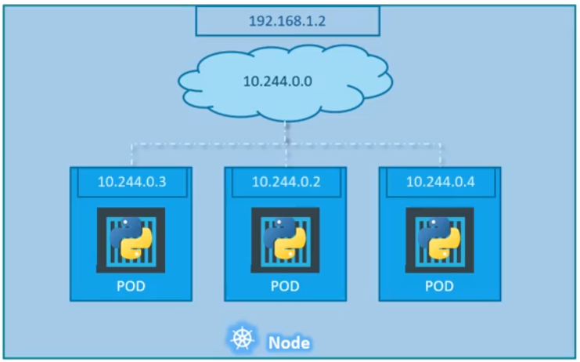

Cluster Networking

When kubernetes cluster is setup it does not automatically setup any kind of networking.
There are pre-built network solutions available
- cisco
- flannel
- Kaliko

Cluster with the set up of custom networking(flannel or kaliko) now manages the networks and IP in the nodes and assign a different network address for each network in the node. This creates a virtual network of all nodes where they are all assigned a unique IP address and by using simple routing techniques the cluster networking enables communication between the different pods or nodes to meet the networking requirements of kubernetes.

Thus all the pods now can communicate to each other using the assigned IP address.

