Kubernetes Services
Kubernetes services enable communication between various components within and outside of the application.
Kubernetes services helps us connect applications together with other applications or users.
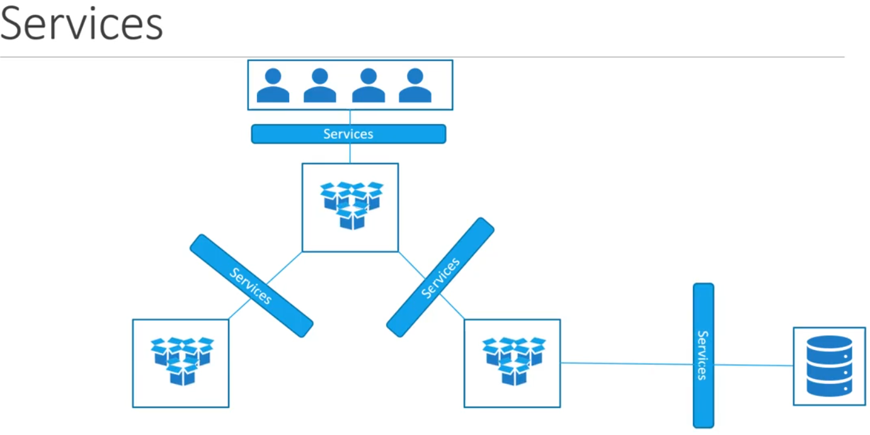
Services Types
- NodePort
- ClusterIP
- LoadBalancer
NodePort
NodePort service listen to port on the node and forward requests to the pods.

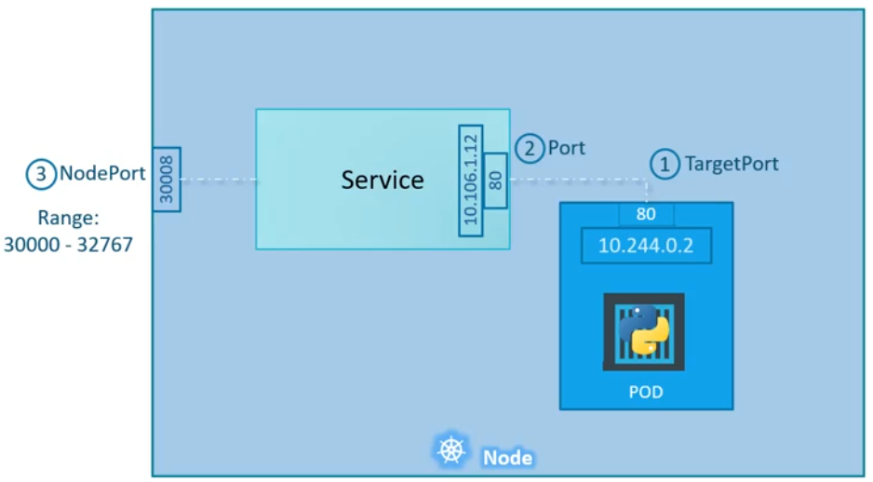
ClusterIP

