Container Orchestration
Container Orchestration is the process of automatically deploying and managing containers.
Kubernetes
Kubernetes is a container orchestration technology used to orchestrate the deployment and managements of containers in a clustered environment.
Nodes
A node is a machine either physical or virtual on which kubernetes is installed.
A node is a worker machine and that is where containers will be launched by kubernetes.
Cluster
A cluster is a set of nodes grouped together. This way even if one node fails you have you application still accessible from the other nodes. Moreover having multiple nodes helps in sharing load as well.
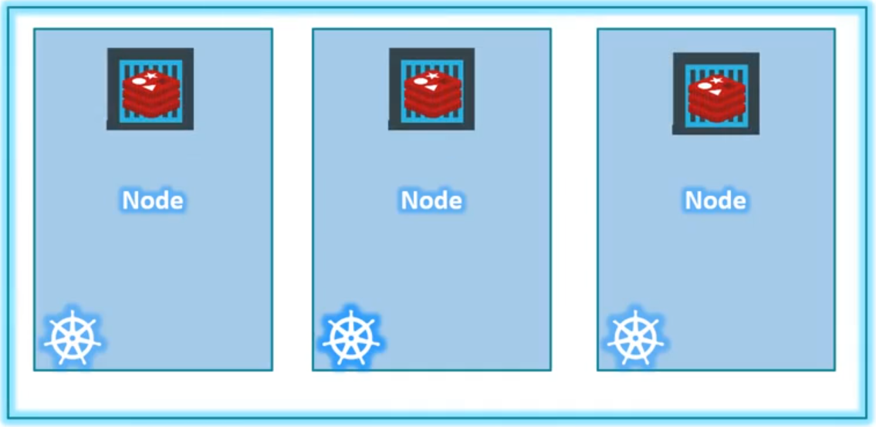

Master
The master is the another node with kubernetes installed in it and is configured as a master.
The master watches over the nodes in the cluster and is responsible for the actual orchestration of containers on the worker nodes.

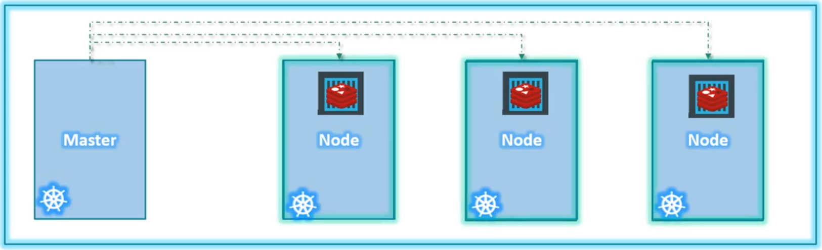

Kubernetes Architecture
The components are:
- API Server
- etcd
- Scheduler
- Controller
- Kubelet
- Container Runtime

The API Server acts as the front end for Kubernetes. The user management device, command line interfaces all talk to the API server to interact with the Kubernetes cluster
Etcd key store is a distributed reliable key value store used by the kubernetes to store all the data for managing the cluster
The scheduler is responsible for distributing work or containers across multiple nodes. It looks for new created containers and assign them to nodes.
The controllers are brain behind orchestration and they are responsible for noticing and responding when nodes, container or end points goes down. The controllers makes decision to bring up new containers in such cases.
The Container runtime is the underlying software that is used to run containers.
Kubelet is the agent that runs on each node in the cluster. The agent is responding for making sure that the containers are running on the nodes as exepected.

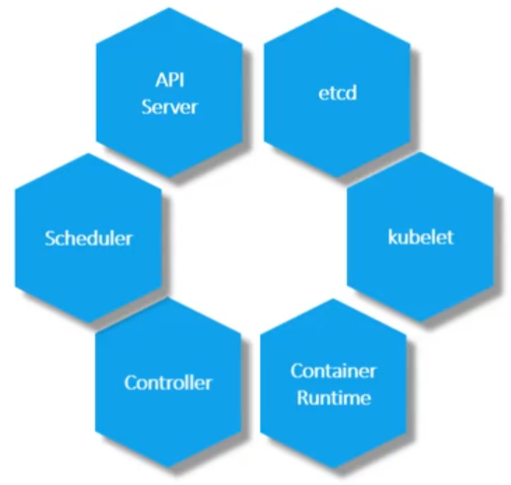

Master Vs Worker Nodes
