MIRA
AI-Powered Project Intelligence Assistant
Capstone Submission — Applied Agentic AI for PMs/TPMs
Author | Bharathi Vasan
Company scenario | Nexora Pvt. Ltd. — supporting the ABCDE Ltd. AI Adoption Project
Platform | n8n multi-agent workflow (OpenAI gpt-4o-mini, Google Drive, Langfuse)
Workflow | MIRA — AI-Powered Project Intelligence Assistant (ID MwdbsS0NqgXApBUQ)
Test status | 12/12 baseline tests executed on 2026-09-30 (11 Pass, 1 Pass with caveat)
GitHub repository | <insert repository link>
Demo video | <insert video link>

Table of Contents
1. README — Project Overview
2. Architecture and Orchestration
3. Baseline Test Results (T1–T12)
4. Q1 — Ideation
5. Q2 — Build Write-up
6. Q3 — Program Charter
7. Q4 — Reflection and Next Steps
8. Demo Video Walkthrough
9. Submission Checklist

1. README — Project Overview

1.1 Purpose
MIRA is a multi-agent project intelligence assistant. It reads a project's source documents from Google Drive and routes a natural-language PM/TPM request to the specialist agent best able to answer it. Every answer is grounded in the supplied project data, and vague requests are met with an insufficient-detail guardrail instead of fabricated content.
Capabilities: project plan generation, risk assessment, weekly status reporting, milestone tracking and blocked-task alerts, and stakeholder update drafting.

1.2 Agents
Agent | Responsibility | Grounding
Orchestrator | Classifies intent by explicit artifact and emits one routing key | User request
Planner | Structured project plan; refuses vague input | project_description + project_timeline
Risk Assessor | Categorized risk matrix / top-N risks | project_risks + project_description
Status Reporter | Weekly status, overall health, counts | Task board + deterministic counts
Milestone Tracker | Upcoming, at-risk and blocked items | Timeline + task board
Stakeholder Update Generator | Sprint-scoped professional update email | Task board

1.3 Source data (Google Drive input folder)
File | Content
project_description.txt | Scope, goals, approach of the ABCDE Ltd. AI Adoption Project
project_timeline.csv | Eight phases over 24 weeks with milestones
project_risks.csv | Risk register R01–R10 with category, impact, mitigation
sample_task_board.csv | 25 tasks (T001–T025) across Sprints 1–10 with status, assignee, due date

1.4 Setup and how to run
- Import or open the MIRA workflow in n8n.
- Connect the Google Drive OAuth2 credential on the Search files and folders node and set the Folder filter to By ID (input folder 1boA13GRucJQAS1betxsyGJQX5um6COmK).
- Keep exactly one copy of each of the four source files in that folder.
- Connect the OpenAI credential on the language-model nodes and the Langfuse credential for tracing.
- Open the chat and submit a request, for example: Generate a weekly status report using the sample task board for Sprint 3.

1.5 Example requests
- Generate a project plan for the AI Adoption Project at ABCDE Ltd.
- What are the top 3 risks for the ABCDE Ltd project based on the risk data?
- Which tasks are blocked or at risk of missing their deadline?
- What milestones are coming up in the next 2 weeks?
- Generate a stakeholder update email summarizing Sprint 2 progress.

1.6 Known limitations
- CSV-based task board only; no live Jira/Trello write-back.
- The sample data uses historical dates, which affects "next two weeks" milestone logic.
- OpenAI credit exhaustion can block all agent runs.
- Duplicate files in the Drive folder inflate counts, so the folder must hold one copy of each file.
- T6 returns a grounded report rather than the literal "no task data available" message (see Section 3).

2. Architecture and Orchestration

2.1 Pattern chosen: Router / Dispatcher
The Orchestrator classifies each request and outputs exactly one specialist name; a Switch then routes to that specialist. Requests are single-intent and heterogeneous, so only the relevant agent needs to run.
Pattern | Fit for MIRA | Decision
Sequential Pipeline | Would run every agent for every request, wasting calls and cost | Not selected
Router / Dispatcher | One intent per request maps cleanly to one specialist | Selected
Hierarchical | Useful for decomposing complex multi-agent tasks; not needed now | Not selected

2.2 Architecture diagram
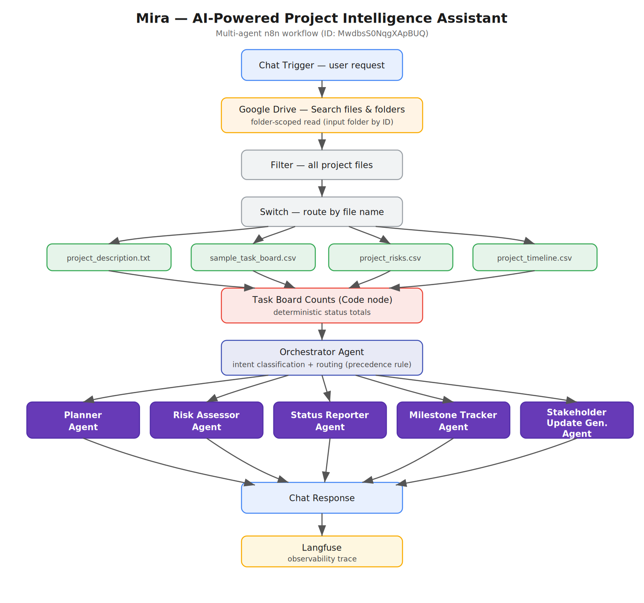
Figure 1 — MIRA architecture (Router / Dispatcher)

2.3 Data flow
- Chat Trigger receives the PM/TPM request.
- Google Drive search reads the single input folder.
- Filter and Switch select the four project files by name.
- Download, Extract From File and Aggregate nodes build usable context.
- The Task Board Counts Code node computes status totals deterministically.
- The Orchestrator classifies intent; the Router sends the request to one specialist.
- The specialist's output is merged, traced to Langfuse and returned through the Chat Response node.

2.4 Design controls
- Specialist prompts are instructed not to invent project facts.
- Vague requests are refused or clarified rather than filled with fabricated detail (Insufficient Detail guardrail).
- Task counts come from code, not from LLM arithmetic.
- The Orchestrator applies a routing-precedence rule: route by explicit artifact intent, not incidental words such as duration or sprint.
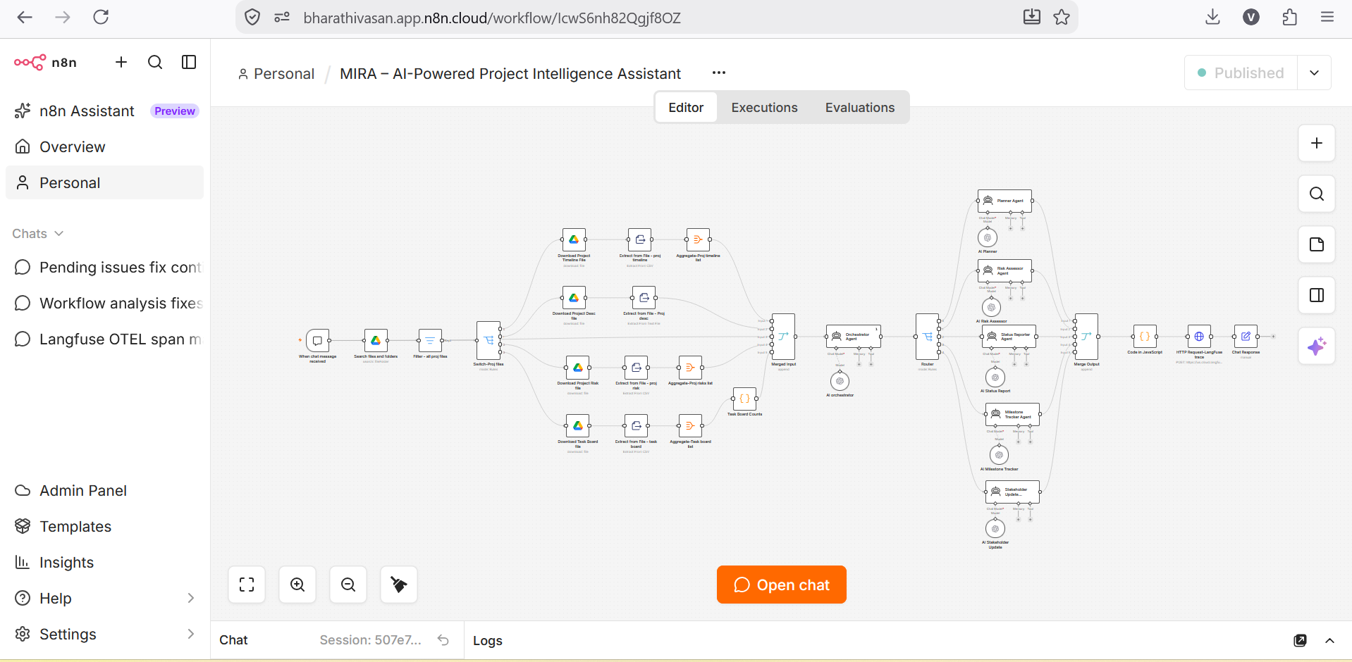
Figure 2 — n8n workflow canvas (overall)
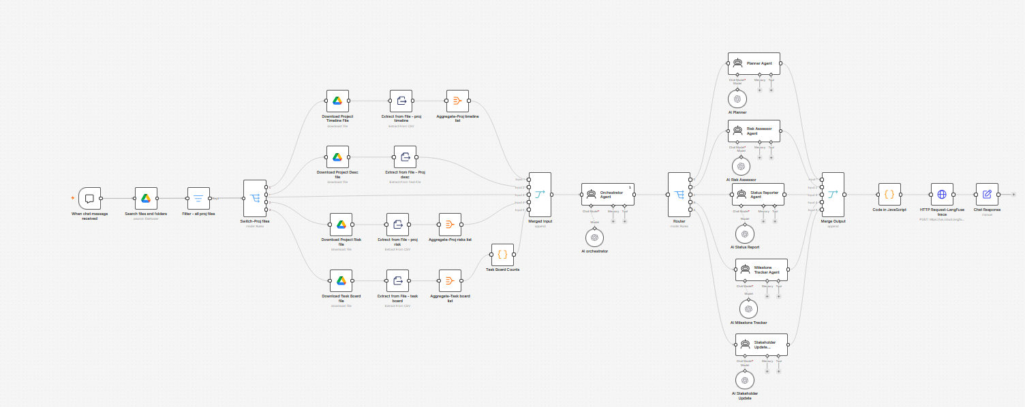
Figure 3 — n8n workflow canvas (close-up)

3. Baseline Test Results (T1–T12)
All 12 baseline inputs were run through the workflow chat on 2026-09-30 and captured with n8n execution IDs and Langfuse traces. Result: 11 Pass, 1 Pass with caveat, 0 Fail.
ID | Category | Agent called | Expected must contain | Exec | Result
T1 | Plan (detailed) | Planner | Phases, milestones, timeline; grounded; no invented goals | 1593 | Pass
T2 | Plan (vague) | Planner | Flag insufficient detail; ask scope/timeline/team size | 1594 | Pass
T3 | Risk (detailed) | Risk Assessor | Categorized logistics/AI risks; none generic | 1595 | Pass
T4 | Risk (vague) | Risk Assessor | Flag insufficient; no invented risks | 1596 | Pass
T5 | Status (data) | Status Reporter | Tasks by status; real task names; none invented | 1597 | Pass
T6 | Status (no data) | Status Reporter | State no task data; no fabricated statuses | 1598 | Pass*
T7 | Risk analysis | Risk Assessor | Top 3 from actual risk CSV | 1599 | Pass
T8 | Tracking | Milestone Tracker | Identify T024 (Blocked); check due dates | 1600 | Pass
T9 | Plan (edge) | Planner | Ask for scope/goals/deliverables; no plan | 1605 | Pass (fixed)
T10 | Status summary | Status Reporter | Counts match task board exactly | 1602 | Pass (fixed)
T11 | Timeline | Milestone Tracker | Actual milestones from timeline; none invented | 1603 | Pass
T12 | Comms | Stakeholder Update | Sprint 2 tasks only; professional | 1604 | Pass

T6 caveat: for "Things are going fine." Mira returned a data-grounded status report with correct counts and no fabricated progress, rather than the literal "no task data available" message. It did not hallucinate, so it satisfies the anti-hallucination intent, but it does not match the expected wording exactly. This is flagged for reviewer awareness.

3.1 Verified task-board counts
Computed directly from sample_task_board.csv: Done 5, In Progress 3, Blocked 1, To Do 16, Total 25. The T10 expected counts match this data.

3.2 Fixes applied during testing
Issue | Cause | Fix
Doubled counts (T5, T10) | Two copies of each file in Drive; Switch selects by name so both passed | Removed duplicate files; counts now 25 total
Slow Drive read (~60s) | Node listed the entire Drive (~6,000 files) | Folder-scoped read by ID; run time ~16s
T9 misrouted to Status Reporter | "2-week" pulled the model toward sprint/status reasoning | Routing-precedence rule added to Orchestrator prompt; re-run 1605 routes to Planner
Full verbatim outputs per test are in the accompanying Mira_Test_Cases_Execution_Sheet.xlsx.

4. Q1 — Ideation
Three use cases were selected from the Mira project area, each with a measurable pain point and success metrics.

Use Case 1 — Automated Project Planning
Pain point: Manual planning takes about 3–4 hours per project and formats vary between PMs.
Agentic solution: The Planner Agent reads the project description and timeline and creates a structured plan. For insufficient input it asks for missing scope, timeline and team information instead of fabricating a plan.
Inputs: Project description, timeline, user request.
Output: Structured plan with phases, activities, milestones, deliverables and timeline.
Success metrics:
- Planning time reduced to under 15 minutes.
- 100% of plans follow the standard template.
- Zero invented goals or phases in reviewed samples.
Knowledge base: Project description, timeline, plan template, historical examples.

Use Case 2 — Consistent Risk Assessment
Pain point: Risk assessments are inconsistent across projects.
Agentic solution: The Risk Assessor produces a categorized risk matrix grounded in the project risk register and description.
Inputs: Project risks, project description, user request.
Output: Categorized risk matrix or focused top-N list with impact and mitigation.
Success metrics:
- 100% of active projects have a current risk matrix.
- 95% of listed risks are project-specific on review.
- Every listed risk has a concrete mitigation.
Knowledge base: Risk register, taxonomy, domain knowledge, mitigation examples.

Use Case 3 — Status Reporting and Milestone Alerts
Pain point: Weekly status takes 1–2 hours and milestone issues are often found only in retrospectives.
Agentic solution: The Status Reporter generates the weekly status from the task board, with counts calculated by code. The Milestone Tracker compares progress with the timeline and flags blocked or at-risk items.
Inputs: Task board, timeline.
Output: Weekly status report and milestone alerts.
Success metrics:
- Status generation under 5 minutes.
- 100% count match with the task board.
- 90% of at-risk or blocked items surfaced before retrospective review.
Knowledge base: Task board, timeline, at-risk rules, sprint definitions.

5. Q2 — Build Write-up

A. Design and Architecture
MIRA is a multi-agent n8n workflow: a Chat Trigger receives the request, Google Drive ingestion reads the four project files, the Orchestrator classifies intent, and the Router sends the request to one specialist. Output is returned through the Chat Response node and traced to Langfuse. The Router / Dispatcher pattern was chosen over sequential and hierarchical designs because requests are single-intent (see Section 2).
Tools: n8n (orchestration); Google Drive, Extract From File and Aggregate (grounded ingestion); Code node (deterministic counts); OpenAI gpt-4o-mini (generation and reasoning); Langfuse via OpenTelemetry/HTTP (observability).

B. Implementation
Core capabilities: project plan generation, risk assessment, weekly status report.
Extended capabilities: milestone alert system (blocked and at-risk tasks) and stakeholder update generator.
Guardrails: outputs grounded in the supplied files; no invented milestones, risks or task statuses; Insufficient Detail response for vague inputs; a scope-anchoring rule so the agents do not substitute ABCDE data for an unrelated vague request; Orchestrator emits one routing key.
Testing: all 12 baseline inputs executed; results in Section 3.

C. Cost and Evaluation
Each request normally costs one short Orchestrator call plus one specialist call. Measured from the Langfuse export (LangFuse_Logs.csv) for the 17 traces recorded on 2026-09-30:
Metric | Value | Note
Model | gpt-4o-mini | All logged generations
Total logged cost, 17 requests | about $0.0024 | Sum of totalCost
Mean cost per request | about $0.00014 | Median about $0.00008; max about $0.0004
Mean Orchestrator call | about $0.000005 | Short routing call
Mean specialist call | $0.00007 – $0.0002 | Planner highest, Status Reporter lowest

Measurement caveat: Langfuse token counts come from the n8n OpenTelemetry spans and appear to exclude the large injected project context, so true cost is likely higher than logged. Latency in the spans is a fixed value, so execution durations from n8n (9–19 seconds per test, Section 3) are used instead. Time-to-first-token, prompt names and scores are not populated.
Evaluation metrics and targets: grounding accuracy 100%; routing accuracy 95%+; count correctness 100%; refusal correctness 100%; latency and cost per request tracked in Langfuse. Observed in the baseline run: routing 12/12 to the intended agent after the T9 fix; counts correct; refusal correct for T2, T4, T9; T6 partial (caveat).

Langfuse observability evidence
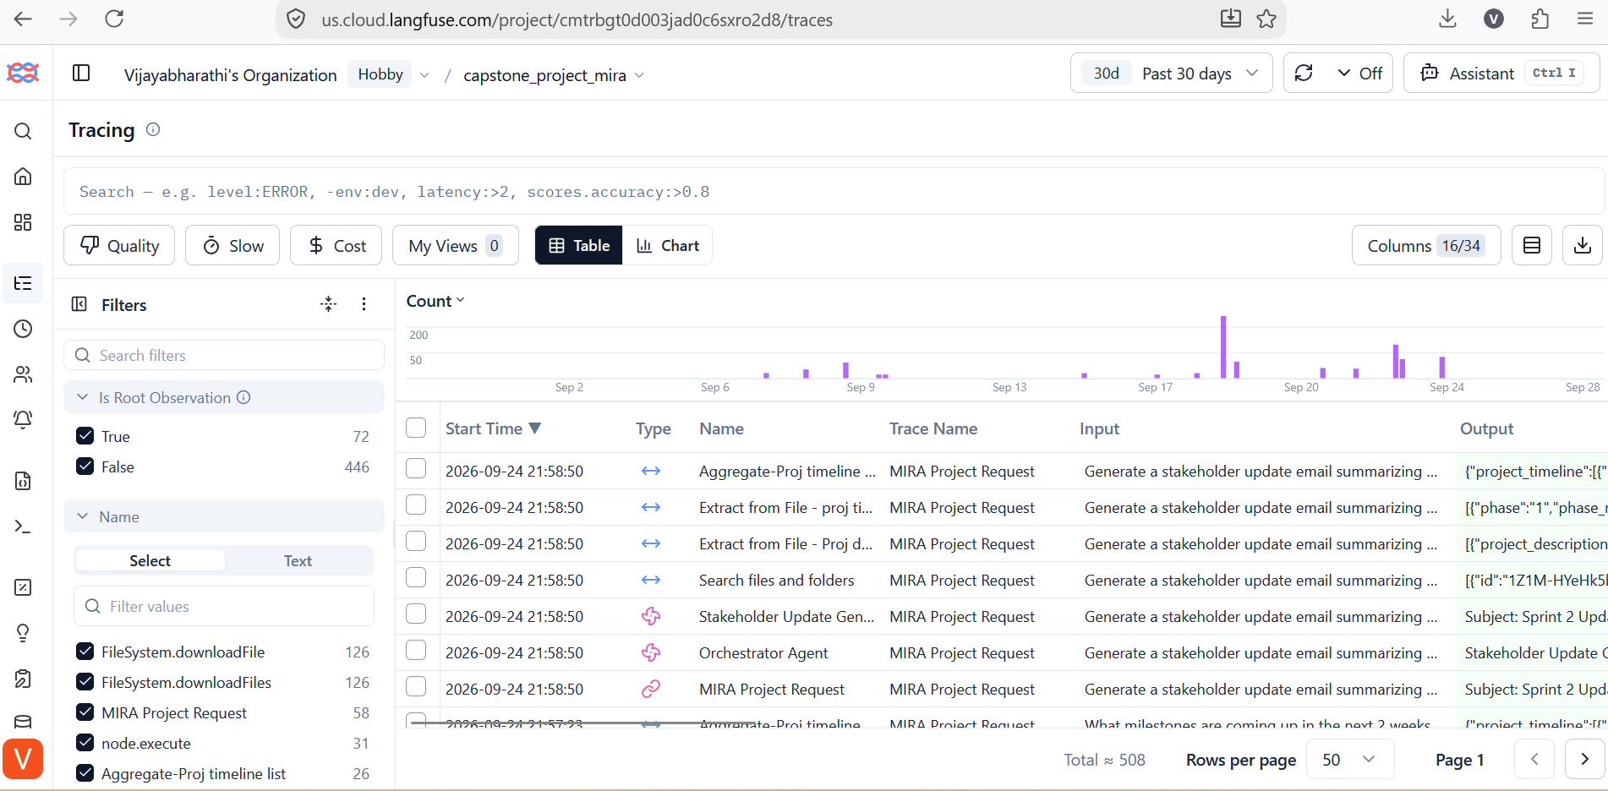
Figure 4 — Langfuse trace list
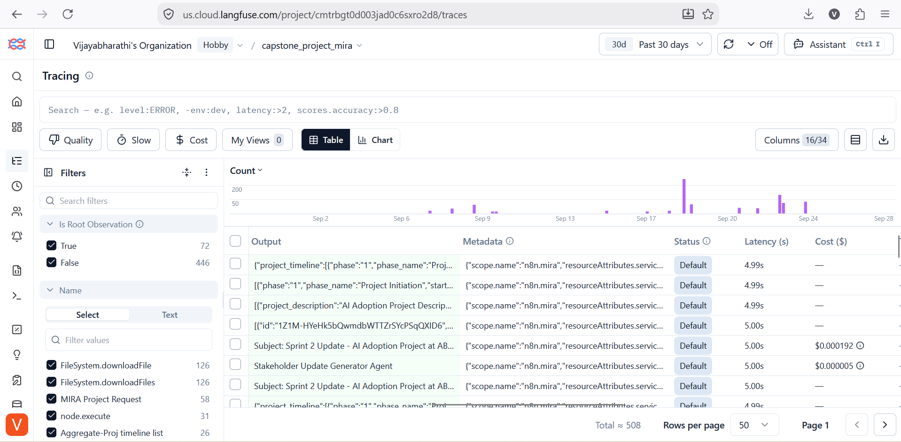
Figure 5 — Langfuse trace detail
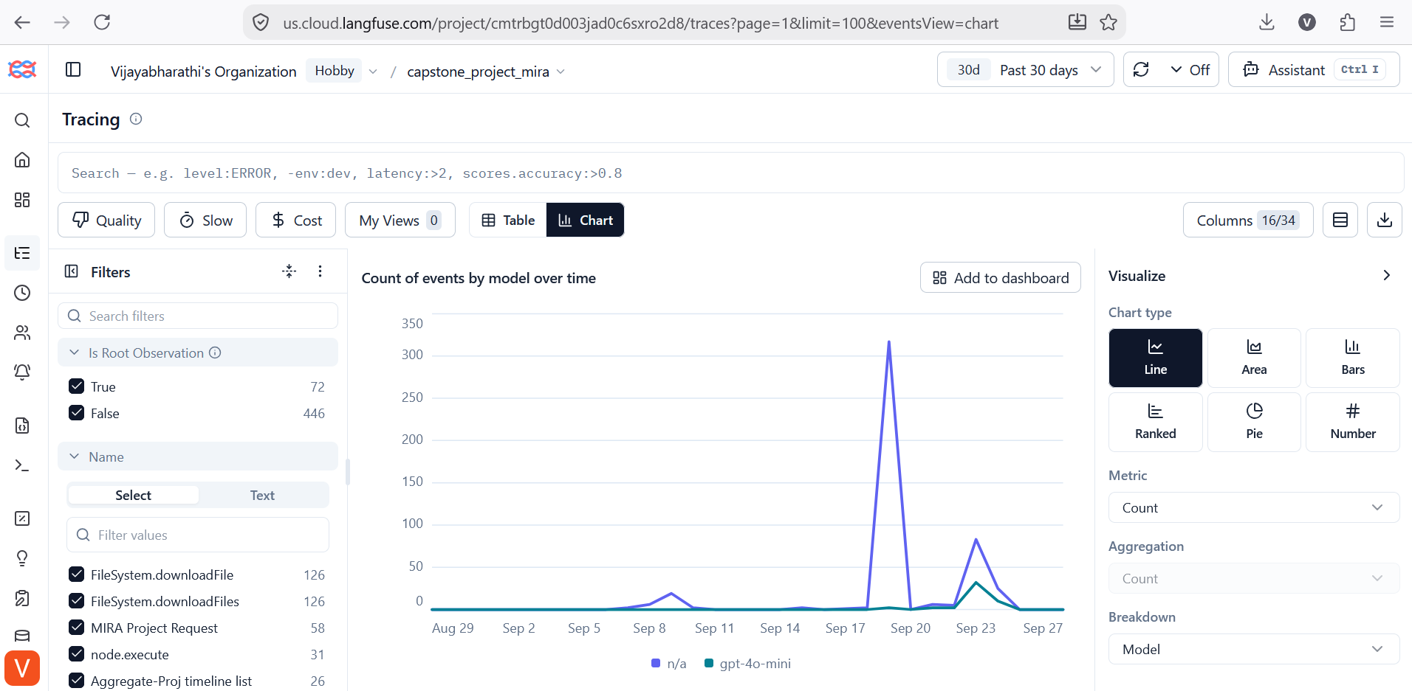
Figure 6 — Langfuse trace observations
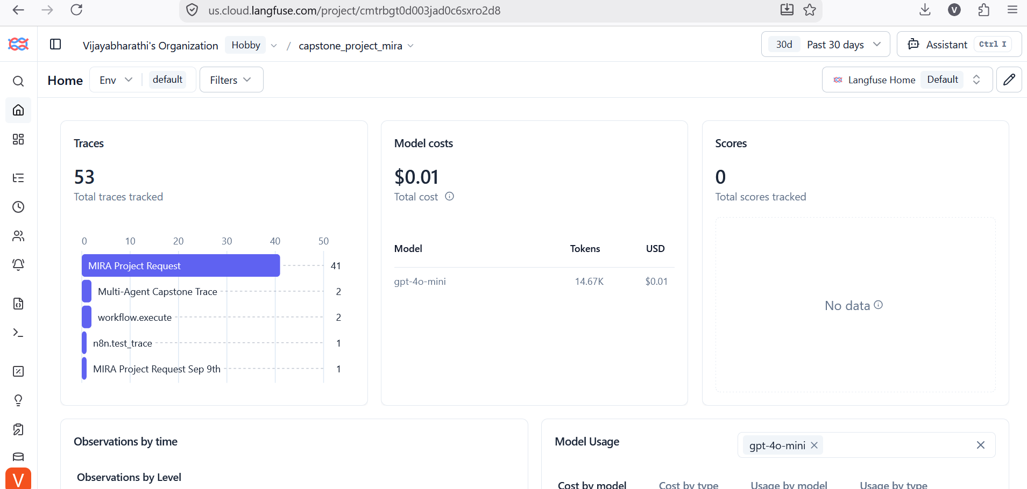
Figure 7 — Langfuse dashboard chart

6. Q3 — Program Charter

Vision
Give Nexora PMs/TPMs an always-available assistant that converts raw project data into structured, grounded and actionable project intelligence.

Scope
In scope | Out of scope (initial release)
Planner, Risk Assessor, Status Reporter, Milestone Tracker and Stakeholder Update agents | Live Jira/Trello write-back
Router orchestration and grounded data ingestion | Fine-tuning
Weekly status automation and milestone/blocker alerts | Autonomous external stakeholder communication without human review
Langfuse observability and baseline evaluation

Success criteria
Objective | Target
Planning effort | 15 minutes or less
Weekly status effort | 5 minutes or less
Projects with a current risk matrix | 100%
Grounding accuracy | 100%
Routing accuracy | 95% or higher
At-risk/blocked detection before retrospective | 90% or higher
Adoption | 8 of 10 PMs/TPMs within one quarter

Indicative timeline
Weeks | Activity
1–2 | Discovery and design
3–5 | Core build (planner, risk, status)
6–7 | Extended capabilities and observability
8 | Evaluation and hardening
9–10 | Pilot with 3 PMs
11–12 | Full rollout

Risks
- Hallucination or invented facts
- LLM cost overruns
- Duplicate or stale source files
- API credit or rate-limit outages
- Low adoption
- Project-data privacy

Stakeholders and decision making
Stakeholders: CTO, PMs/TPMs, data scientists/ML engineers, product stakeholders/clients, Security/Compliance.
The AI PM/TPM is responsible; the CTO is accountable; Security and senior PMs are consulted. Changes to data handling or external communication require review.

Rollout
Pilot with 3 PMs, collect trace and feedback data, tune prompts and routing, confirm baseline tests, then onboard the wider PM/TPM group. Continue weekly quality and cost reviews.

7. Q4 — Reflection and Next Steps

Trace findings
Area | Finding | Resolution
Routing | Orchestrator output could name several agents, so the Switch misrouted; T9 was pulled to Status by the words "2-week" | Constrain output to one agent name; add routing-precedence rule
Counting | LLM counting on the 25-task board gave wrong totals | Deterministic Code node computes counts
Ingestion | Name-based Drive search returned duplicate copies and inflated rows | Remove duplicates; folder-scoped read by ID
Environment | OpenAI credit exhaustion blocked agent runs | Add cost monitoring and a fallback provider

Improvement plan
- Add automated grounding checks.
- Harden ingestion: single-source folder, trashed=false filter, schema and row-count validation.
- Add token budgets, credit alerts and fallback provider controls.
- Expand refusal-case regression tests; make T6 return the explicit "no task data" message.
- Correct the Langfuse instrumentation so token counts include injected context and latency is real.

Evaluation and fine-tuning
Langfuse traces provide feedback data. Corrected examples can become candidates for future Planner and Risk fine-tuning, followed by re-evaluation against the same 12-case baseline.

Privacy
- Minimize project-sensitive and personal data sent to the LLM; pseudonymize PII where feasible.
- Review provider retention and training terms.
- Restrict Drive access by least privilege and control access to traces.
- Require human review before external sharing.

Future backlog
Resource allocation advice, live task-board integration (Jira/Trello), optional fine-tuning, and a Markdown/Docs/Slack export for team use.

8. Demo Video Walkthrough (8–10 minutes)
# | Segment | Time | What to show
1 | Introduction: problem and MIRA | 45s | Business problem; multi-agent design
2 | Source data | 60s | The four project files
3 | Workflow canvas | 90s | Chat Trigger to Chat Response; Orchestrator only routes
4 | Planner demo | 60s | Plan for AI Adoption Project
5 | Status demo | 60s | Sprint 3 report; code-computed counts
6 | Risk or Milestone demo | 60s | Top 3 risks or upcoming milestones
7 | Langfuse | 60s | Trace, routing, cost
8 | Guardrail | 45s | "We want to build a chatbot." returns Insufficient Detail
9 | Close | 45s | Summary and known limitations

Questions to be ready for
Question | Answer
Why Router, not Sequential? | Requests are single-intent; only the relevant specialist runs.
Why code for counts? | LLM arithmetic was unreliable; code is deterministic.
How is hallucination prevented? | Grounding prompts, file context, refusal for vague input, deterministic calculations, testing, human review.
What if source files are duplicated? | Counts inflate; the folder is scoped by ID and holds one copy of each file.
What is not implemented? | Live write-back, fine-tuning, autonomous external communication.

9. Submission Checklist
Deliverable | File / location | Status
README | Section 1 / README.md | Ready
Architecture diagram | Section 2 / architecture.svg, .mmd | Ready
Baseline results T1–T12 | Section 3 / Mira_Test_Cases_Execution_Sheet.xlsx | Ready
Q1 Ideation | Section 4 | Ready
Q2 Build write-up | Section 5 | Ready
Q3 Program Charter | Section 6 | Ready
Q4 Reflection | Section 7 | Ready
Workflow JSON export | n8n/MIRA_COMPLETED_COPY.json | Ready
Screenshots (canvas, Langfuse) | screenshots/ | Ready
Mira-in-action screenshot (chat response) | Not in the package | To add
Demo video | Section 8 script | To record
GitHub repository link | Cover page | To add

