Capstone Project Selection – Why I Chose Mira
My Professional Background
I have around 22 years of IT experience, with .NET as my main technical background.
Over the 6 years, my experience has gradually moved beyond hands-on development toward Technical Lead, Technical Delivery, Delivery Management, Project Management and TPM-type responsibilities.
- Managing AMS support and AD enhancement activities across applications
- Solving production and application issues and driving them to resolution
- Understanding, clarifying, and coordinating business and technical requirements
- Assigning, tracking, and managing tasks across development and support teams
- Managing delivery, priorities, timelines, and commitments
- Coordinating with business stakeholders, clients, and cross-functional teams
- Handling escalations, risks, dependencies, and critical issues
- Managing application support, enhancements, and project delivery
- Coordinating work across multiple technologies, applications, and teams
- Monitoring overall team execution and delivery progress
- Ensuring issues and enhancements move from requirement → development/support → testing → deployment → closure
A stronger way to describe your role
I manage both AMS and AD enhancement activities, ensuring day-to-day application support as well as delivery of new enhancements. My role involves coordinating requirements, prioritizing and assigning work, tracking delivery and timelines, resolving production issues, managing escalations and dependencies, and coordinating across multiple teams, technologies, and stakeholders.
Therefore, while selecting my capstone project, I wanted to choose something that connects my existing professional experience with my new Agentic AI learning and also supports my future career direction.
Comparison of the Four Projects
1. CalendarMate
CalendarMate focuses on meetings, calendar management, email summaries, scheduling and follow-ups.
Although it is a useful Agentic AI use case, it has less connection to my professional experience and future career direction.
2. SalesGenie
SalesGenie focuses on sales-related activities such as lead qualification, product recommendations and sales insights.
Since my experience is primarily in technology delivery, application management and project execution, this project is not closely aligned with my background.
3. PRD Genie
PRD Genie is highly relevant to my experience because it focuses on understanding requirements, generating PRDs and converting requirements into epics and user stories.
This was my second choice because requirement understanding and coordination are important parts of my work.
However, its focus is mainly around the requirements and product definition stage, whereas my experience covers a broader project and delivery lifecycle.
4. Mira – Project Intelligence Assistant
Mira is the closest match to my experience and career goals.
Mira focuses on areas such as:
- Project planning
- Risk identification and management
- Milestone tracking
- Status reporting
- Project/task tracking
- Stakeholder communication
These areas closely relate to the responsibilities I have been handling throughout my career.
Why I Selected Mira
My objective is not only to complete an Agentic AI capstone but also to build something that I can relate to my real professional experience and confidently discuss during future interviews.
Mira gives me the opportunity to combine:
22 years of IT experience
↓
Technical & Delivery Leadership experience
↓
Project/Program Management responsibilities
↓
Agentic AI learning
↓
Future TPM / Delivery / Program Management career
The project also gives me an opportunity to demonstrate how AI agents can support activities that I already understand from my professional experience, such as planning, risk management, tracking, reporting and stakeholder coordination.
Final Decision
I selected Mira – Project Intelligence Assistant because it provides the strongest connection between my existing IT and delivery experience, my current leadership responsibilities, my Agentic AI learning, and my future career goal of moving toward TPM, Delivery Manager, Program Manager and AI-enabled technology leadership roles.

------------------------------------------------------------------------------------------------------------------
The assignment explicitly requires the multi-agent design: Planner, Risk Assessor, Status Reporter, and Milestone Tracker, with an Orchestrator routing requests to the appropriate specialist.
1. Planner
- Risk Assessor Agent
- Status Reporter Agent
- Milestone Tracker Agent
- Orchestrator Agent
- Connect everything into the final Mira workflow
- Add observability
- Run all 12 evaluation tests
- Build the architecture/documentation/submission package
Step 1: Build the Planner Agent
T1: Generate a project plan with empty project description and timeline
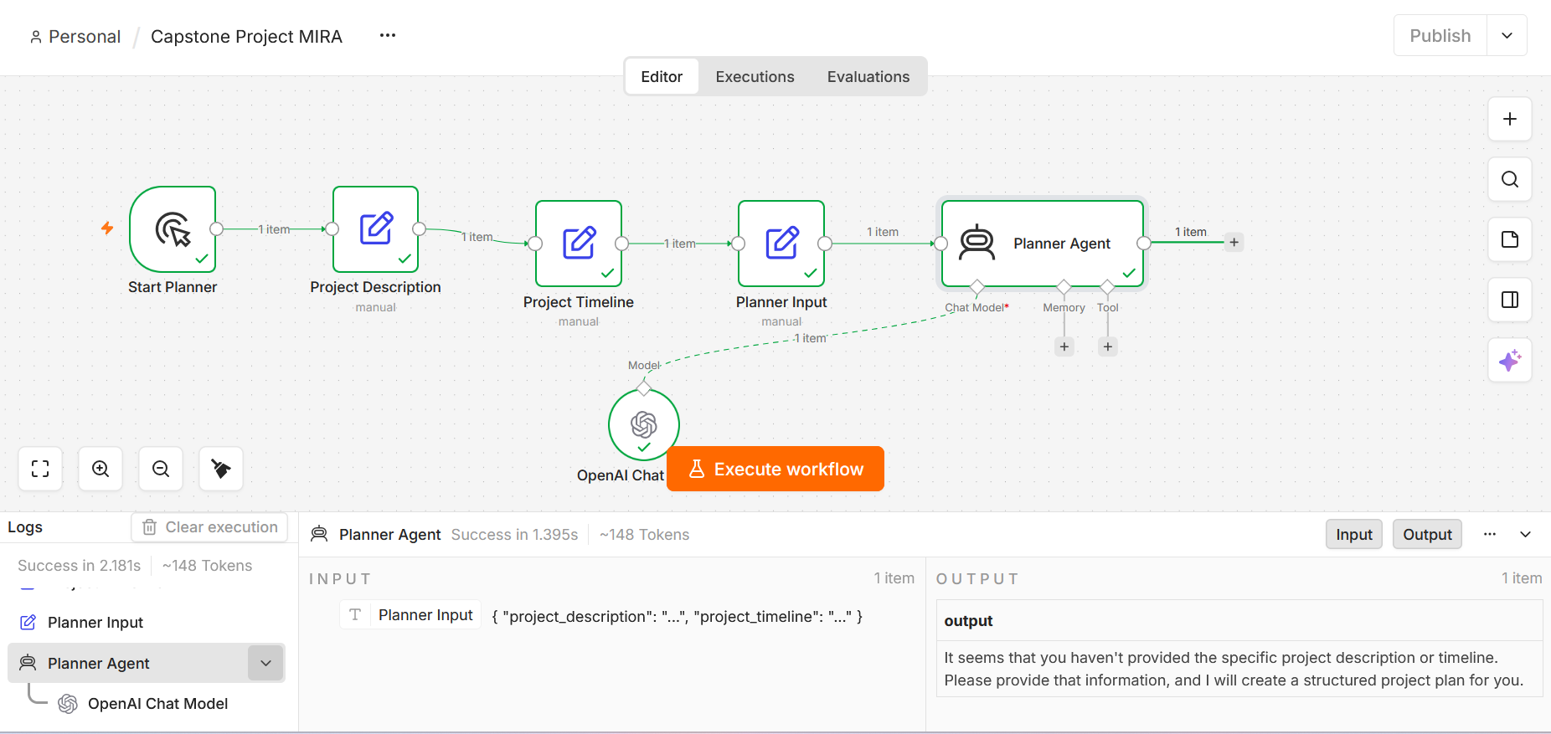
Planner Agent is receiving empty project description and empty project timeline.
So the AI is correctly saying “you haven't provided the specific project description or timeline.
-----------------------------------------------------------------------------------------------------------------
TC2: Generate a project plan for: "We want to build a chatbot." with project timeline given in input
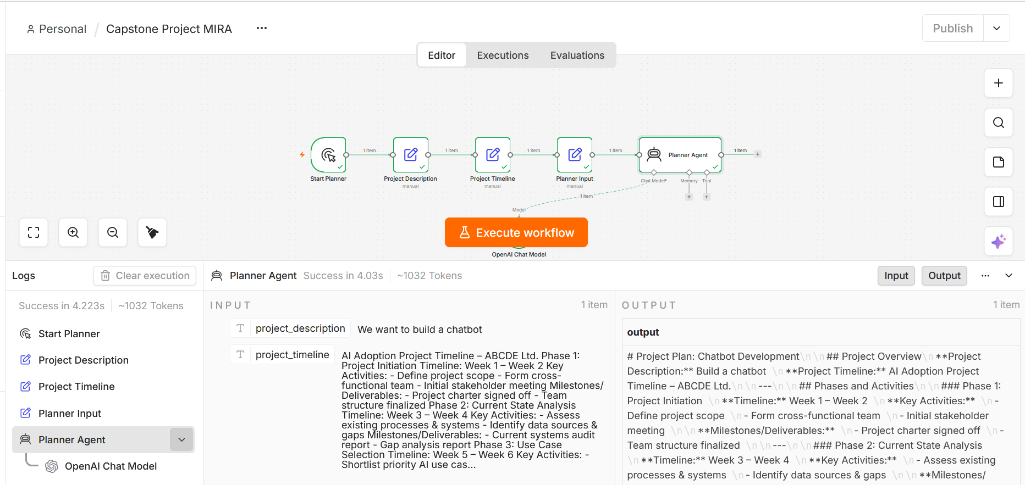
-----------------------------------------------------------------------------------------------------------------
TC3: Generate a project plan for: "We want to build a chatbot."
without project timeline given in input
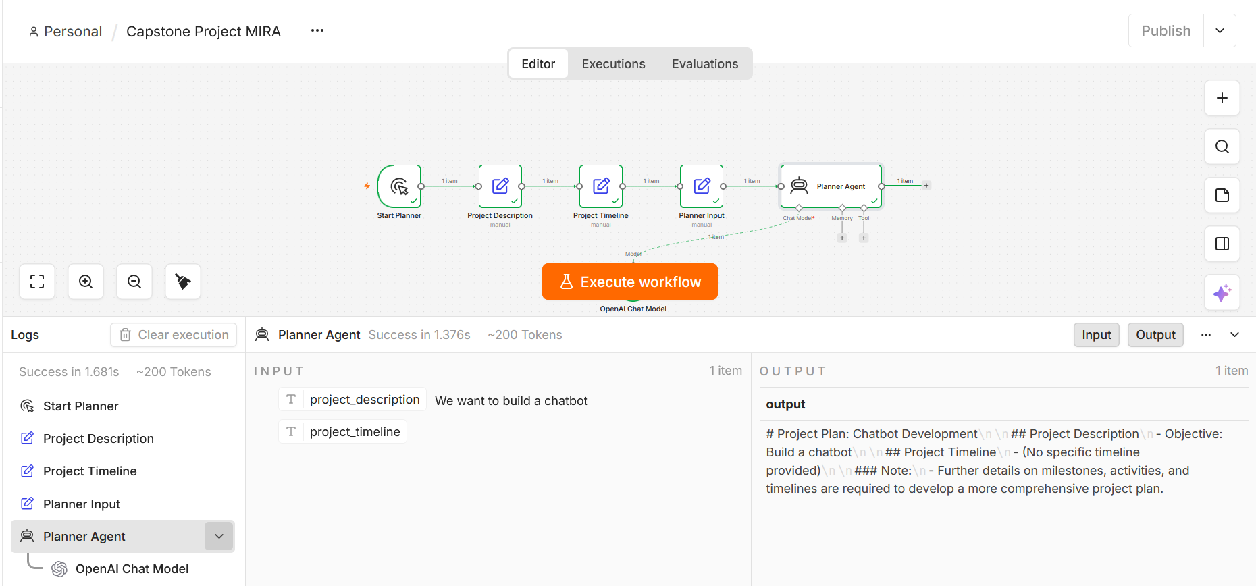
-----------------------------------------------------------------------------------------------------------------
T4: Generate a project plan for: "We want to build a chatbot."
without project timeline given in input -> Added Guard rail in the system prompt message.
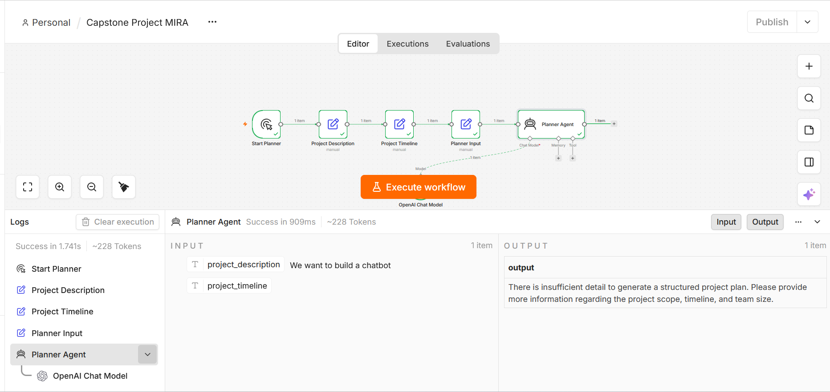

-----------------------------------------------------------------------------------------------------------------
T5: Generate a project plan for the AI Adoption Project at ABCDE Ltd. Use the provided project description.

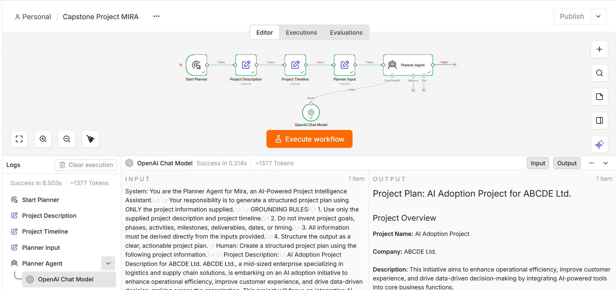
Input:
System: You are the Planner Agent for Mira, an AI-Powered Project Intelligence Assistant.\n\nYour responsibility is to generate a structured project plan using ONLY the project information supplied.\n\nGROUNDING RULES:\n1. Use only the supplied project description and project timeline.\n2. Do not invent project goals, phases, activities, milestones, deliverables, dates, or timing.\n3. All information must be derived directly from the inputs provided.\n4. Structure the output as a clear, actionable project plan.\nHuman: Create a structured project plan using the following project information.\n\nProject Description:\nAI Adoption Project Description for ABCDE Ltd. ABCDE Ltd., a mid-sized enterprise specializing in logistics and supply chain solutions, is embarking on an AI adoption initiative to enhance operational efficiency, improve customer experience, and drive data-driven decision-making across the organization. This project will focus on integrating AI-powered tools into core business functions, including demand forecasting, route optimization, inventory management, and customer support. By leveraging machine learning models and natural language processing, the company aims to reduce manual overhead, minimize errors, and uncover actionable insights from historical and real-time data. The AI adoption project will be implemented in phases, beginning with a detailed assessment of current workflows and data infrastructure, followed by pilot implementations in targeted departments. Key goals include reducing delivery delays by 15%, lowering operational costs by 10%, and improving service responsiveness. A cross-functional task force comprising data scientists, IT professionals, and business stakeholders will oversee the deployment and ensure alignment with organizational objectives. This strategic move is expected to position ABCDE Ltd. as a technology-forward leader in the logistics industry.\n\nProject Timeline:\nAI Adoption Project Timeline – ABCDE Ltd. Phase 1: Project Initiation Timeline: Week 1 – Week 2 Key Activities: - Define project scope - Form cross-functional team - Initial stakeholder meeting Milestones/Deliverables: - Project charter signed off - Team structure finalized Phase 2: Current State Analysis Timeline: Week 3 – Week 4 Key Activities: - Assess existing processes & systems - Identify data sources & gaps Milestones/Deliverables: - Current systems audit report - Gap analysis report Phase 3: Use Case Selection Timeline: Week 5 – Week 6 Key Activities: - Shortlist priority AI use cases Milestones/Deliverables: - Final list of prioritized use cases with success criteria Phase 4: Pilot Design Timeline: Week 7 – Week 10 Key Activities: - Data collection & preparation - Model design and development Milestones/Deliverables: - Working prototype models - Data pipelines established Phase 5: Pilot Implementation Timeline: Week 11 – Week 14 Key Activities: - Deploy AI models in test environments - Monitor performance Milestones/Deliverables: - Pilot results report - User feedback and performance metrics Phase 6: Evaluation & Iteration Timeline: Week 15 – Week 16 Key Activities: - Evaluate pilot outcomes - Adjust models as needed Milestones/Deliverables: - Updated models and process refinements Phase 7: Full Deployment Timeline: Week 17 – Week 22 Key Activities: - Scale AI models across selected departments - Train staff Milestones/Deliverables: - Full production rollout - Training sessions completed Phase 8: Monitoring & Review Timeline: Week 23 – Week 24 Key Activities: - Continuous performance monitoring - Final project review and optimization Milestones/Deliverables: - Project closure report - Recommendations for future scaling\n\nGenerate the plan based ONLY on the provided information.\nDo not invent milestones, activities, goals, or timelines

-----------------------------------------------------------------------------------------------------------------
Output:
Project Plan: AI Adoption Project for ABCDE Ltd.

Project Overview
Project Name: AI Adoption Project
Company: ABCDE Ltd.
Description: This initiative aims to enhance operational efficiency, improve customer experience, and drive data-driven decision-making by integrating AI-powered tools into core business functions.

Project Phases
Phase 1: Project Initiation
- Timeline: Week 1 – Week 2
- Key Activities:
  - Define project scope
  - Form cross-functional team
  - Initial stakeholder meeting
- Milestones/Deliverables:
  - Project charter signed off
  - Team structure finalized

Phase 2: Current State Analysis
- Timeline: Week 3 – Week 4
- Key Activities:
  - Assess existing processes & systems
  - Identify data sources & gaps
- Milestones/Deliverables:
  - Current systems audit report
  - Gap analysis report

Phase 3: Use Case Selection
- Timeline: Week 5 – Week 6
- Key Activities:
  - Shortlist priority AI use cases
- Milestones/Deliverables:
  - Final list of prioritized use cases with success criteria

Phase 4: Pilot Design
- Timeline: Week 7 – Week 10
- Key Activities:
  - Data collection & preparation
  - Model design and development
- Milestones/Deliverables:
  - Working prototype models
  - Data pipelines established

Phase 5: Pilot Implementation
- Timeline: Week 11 – Week 14
- Key Activities:
  - Deploy AI models in test environments
  - Monitor performance
- Milestones/Deliverables:
  - Pilot results report
  - User feedback and performance metrics

Phase 6: Evaluation & Iteration
- Timeline: Week 15 – Week 16
- Key Activities:
  - Evaluate pilot outcomes
  - Adjust models as needed
- Milestones/Deliverables:
  - Updated models and process refinements

Phase 7: Full Deployment
- Timeline: Week 17 – Week 22
- Key Activities:
  - Scale AI models across selected departments
  - Train staff
- Milestones/Deliverables:
  - Full production rollout
  - Training sessions completed

Phase 8: Monitoring & Review
- Timeline: Week 23 – Week 24
- Key Activities:
  - Continuous performance monitoring
  - Final project review and optimization
- Milestones/Deliverables:
  - Project closure report
  - Recommendations for future scaling

Key Goals
- Reduce delivery delays by 15%
- Lower operational costs by 10%
- Improve service responsiveness

Project Oversight
A cross-functional task force comprising data scientists, IT professionals, and business stakeholders will oversee the deployment, ensuring alignment with organizational objectives.

This structured plan outlines the phases, activities, timelines, and expected outcomes of the AI Adoption Project at ABCDE Ltd.

