**UNIT-I**

**1. Discuss the construction and working of Liquid Flat Plate Collector with a neat sketch. Explain the various parameters that affect the performance of the collector.**

**Construction of Liquid Flat Plate Collector**

A **Liquid Flat Plate Collector (LFPC)** is a widely used solar thermal device designed to absorb solar radiation and transfer heat to a fluid, typically water or a heat transfer fluid. Its main components include:

1. **Transparent Cover (Glazing):** Protects the collector from dust and reduces heat loss through convection and radiation.
2. **Absorber Plate:** A black-coated metal sheet (usually copper or aluminum) that absorbs solar energy and converts it to heat.
3. **Tubes/Piping System:** Attached to the absorber plate, through which the heat transfer fluid flows.
4. **Insulation:** Prevents heat loss from the bottom and sides of the collector.
5. **Casing (Outer Shell):** Provides structural support and houses the components.

**Working of Liquid Flat Plate Collector**

* Solar radiation passes through the transparent cover and strikes the absorber plate.
* The black coating on the absorber plate absorbs the radiation and converts it into thermal energy.
* Heat is transferred to the fluid circulating through the tubes/piping system.
* Insulation minimizes heat loss to the surroundings.
* The heated fluid exits the collector and is stored or utilized in applications such as domestic hot water or space heating.
* 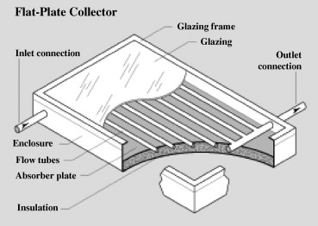

**Parameters Affecting Performance**

1. **Absorber Plate Material and Coating:** Higher thermal conductivity and selective coatings improve efficiency.
2. **Glazing Material:** Transparency and low emissivity reduce radiation losses.
3. **Insulation Quality:** Minimizes heat loss, enhancing performance.
4. **Fluid Flow Rate:** Proper flow rate ensures optimal heat transfer.
5. **Incident Solar Radiation:** Higher solar intensity improves performance.
6. **Ambient Temperature:** Affects heat loss and collector efficiency.
7. **Collector Tilt Angle and Orientation:** Maximizes solar radiation absorption based on geographic location.

**2. a) Advantages and Disadvantages of Concentrating Collectors Over Flat Plate Collectors [7M]**

**Advantages**

1. **Higher Efficiency:** Concentrating collectors achieve higher temperatures due to focused solar radiation.
2. **Compact Design:** Smaller surface area required for the same energy output.
3. **Suitable for High-Temperature Applications:** Ideal for industrial heating and power generation.
4. **Reduced Material Usage:** Less absorber material is required compared to flat plate collectors.
5. **Better Heat Utilization:** More effective in regions with high direct sunlight.

**Disadvantages**

1. **Tracking Requirement:** Requires solar tracking to ensure maximum efficiency, increasing complexity and cost.
2. **Not Suitable for Diffuse Radiation:** Performs poorly in overcast or cloudy conditions.
3. **Maintenance Needs:** Optical components like mirrors and lenses require regular cleaning and maintenance.
4. **Higher Initial Cost:** More expensive due to advanced design and tracking systems.

**2. b) Fill Factor and Its Importance as a Performance Parameter for a Solar Cell [7M]**

**Fill Factor (FF)**

The **fill factor (FF)** is a measure of the quality of a solar cell and is defined as the ratio of the **maximum power output (P_max)** to the product of the **open-circuit voltage (V_oc)** and **short-circuit current (I_sc):**

FF=PmaxVoc⋅IscFF = \frac{P_{\text{max}}}{V_{\text{oc}} \cdot I_{\text{sc}}}

Where Pmax=Vm⋅ImP_{\text{max}} = V_{\text{m}} \cdot I_{\text{m}}, and VmV_{\text{m}} and ImI_{\text{m}} are the voltage and current at the maximum power point.

**Importance**

1. **Efficiency Indicator:** Higher fill factors indicate better solar cell performance and higher efficiency.
2. **Design Optimization:** Helps in evaluating and improving the quality of materials and processes used in solar cell fabrication.
3. **Power Output Prediction:** FF contributes to determining the maximum power a solar panel can deliver under standard conditions.
4. **Comparison Metric:** Useful for comparing different solar cells and technologies.

Typical values for FF range from **0.7 to 0.85** for high-quality solar cells.

**1. a) Define Solar Constant. What is its Standard Value? [7M]**

**Definition**

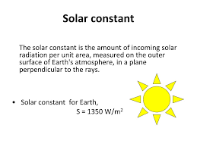

The **Solar Constant** is the average amount of solar energy received per unit area on a surface perpendicular to the Sun's rays at the top of the Earth’s atmosphere, when the Earth is at its mean distance from the Sun. It represents the intensity of solar radiation reaching Earth before it is affected by the atmosphere.

**Standard Value**

The value of the solar constant is approximately:

Solar Constant=1361 W/m2\text{Solar Constant} = 1361 \, \text{W/m}^2

This value may vary slightly due to fluctuations in solar activity and Earth’s elliptical orbit. Despite these variations, it serves as a critical parameter in solar energy studies and climate modeling.

**1. b) Write a Short Note on Sizing of PV System and Its Storage [7M]**

**Sizing of PV System**

The design of a photovoltaic (PV) system starts with determining its capacity to meet specific energy demands. The process includes:

1. **Energy Demand Calculation:** Calculate the total daily energy requirement (in kilowatt-hours, kWh). This involves evaluating energy needs of appliances or systems.
2. **Peak Sun Hours (PSH):** Identify the average daily solar radiation in the location. For example, a site with 5 PSH means 5 hours of optimal solar energy.
3. **Solar Panel Sizing:** Required Panel Capacity (kW)=Daily Energy Demand (kWh)PSH\text{Required Panel Capacity (kW)} = \frac{\text{Daily Energy Demand (kWh)}}{\text{PSH}} Additional capacity is often added to account for system losses, typically 20–30%.
4. **Inverter Sizing:** Ensure the inverter matches or slightly exceeds the maximum power output of the panels.

**Storage Sizing**

A PV system with energy storage (e.g., batteries) ensures energy availability during periods without sunlight.

1. **Battery Capacity Calculation:** Required Battery Capacity (kWh)=Daily Energy Demand (kWh)×Days of Autonomy\text{Required Battery Capacity (kWh)} = \text{Daily Energy Demand (kWh)} \times \text{Days of Autonomy} Days of autonomy refers to the number of days the system can operate without sunlight.
2. **Depth of Discharge (DoD):** Batteries are sized considering their usable capacity, typically 70–90% of their total capacity.
3. **Charge Controller:** Ensures proper charging and discharging to extend battery life.

**2. a) What are the Main Advantages of Flat-Plate Solar Collectors? [7M]**

Flat-plate solar collectors are commonly used for low- to medium-temperature solar thermal applications, such as water heating and space heating. Their advantages include:

1. **Simple Design:** Flat-plate collectors have a straightforward construction, making them easy to install and maintain.
2. **Cost-Effective:** Compared to advanced solar technologies, they are more affordable and widely available.
3. **Suitable for Various Applications:** Ideal for domestic and industrial uses such as water heating, drying, and preheating.
4. **Works Without Solar Tracking:** Unlike concentrating collectors, flat-plate collectors can harness both direct and diffuse solar radiation.
5. **Durability:** Their robust design and use of weather-resistant materials ensure a long lifespan.
6. **Wide Operational Range:** They perform efficiently in different climatic conditions, including moderate cloud cover.
7. **Low Maintenance Requirements:** Minimal moving parts reduce the need for frequent maintenance.

**2. b) Construction and Working of Solar Pond-Based Electric Power Plant with Cooling Tower [7M]**

**Solar Pond-Based Electric Power Plant**

A **solar pond** is a large-scale, shallow body of water that collects and stores solar energy. It is designed to produce thermal energy that can be converted into electricity. The key components of a solar pond-based power plant are:

1. **Solar Pond:** Captures and stores solar energy.
2. **Power Conversion Unit:** Converts thermal energy into mechanical and then electrical energy.
3. **Cooling Tower:** Removes waste heat from the system, maintaining operational efficiency.

**Construction**

1. **Solar Pond Structure:**
   * **Upper Convective Zone (UCZ):** The top layer of water at ambient temperature.
   * **Non-Convective Zone (NCZ):** A layer with a steep salinity gradient that prevents heat loss through convection.
   * **Lower Convective Zone (LCZ):** The bottom layer that absorbs and stores heat, reaching temperatures up to 90°C.
2. **Heat Exchanger System:** Transfers heat from the LCZ to the power conversion unit.
3. **Cooling Tower:** Dissipates excess heat to the environment.

**Working**

1. **Energy Absorption:** Solar radiation penetrates the pond, with heat trapped in the LCZ due to the salinity gradient.
2. **Heat Extraction:** Heat from the LCZ is transferred via a heat exchanger to a working fluid (e.g., organic Rankine cycle).
3. **Electricity Generation:** The heated working fluid drives a turbine to generate electricity.
4. **Cooling:** The cooling tower ensures the system operates efficiently by dissipating waste heat.

**Schematic**

The schematic of a solar pond power plant includes the solar pond, heat exchanger, turbine, generator, and cooling tower connected in sequence to complete the energy conversion cycle.

**Advantages**

* Utilizes abundant and renewable solar energy.
* Provides a low-cost thermal energy storage solution.
* Simple construction with minimal environmental impact.

**Applications**

* Electricity generation in remote areas.
* Industrial process heating.
* Desalination of seawater.

**1. Briefly Discuss the Following: [14M]**

**i) Solar Irradiance**

* **Definition:** Solar irradiance is the power per unit area (measured in W/m²) received from the Sun's radiation on a surface.
* **Types:** It can be categorized into direct, diffuse, and reflected irradiance.
* **Significance:** Solar irradiance is crucial for evaluating solar energy potential and designing solar systems.
* 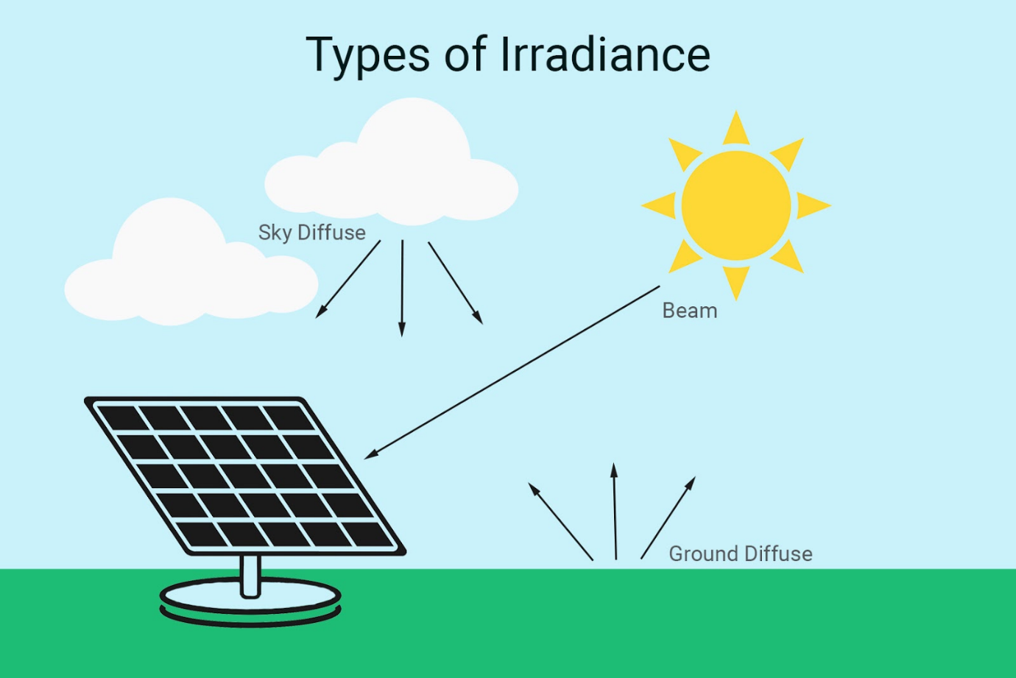

**ii) Solar Constant**

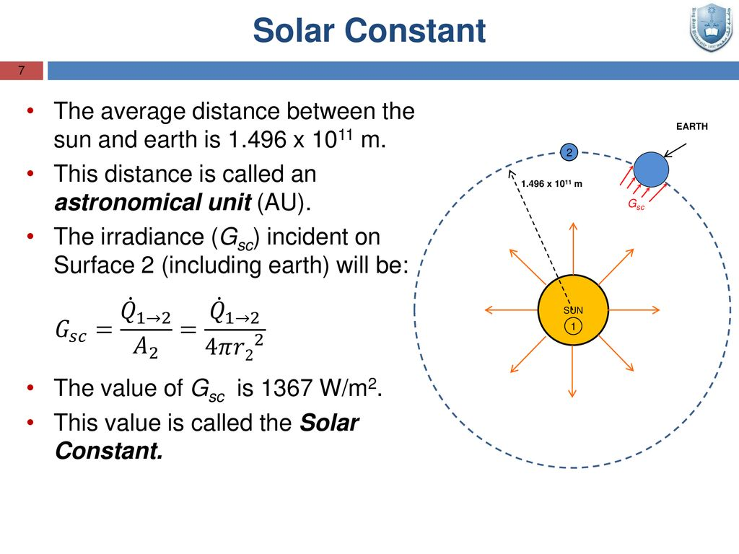

* **Definition:** The solar constant is the average solar energy received per unit area on a surface perpendicular to the Sun’s rays, measured at the top of Earth’s atmosphere.
* **Standard Value:** Approximately 1361 W/m21361 \, \text{W/m}^2.
* **Application:** Used in climate modeling, solar system design, and understanding Earth’s energy balance.

**iii) Extraterrestrial Radiations**

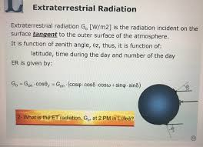

* **Definition:** Solar radiation that reaches the outer edge of Earth’s atmosphere without any atmospheric interference.
* **Characteristics:** It remains nearly constant, only varying slightly due to solar activity and Earth’s elliptical orbit.
* **Importance:** Forms the basis for understanding the solar constant and Earth’s energy input.

**iv) Terrestrial Radiations**

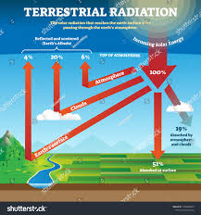

* **Definition:** Radiation emitted by Earth as a result of its absorption of solar energy.
* **Characteristics:** Earth radiates energy primarily in the infrared spectrum to maintain thermal balance.
* **Importance:** Affects Earth’s climate and is a key component in studying global warming and energy exchange processes.

**2. a) Status of Non-Conventional Energy Sources in India and Future Prospects [7M]**

**Current Status in India**

India is rapidly transitioning toward non-conventional energy sources to meet growing energy demands while reducing dependency on fossil fuels. Key highlights include:

1. **Solar Energy:** India is among the global leaders, with an installed solar capacity of over 70 GW (2024). Major initiatives like the **National Solar Mission** aim to achieve 280 GW by 2030.
2. **Wind Energy:** India ranks 4th globally, with an installed capacity of approximately 44 GW, primarily in Tamil Nadu, Gujarat, and Maharashtra.
3. **Biomass Energy:** Biomass contributes around 10 GW, with potential for significant expansion in rural areas.
4. **Hydropower (Small Scale):** India has over 4.5 GW installed capacity for small hydropower projects.
5. **Waste-to-Energy:** Emerging as an urban energy solution, with over 200 MW installed capacity.

**Future Prospects**

1. **Increased Investments:** Government schemes like **KUSUM** and foreign investments are boosting renewable sector growth.
2. **Energy Storage Technologies:** Advancements in battery storage will enhance the reliability of renewable sources.
3. **Green Hydrogen:** India is investing heavily in green hydrogen to decarbonize industrial processes.
4. **Policy Support:** Tax incentives, subsidies, and renewable energy targets encourage growth.
5. **Decentralized Energy Systems:** Expansion of microgrids and off-grid renewable solutions for rural electrification.

**2. b) Main Features of Various Types of Renewable Energy Resources [7M]**

**1. Solar Energy**

* **Features:**
  + Abundant and inexhaustible.
  + Used for electricity generation (solar PV) and heating (solar thermal).
  + Dependent on weather and sunlight availability.
* **Applications:** Rooftop solar systems, solar water heaters, and large-scale solar farms.

**2. Wind Energy**

* **Features:**
  + Harvests kinetic energy of wind using turbines.
  + Requires locations with consistent wind speeds.
  + Clean and efficient, but dependent on site-specific conditions.
* **Applications:** Grid-connected wind farms and small-scale turbines for local use.

**3. Biomass Energy**

* **Features:**
  + Utilizes organic materials like agricultural residues, wood, and waste.
  + Can be converted into biogas, bioethanol, or directly combusted for energy.
  + Sustainable if properly managed.
* **Applications:** Rural electrification, cooking fuel, and industrial heating.

**4. Hydropower**

* **Features:**
  + Uses flowing or falling water to generate electricity.
  + Environmentally friendly but may disrupt ecosystems.
  + Ideal for regions with perennial rivers.
* **Applications:** Large dams (e.g., Bhakra Nangal) and small hydropower plants.

**5. Geothermal Energy**

* **Features:**
  + Harnesses heat from Earth’s interior.
  + Reliable and available year-round.
  + Limited to geologically suitable locations.
* **Applications:** Electricity generation and direct heating systems.

**6. Tidal and Wave Energy**

* **Features:**
  + Extracts energy from ocean tides and waves.
  + Predictable but geographically restricted.
  + High initial costs for infrastructure.
* **Applications:** Coastal energy systems.

**Conclusion**

Each renewable energy source has unique features and applications. A diversified mix is crucial to meet energy demands sustainably while addressing environmental concerns.

**1. P-V and I-V Characteristics of a PV System [14M]**

**Introduction**

Photovoltaic (PV) systems convert solar irradiance into electrical energy. The performance of a PV cell is represented using **Power-Voltage (P-V)** and **Current-Voltage (I-V)** curves under varying irradiance and temperature conditions.

**P-V and I-V Characteristics**

1. **I-V Characteristics:**
   * **Definition:** Describes the relationship between the output current (I) and voltage (V) of a PV cell at different irradiance and temperature levels.
   * **Behavior:**
     + At **short circuit** (V = 0), the current is maximum, called the **short-circuit current (I_sc)**.
     + At **open circuit** (I = 0), the voltage is maximum, called the **open-circuit voltage (V_oc)**.
     + The curve is non-linear due to the diode-like behavior of the PV cell.
2. **P-V Characteristics:**
   * **Definition:** Describes the relationship between the output power (P) and voltage (V) of a PV cell.
   * **Behavior:**
     + The power increases with voltage, reaches a **maximum power point (MPP)**, and then drops to zero at open circuit voltage.
     + The **MPP** is critical for optimizing energy extraction.

**Effect of Irradiance**

1. **Higher Irradiance:**
   * Increases the **short-circuit current (I_sc)**, resulting in higher power output.
   * The I-V curve shifts upward, while the P-V curve shows an increased peak.
2. **Lower Irradiance:**
   * Decreases the current, reducing power output.

**Effect of Temperature**

1. **Higher Temperature:**
   * Reduces the **open-circuit voltage (V_oc)**, shifting the I-V curve leftward and decreasing MPP.
   * Power output decreases due to lower efficiency.
2. **Lower Temperature:**
   * Increases voltage, improving efficiency and power output.

**Diagrams**

1. **I-V Curve:** Shows changes in current with voltage for different irradiance and temperature levels.
2. **P-V Curve:** Shows how power varies with voltage under similar conditions.

*(Draw labeled curves to demonstrate the described behavior.)*

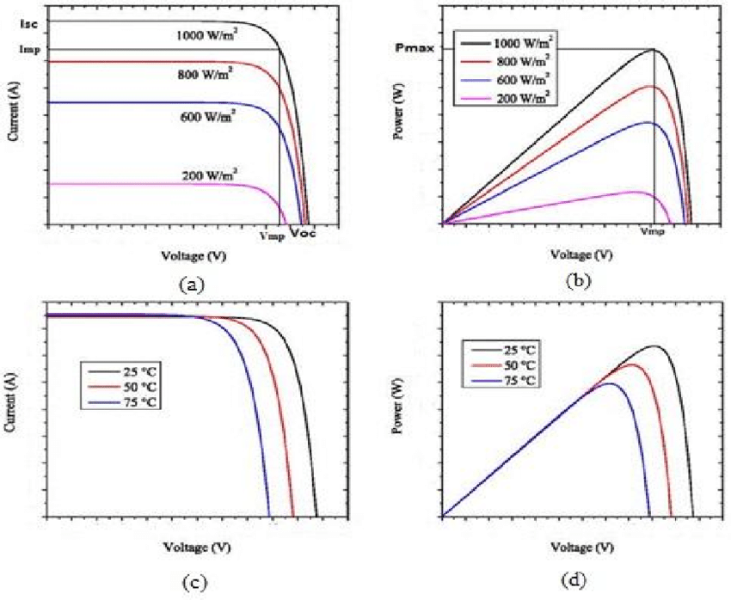

**2. Solar Energy Storage Systems [14M]**

**Introduction**

Energy storage systems enable the utilization of solar energy when sunlight is unavailable. Two commonly used storage systems are **battery storage systems** and **thermal energy storage systems**.

**1. Battery Storage System**

1. **Definition:** Batteries store excess solar energy as chemical energy for later use.
2. **Components:**
   * Batteries (e.g., lithium-ion, lead-acid).
   * Charge controller to regulate charging and discharging.
   * Inverter to convert stored DC energy into AC.
3. **Working:**
   * During sunlight, excess energy is stored in batteries.
   * When sunlight is unavailable, batteries supply energy to the load.
4. **Illustration:** A schematic showing solar panels connected to a battery through a charge controller.

**Advantages:**

* Provides energy during the night or cloudy days.
* Enables off-grid applications.

**Disadvantages:**

* High initial cost.
* Limited lifespan and disposal issues.

**2. Thermal Energy Storage System**

1. **Definition:** Stores solar energy as heat for later use in heating or electricity generation.
2. **Types:**
   * **Sensible Heat Storage:** Uses materials like water or rocks to store heat by changing temperature.
   * **Latent Heat Storage:** Uses phase-change materials (PCMs) to store energy during melting/freezing.
3. **Working:**
   * Solar energy is absorbed by a thermal collector and stored in a medium.
   * The stored heat is used directly for applications like water heating or to drive turbines for electricity.
4. **Illustration:** A schematic showing a solar collector connected to a storage tank with heat exchange.

**Advantages:**

* High storage capacity.
* Suitable for industrial processes and large-scale power plants.

**Disadvantages:**

* Efficiency depends on insulation and material properties.
* Large space requirements.

**Conclusion**

Both battery and thermal storage systems are vital for maximizing solar energy utilization. Batteries are more suitable for small-scale applications, while thermal storage is ideal for large-scale industrial or power generation needs.