1-Write a query to insert a new employee into the Employees table with values (1, 'John', 'HR', 50000).

QUERRY:

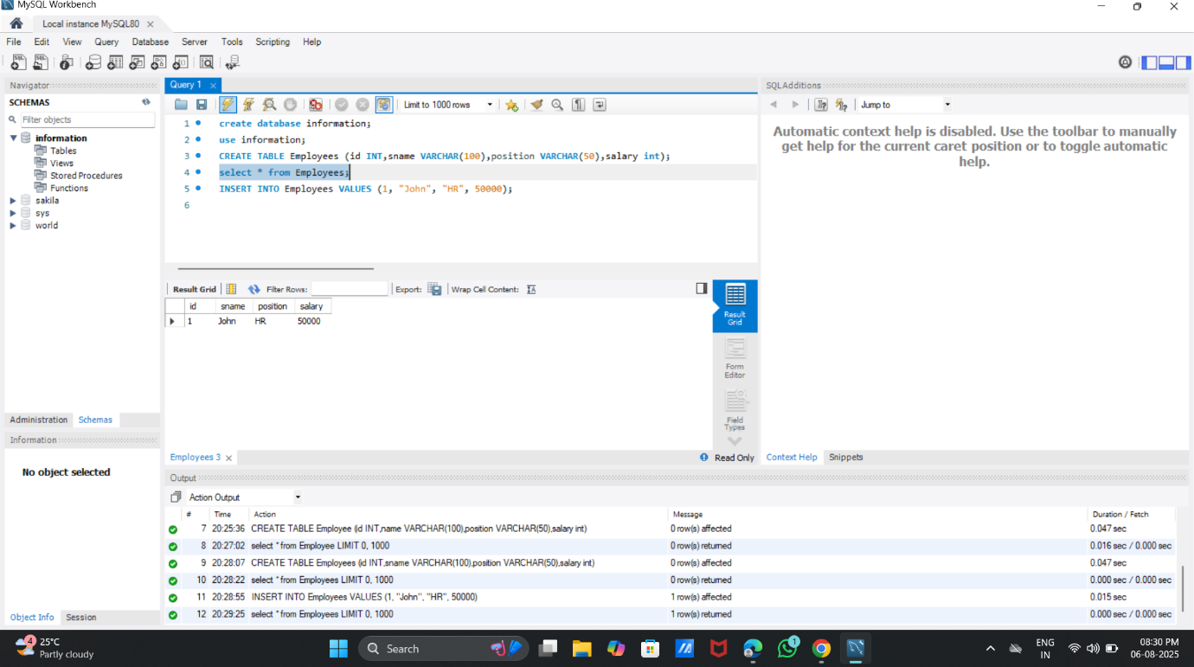

2. Write a query to insert multiple rows into a table in a single query.

QUERRY:

