**2. Accept average marks of five students. Display the highest marks obtained.**

**Program:**

using System;

using System.Collections.Generic;

using System.Globalization;

using System.Linq;

using System.Text;

using System.Threading.Tasks;

namespace Assignment

{

class Student

{

static void Main()

{

String name;

int marks;

int higest = 0;

for (int x = 1; x <= 5; x++)

{

Console.WriteLine("Enter Student name=");

name = Console.ReadLine();

Console.WriteLine("Enter Student Marks =");

marks = int.Parse(Console.ReadLine());

if (marks < 0 || marks > 100)

{

Console.WriteLine(" INVALID");

int newmarks = int.Parse(Console.ReadLine());

marks = newmarks;

}

if (marks > higest)

{

higest = marks;

}

}

Console.WriteLine("Highest marks=" + higest);

Console.ReadLine();

}

}

}

**OUTPUT:**

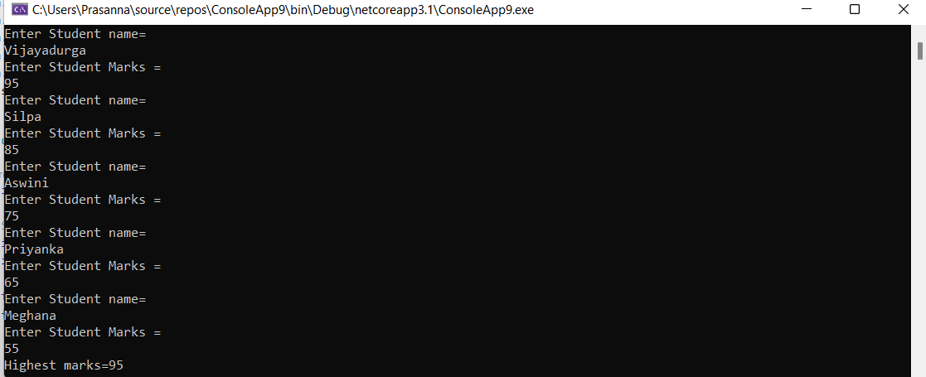

**3.Write a static method to accept param array of integers. The method should find the sum of all the integers passed and display the result. Write a client program to call the method.**

**Program:**

using System;

namespace sumofaray

{

class Program

{

static void Main(string[] args)

{

int[] a = new int[0];

int sum = 0;

int i;

Console.WriteLine("Enter the number of elements");

int n = Convert.ToInt32(Console.ReadLine());

Console.WriteLine("Enter the array Elements");

for (i = 0; i < n; i++)

{

a[i] = Convert.ToInt32(Console.ReadLine());

}

for (i = 0; i < n; i++)

{

Console.WriteLine(a[i]);

}

for (i = 0; i < n; i++)

{

sum = sum + a[i];

}

Console.WriteLine("The Sum is" + sum);

Console.ReadLine();

}

}

}

**4. Write a method to swap two integers. The client code should call the method and print the swapped value.**

**Program:**

using System;

namespace example_program

{

class Swapping

{

static void Main(string[] args)

{

int number1, number2, temp;

Console.Write("Enter the number for number1");

number1 = int.Parse(Console.ReadLine());

Console.Write("Enter the number for number2 ");

number2 = int.Parse(Console.ReadLine());

Console.WriteLine("Before swapping number1 = {0} and number2 = {1}", number1, number2);

temp = number1;

number1 = number2;

number2 = temp;

Console.WriteLine("After swapping number1 = {0} and number2 = {1}", number1, number2);

}

}

}

**Output:** 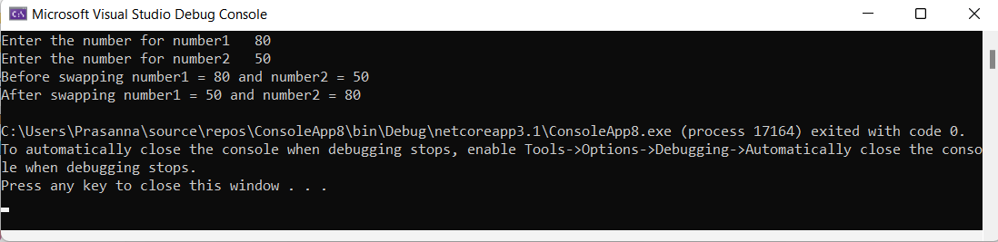

**5.** **Write a single method that calculates the area and circumference of the circle. The area and circumference should be displayed through the client code.**

**Program:**

using System;

namespace AssignmentCsharp

{

public class Circle

{

public static void Main(string[] args)

{

double rad, Area, Circumference;

const double PI = 3.14;

Console.WriteLine("Input the radius of the circle");

Console.Write("\nEnter the radius of circle ");

rad = Convert.ToDouble(Console.ReadLine());

Area = PI * rad * rad;

Circumference = 2 * PI * rad;

Console.WriteLine("\nThe area of a circle is {0} ", Area);

Console.WriteLine("\nThe circumference of a circle is {0}", Circumference);

}

}

}

**Output:**

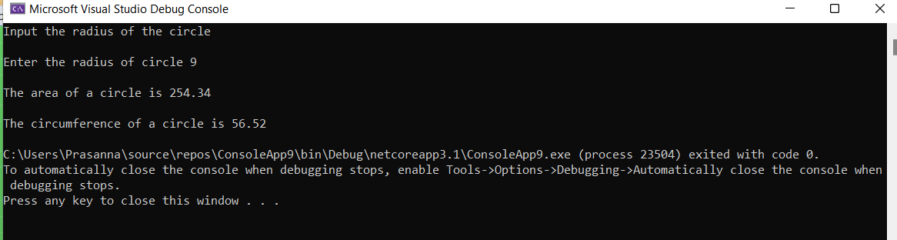

**6.Create a structure Book which contains the following members:**

**bookId, title, price, bookTyp**

**Type of the book should an enumerated data type with values as Magazine, Novel, ReferenceBook, Miscellaneous. Write a console based application to do the following tasks.**

**a.Accept the details of the book**

**b.Display the details of the book. The type of book should be displayed as a string e.g.:**

**Magazine**

**Note: Use methods for accepting and displaying details.**

**Program:**

using System;

namespace Program

{

public enum BookType

{

Magazine,

Novel,

ReferenceBook,

Miscellaneous

}

struct Book

{

public string bookId;

public string title;

public string booktype;

public string price;

}

public class Bookrecords

{

static void RecordBook()

{

int nobook = 1000;

Book[] books = new Book[nobook];

int i, j, n, number, k = 0;

Console.Write("Enter no of books stored : ");

n = Convert.ToInt32(Console.ReadLine());

Console.Write("Enter {0} elements in the array \n\n", n);

for (j = 0; j < n; j++)

{

Console.WriteLine("Details of book :", k);

Console.Write("Enter Id of the book : ");

books[j].bookId = Console.ReadLine();

Console.Write("Enter Title of the book : ");

books[j].title = Console.ReadLine();

Console.WriteLine("...........................................");

Console.WriteLine("Select Type of the book : ");

foreach (int b in Enum.GetValues(typeof(BookType)))

Console.WriteLine((BookType)b);

Console.Write("Enter Book Type : ");

books[j].booktype = Console.ReadLine();

Console.WriteLine("............................................");

Console.Write("Enter the Price of the book : ");

books[j].price = Console.ReadLine();

k++;

Console.WriteLine();

}

for (i = 0; i < n; i++)

{

Console.WriteLine("{0}: BookId = {1}, Title = {2} ,BookType = {3}, Price = {4} ", i + 1, books[i].bookId, books[i].title, books[i].booktype, books[i].price);

Console.WriteLine();

}

}

public static void Main()

{

RecordBook();

}

}

}

**Output**